Resend account invitation email

Portal User Guide

|  |  |  |
| --- | --- | --- |
| Purpose | | |
| User Guide shows how to: Resend account invitation email in CMS Portal | | |
|  | Note:  Account activation emails are only resent to users who have not previously activated their CMS Portal account. | |
|  |  | |

1. From Home page screen, click: Organisation Administration

Organisation Administration screen displays:

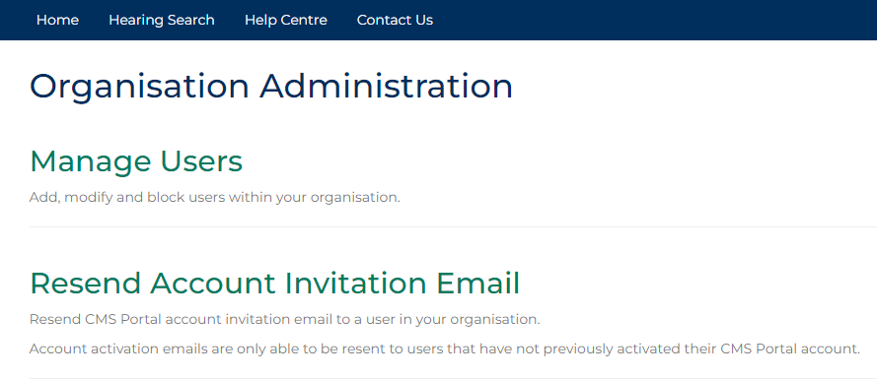

1. Click: Resend Account Invitation Email

Resend User Activation Email screen displays:

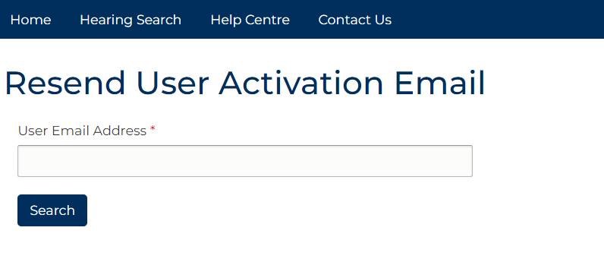

1. Enter User email into User Email Address field.

|  |  |
| --- | --- |
|  | Note:  Error message displays if User is not from organisation or has previously activated account. |

1. Click: Search

Confirmation status message displays:

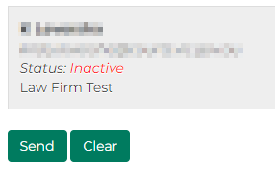

1. Click: Send

Confirmation message displays:

Confirmation message showing that further instructions have been sent.

|  |  |
| --- | --- |
|  | Note:  User is sent email notification with account activation link. |