CMS Portal enrolment guide
Background
CMS Portal will be the single point of entry for all cases in the Magistrates' Court of Victoria (MCV) and Children's Court of Victoria (ChCV). It will allow external parties to interact with the Courts digitally, leading to improved information flow and safety outcomes for the community.
This document provides instructions for setting up and activating CMS Portal accounts for you and your staff.
Note: CMS Portal is not available for self-represented parties.

Table of Contents
What you need to do | 1-2
How to complete the CMS Enrolment spreadsheet | 2-5
Errors to avoid when completing the spreadsheet | 6
How to update your organisation's email address | 6
How to add the CMS Portal to your safe list (to ensure you have access) | 7-10
Activating your account | 11-18
Resetting your Two-Factor Authentication (2FA) | 18-19
Further information | 19

What you need to do
- Read the CMS Portal Terms of Use.
- Download the CMS spreadsheet for enrolment and save it to your local drive. The file is provided in an xlsx format. Please download it to your local drive in a csv format. We recommend that the file name be saved as your organisation’s name, for example: Bloggs Legal CMS Portal enrolment.
CMS-Spreadsheet for enrolments
- Follow the instructions on pages 2-5 to complete the spreadsheet. It is important that you enter the data exactly as outlined, to ensure we can load it into our system.
- Have a senior representative of the organisation endorse the content. Your organisation is accountable for ensuring that the details for individuals are true and accurate.
- Email the completed spreadsheet to the relevant jurisdiction:
Magistrates' Court of Victoria (MCV) | cms.support@courts.vic.gov.au
Children's Court of Victoria (ChCV) | chcvcms@courts.vic.gov.au
Subject line: [your organisation’s name] – CMS Portal enrolment, for example: Bloggs Legal – CMS Portal enrolment
- Ask your IT support person to add @courts.vic.gov.au to your organisation’s safe list. This will ensure communications from CMS Portal will not be blocked or sent to junk mail. Instructions for how to do this yourself are below.
- Have staff (users) activate their accounts when they receive the notification email.

How to complete the CMS Enrolment Spreadsheet
It is essential that you follow the instructions below for what information is needed in each column. Those columns with mandatory fields are marked with an asterisk.
Use a single sheet to enter staff information, starting at row 2. Please ensure you don’t remove any columns or change any of the headings (row 1).
Column A – profile_firstName
Enter the user’s first name. If not required, leave it blank.
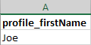
*Column B – profile_lastName
Enter the user’s last name. Where a person has a single name, record it as a last name.
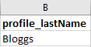
*Column C – profile_barNumber
Each user will need to be given a Unique Identification Number. The number can be up to 9 characters if it’s purely numeric, and up to 10 characters if alphanumeric. It cannot contain special characters.
All Unique IDs should follow the same format. This could be an employee number, a Practitioner ID or something you have created – see an example below. Ideally this is an identifier that only the bona fide recipient would know.
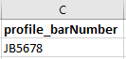

*Column D – username
This must be a user’s organisation email address (not a general email or a personal one), and the same email you enter in column R.
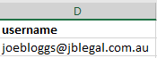
Column E – profile_employeeId
Someone at your organisation will need to decide whether they want to include employee IDs. If not required, leave it blank.
Column F – profile_mobile
Include a mobile number here if a user wants to receive SMS notifications, such as a submission approval. See below for the format/examples. Leave blank if you choose not to provide a number.
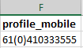
Column G – profile_phone
A phone number can be provided for court staff to contact if they have any queries. See below for the format/example. Leave blank if you choose not to provide a number.
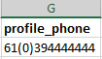
Column H – profile_fax
See below for the format/example. Leave blank if you choose not to provide a number.
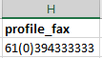
Columns I - L
Please leave these columns blank – do not remove any of these columns.

Column M – profile_rejectionEmail
A user can choose to receive rejection notifications to a different email address. This can be a general email, for example: admin@jblegal.com.au. If not required, leave it blank.
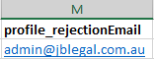
Column N – profile_secondaryEmail
A user can choose to receive updates on a case to a different email address (except rejections). This can be another person or a general email, for example: admin@jblegal.com.au. If not required, leave it blank.
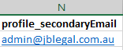
Column O & P
Please leave these columns blank – do not remove any of these columns.
*Column Q - role
There are two types of users – user (LLFUser) and an organisation administration user (LLFAdmin).
User (LLFUser) | Organisation administration user (LLFAdmin)
This will be assigned to most staff, and allow them to:  - Lodge a new filing  - Upload documents  - Lodge a payment (if required)  - Receive email notifications  - Print issued documents  - View/search own filings  - Download documents | This role should be assigned to 1-2 staff (more in a bigger organisation), delegated the authority to view and access sensitive/confidential information.  These people have the same access as a user, and also be able to:  - Add and modify users  - Block/unblock user accounts  - Update user information  - Run organisation filing report
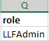
*Column R – email
This must be a user’s organisation email address and the same email you enter in column R.
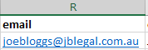
*Column S – organizationName
This is your ‘Trading as name’, as provided to VLSBC. This needs to be the exact name of the organisation.
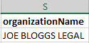
Column T – Solicitor_Code
This is your firm’s Victorian Legal Services Board CR number/solicitor code – a unique identifier assigned to you. This will need to be entered as CR, then six-digits (no space). If your code is less than six-digits, please use zeros to make up a six-digit number (for example, CR000001).
If you do not know this number, please contact the Victorian Legal Services Board on (03) 9679 8000.
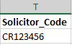
Column U – Org_Email
This is an email address for your firm to receive eNotifications from the Magistrates Court of Victoria and/or the Children’s Court of Victoria, such as hearing listings.
We recommend using a general email (for example: admin@jblegal.com.au) that is regularly monitored. If you have multiple branches and different emails for each, please specify using the CR number/solicitor code to articulate which email address goes with which branch.
If you do not include an email in this column, these notifications will be sent to you by post.
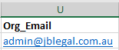

Errors to avoid when completing the spreadsheet
Please pay particular attention to commonly observed errors:
- Spaces before or after the text you enter – for example, info@bloggslegal.com.au
- “Username” and “email” email addresses not matching exactly
- Duplicate email addresses – more than one user with the same email in Columns D & R
- Incorrectly formatted phone numbers – for example, 0394444444
- Missing information from mandatory fields – for example, no unique identification number listed in Column C
- Column headings (row 1) changed or deleted
- The organisation name doesn’t match the ‘Trading as name’ provided to VLSBC
- The Solicitor Code provided does not match the one provided by the VLSBC

How to update your organisation’s email address
To ensure your organisation receives eNotifications from the Magistrates Court of Victoria and/or the Children’s Court of Victoria, it is important that the email address for the organisation is kept up-to-date.
Where an email address is not nominated for an organisation, all notifications will continue to be sent via post.
To update your organisation’s email address:
(1) Complete the below table (see example)
Solicitor code | Email address
CR987654 | jblegal@jblegal.com.au
(2) Email table to relevant jurisdiction:
Magistrates' Court of Victoria (MCV) | cms.support@courts.vic.gov.au
Children's Court of Victoria (ChCV) | chcvcms@courts.vic.gov.au
Subject line: Update to Organisation email address

How to add the CMS Portal to your safe list (to ensure you have access)
In some situations, an organisation’s internet settings can prevent them from being able to access particular sites.
To ensure you can access CMS Portal and receive all eNotifications from the Magistrates Court of Victoria and/or the Children’s Court of Victoria, it is important that you add the CMS Portal to a safe list.
If you have an IT department, contact them for assistance with this. If not, please follow the instructions below for adding CMS Portal to:
- Your Outlook email safe list
- Microsoft Edge and/or Google Chrome browser safe list.
Outlook
  - Navigate to the Home tab and click the option Junk.
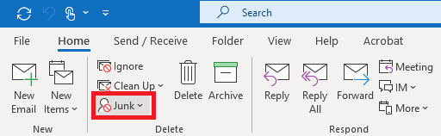
  - Select the option Junk E-mail Options.
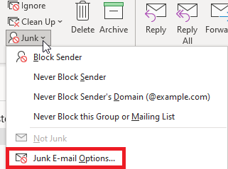

  - In the Safe Senders tab, select the option Add.
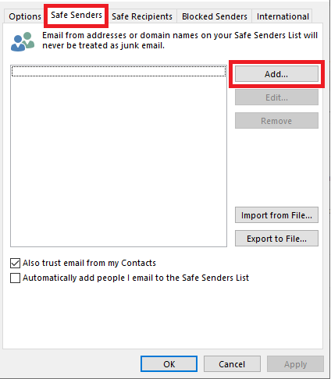
  - Enter the internet domain @courts.vic.gov.au and click OK.
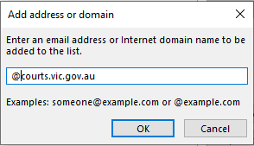
  - Click OK.
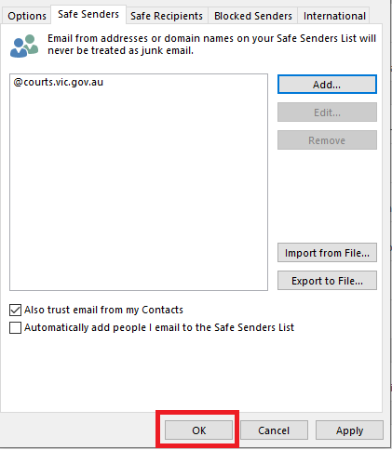
Microsoft Edge and/or Google Chrome
Note: These steps may vary if you are using an Apple device.
- Click on the Start Menu, and search for Control Panel.
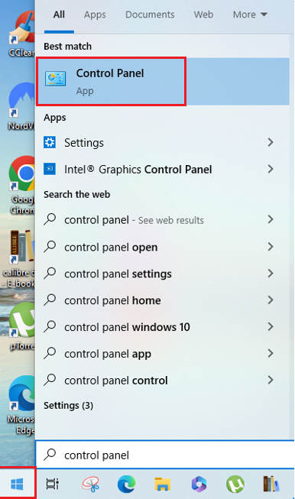
- Select the option Network and Internet.
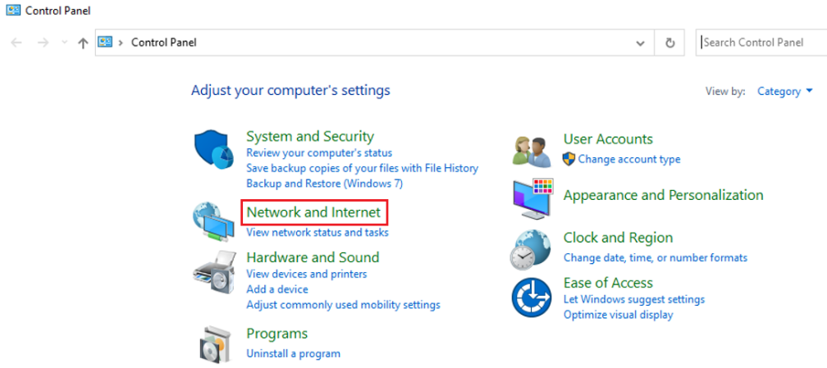
- Select the option Internet Options.
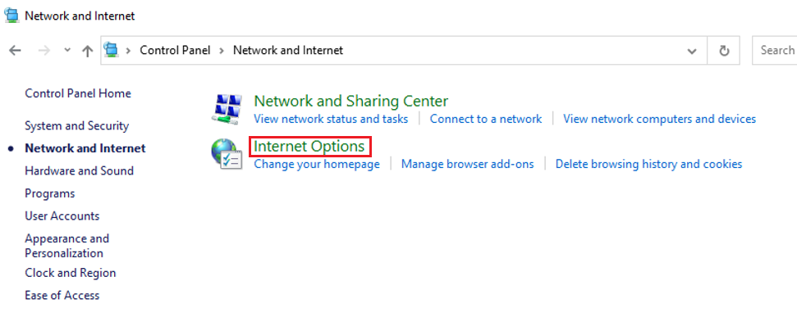
- In the Security tab, click on Trusted sites.
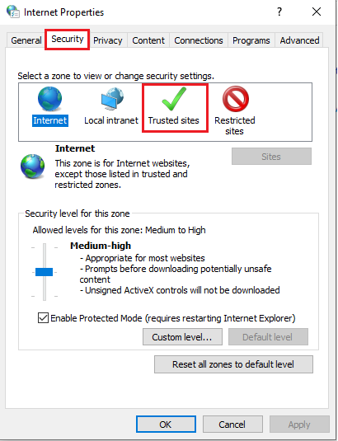
- Click on Sites.
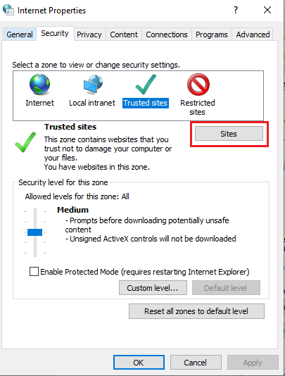
- Enter the website https://cmsportal.courts.vic.gov.au and click Add and then click Close.
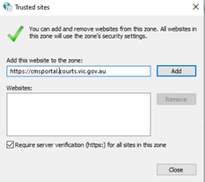
How to activate your account
Users will need their Unique Identification Number to activate their account. Once they are decided, please provide each user with their number.
When accounts are set up, each user will be sent an email from the CMS Portal with a unique link to activate their account. Please encourage users to do this ASAP – the link will expire after 45 days.

Activation process
Users will need to:
- Click the account activation link in the Welcome to the CMS Portal email sent to the email address linked to your CMS Portal account.
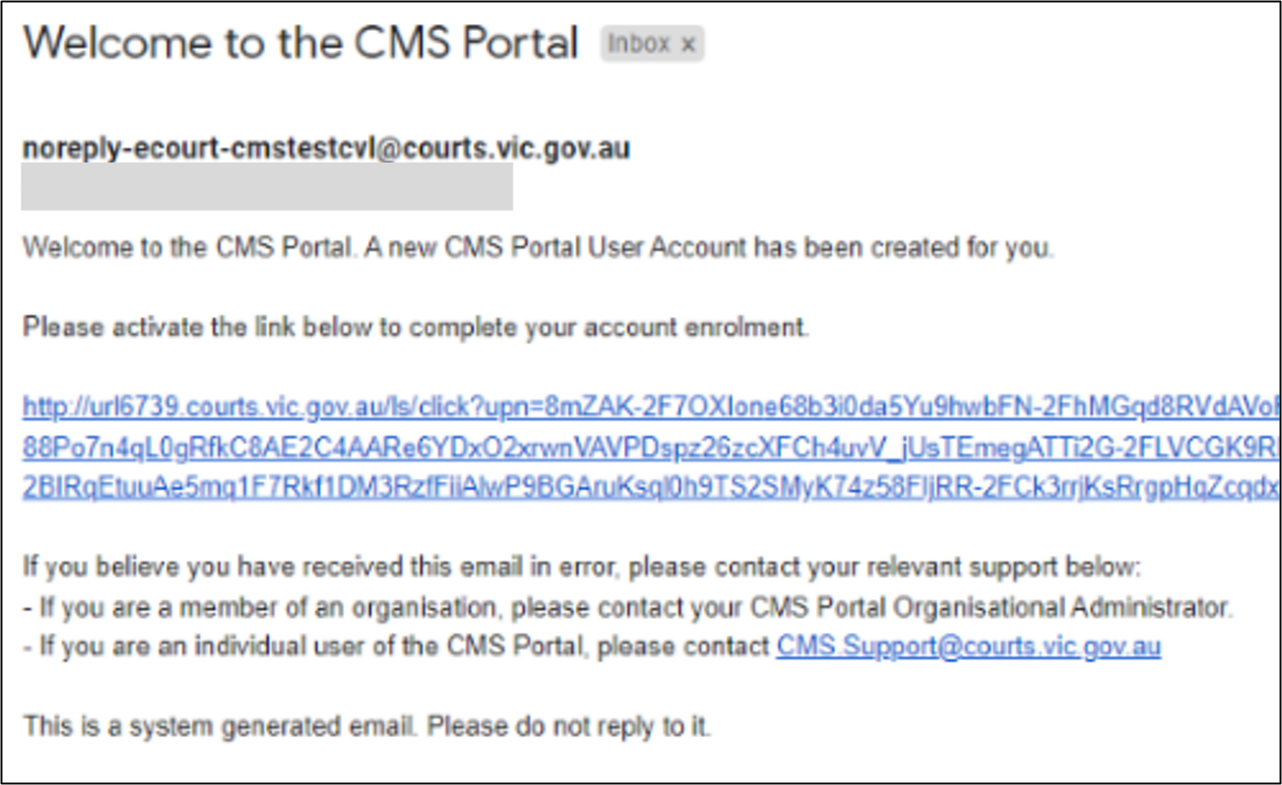

The Identity Verification screen displays:
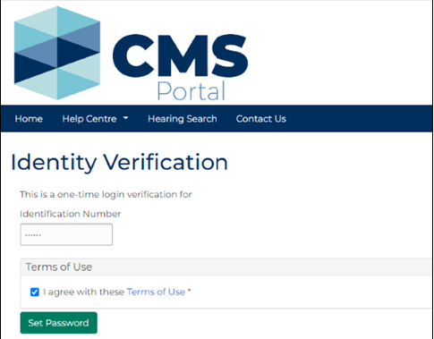
Note: You may not be prompted to enter an Identity Verification number and accept terms and conditions. If prompted, your Identity Verification number is the profile_barNumber your organisation provided at registration.
- Review the CMS Portal Terms of Use, if you haven’t already, then click: Set Password.
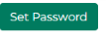
The My Account screen displays.
- Type a new password and click Save. 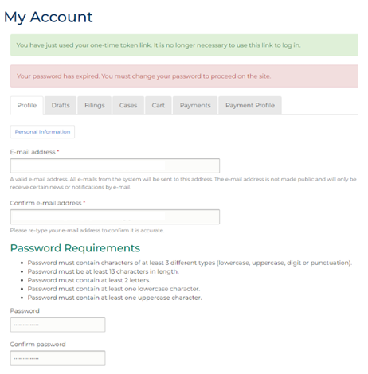

A confirmation message displays:
- The Register popup displays for you to set up a Two-Factor Authentication (2FA). Enter the email address linked to your CMS Portal account and click Get Started. This is the first authentication method.
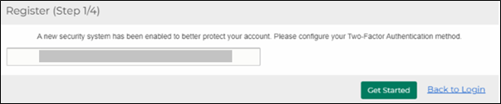
The Verify Email popup displays.
- A one-time passcode (OTP) is sent to your email account. Type this into the Enter the passcode field and click: Verify.
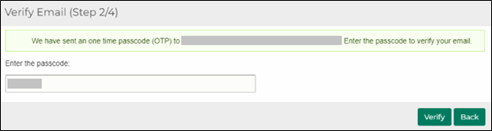
You will now need to set up your second authentication method. For Email Verification, see steps 6-9. For OTP Over SMS, see steps 10-13.
- Email Verification – Select Email Verification and click Next. An email will be sent to the email address linked to your CMS Portal account.
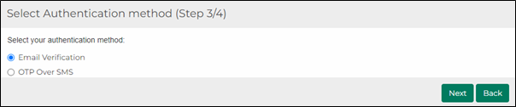

The Verify your identity screen displays:
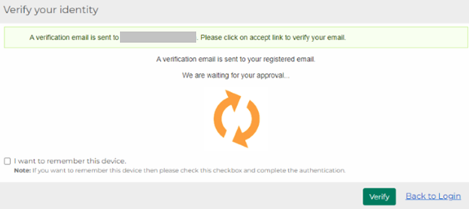
- Another email will be sent to the email address linked to your CMS Portal account. Click: Accept Transaction in the email.
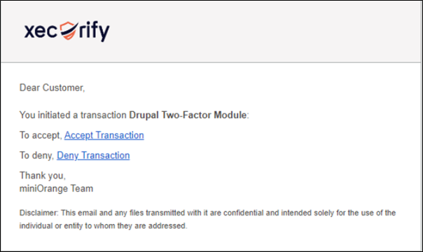

The Transaction Successful popup will display:
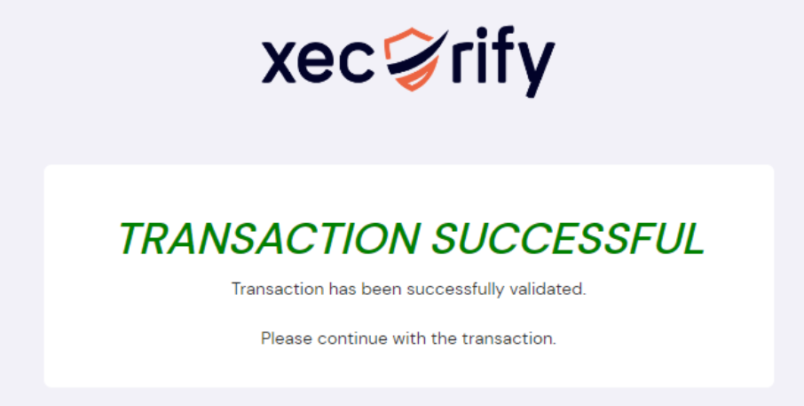
- Click: Verify in the CMS Portal (browser).
A confirmation message displays:

- Optional step to reduce how often you need to verify your identity to access the CMS Portal – select: I want to remember this device, then click: Verify the next time you log in.
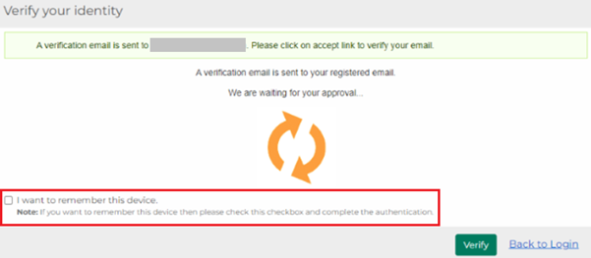
The next time you will be prompted to verify will be in 14 days unless you use a different device and/or browser.
Note:
- You will be sent an email with a verification link each time you log in unless you undertake step 9.
- If you change the email address linked to your CMS Portal account, you will need to contact the CMS Support Team to reset your 2FA.
- OTP Over SMS – Select OTP Over SMS and click Next.
The Configure OTP Over SMS popup will display.
- Enter the mobile number you wish to register into the Verify your phone number field. Click: Send OTP.
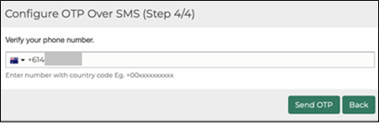
- Enter the passcode into the Configure OTP over SMS popup. Click: Validate OTP and Save.
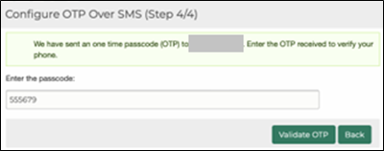
A confirmation message displays:
- Optional step to reduce how often you need to verify your identity to access the CMS Portal – select: I want to remember this device, then click: Verify the next time you log in.
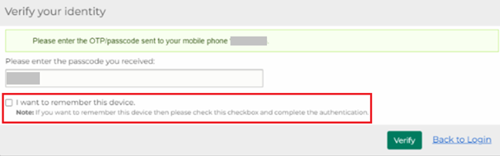
The next time you will be prompted to verify will be in 14 days unless you use a different device.
Note:
- You will be sent an SMS with a passcode to enter each time you log in unless you undertake step 13.
- If you change your mobile number, you will need to contact the CMS Support Team to reset your 2FA.

Organisation administration user: What to do if a user doesn’t activate their account within 45 days
If a user fails to activate their account within the activation period (45 days), an Organisation Administration user can resend an account invitation email with a new activation link:
- Once logged in, click: Organisation Administration
- Click: Resend Account Invitation Email
- Type the user’s email address, then click: Search
- Once the search result shows, click: Send

Resetting your Two Factor Authentication (2FA)
In the event that you have changed your email, mobile device or phone numbers, you will need to reset Two-Factor Authentication (2FA) for your CMS Portal account.
- Request your Organisation Administration user (or an alternate administrator if you are also an Organisation Administration user) to send an email from their registered CMS Portal account email to the relevant jurisdiction:
Magistrates' Court of Victoria (MCV) | cms.support@courts.vic.gov.au
Children's Court of Victoria (ChCV) | chcvcms@courts.vic.gov.au
In the email, provide the following:
  - The user’s registered CMS Portal account email
  - The user’s full name details as submitted for enrolment
  - The users Unique Identification Number (Column C) as submitted for enrolment
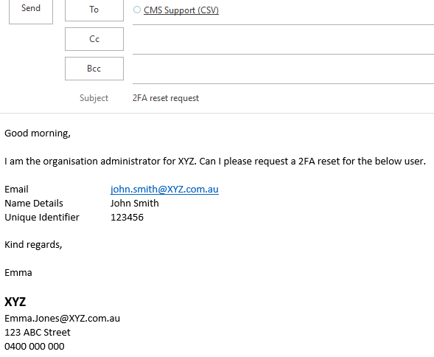

Note:
- If you are a sole practitioner or the only Organisation Administration user in your practice, please make sure to mention this in your email.
- If the Organisation Administration user cannot provide the required enrolment details, the CMS Support Team will request further information to confirm your identity to proceed with the 2FA request.
- The CMS Support Team will validate your details and process the request. Once reset, you will receive an email to confirm this.
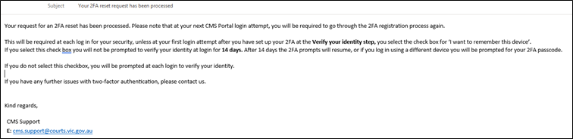
- At your next log in to the CMS Portal, you will be required to go through the 2FA registration process again. Follow step 4 onwards from the Activate your CMS Portal account instructions.

Further information
Please view the Case Management System Project page or the CMS Help Centre on the CSV website for the most up-to-date information on the CMS Portal, including detailed support material such as our frequently asked questions.
For further questions regarding the enrolment process, please email your relevant jurisdiction:
Magistrates' Court of Victoria (MCV) | cms.support@courts.vic.gov.au
Children's Court of Victoria (ChCV) | chcvcms@courts.vic.gov.au

