
Portal Quick Reference Guide
MCV and ChCV | Criminal
Request case access
Purpose
Quick Reference Guide shows how to Request case access in CMS Portal.
Prerequisite
Before start, ensure name of accused or case number/record number is known.

- From CMS Portal Home page, select: Magistrates' Court of Victoria or Children's Court of Victoria
Select a Case Type screen displays:
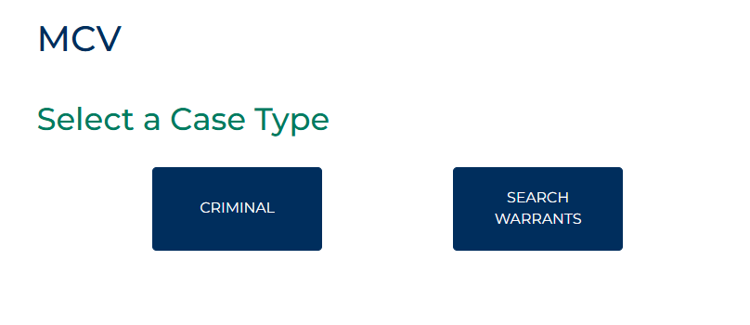
- Select: Criminal
Criminal screen displays:
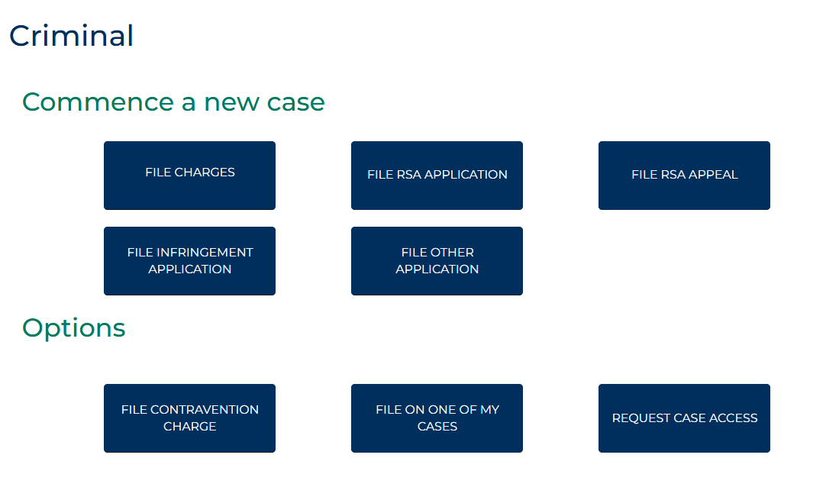
- Select: Request Case Access
Request Case Access screen displays:
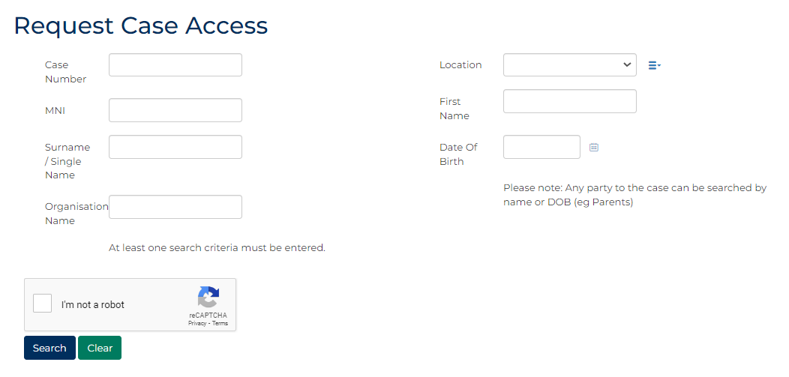

- Complete required panels and fields.
Panel: Request Case Access
Field: | Action:
Case Number | Type case number.
Location | Select court location.
MNI | Type relevant number if known.
First Name | Type name.
Surname / Single Name | Type name.
Date Of Birth | Type date or click calendar icon to select date.
Organisation Name | Type name, if relevant
Solicitor Code | Type number if known  Note:  Field only available for Lawyer/Law Firm or Victoria Legal Aid users.

 | Note:  Data must be entered into at least one field.
- Select: I'm not a robot.

- Click: Search
Result matching the search criteria displays:
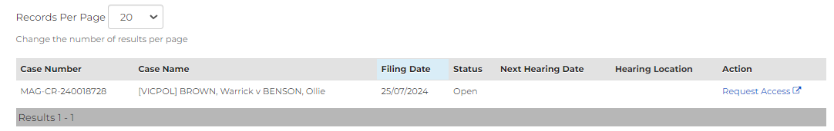
- For relevant case, from Action column, select: Request Access
Request Case Access screen displays:
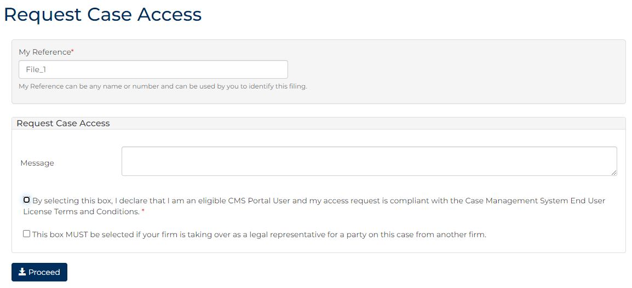

- Complete required panels and fields.
Panel: Request Case Access
Field: | Action:
My Reference | To identify filing, type reference.
Message | Type relevant information to support case access request.
I declare that I am eligible to use the CMS Portal and seek access to this proceeding for an "Authorised Purpose". I will comply with the CMS Terms of Use, which I have read, understood and accepted. | Select checkbox.
Information and documents in the CMS Portal, and downloaded from the CMS Portal, remain subject to prohibitions on publication pursuant to s534 of the Children, Youth and Families Act 2005 (Vic) | -
This box MUST be selected if your firm is taking over as a legal representative for a party on this case from another firm | Select checkbox  Note:  Field only available for Lawyer/Law Firm or Victoria Legal Aid users.

- Click: Proceed
Confirmation of Filing screen displays:
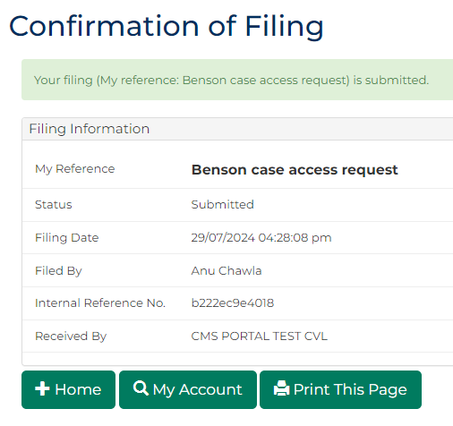
Note:
Case access link sent to email associated to user's CMS Portal account.

- In Case Access notification email, click link to activate case access.
Confirmation message with a case link displays in CMS Portal.
Note:
You must click link whilst logged into Portal on the same device.
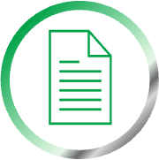 | Resource:  See Quick Reference Guide: View and action case

