
Portal Quick Reference Guide
MCV | Criminal
Manage Case Access
Purpose
Quick Reference Guide shows how to Manage Case Access in CMS.
Prerequisite
Before start, log in as CV Admin user.
Contents
Case Access Search 2
User Access Search 5

Case Access Search
 | Note:  Process used to see list of users with access to case.
- From CMS Portal Home page, select: Organisation Administration
Organisation Administration screen displays:
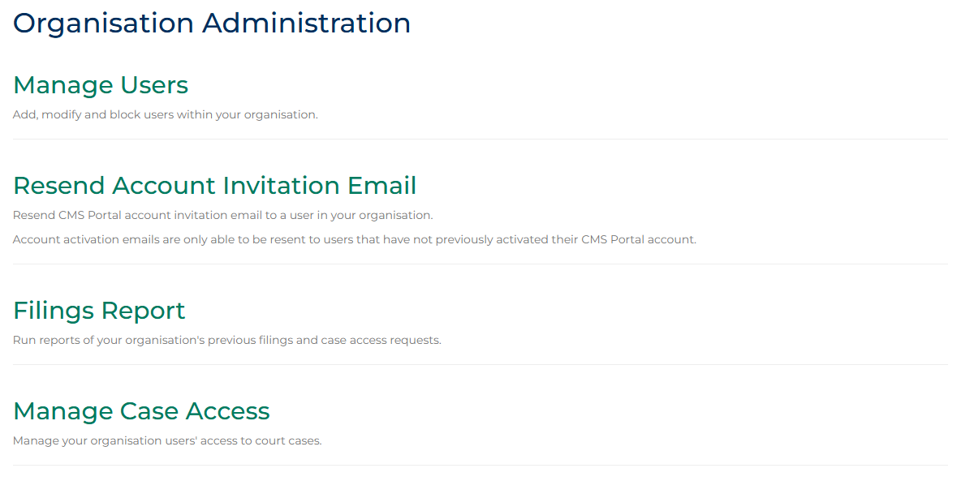

- Click: Manage Case Access
Manage Case Access screen displays:
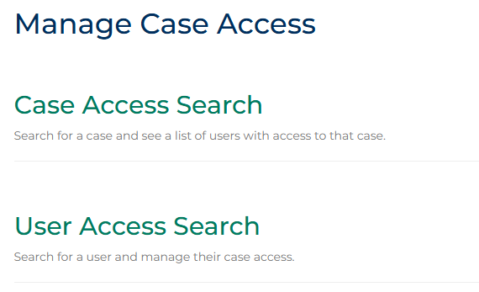
- Click: Case Access Search
Case Access Search screen displays:
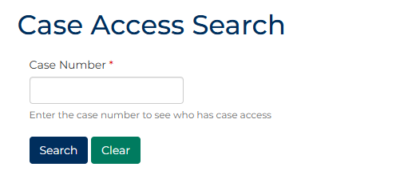
- Type case number into Case Number field.

- Click: Search
Search results display:
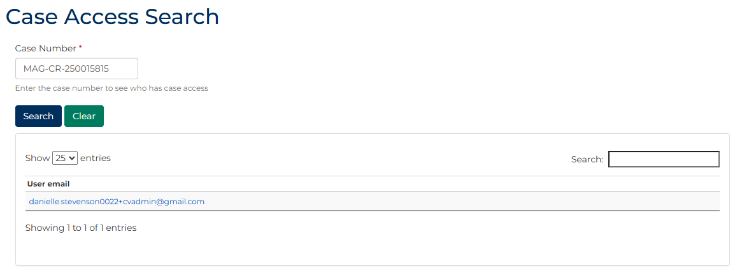
Note:
If no results returned, no user within your Organisation has access to the case.

User Access Search
Prerequisite
Before start, conduct Case Access Search to ensure Organisation has access to case.
Note:
Process used to search for a user and manage their case access.
- From CMS Portal Home page, select: Organisation Administration
Organisation Administration screen displays:

- Click: Manage Case Access
Manage Case Access screen displays:
- Click: User Access Search
Manage Case Access screen displays:
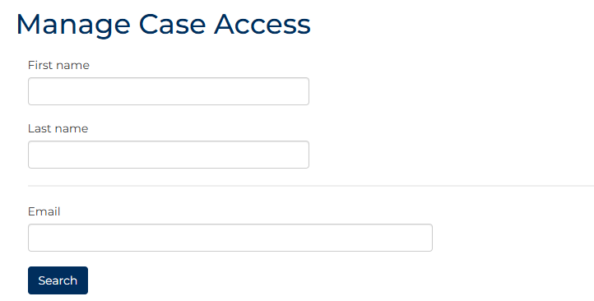

- Complete required panels and fields.
Panel: Manage Case Access
Field: |  | Action:
First name |  | Type first name.
Last name |  | Type last name.
Email |  | Type email address.
Note:
At least one search criteria must be completed.
- Click: Search
Search result displays:
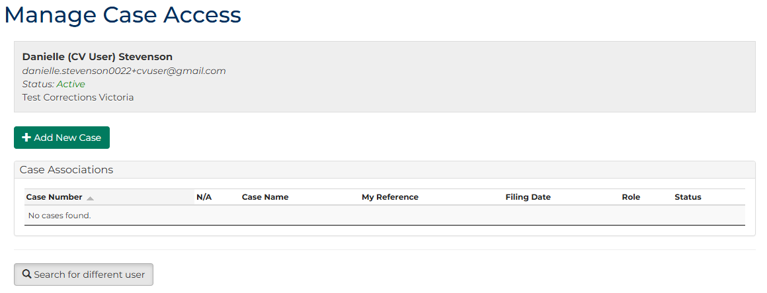
Note:
If more than one result, click Edit Access link for relevant user.

- Does case access need to be granted?
If | Then
Yes | Go to next step
No | Go to step 12
- Click: + Add New Case
Add User Case Access screen displays:
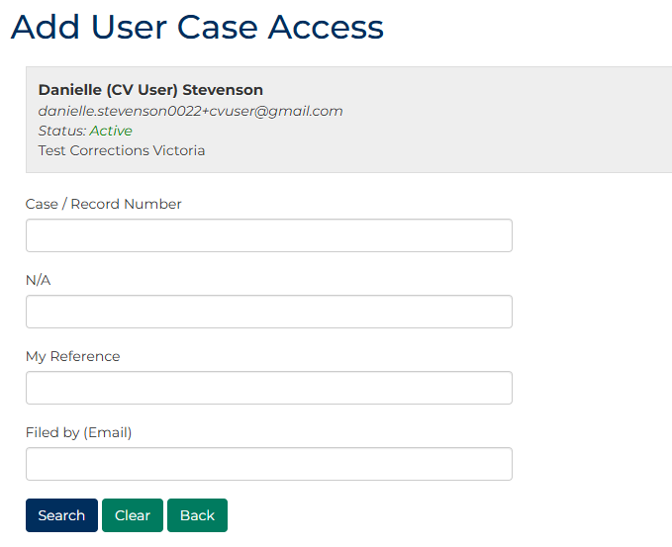

- Complete required panels and fields.
Panel: Add User Case Access
Field: | Action:
Case / Record Number | Type number.  Note:  If case commenced as a Record Number (RN), user must type this number into field.
N/A | -
My Reference | Type reference.
Filed by (Email) | Type name.
- Click: Search
Search results display:
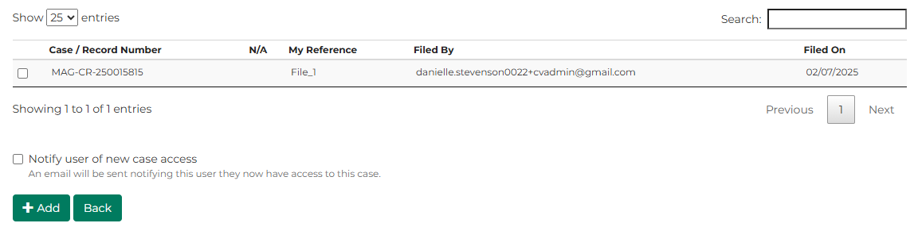
Note:
Cases will only be available if a user within your Organisation already has access to the case.

- For relevant case, select case checkbox.
Note:
To notify user of access to case, select Notify user of new case access checkbox.
- Click: + Add
Confirmation message displays:
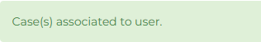
- Does case access need to be removed?
If | Then
Yes | Go to next step
No | End of process.
- For relevant case, select case checkbox.
- In Update Associations field, select: Inactive
Note:
- Update Status to Active if required
- Do not select Delete. If selected, no record kept that user previously had access to case

- Click: Update
Confirmation screen displays:
