
Portal Quick Reference Guide
MCV and ChCV | Criminal
File executed or unexecuted warrant
Purpose
Quick Reference Guide shows how to File executed or unexecuted warrant in CMS Portal.
 | Note:  - If accused is in custody, do not follow this process. Please take paperwork directly to relevant court location.  - If returning a charge-sheet and warrant to arrest for cancellation, file Charge-Sheet and Warrant (Request for Cancellation) document.
Contents
File executed or unexecuted Charge and Warrant to Arrest 2
File executed or unexecuted court ordered warrant (bench warrant) 8

File executed or unexecuted Charge and Warrant to Arrest
Prerequisite
Before start, ensure Charge and Warrant to Arrest has been issued on case.
- From CMS Portal Home page, click: File on One of My Cases
List of cases display:
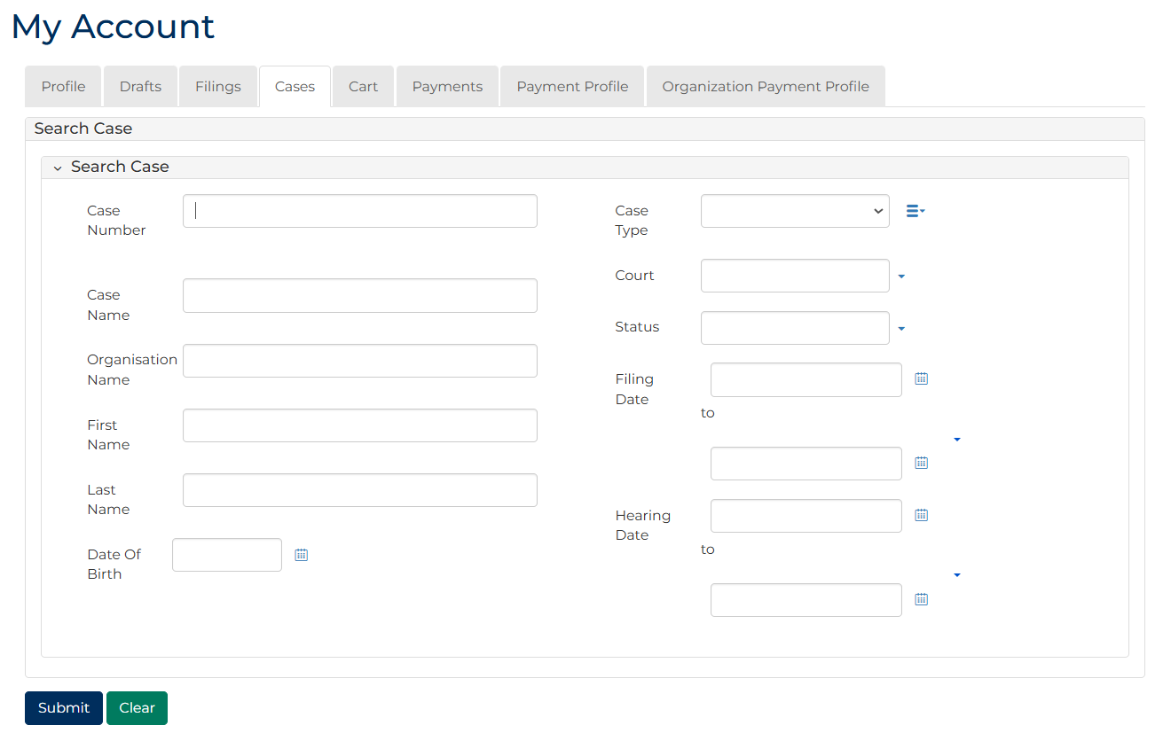
Note:
Only cases user previously filed on or requested access to, display.
 | Resources:  See Quick Reference Guides:  - View and action case  - Request case access

- For relevant case, click: File a Document
SubCases panel displays:
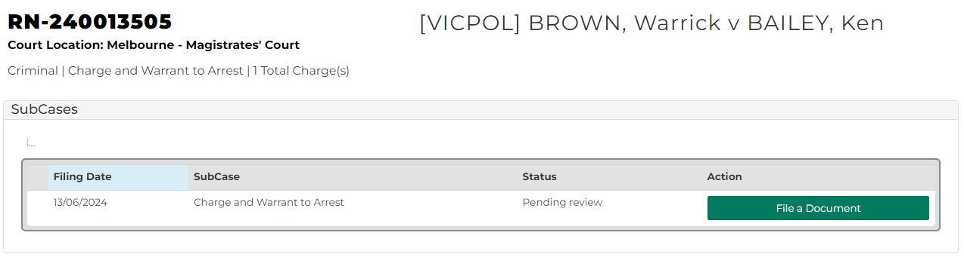
- For relevant subcase, click: File a Document
Add Filing screen displays:
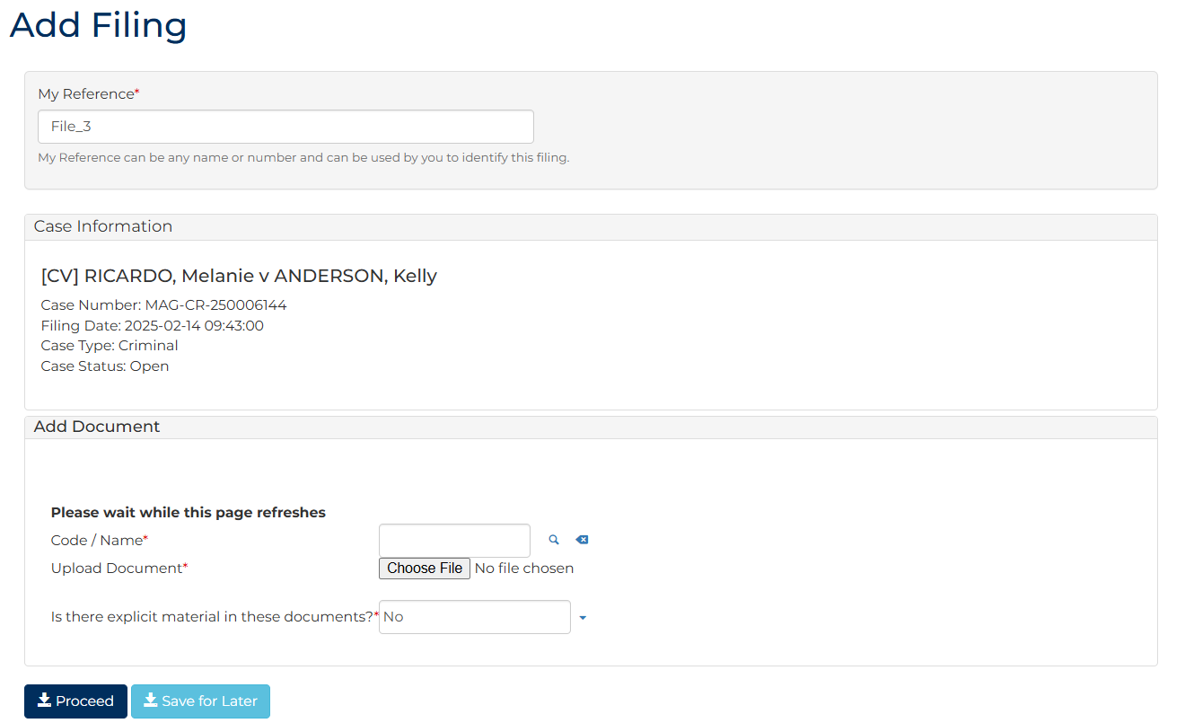
- To identify filing, type reference in My Reference field.

- Complete required panels and fields.
Panel: Add Document
Field: | Action:
Code/Name | Type WOARR and select Returned/Executed warrant
Upload Document | Click: Choose File and attach PDF document
Is there explicit material in these documents? | Change if required.

Panel: Additional Information
Field: | Action:
Warrant Outcome | Select relevant option.
Bail/Custody Status | Select relevant option.  Note:  If In Custody selected, user will not be able to proceed and must filed document physically with Court.

Additional Panels
Field: | Action:
Filed By | Select party.
Filed Against | Select party.
Related Documents | Select relevant Charge-sheet and warrant to arrest or Contravention charge-sheet and warrant to arrest  Note:  Ensure selected document has filed by date that matches issuing date of warrant being returned.

Panel: Hearing Details
Field: | Action:
Court Location | Change if required.
Category | Select relevant option.
Hearing Type | Select relevant option.  Select relevant option from Listing Widget  Note:  - If filing Contravention charge-sheet and warrant to arrest, hearing type of Contravention/Breach must be selected  - For all other warrants, select either Mention or Filing Hearing
Date and Time | -
Resources | Select resource(s).
Interpreter | Select party who requires Interpreter.
Duration | Type duration required in minutes.
Interpreter Language | Select language.
Is gender specific interpreter required? | Select relevant option.
Gender | Select relevant option.

Panel: Additional Documents
Field: | Action:
Code/Name | Type name and select additional document(s).
Upload Document | Click: Choose File and attach PDF document.

Note:
To add another document, click: + Upload Document

- Click: Proceed
Confirmation of Filing screen displays:
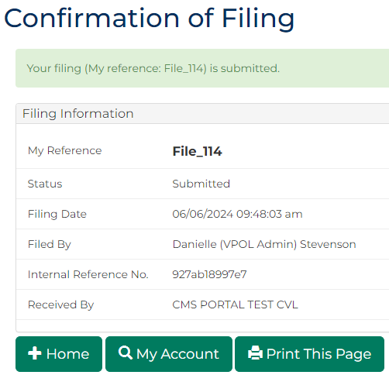
Note:
- Document is placed in work queue for registry to review
- Once reviewed, notification will be sent advising of outcome

File executed or unexecuted court ordered warrant (bench warrant)
Prerequisite
Before start, ensure Warrant to Arrest has been issued on case.
- From CMS Portal Home page, click: File on One of My Cases
List of cases display:
Note:
Only cases user previously filed on or requested access to, display.
Resources:
See Quick Reference Guides:
- View and action case
- Request case access

- For relevant case, click: File a Document
SubCases panel displays:
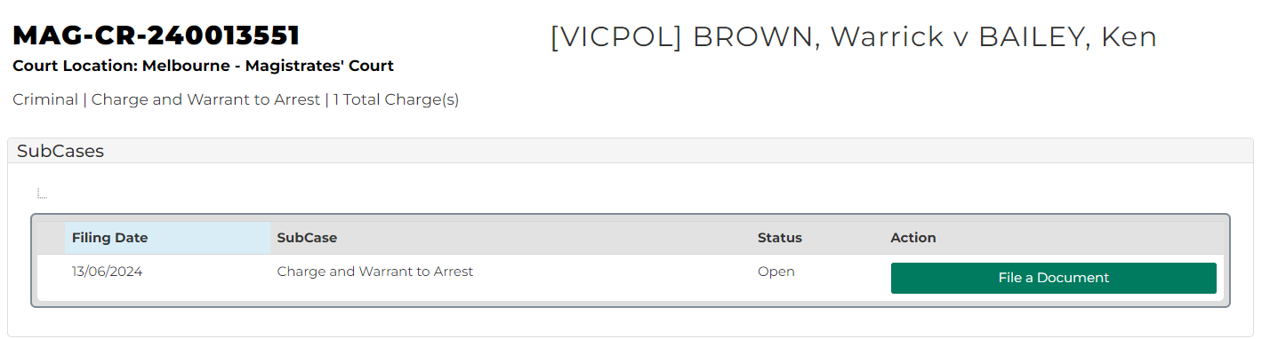
- For relevant subcase, click: File a Document
Add Filing screen displays:
- To identify filing, type reference in My Reference field.

- Complete required panels and fields.
Panel: Add Document
Field: | Action:
Code/Name | Type WOARR and select Returned/Executed warrant
Upload Document | Click: Choose File and attach PDF document
Is there explicit material in these documents? | Change if required.

Panel: Additional Information
Field: | Action:
Warrant Outcome | Select relevant option.
Bail/Custody Status | Select relevant option.  Note:  If In Custody selected, user will not be able to proceed and must filed document physically with Court.

Additional Panels
Field: | Action:
Filed By | Select party.
Filed Against | Select party.
Related Documents | Select relevant Warrant to arrest document.  Note:  Ensure selected document has filed by date that matches issuing date of warrant being returned.

Panel: Hearing Details
Field: | Action:
Court Location | Change if required.
Category | Select relevant option.
Hearing Type | Select relevant option.  Select relevant option from Listing Widget  Note:  - If filing relates to Contravention charge, hearing type of Contravention/Breach must be selected  - For all other warrants, select either Mention or Filing Hearing
Date and Time | -
Resources | Select resource(s).
Interpreter | Select party who requires Interpreter.
Duration | Type duration required in minutes.
Interpreter Language | Select language.
Is gender specific interpreter required? | Select relevant option.
Gender | Select relevant option.

Panel: Additional Documents
Field: | Action:
Code/Name | Type name and select additional document(s).
Upload Document | Click: Choose File and attach PDF document.

Note:
To add another document, click: + Upload Document

- Click: Proceed
Confirmation of Filing screen displays:
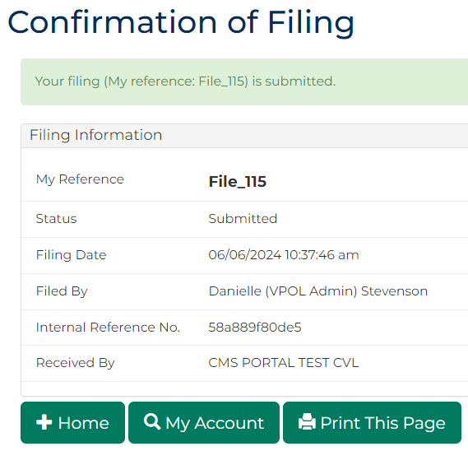
Note:
- Document is placed in work queue for registry to review
- Once reviewed, notification will be sent advising of outcome

