File document on existing case

Portal User Guide

|  |
| --- |
| Purpose |
| User Guide shows how to: File document on existing case in CMS |

1. Log in to Portal.

Home screen displays:

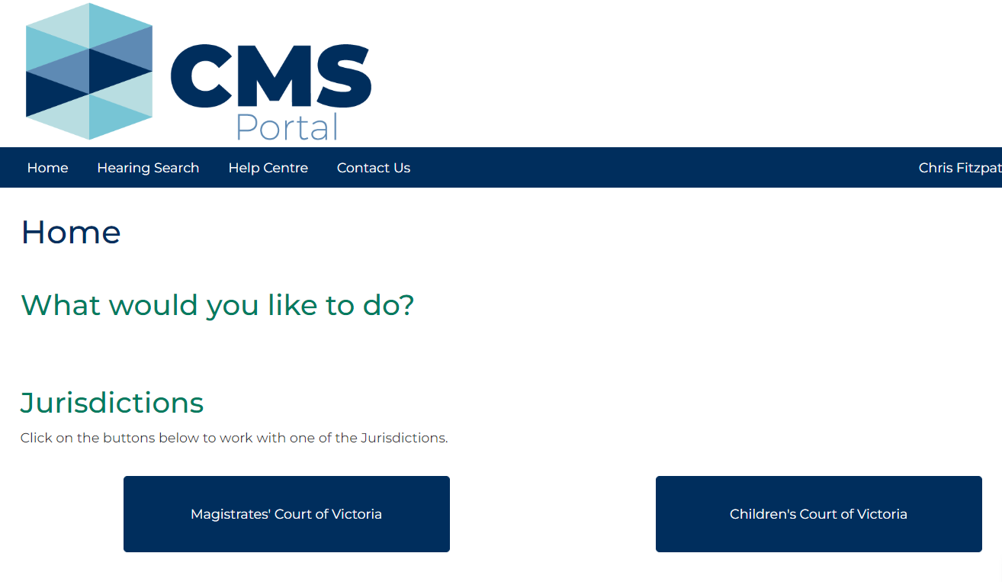

1. Click: File on One of My Cases

Search Case screen displays:

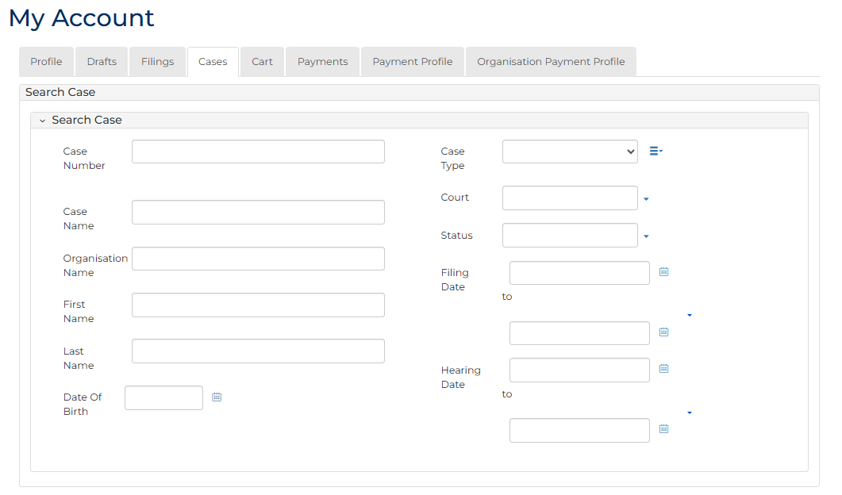

|  |  |
| --- | --- |
|  | Note:  List of cases that have permitted access display at bottom of screen. If relevant case is visible in list, click Case Number to access or link in Actions column to file on case  This page enables to search by numerous filters  If viewing is denied, requesting access to case is required |

|  |  |
| --- | --- |
|  | Resource:  See User Guide: Request access to a case |

1. In Action column for relevant case, click: File a document link.

Case Summary screen displays:

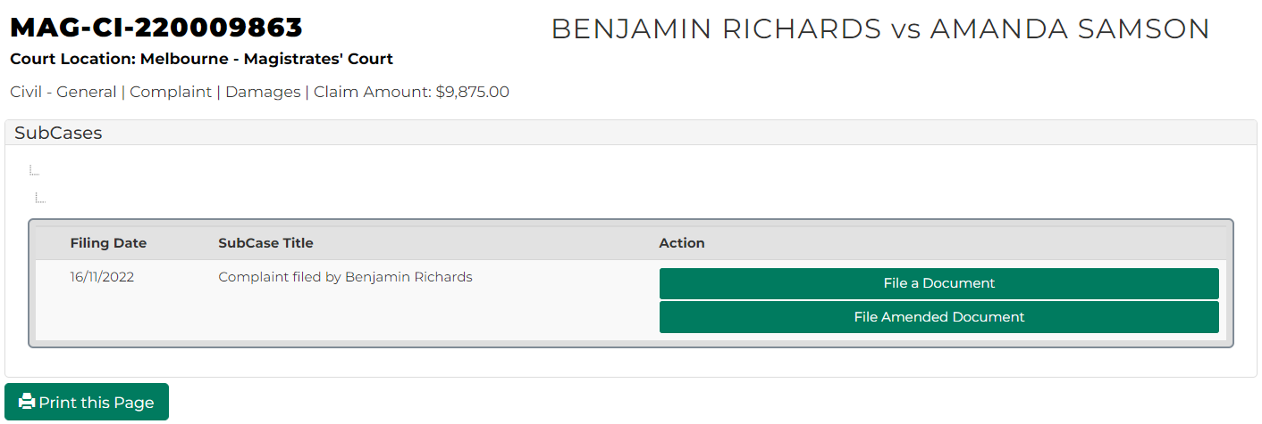

1. Click: File a Document

Add Filing screen displays:

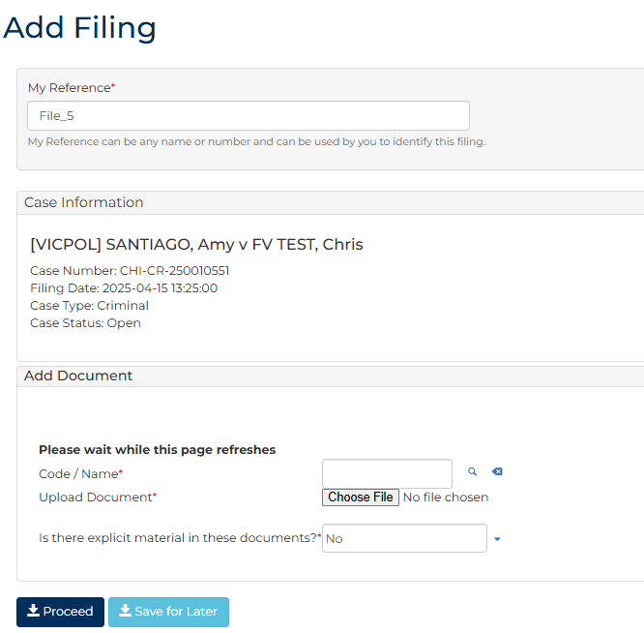

|  |  |
| --- | --- |
|  | Note:  Panels and fields will vary depending on document type selected. |

1. Complete required panels and fields.

| Panel: My Reference | |
| --- | --- |
| Field: | Action: |
| My Reference | Type reference name or number to identify filing. |
| Panel: Add Document | |
| Field: | Action: |
| Code/Name | Type document Code/Name and select document from list.  Note:  If unsure of document Code/Name click magnifying glass icon to open search functionality. |
| Upload Document | Click: Choose File and add required PDF document to case.  Note:  All document uploads must be PDF |
| Is there explicit material in these documents? | Change to Yes if required. |

| Additional Panels | |
| --- | --- |
| Field: | Action: |
| Filed by | Select party. |
| Representation | Select filing party’s legal representation if applicable.  To add representation, click: Add Representation |
| Related Documents | Select related documents. |
| Related Hearings | Select related hearings date. |
| Fee Waiver | Change to Yes if applying for a fee waiver. |

1. Click: Proceed
2. Is there fee for filing document?

|  |  |
| --- | --- |
| If | Then |
| Yes | Go to next step |
| No | Go to step 9 |

1. Select item requiring payment. Click: Submit Payment

Process Payment screen displays:

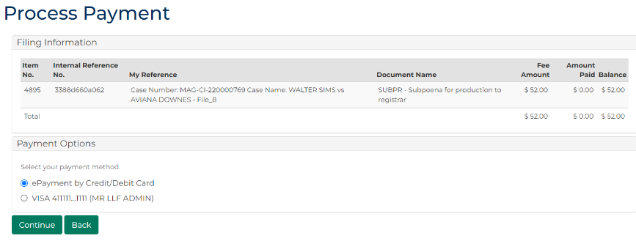

1. In Payment Options panel, select payment method, click: Continue

Confirmation of Filing screen displays:

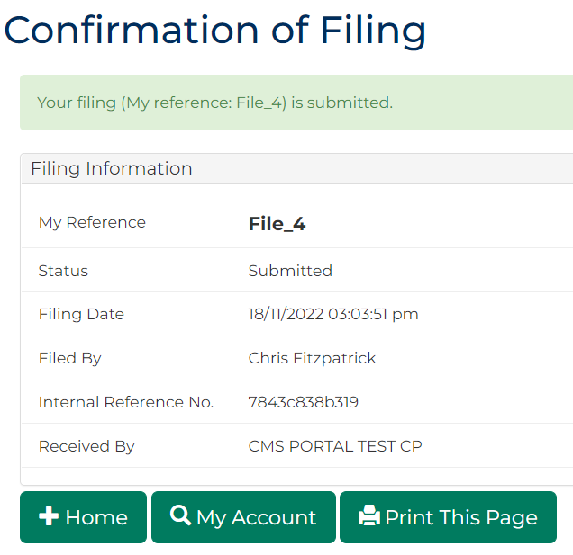

|  |  |
| --- | --- |
|  | Notes:  Acknowledgment for filing email sent to Portal user when document is filed  An additional email is sent once document is reviewed by registry staff |

1. Click: My Account

My Account screen displays indicating pending review, accepted or rejected:

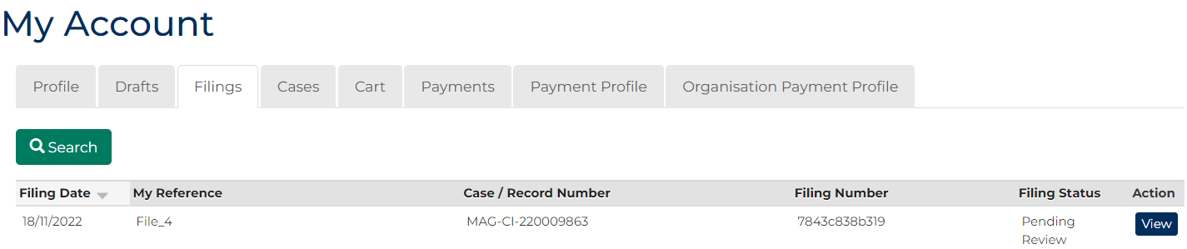

1. To see record of filing, in the Action column, click: View

Case Summary screen displays:

