File complaint

Portal User Guide

|  |
| --- |
| Purpose |
| User Guide shows how to: File complaint in CMS Portal |

1. Log in to Portal.

Home screen displays:

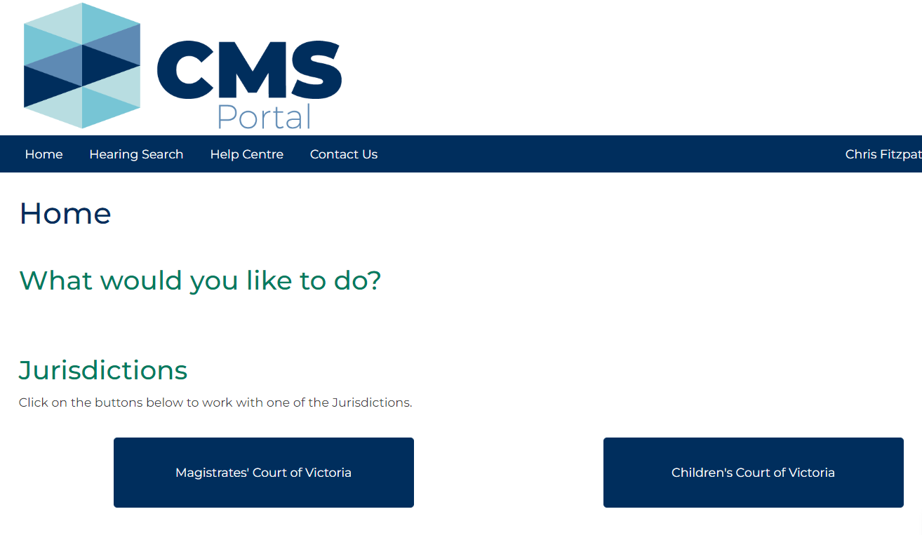

1. Click: Magistrates' Court of Victoria

Case Type screen displays:

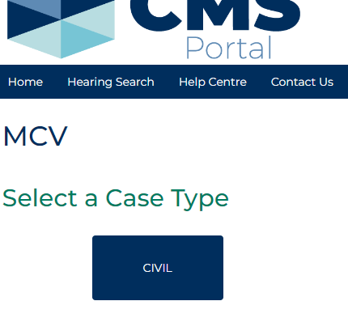

1. Click: Civil

Civil screen displays:

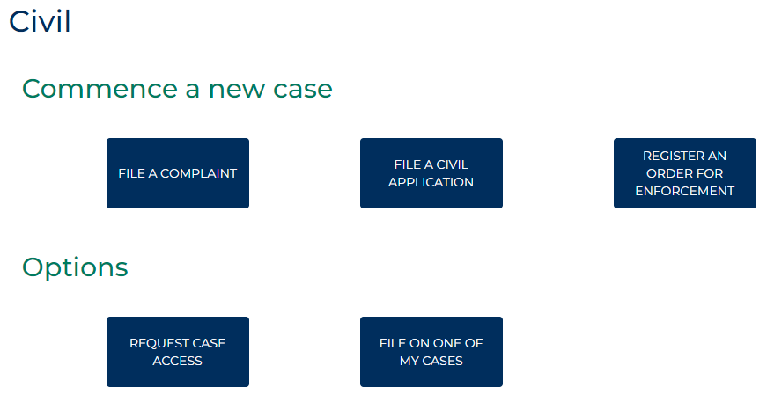

1. Click: File a Complaint

Civil Complaints screen displays:

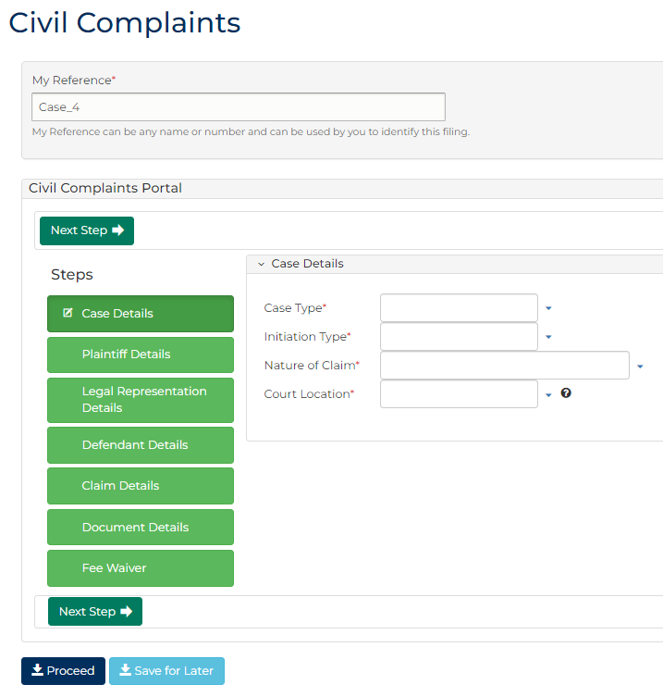

1. Complete required panels and fields.

| Panel: My Reference | |
| --- | --- |
| Field: | Action: |
| My Reference | Type reference name or number to identify filing. |

| Panel: Case Details | |
| --- | --- |
| Field: | Action: |
| Case Type | Select case type. |
| Initiation Type | Select initiation type. |
| Nature of Claim | Select claim type. |
| Court Location | Change if required. |

|  |  |
| --- | --- |
|  | Note:  Click: Save for Later at any stage prior to application being filed  Complaint can be retrieved from Drafts tab located in My Account screen |

1. Click: Next Step

Plaintiff Details (1) screen displays:

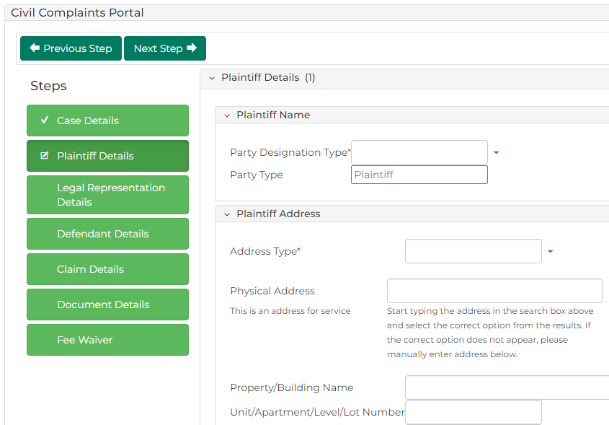

|  |  |
| --- | --- |
|  | Note:  Use green panels to navigate back and forth through initiation steps. |

1. Complete required panels and fields:

| Panel: Plaintiff Name | |
| --- | --- |
| Field: | Action: |
| Party Designation Type | Select Plaintiff type.  Note:  When designated party is business, select Organisation as designation type.  Do not select Agency or Company |
| Party Type | - |
| Other fields | Complete all required fields. |

| Panel: Plaintiff Address | |
| --- | --- |
| Field: | Action: |
| Address Type | Select address type. |
| Physical Address | Start typing address in search box and select correct option from auto-results.  Note:  To add another address, click: Add another Address |

| Panel: Plaintiff Contact Details | |
| --- | --- |
| Field: | Action: |
| All fields | Type relevant contact information. |
| Email Address | Type email address.  Note:  If Plaintiff does not have legal representation, email address is mandatory. |

| Panel: Plaintiff Identification Details | |
| --- | --- |
| Field: | Action: |
| Australian Business Number (ABN) | Type Plaintiff’s ABN if relevant. |
| Australian Company Number (ACN) | Type Plaintiff's ACN if relevant. |

| Panel: Plaintiff Financial Details | |
| --- | --- |
| Field: | Action: |
| Financial Details | Type financial information if relevant. |

| Panel: Plaintiff Representation Capacity or Litigation Guardian | |
| --- | --- |
| Field: | Action: |
| Are you acting in a Representative Capacity? | Select Yes or No for each field. |
| Do you have a Litigation Guardian? |

1. Is there only one Plaintiff?

|  |  |
| --- | --- |
| If | Then |
| Yes | Go to next step |
| No | Click: Add Another Plaintiff  Go to step 7 |

1. Click: Next Step
2. Complete required panels and fields.

| Panel: Plaintiff’s Legal Representation Details | |
| --- | --- |
| Field: | Action: |
| Business Name | Start typing legal firm name into search box and select correct option from results. |
| Reference Number | Type reference name or number to identify filing. |

1. Click: Next Step
2. Complete required panels and fields.

| Panel: Defendant Name | |
| --- | --- |
| Field: | Action: |
| Party Designation Type | Select Defendant type.  Note:  When designated party is business, select Organisation as designation type.  Do not use Agency or Company |
| Party Type | - |
| Other fields | Complete all required fields. |

| Panel: Defendant Address | |
| --- | --- |
| Field: | Action: |
| Address Type | Select address type. |
| Physical Address | Type address in search field and select correct option from auto-results. |
|  | To add another address, click: Add Another Address |

| Panel: Defendant Identification Details | |
| --- | --- |
| Field: | Action: |
| Australian Business Number (ABN) | Type Defendant's ABN if relevant. |
| Australian Company Number (ACN) | Type Defendant's ACN if relevant. |

1. Is there only one Defendant?

|  |  |
| --- | --- |
| If | Then |
| Yes | Go to next step |
| No | Click Add Another Defendant  Go to step 12 |

1. Click: Next Step
2. Complete required panels and fields.

| Panel: Claim Details | |
| --- | --- |
| Field: | Action: |
| Is this a monetary claim? | Select Yes or No |
| Claim Amount | Type claim amount.  Note:  Claim Amount field only displays if monetary claim. |
| Costs | Type costs amount.  Note:  If no costs claimed, enter $0.00 in Costs field. |

| Panel: Place of Claim | |
| --- | --- |
| Field: | Action: |
| Was the place of claim outside the state of Victoria? | Select Yes or No  Note:  If Yes and not in Victoria, type location name. |
| Where did the claim occur? | - |
| Suburb/Town | Type claim's suburb location and select option from results. |
| Postcode | - |
| Statement of Claim | Expand panel and type Statement of Claim, if required. |

1. Click: Next Step
2. Complete required panels and fields.

| Panel: Optional at Filing | |
| --- | --- |
| Field: | Action: |
| Code/Name | Type name and select additional document(s). |
| Upload Documents | Click: Choose File and add required PDF document to case.  Note:  All document uploads must be PDF. |
| Electronic signature | Select item Electronic Signature Consent. |

1. Click: Next Step
2. Complete required panels and fields.

| Panel: Fee Information | |
| --- | --- |
| Panel: | Action: |
| Are you applying for a fee waiver? | Change to Yes if applying for fee waiver.  Note:  When Yes is selected complete additional fields |
| Fee payer type | Select Fee payer type  Note:  When Standard Fee payer is selected complete additional fields |
| Acknowledgement | Select item The Information supplied is true and correct |

1. Click: Proceed

My Account screen displays:

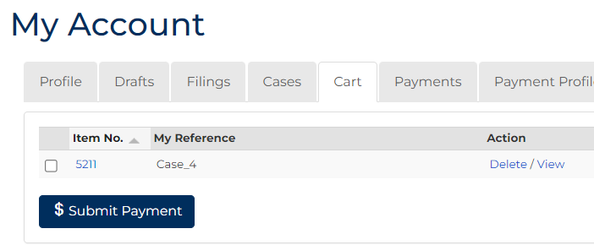

1. Select item requiring payment. Click: Submit Payment

Process Payment screen displays:

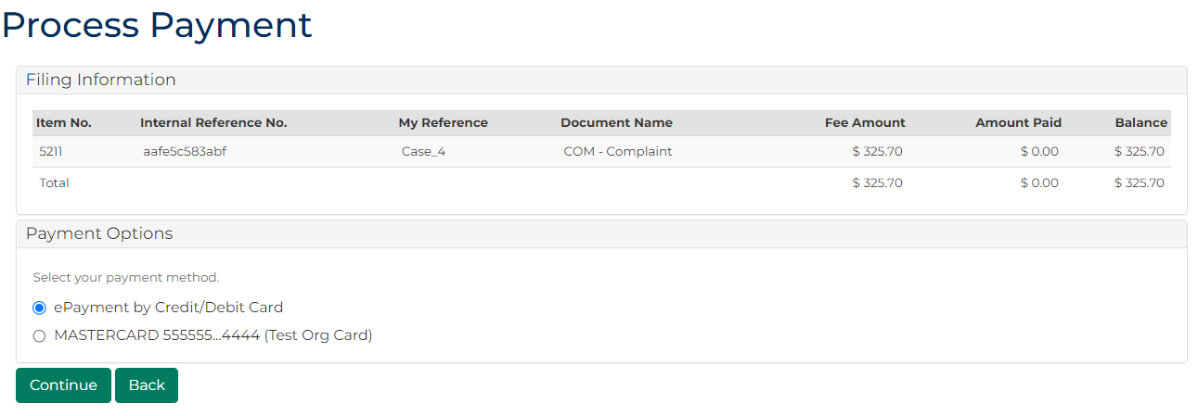

1. In Payment Options panel, select payment method. Click: Continue

Confirmation of Filing screen displays:

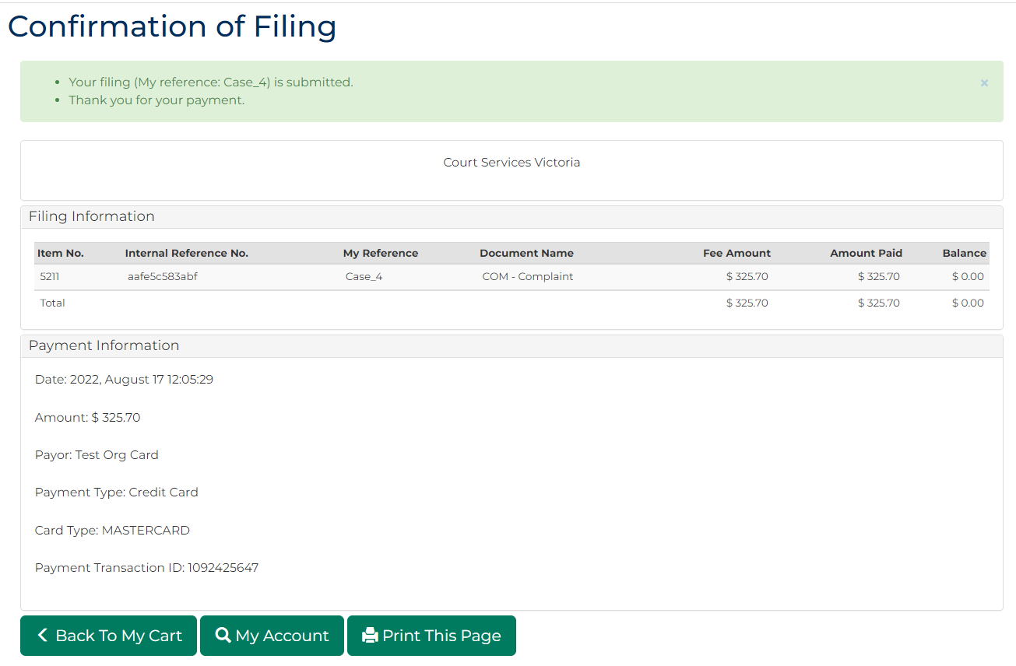

|  |  |
| --- | --- |
|  | Note:  Acknowledgment for filing email is sent to Portal user when document is filed |