
Portal Quick Reference Guide
MCV and ChCV | Criminal
View and action case
Purpose
Quick Reference Guide shows how to View and action case in CMS Portal.

- From CMS Portal Home page, click: My Account
My Account screen displays:
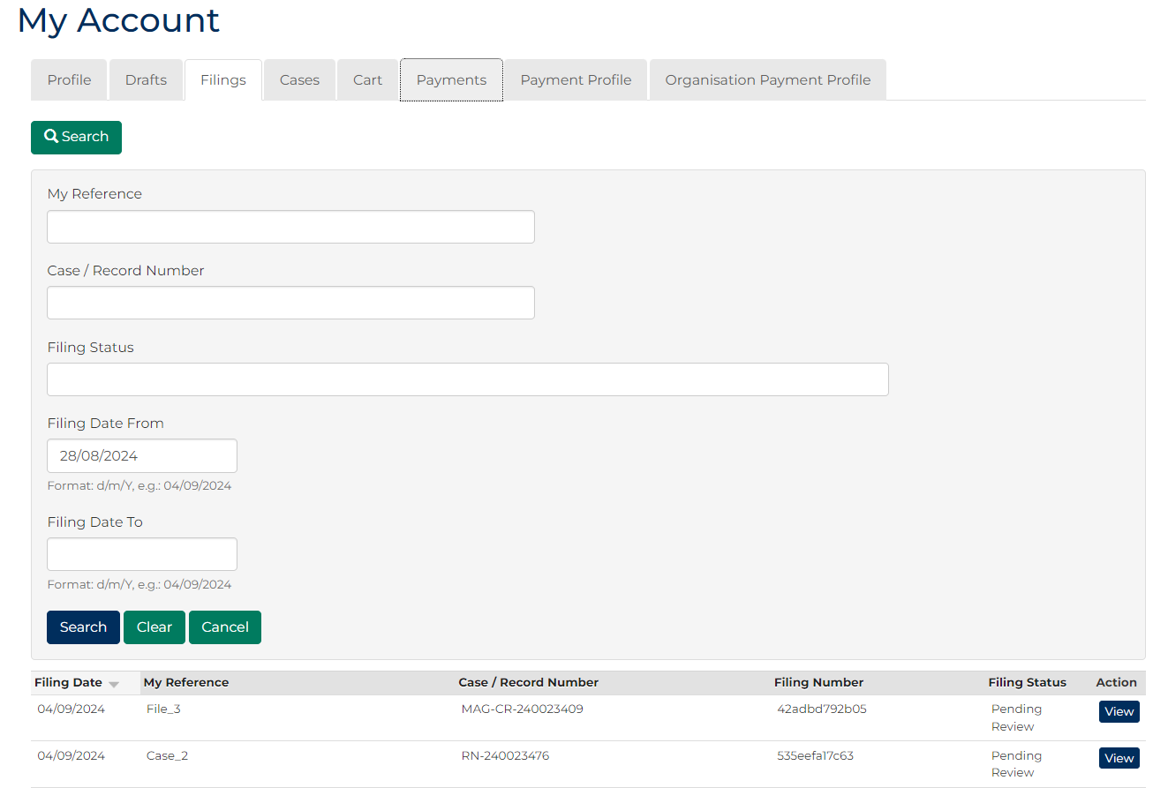

- Click Cases tab.
Search Case panel displays:
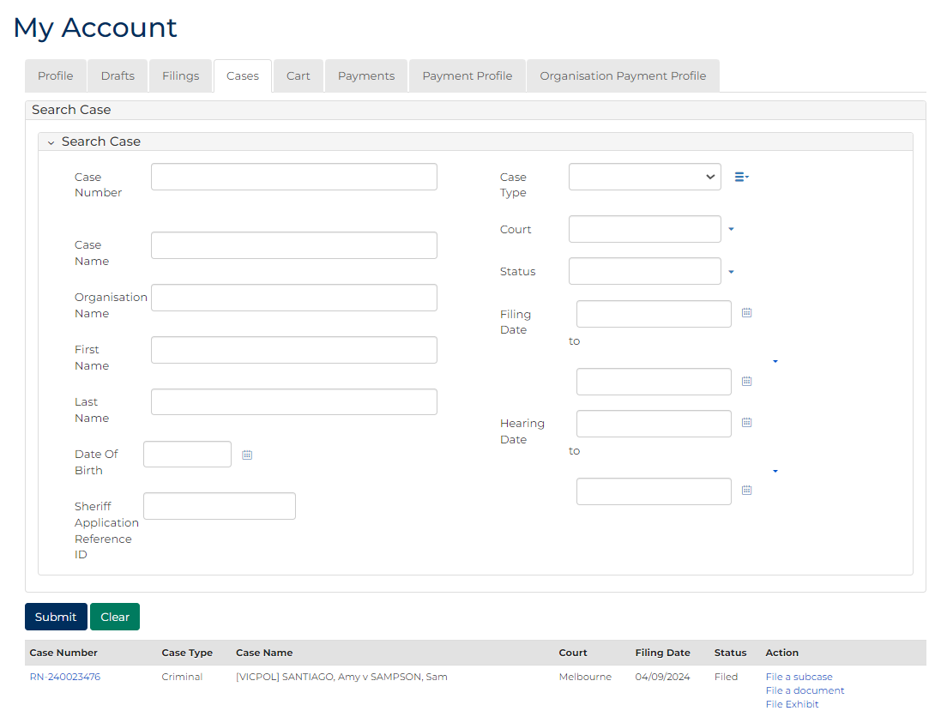
 | Note:  - List of recently accessed cases display at bottom of screen  - Case search not required if case displays  - Only cases user previously filed on or requested access to, display
 | Resource:  See Quick Reference Guide: Request case access

- Is case search required?
If | Then
Yes | Go to next step
No | Go to step 6
- Type details in one or more Search Case fields.
Panel: Search filters
Field: | Action:
Case Number | Type full or partial case number.
Case Name | Type full or partial case name.
Organisation Name | Type organisation name.
First Name | Type first name of party.
Last Name | Type last name of party.
Date Of Birth | Type date or click calendar icon to select date.
Case Type | Select relevant option.
Court | Select relevant option.
Status | Select relevant option.
Filing Date | Select date (or range of dates) of filing.
Hearing Date | Select date (or range of dates) of hearing.
- Click: Submit
Search results display:
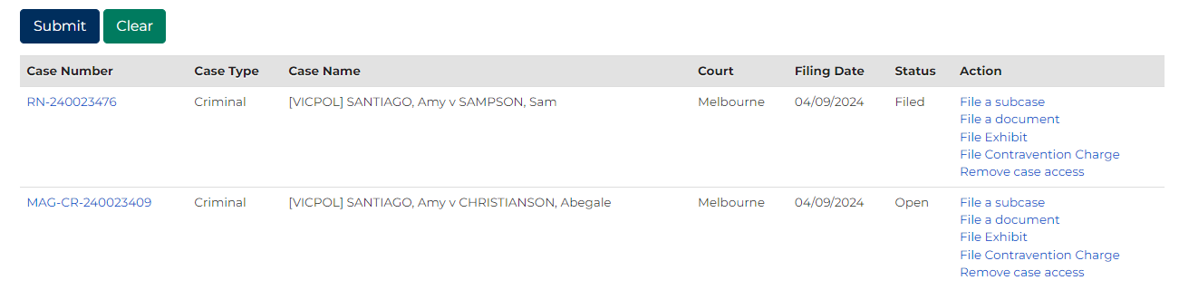
- Does case display in Results panel?
If | Then
Yes | Go to next step
No | Refine search criteria and repeat search  Note:  If relevant case does not display in list of results, adjust search criteria and click: Submit  To reset all fields, click: Clear
- Is view of full case required?
If | Then
Yes | Go to next step
No | Go to step 9

- Click Case Number link.
Filings screen displays:
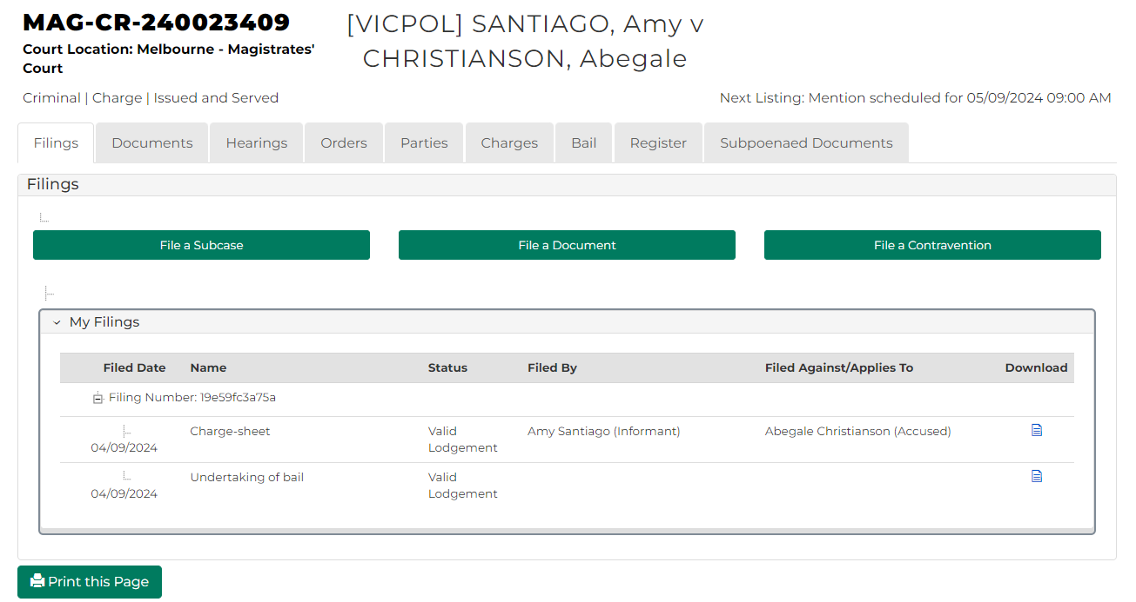
- Is filing required on case?
If | Then
Yes | Click relevant option.  Resources:  - See Quick Reference Guide: File document on case  - See relevant Quick Reference Guides for other filing types
No | Complete required action on case.

