
Portal Quick Reference Guide
MCV and ChCV | Criminal
Search Duty Lawyer Referrals
Purpose
Quick Reference Guide shows how to Search Duty Lawyer Referrals in CMS.
Prerequisite
Before start, ensure you are logged in as Victoria Legal Aid user.

- From CMS Portal Home page, select: Duty Lawyer Referrals
Duty Lawyer List screen displays:
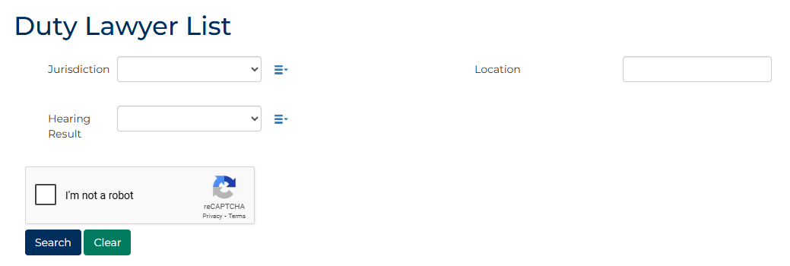
- Complete required panels and fields.
Panel: Duty Lawyer List
Field: | Action:
Jurisdiction | Select relevant option.  Note:  Click multi-select icon to select multiple options.
Hearing Result | Select relevant option.  Note:  Click multi-select icon to select multiple options.
Location | Select relevant option(s).
I'm not a robot | Select checkbox.

- Click: Search
Search results display:
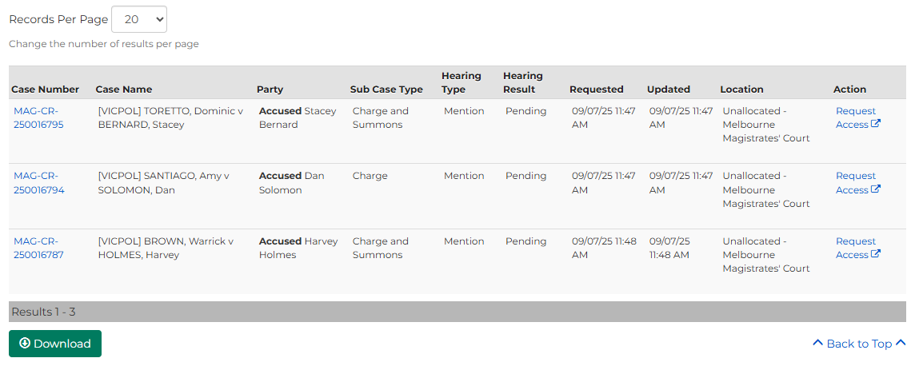
 | Note:  - Results can be downloaded if required  - User can request access to case if required
 | Resource:  See Quick Reference Guide: Request case access

