
Portal Quick Reference Guide
MCV and ChCV | Criminal
Search Agency case listings
Purpose
Quick Reference Guide shows how to Search Agency case listings in CMS Portal.

- From CMS Portal Home page, select: Agency Listing Search
Hearing Search Portal screen displays:
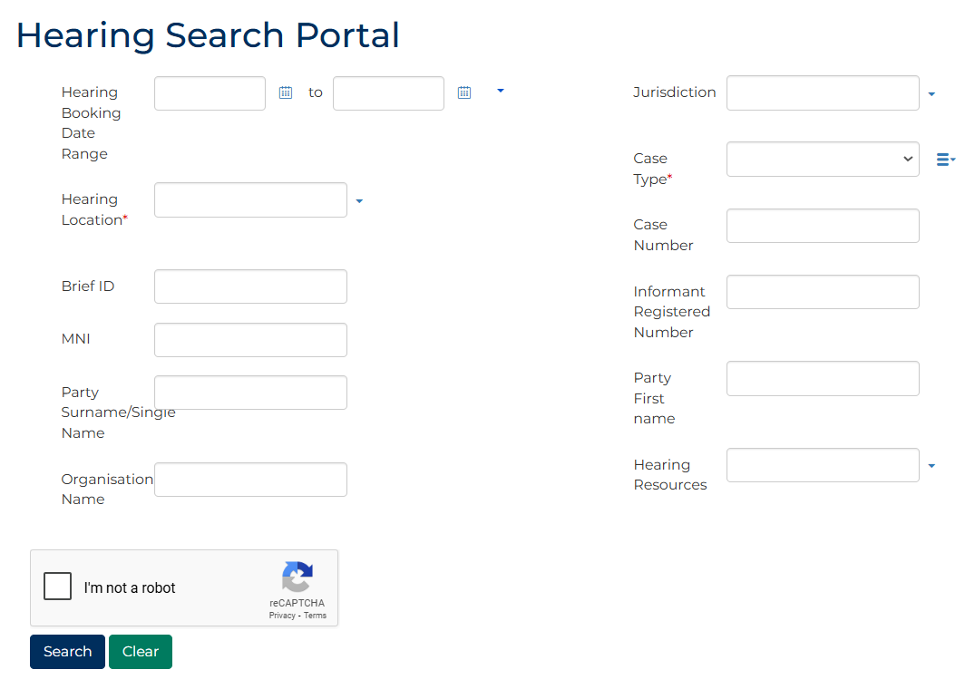

- Complete required panels and fields.
Panel: Hearing Search Portal
Field: | Action:
Date | Type date or click calendar icon to select date.
Location | Select relevant option.
Brief ID | Type Brief ID if relevant.  Note:  CMS will only search for exact match.
MNI | Type MNI number if relevant.  Note:  CMS will only search for exact match.
Surname | Type surname/single name.
First Name | Type name.
Jurisdiction | Select relevant option.
Case Type | Select relevant option.  Note:  Click multi-select icon to select multiple case types.
Case Number | Type case number if relevant.  Note:  CMS will only search for exact match.
Registered Number | Type Informant Registered Number if relevant.  Note:  CMS will only search for exact match.
Organisation Name | Type Organisation Name.
Resources | Select relevant option.
- Select: I'm not a robot
- Click: Search
Search results display:
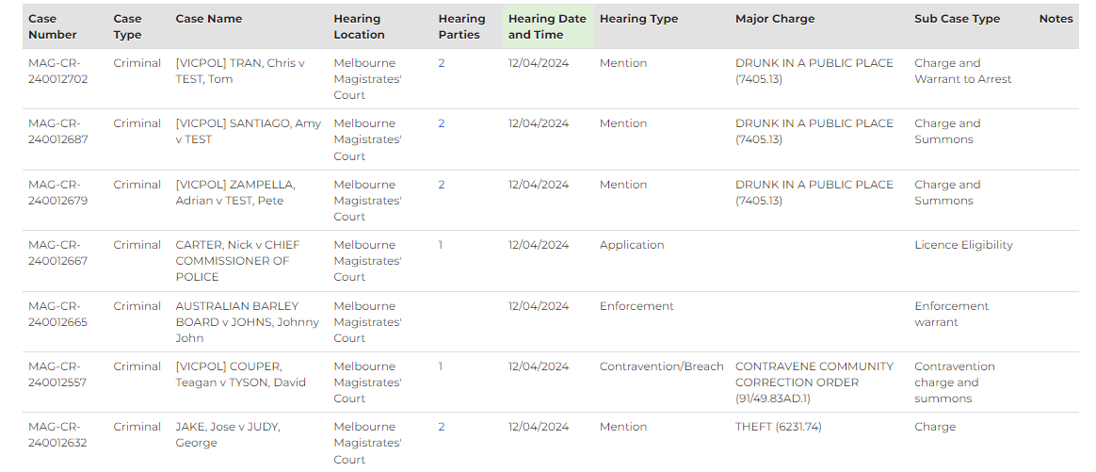
 | Note:  - Hearings with Finalised status will not display  - Results can be downloaded if required

