
Portal Quick Reference Guide
MCV and ChCV | Criminal
Run Filings Report
Purpose
Quick Reference Guide shows how to Run Filings Report in CMS Portal.

- From Portal Home page, click: Organisation Administration
Organisation Administration screen displays:
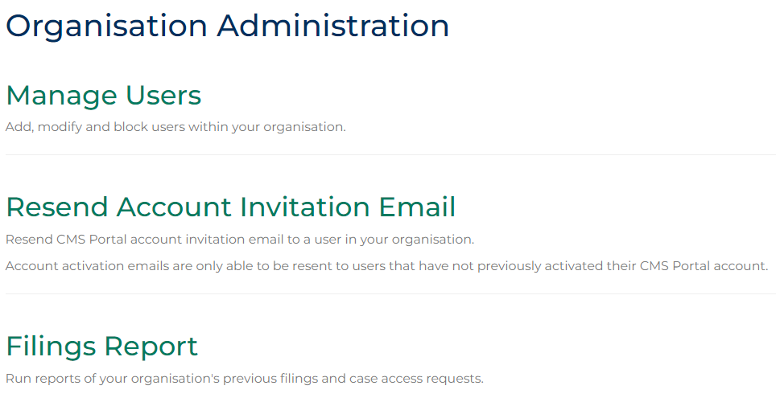
- Click: Filings Report
Filings Report screen displays:
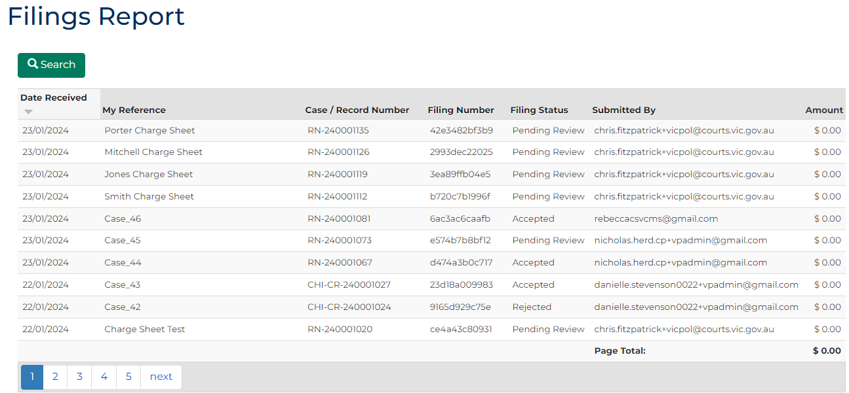

- Click: Search
Search fields display:
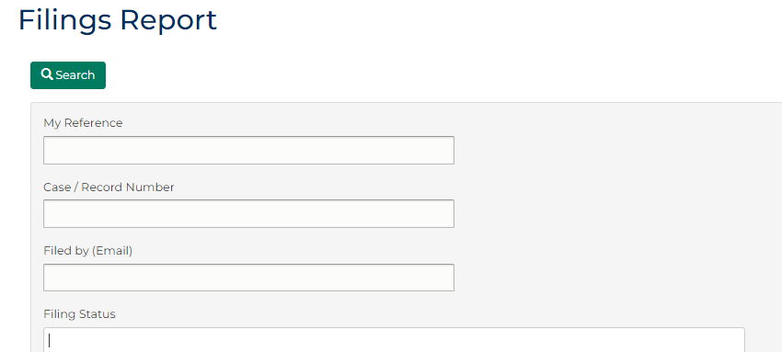
- Complete required panels and fields.
Panel: Filing Report
Field: | Action:
My Reference | Type case reference assigned to case.
Case/Record Number | Type case or record number assigned to case.
Filed by (Email) | Type email address of person who submitted case.
Filing Status | Select relevant option.
Filing Date From | Type date.
Filing Date To | Type date.

- Click: Search
Search results displays:
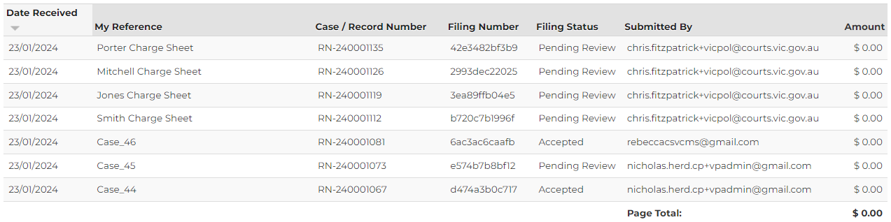
 | Note:  Filings report results can be sorted by column headings.
- Click: Download
Results download as Excel spreadsheet:
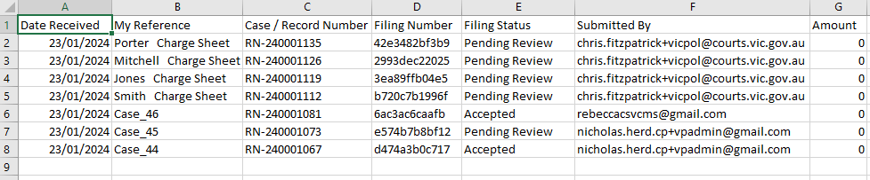
Note:
- Save files as per internal processes and naming conventions.
- No more than 1000 records can be downloaded at one time.

