
Portal Quick Reference Guide
MCV and ChCV | All Jurisdictions
Resend account invitation email
Purpose
Quick Reference Guide shows how to Resend account invitation email in CMS Portal.
Prerequisite
Before start, ensure account activation emails are only re-sent to users who have not previously activated their Portal account.

- From Home page screen, click: Organisation Administration
Organisation Administration screen displays:
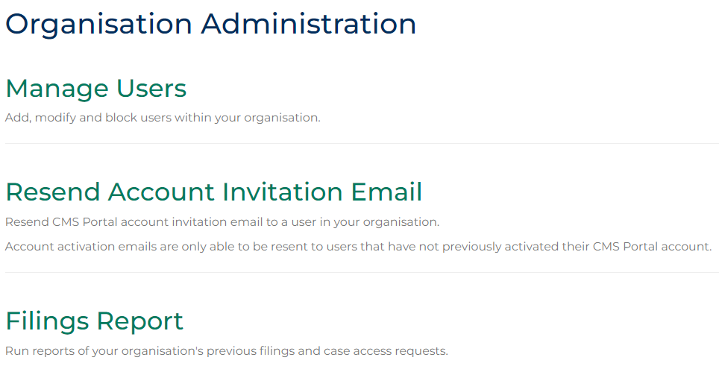
- Click: Resend Account Invitation Email
Resend User Activation Email screen displays:
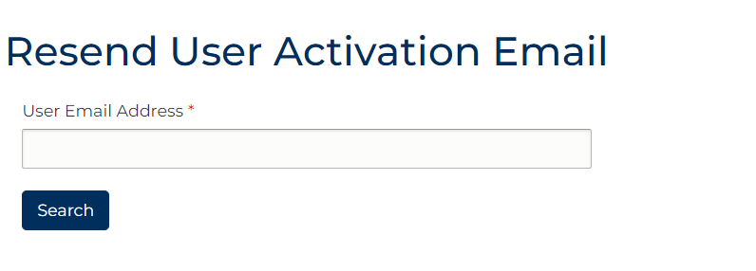

- Enter User email into User Email Address field.
 | Note:  Error message displays if user is not from organisation or has previously activated account.
- Click: Search
Confirmation message displays:
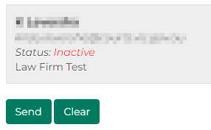
- Click: Send
Confirmation message displays:
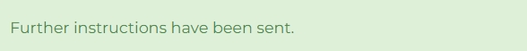
Note:
User is sent email notification with account activation link.

