
Portal Quick Reference Guide
MCV and ChCV | Criminal
Request Interpreter
Purpose
Quick Reference Guide shows how to Request Interpreter in CMS Portal.
Prerequisite
Before start, ensure hearing exists on case.

- From CMS Portal Home page, click: File on One of My Cases
List of cases display:
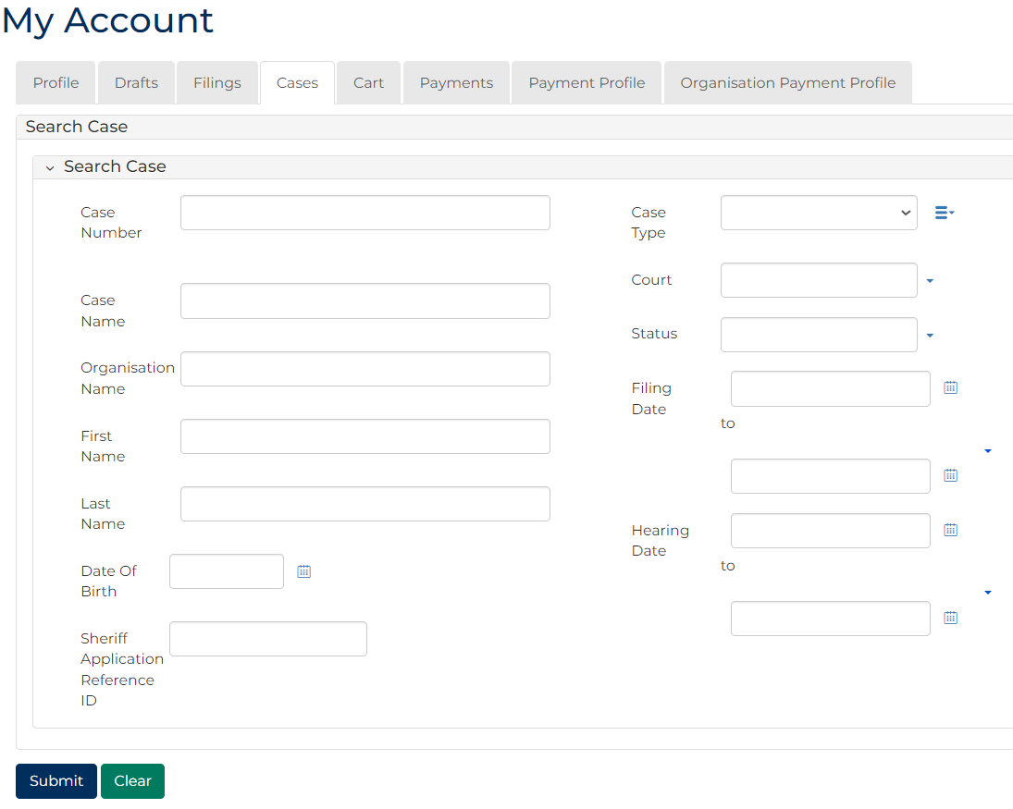
 | Note:  Only cases user previously filed on or requested access to, display.
 | Resources:  See Quick Reference Guide:  - View and action case  - Request case access

- For relevant case, click: Case Number
Filings panel displays:
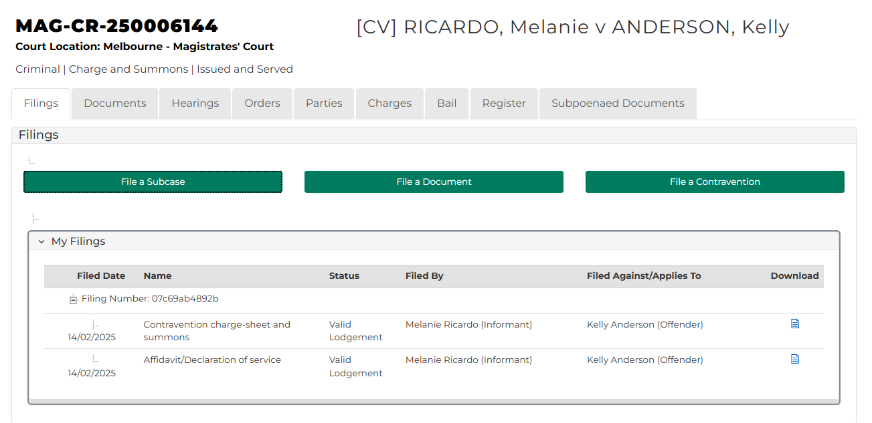
- Click: Hearings tab
Pending Hearings screen displays:
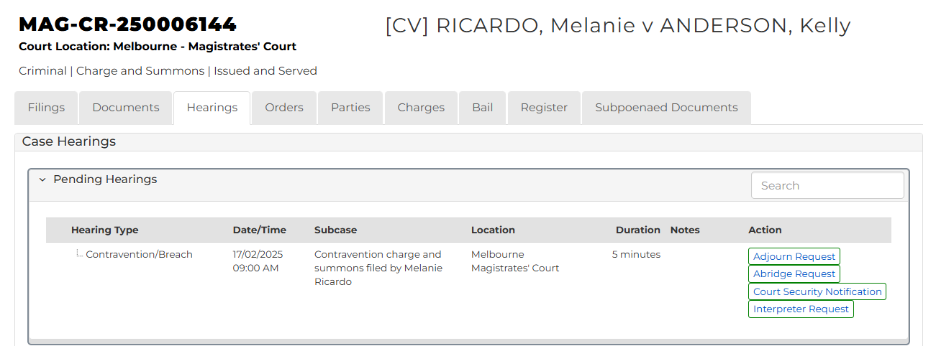

- Click: Interpreter Request
- Complete required panels and fields.
Panel: Interpreter Request
Field: | Action:
ADD PARTY | Select party.
Interpreter Language | Select language
Is gender specific Interpreter required? | Select Yes or No  Note:  If Yes, complete additional fields.

Note:
To add additional Interpreter
- Click: + Interpreter
- Complete additional panels

- Click: Proceed
Confirmation of Filing screen displays:
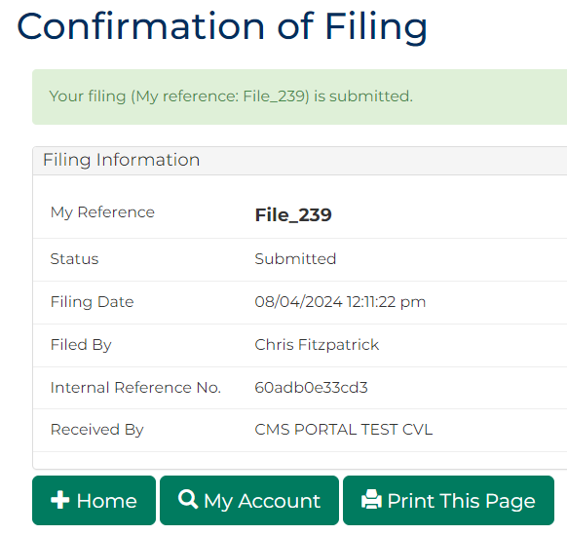
Note:
- Request is placed in work queue for registry to review
- If approved, request is accessed through My Account screen

