
Portal Quick Reference Guide
ChCV | Criminal
Register Infringement Penalty
Purpose
Quick Reference Guide shows how to Register Infringement Penalty in CMS Portal.
Prerequisite
Before start, ensure an outstanding infringement exists and is unpaid.

- From CMS Portal Home page, select: Children's Court of Victoria
Select a Case Type screen displays:
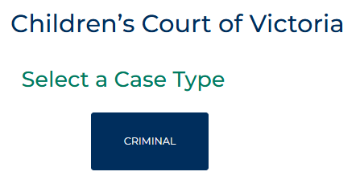
- Select: Criminal
Criminal screen displays:
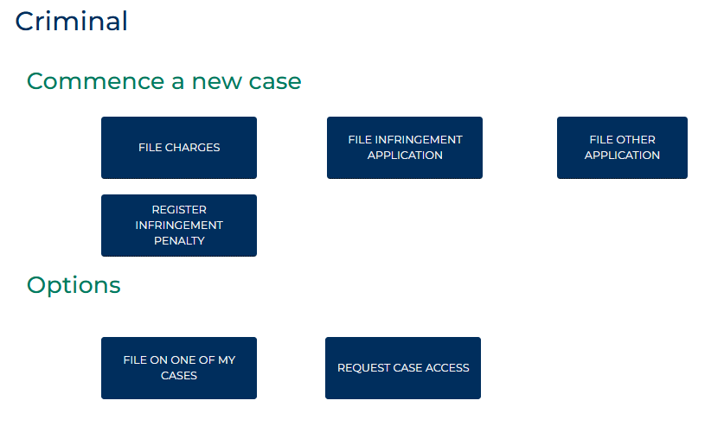

- Select: Register Infringement Penalty
Criminal Case CAYPINS Portal screen displays:
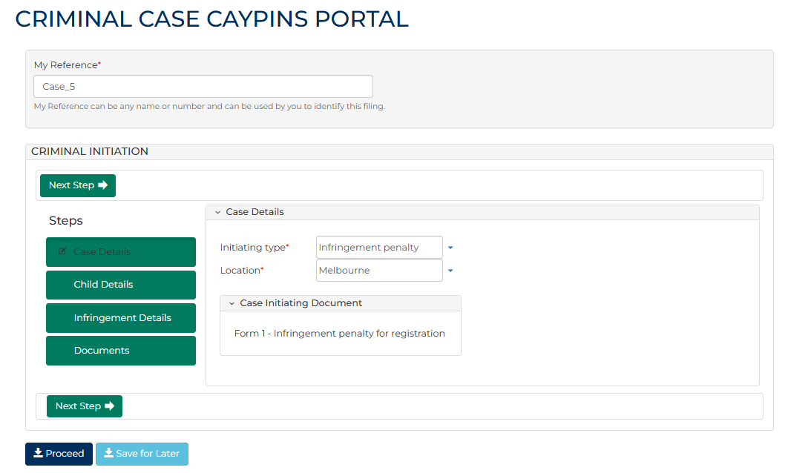
- To identify filing, type reference in My Reference field.
- Complete required panels and fields.
Panel: Case Details
Field: | Action:
Initiating type | -
Location | Do not change.

- Click: Next Step
Child Details screen displays:
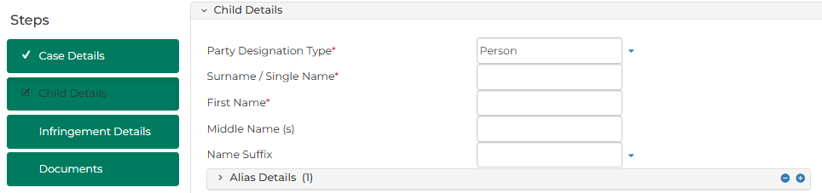
- Complete required panels and fields
Panel: Child Details
Field: | Action:
Party Designation Type | Change if required.  Note:  Different fields display based on selection.
Surname/Single Name | Type name.
First Name | Type name.
Middle Name | Type name(s) if provided.
Name Suffix | Select relevant option if provided.

Panel: Alias Details
Field: | Action:
Party Designation Type | Change if required.  Note:  Different fields display based on selection.
Surname/Single Name | Type name.
First Name | Type name.
Middle Name(s) | Type name(s) if provided.
Name Suffix | Select relevant option if provided.

Panel: Address Details
Field: | Action:
Address Type | Select relevant option.
Physical Address | Type address.  Select correct option from results.  Note:  If address cannot be located, type address details into relevant fields.

 | Note:  To add another address:  - Click: + Add Another Address  - Complete additional panels
Panel: Contact Details
Field: |  | Action:
Mobile Number |  | Type number if provided.
Email Address |  | Type address if provided.

Panel: Additional Details
Field: | Action:
Date Of Birth | Type date or click calendar icon to select date.
Gender | Select relevant option.
First Nations Status | Select relevant option.
Is an interpreter required? | Select Yes or No  Note:  If Yes, complete additional fields.

Panel: Identification Details
Field: | Action:
MNI | Type number if provided.

Panel: Driver’s Licence / Permit Details
Field: | Action:
Is it an international driver’s licence/permit? | Change if required.
Driver’s licence/permit state | Change if required.
Driver’s licence / permit number | Type number if provided.
Vehicle registration number | Type number if provided.
Vehicle registration state | Select relevant option if provided.
Vehicle Class | Type if provided.
- Click: Next Step
Infringement Details screen displays:
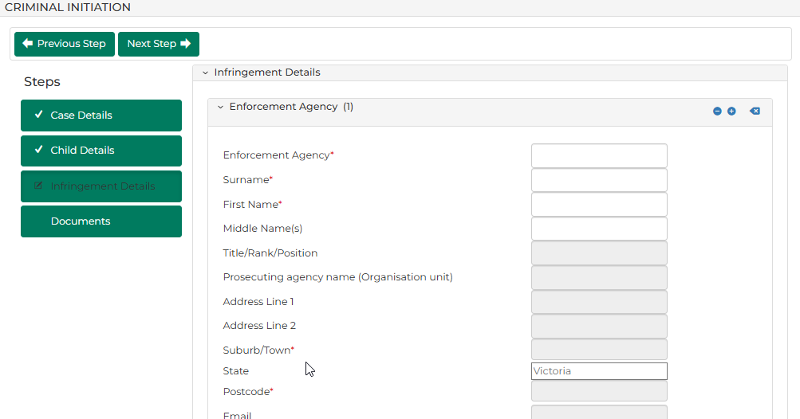

- Complete required panels and fields.
Panel: Enforcement Agency
Field: | Action:
Surname | Type name.  Select correct option from results.

Panel: Infringement Details
Field: | Action:
Act and Section | Type offence code or keyword(s).  Select correct option from results.  Resource:  See Cheat Sheet: Act and Section Search
Date Period | Change if required.  Note:  Offence To Date field displays if In between dates selected.
Offence Date | Type date or click calendar icon to select date.
Offence Time | Type time or click clock icon to select time.
Place of Offence | Type suburb.  Select correct option from results.  Note:  If offence took place at unknown location, type suburb in Place of Offence (Text only) field.
Place of Offence (Text only) | Type place of offence if relevant.
Infringement Notice Number | Type number.
Date of issue of Infringement Notice | Type date or click calendar icon to select date.
Original Infringement Amount | Type amount.
The amount that has been paid | Type amount paid.
Cost amount | Type cost amount.
The amount to be registered | -

Panel: Extension of Time
Field: | Action:
The registrar has cancelled the registration and remitted the infringement notice to the enforcement agency under clause 6(5)(b) or 8(3)(a) of Schedule 3 to the Children, Youth and Families Act 2005. | Change if required.
The Court has cancelled the infringement notice under Part 3 of Schedule 3 to the Children, Youth and Families Act 2005 and a new infringement notice has been served on the child. | Change if required.

Panel: Extension of Time
Field: | Action:
A person has nominated the child for an offence committed under the Road Safety Act 1986, the Melbourne City Link Act 1995 or the EastLink Project Act 2004. | Change if required.
A nomination for an offence committed under the Road Safety Act 1986, the Melbourne City Link Act 1995 or the EastLink Project Act 2004 was made and has subsequently been cancelled under section 84BF(1) of the Road Safety Act 1986 so that the liability has reverted to the child. | Change if required.
The offence is against section 204 of the EastLink Project Act 2004 or section 73 of the Melbourne City Link Act 1995. | Change if required.
A payment plan applies to the child in respect of the offence and the child has defaulted on a payment in respect of the offence. | Change if required.
A payment plan applies to the child in respect of the offence and the child has removed the infringement penalty and any prescribed costs in respect of the infringement offence from the plan. | Change if required.
A payment plan applies to the child in respect of the offence and the child has cancelled that plan | Change if required.
An infringement notice has been reviewed under Division 3 of Part 2 of the Infringements Act 2006 and advice of the outcome of the review has been served on the child under section 24(3) of that Act. | Change if required.
Date of Cancellation | Type date or click calendar icon to select date.
Date of service of Infringement | Type date or click calendar icon to select date.

Note:
To add another Infringement:
- Click: +Add another Infringement
- Complete additional panels
- Click: Next Step
Documents panel displays:
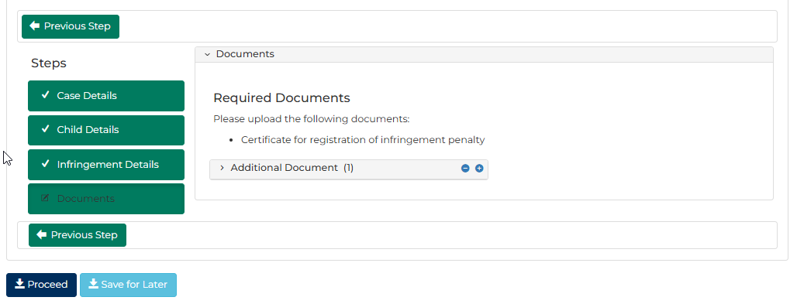

- Complete required panels and fields
Panel: Additional Document
Field: | Action:
Code / Name | Type name and select additional document(s).
Upload Documents | Select: Attach File  Click: Choose File and attach PDF document.

Note:
To add another document, click: + Additional Document

- Click: Proceed
Confirmation of Filing screen displays:
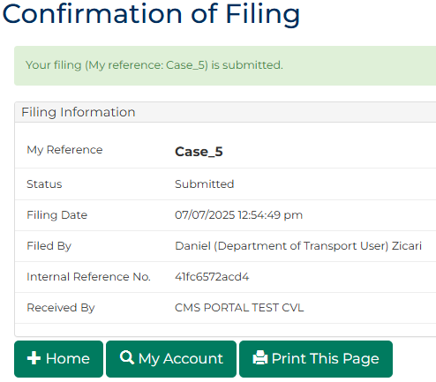
Note:
- Document is generated and placed in work queue for registry to review
- If approved, document is accessed through My Account screen
 | Resource:  See Quick Reference Guide: Download document

