
Portal Quick Reference Guide
MCV and ChCV | All Jurisdictions
Manage user
Purpose
Quick Reference Guide shows how to Manage user in CMS Portal.
Contents
Add user 2
Modify user 6
Block user 12

Add user
- From CMS Portal Home page, click: Organisation Administration
Organisation Administration screen displays:
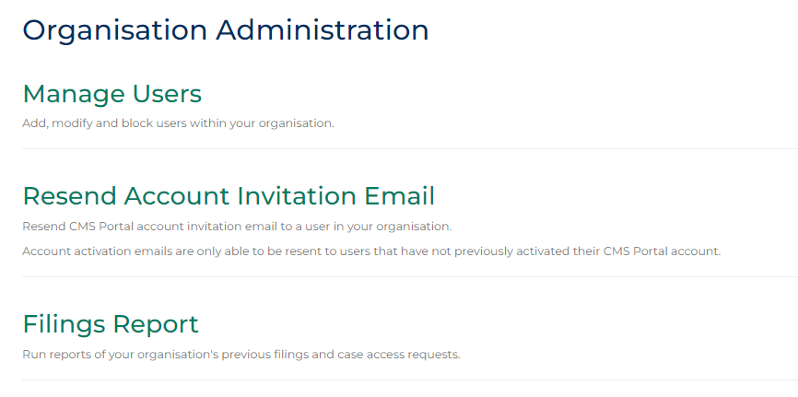
- Click: Manage Users
People screen displays:
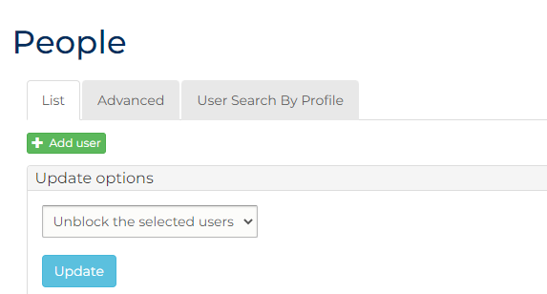

- Click: Add User
Further fields display:
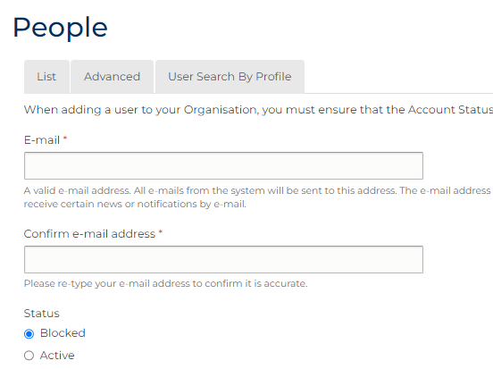

- Complete required panels and fields.
Panel: People
Field: | Action:
E-mail | Type user email address.
Confirm e-mail address | Type user email address again.
Status | Select: Blocked  Note:  Account must be changed to Blocked to prompt user to acknowledge CMS terms and conditions
Type of User | Select user type.  Note:  Select Admin role only if another organisation administrator required.
Organisation | -
First Name | Type user first name.
Surname | Type user surname.
Unique ID Number | Type value as unique user identifier.  Note:  Number must be provided to user for account activation.
Secondary Email Address for All Notifications | Type additional email address to receive copies of notifications, if required.
Secondary Email Address for Rejections | Type additional email address to receive copies of rejections, if required.
Mobile Number for SMS Notifications | Type mobile number to receive SMS notifications, if required.
Phone Number | Type user’s preferred contact number, if relevant.
Fax | Type user’s fax number, if required.
Division | Type user’s division within organisation, if required.
Employee Identifier | Type Employer Identifier used internally, if required.
- Click: Captcha box
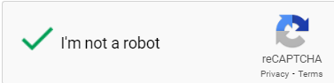
- Click: Create new account
Confirmation message displays:
 | Notes:  - User is sent email notification to activate account  - Provide Unique ID Number to user to enter as part of activation process

Modify user
Note:
This section of Quick Reference Guide shows how to modify user account
- From CMS Portal Home page, click: Organisation Administration
Organisation Administration screen displays:
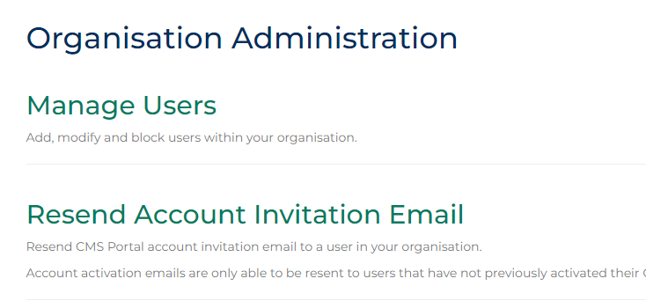

- Click: Manage Users
People screen displays:
- Is search with user profile details required?
If | Then
Yes | Go to next step
No | Go to step 8
- Click User Search By Profile tab.
Search screen displays:
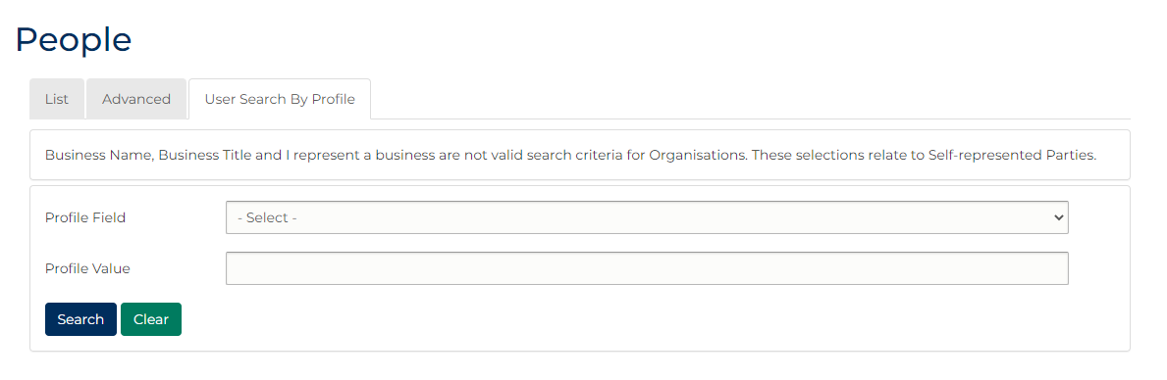

- Complete required panels and fields:
Panel: User Search By Profile
Field: | Action:
Profile Field | Select relevant option.
Profile Value | Type value.
- Click: Search
User results display:
- Has profile been located?
If | Then
Yes | Go to next step
No | Refine criteria and repeat search.

Note:
Select Advanced tab to perform more complex searches.

- In Operations column, click: edit
User My Account screen displays:
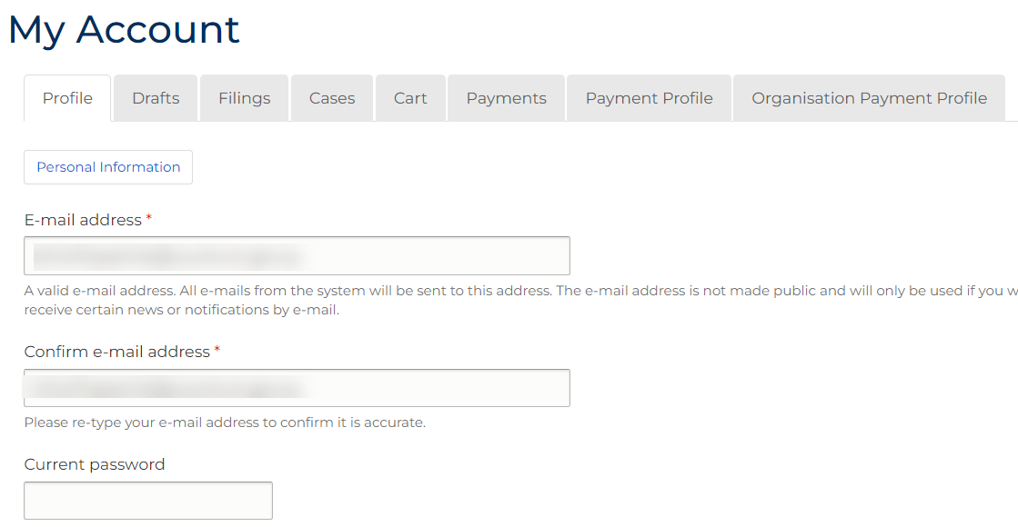
Note:
To see additional fields, click: Personal Information
- Does email address update required?
If | Then
Yes | Go to next step
No | Go to step 11

- Complete required panels and fields.
Panel: User Profile
Field: | Action:
E-mail address | Type user email address.
Confirm e-mail address | Type user email address again.
- Is password update required?
If | Then
Yes | Go to next step
No | Go to step 13
- Complete required panels and fields.
Panel: User Profile
Field: | Action:
Password | Type password.
Confirm password | Type password again.
- Is user account block required?
If | Then
Yes | Go to next step
No | Go to step 15
- In Status field, select: Blocked
- Is Role, Password settings or Organisation update required?
If | Then
Yes | Go to next step
No | Go to step 17
- Complete required panels and fields.
Panel: User Profile
Field: | Action:
Roles | Change if required.
Force password change on next login | De-select if password change not required.
Organisation Name | Change if required.
- Click: Save
Confirmation message displays:
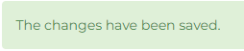

Block user
Note:
This section of Quick Reference Guide shows how to Block user accounts from accessing Portal with your organisation login.
- From CMS Portal Home page, click: Organisation Administration
Organisation Administration screen displays:
- Click: Manage Users
People screen displays:
- From list of users on People screen, select user(s) to block.
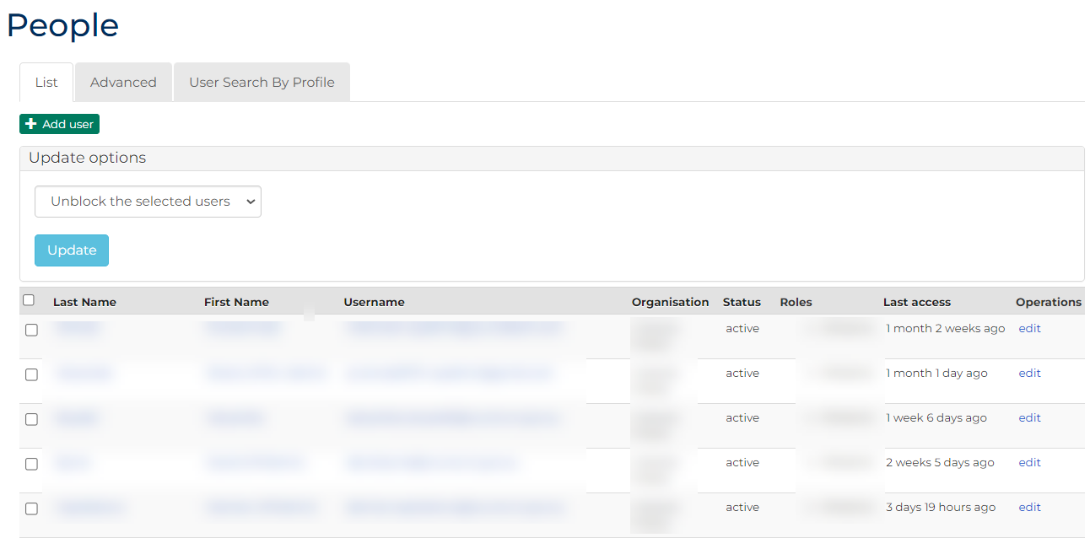
- From Update options menu, select: Block the selected users
- Click: Update

