
Portal Quick Reference Guide
MCV and ChCV | Criminal
Make payment
Purpose
Quick Reference Guide shows how to Make payment in CMS Portal.
Prerequisite
Before start, ensure Cart tab is displayed.

- Select item requiring payment.
- Click: Submit Payment
Process Payment screen displays:
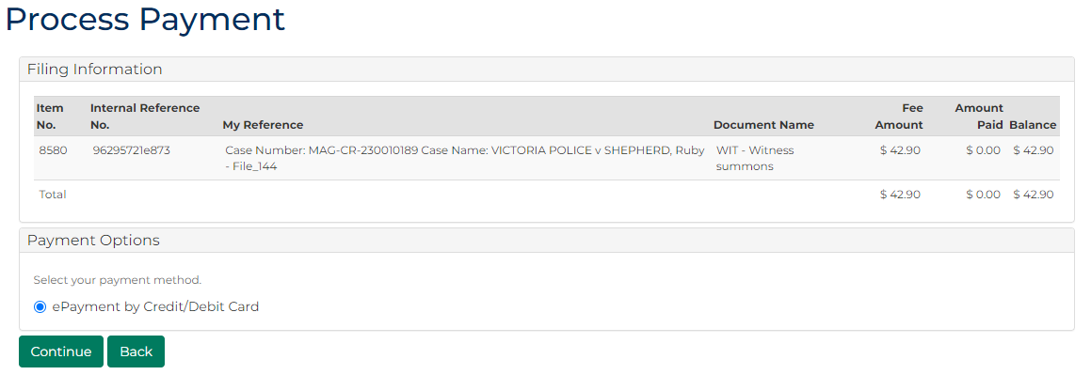
- In Payment Options panel, select payment method.
 | Note:  Credit/debit cards attached to account display.
- Is payment method attached to account?
If | Then
Yes | Go to next step
No | Go to step 6

- Click: Continue
Confirmation of Filing screen displays:
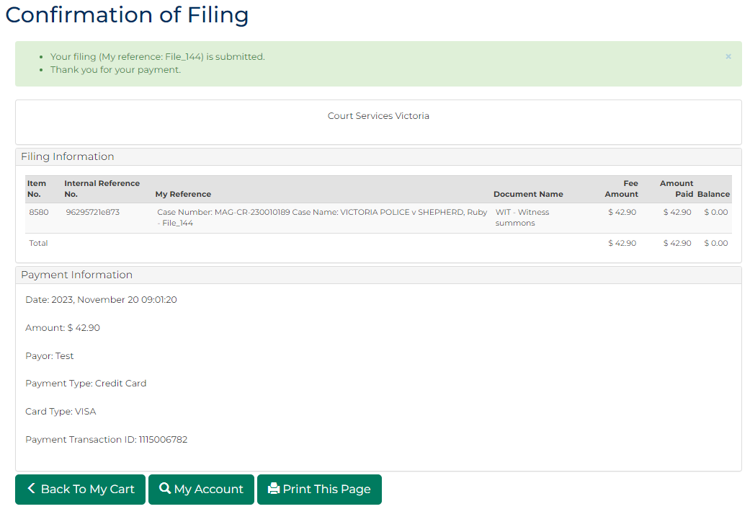
- Are credit/debit card details required to be entered?
If | Then
Yes | Go to next step
No | End of process

- Click: Continue
Payment Processing screen displays:
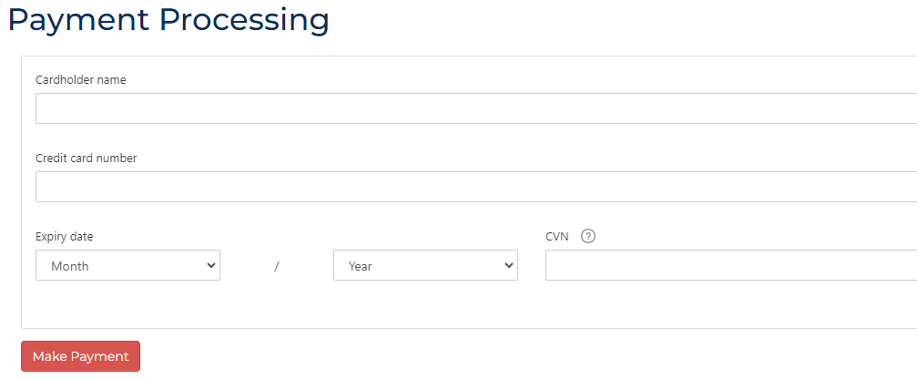
- Input required credit/debit card information.

- Click: Make Payment
Confirmation of Filing screen displays:
Note:
- Click My Account to view status of filing:
  - If valid filing, document download is available
  - If Pending Review, document is reviewed by Registry before download is available
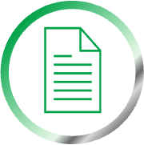 | Resource:  See Quick Reference Guide: Download document

