
Portal Quick Reference Guide
MCV and ChCV | All Jurisdictions
Log in to and activate Portal account
Purpose
Quick Reference Guide shows how to Log in to and activate Portal account in CMS Portal.
Contents
Log in 2
Activate account 4
Set up multi factor authentication 6

Log in
- Click: Log-In
Log-In screen displays:
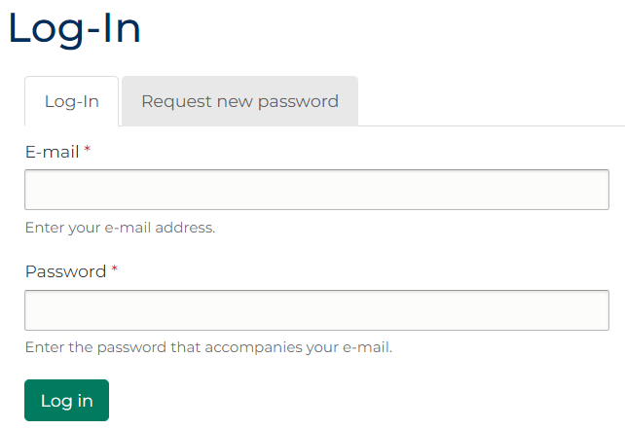
 | Note:  - To request new password, click: Request new password  - Password is sent to email address linked to Portal account  - Two-Factor Authentication (2FA) may be required to verify account

- Click: Log in
Home screen displays:
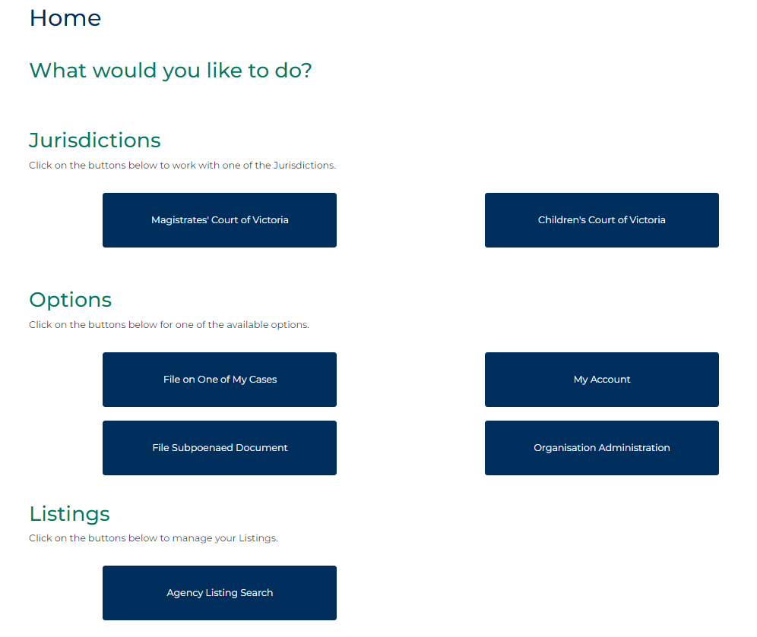
Note:
Contact CMS Portal Administrator within organisation if log in unsuccessful.

Activate account
Prerequisite
Before start, ensure Welcome to the CMS Portal email is received.
- Click account activation link in email.
Identity Verification screen displays:
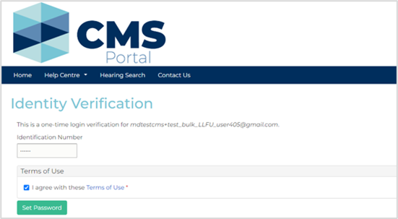
- Click: Set Password
My Account screen displays:
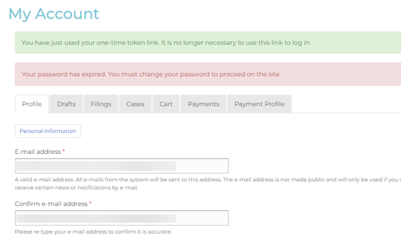

- Type desired password.
Note:
If enrolled as Organisational Administration, deselect Force password change on next login
- Click: Save
Confirmation message displays:

Set up multi factor authentication
Prerequisite
Before start, ensure Portal account is activated.
Note:
Process is completed at second log in to Portal.
- In Register popup box, type email address linked to Portal account.
- Click: Get Started
Verify Email popup displays:
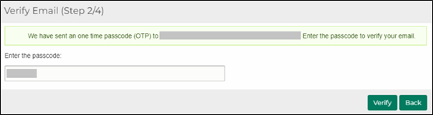
Note:
- One-time password is sent to nominated email address
- If code not entered before expiration time, new code is generated
- Type one-time password into Enter the passcode field.

- Click: Verify
Select Authentication method screen displays:
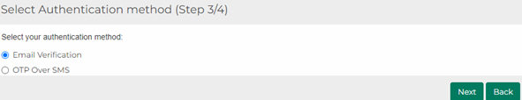
Note:
A second authentication method now needs to be set up.
- Is second authentication method through email?
If | Then
Yes | Go to next step
No | Go to step 10
- In Select Authentication method field, select: Email Verification

- Click: Next
Verify your identity screen displays:
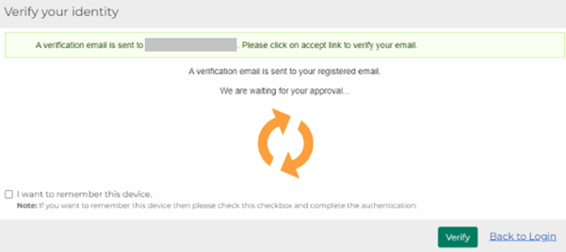
Note:
Email is sent to email address linked to Portal account.
- In email, click: Accept Transaction
Confirmation message displays:
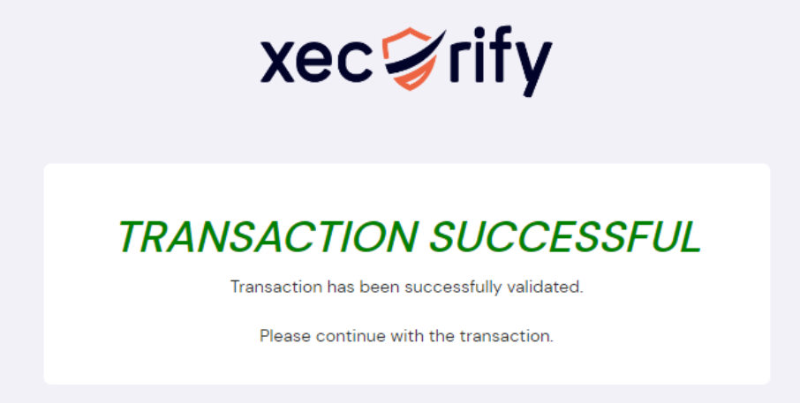

- In Portal, on Verify your identity screen, click: Verify
Confirmation message displays:
Note:
- 2FA code is required for each login to Portal
- If Remember my device selected, 2FA process is bypassed for 14 days
- Is second authentication method through SMS?
If | Then
Yes | Go to next step
No | End of process.
- In Select Authentication method field, select: OTP Over SMS
- Click: Next
Configure OTP Over SMS screen displays:
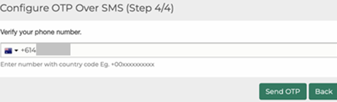
- Type mobile phone number into Verify your phone number field.

- Click: Send OTP
Configure OTP Over SMS screen displays:
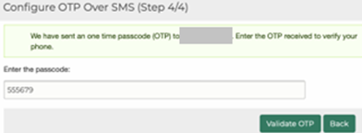
Note:
SMS with passcode is sent to nominated mobile phone number.
- Type passcode in Enter the passcode field.
- Click: Validate OTP
Confirmation message displays:
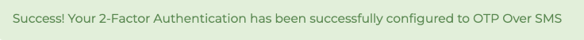
Note:
2FA code is required for each login to Portal
If Remember my device selected, 2FA process is bypassed for 14 days
If SMS authentication selected and mobile number is changed, contact CMS Support Team to reset 2FA

