
Portal Quick Reference Guide
MCV and ChCV | Criminal
File Witness Summons
Purpose
Quick Reference Guide shows how to File Witness Summons in CMS Portal.

- From CMS Portal Home page, click: File on One of My Cases
List of cases display:
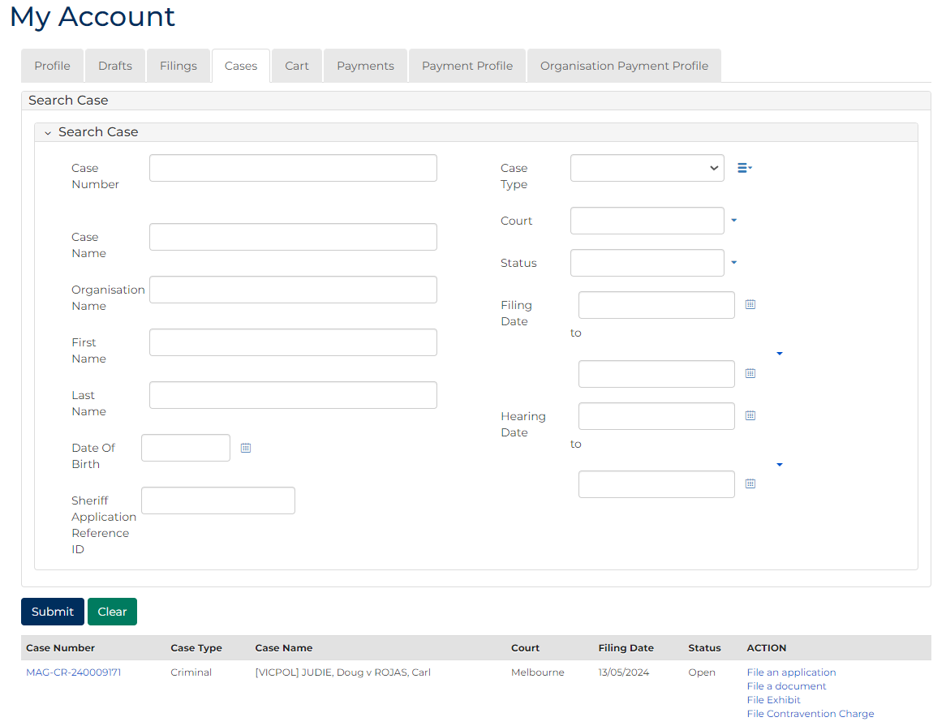
 | Note:  Only cases user previously filed on or requested access to display.
 | Resources:  See Quick Reference Guides:  - View and action case  - Request case access

- For relevant case, click: File a document
SubCases panel displays:
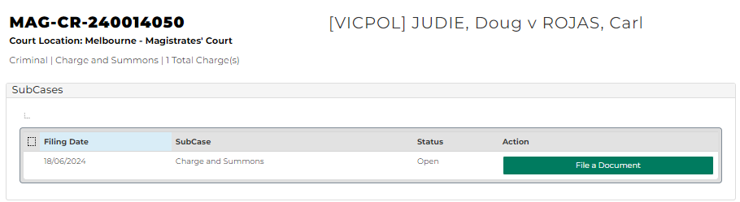
- For relevant subcase, click: File a Document
Add Document Submission CRIM screen displays:
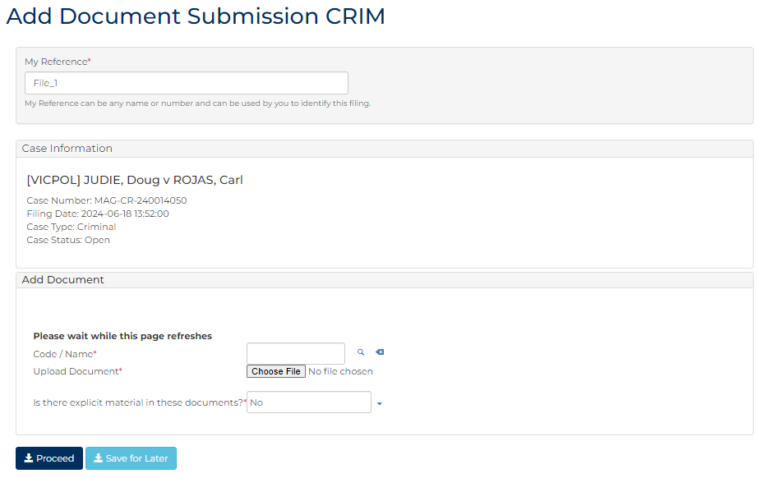

- To identify filing, type reference in My Reference field.
- Complete required panels and fields.
Panel: Add Document
Field: | Action:
Code/Name | Type: Witness to select Witness Summons
Is there explicit material in these documents? | Change if required.

Panel: Additional Information
Field: | Action:
Type of hearing | Select relevant option.  Note:  Field displays for ChCV cases only.
Summary of the charges | Type description of charges.
Description | Type description.  Note:  Field displays if Other selected in Type of Hearing field.
Witness Summons Type | Select relevant option.  Note:  Different fields display based on selection.
Relevant documents or things likely to be in possession or control of the witness | Type relevant details.  Note:  - Field displays for MCV cases only  - Field displays if Attend court and produce or Produce documents options selected in Witness Summons Type field
Documents or things to produce | Type relevant details.  Note:  Field displays if Attend court and produce or Produce documents options selected in Witness Summons Type field.

Additional Panels
Field: | Action:
Filed By | Select party.
Representation | Select filing party's legal representation if applicable.  Note:  To add representation, click: Add Representation
Filed Against | Select party.  Note:  To add new party, complete Filed Against (New Party) panel.
Related Hearing | Select relevant hearing.
Are you applying to waive the fee? | Change if required.  Note:  - Field displays for MCV cases only  - If Yes, upload fee waiver application
Electronic Signature Consent | Select checkbox.

Note:
Witness Summons document is generated by the system.

- Is fee required?
If | Then
Yes | Click: Proceed  Resource:  See Quick Reference Guide: Make payment
No | Go to next step
- Click: Proceed
Confirmation of Filing screen displays:
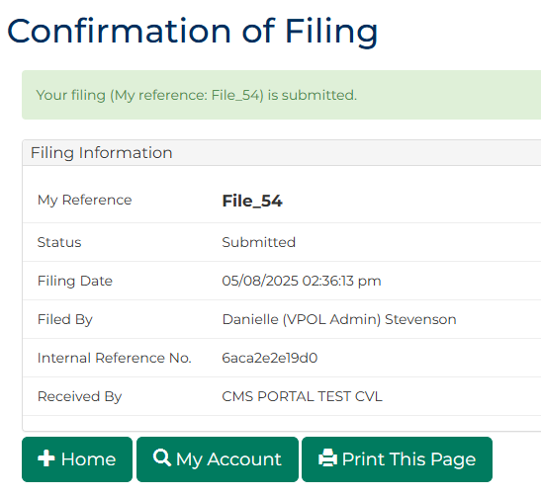
Note:
- Document is placed in work queue for registry to review
- If approved, Witness Summons document is accessed through My Account screen

