
Portal Quick Reference Guide
MCV and ChCV | Criminal
File subpoenaed document
Purpose
Quick Reference Guide shows how to File subpoenaed document in CMS Portal.

- From Portal Home page, click: File Subpoenaed Document
Case Number Search screen displays:
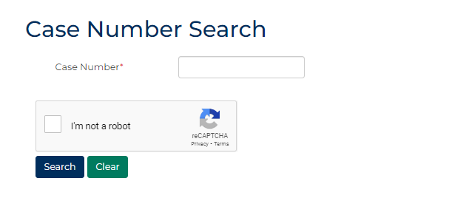
- Type case number in Case Number field.
- Select: I'm not a robot
- Click: Search
Search results display:
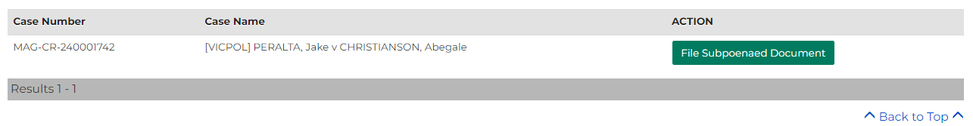

- Click: File Subpoenaed Document
File Subpoenaed Document screen displays:
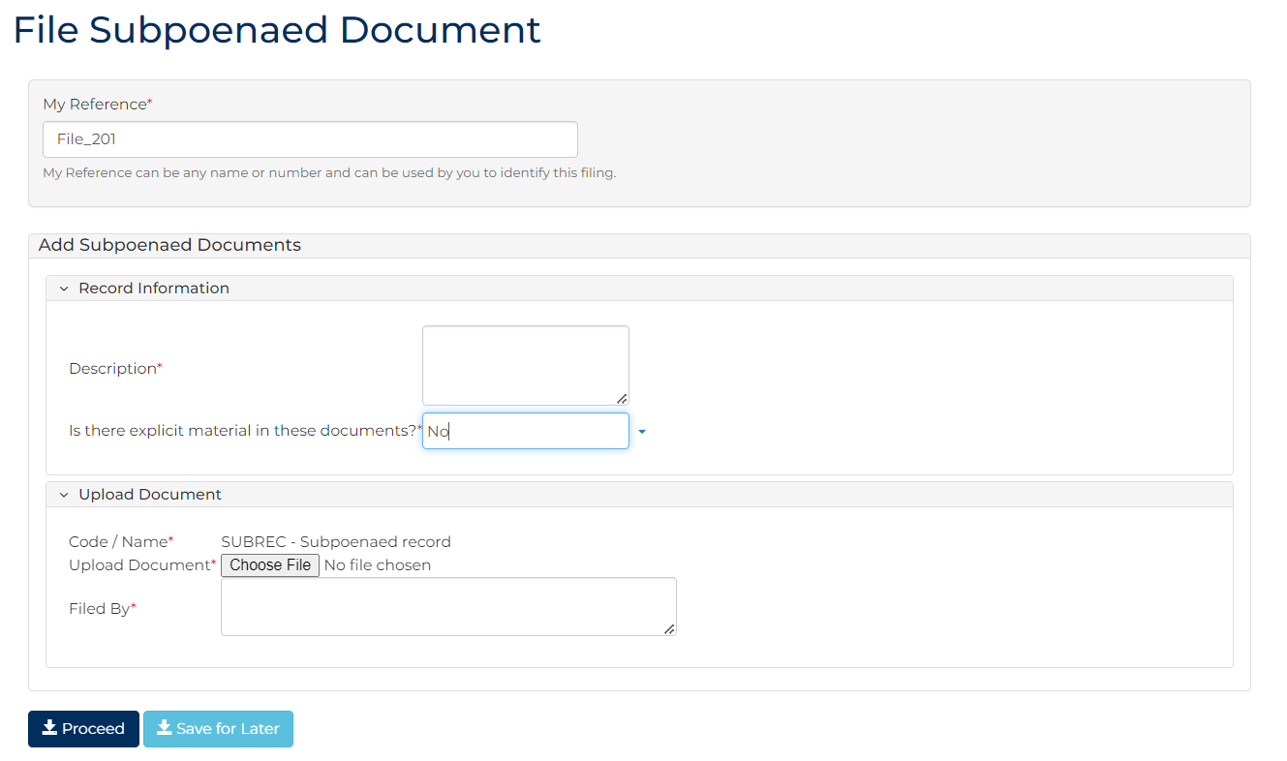
- To identify filing, type reference in My Reference field.

- Complete required panels and fields.
Panel: Add Subpoenaed Documents
Field: | Action:
Description | Type document description.
Is there explicit material in these documents? | Change if required.
Code / Name | -
Upload Document | Click: Choose File and attach PDF document.
Filed By | Type Filer's name.
- Click: Proceed
Confirmation of Filing screen displays:
