
Portal Quick Reference Guide
MCV | Criminal
File Search Warrant Request
Purpose
Quick Reference Guide shows how to File Search Warrant Request in CMS Portal.

- From CMS Portal Home page, select: Magistrates' Court of Victoria
Select a Case Type screen displays:
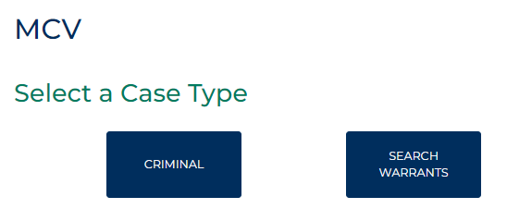
- Select: Search Warrants
Search Warrant screen displays:
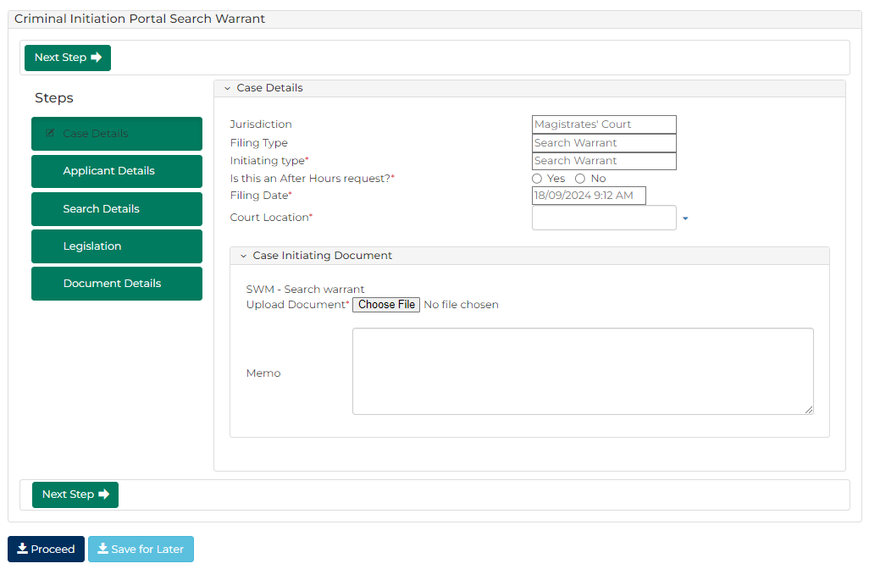
- To identify filing, type reference in My Reference field.

- Complete required panels and fields.
Panel: Case Details
Field: | Action:
Jurisdiction | -
Filing Type | -
Initiating Type | -
Is this an After Hours request? | Select: Yes or No
What would you like to do? | -
Filing Date | Change if required.
Court Location | Select location.

Panel: Case Initiating Document
Field: | Action:
Upload Document | Click: Choose File and attach PDF document
Memo | Type details if required.
- Click: Next Step

- Complete required panels and fields.
Panel: Applicant Details
Field: | Action:
Prosecuting Agency | Type number.  Select correct option from results.  Note:  - Available for VPOL only  - If not VPOL, complete Surname field
Registered Number | Type number.  Select correct option from results.  Note:  - Available for VPOL only  If not VPOL, complete Surname field
Surname | Type surname.  Select correct option from results.
- Click: Next Step
- Complete required panels and fields.
Panel: Search Details
Field: | Action:
What is to be searched? | Select relevant option.  Note:  - Additional fields will display based on selection  - Complete additional panels
- Click: Next Step
- Complete required panels and fields.
Panel: Legislation
Field: | Action:
Legislation Act and Section | Select relevant option.
- Click: Next Step
- Complete required panels and fields.
Panel: Document Details
Field: | Action:
Required Document | Click: Choose File and attach PDF document.  Note:  Affidavit in support of search warrant document must be attached.

- Click: Proceed
Confirmation of Filing screen displays:
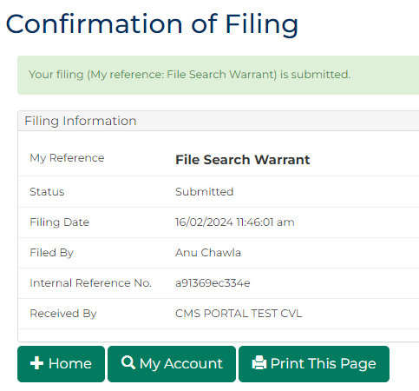
 | Note:  Application is placed in work queue for registry to review  Document status displays as Pending Review and is updated once work queue task is actioned  If application is granted, signed copy of search warrant will be available for download on CMS Portal
 | Resource:  See Quick Reference Guide: Download document

