
Portal Quick Reference Guide
MCV | Criminal
File Result of Search
Purpose
Quick Reference Guide shows how to File Result of Search in CMS Portal.
Prerequisites
Before start, ensure search warrant case exists with warrant status as Issued.

- From CMS Portal Home page, click: File on One of My Cases
List of cases display:
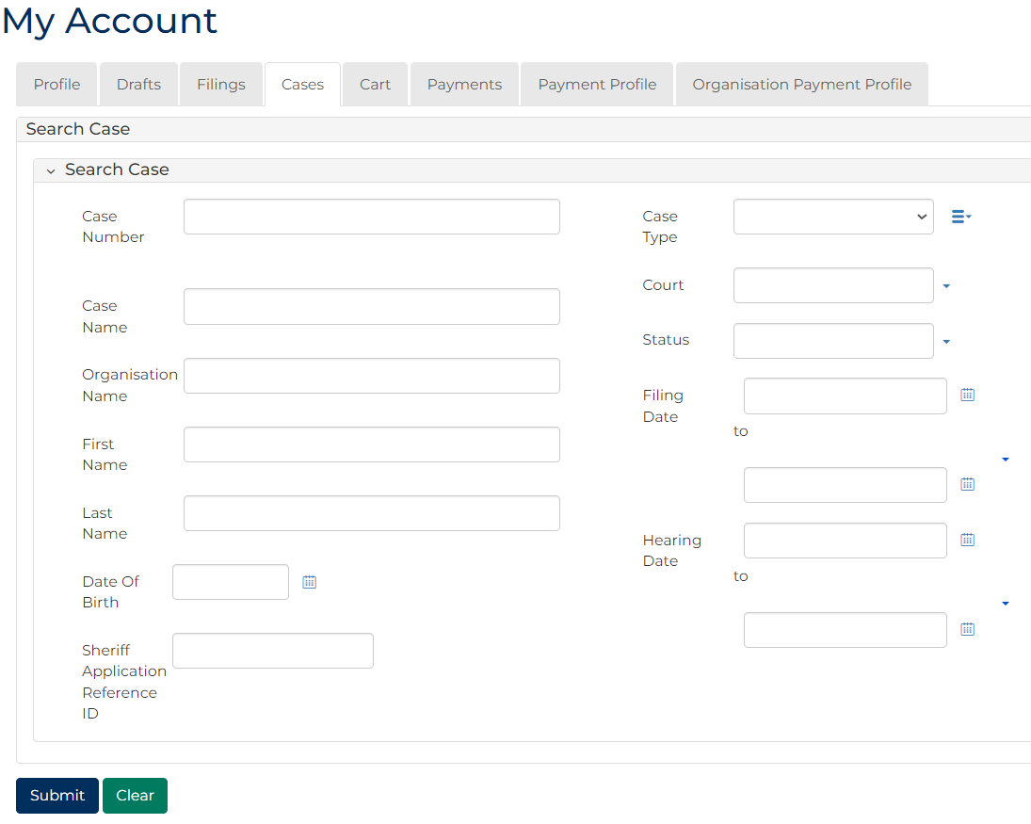
 | Note:  Only cases user previously filed on or requested access to display.
 | Resources:  See Quick Reference Guide:  - View and action case  - Request case access

- For relevant case, click: File a Document
SubCases panel displays:
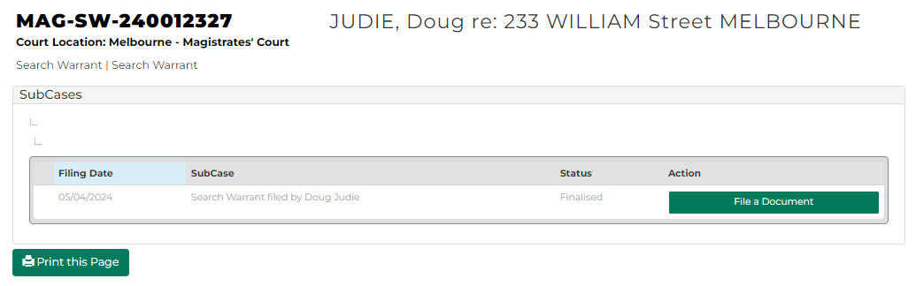
- For relevant subcase, click: File a Document
Add Document Submission CRIM screen displays:
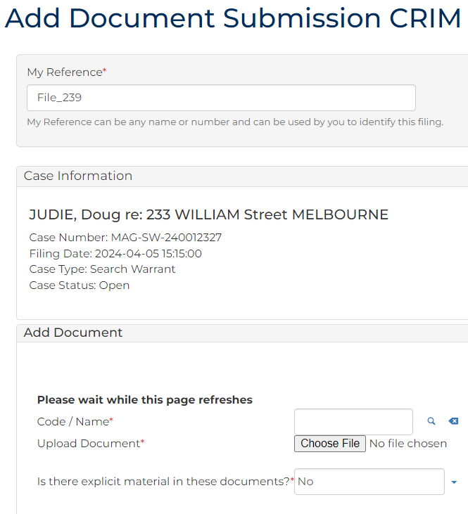

- To identify filing, type reference in My Reference field.
- Complete required panels and fields.
Panel: Add Document
Field: | Action:
Code/Name | Type ROS and select Result of Search
Upload Document | Click: Choose File and attach PDF document.
Is there explicit material in these documents? | Change if required.

Panel: Additional Panels
Field: | Action:
Has the search warrant been executed? | Select relevant option.
Filed By | Select party.
Related Documents | Select related search warrant document.
Related Orders | Select if required.

Panel: Additional Documents
Field: | Action:
Code / Name | Type name and select additional document(s).
Upload Documents | Select: Attach File  Click: Choose File and attach PDF document.

- Click: Proceed
Confirmation of Filing screen displays:
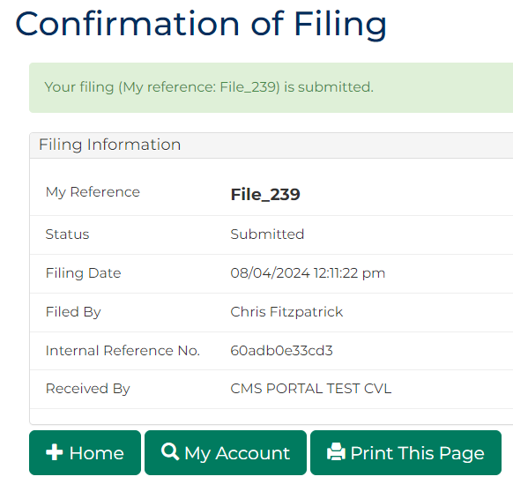
Note:
- Document is placed in work queue for registry to review
- If approved, document is accessed through My Account screen
Resource:
See Quick Reference Guide: Download document

