
Portal Quick Reference Guide
MCV | Criminal
File Licence Eligibility Application
Purpose
Quick Reference Guide shows how to File Licence Eligibility Application in CMS.
Contents
Initiate primary licence eligibility application 2
Initiate secondary licence eligibility application 17

Initiate primary licence eligibility application
Prerequisite: Before start, ensure applicant has lost licence by infringement notice.

- From CMS Portal Home page, select: Magistrates' Court of Victoria
Select a Case Type screen displays:
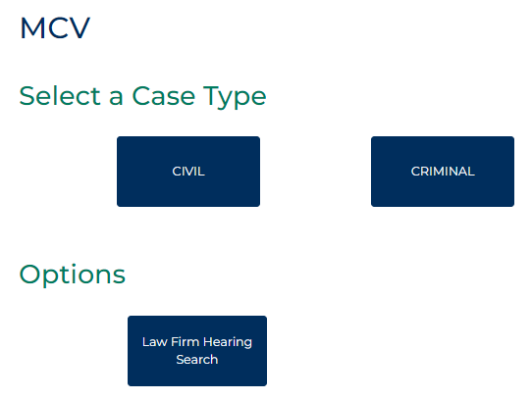

- Select: Criminal
Criminal screen displays:
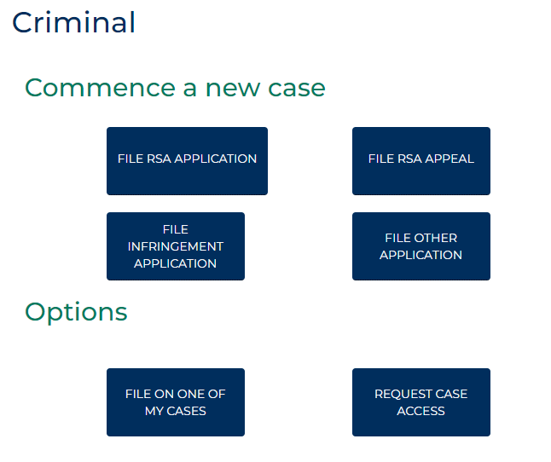

- Select: File RSA Application
Criminal Initiation-RSA-Application-Portal screen displays:
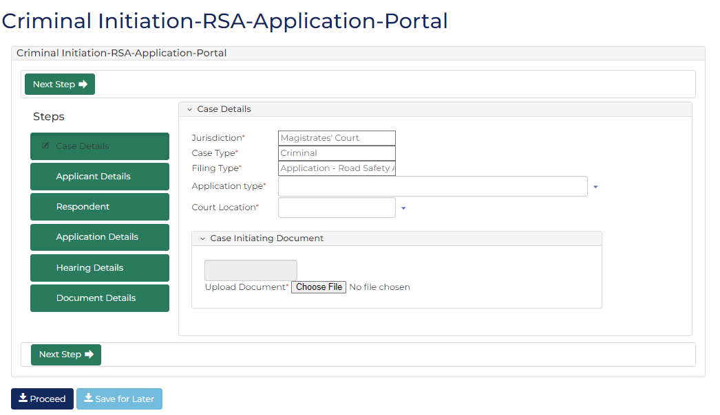

- Complete required panels and fields.
Panel: Case Details
Field: | Action:
Jurisdiction | -
Case Type | -
Filing Type | -
Application Type | Select: Licence Eligibility
Court Location | Change if required.

Panel: Case Initiating Document
Field: | Action:
Upload Document | -

- Click: Next Step
Applicant Details screen displays:
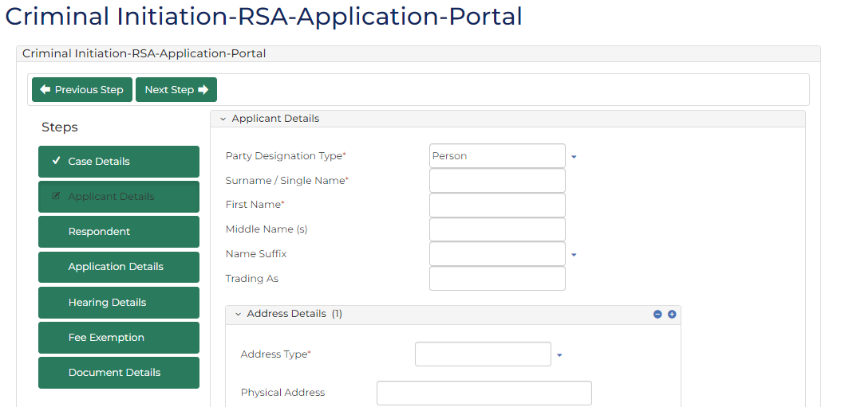
- Complete required panels and fields.
Panel: Applicant Details
Field: | Action:
Party Designation Type | Change if required.
Surname / Single Name | Type name.
First Name | Type name.
Middle Name (s) | Type name(s) if provided.
Name Suffix | Select relevant option if provided.
Trading As | Type name if provided.

Panel: Address Details
Field: | Action:
Address Type | Select relevant option.
Physical Address | Type address.  Select correct option from results.  Note:  If address cannot be located, type address details into relevant fields.

Panel: Contact Details
Field: | Action:
Mobile Number | Type number if provided.
Home Number | Type number if provided.
Work Number | Type number if provided.
Fax Number | Type number if provided.
Email Address | Type address if provided.

 | Note:  Mobile Number and Email Address allow electronic notifications from CMS.

Panel: Additional Details
Field: | Action:
Date Of Birth | Type date or click calendar icon to select date.

Panel: Driver’s Licence / Permit Details
Field: | Action:
Is it an international driver’s licence/permit? | Change if required.
Driver’s licence/permit state | Change if required.
Driver’s licence / permit number | Type number if provided.
Vehicle registration number | Type number if provided.
Vehicle registration state | Select relevant option if provided.

Panel: Legal Representation
Field: | Action:
Does the applicant have legal representation? | Change if required.  If Yes, complete Applicant Legal Representation Details panel.

- Click: Next Step
Respondent screen displays:
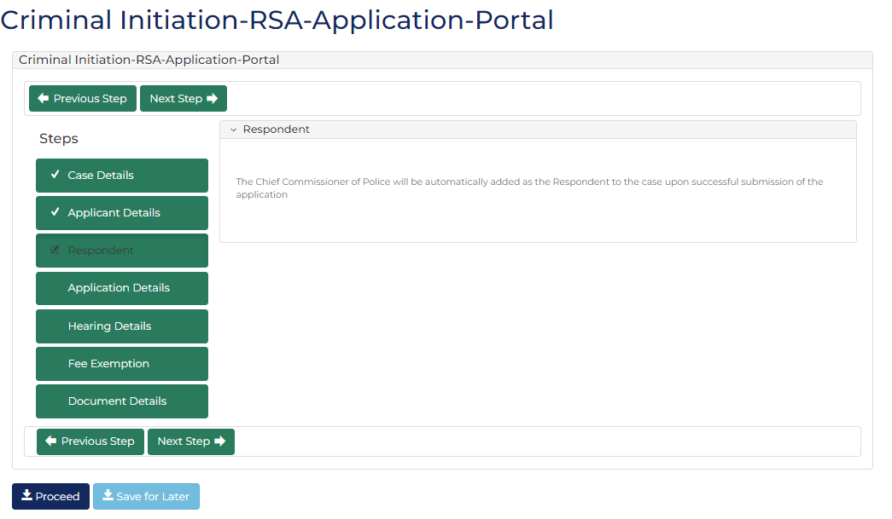
- Complete required panels and fields.
Panel: Respondent Details
Field: | Action:
Respondent | -

- Click: Next Step
Application Details screen displays:
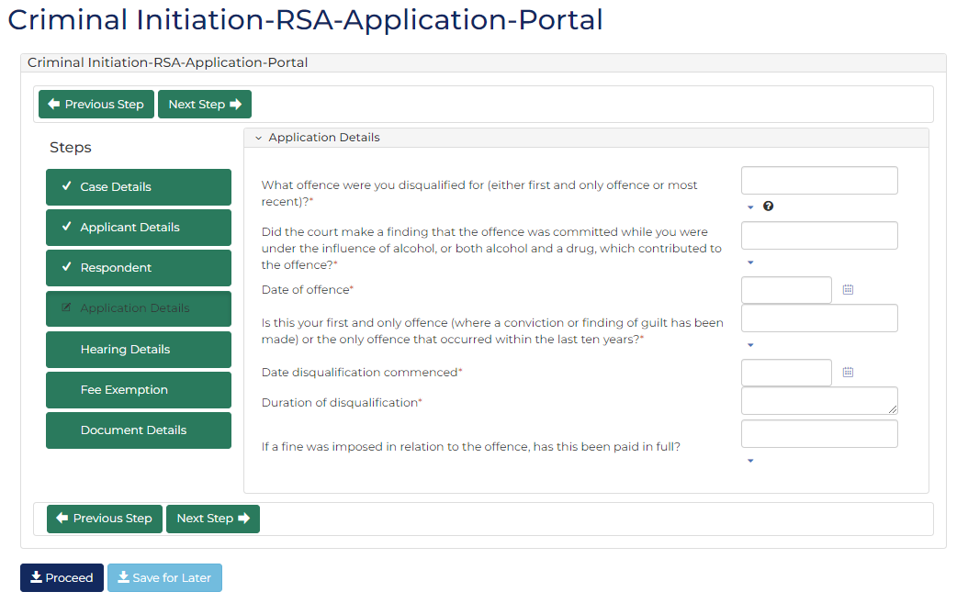

- Complete required panels and fields.
Panel: Application Details
Field: | Action:
What offence were you disqualified for (either first and only offence or most recent)? | Select relevant option.
Did the court make a finding that the offence was committed while you were under the influence of alcohol, or both alcohol and a drug, which contributed to the offence? | Select Yes or No  Note:  Field does not display if Drug driving option selected in What offence were you disqualified for (either first and only offence or most recent)? field.
Date of offence | Type date or click calendar icon to select date.
Is this your first and only offence (where a conviction or finding of guilt has been made) or the only offence that occurred within the last ten years? | Select Yes or No
Date disqualification commenced | Type date or click calendar icon to select date.
Duration of disqualification | Type duration.
If a fine was imposed in relation to the offence, has this been paid in full? | Select Yes or No

- Click: Next Step
Hearing Details screen displays:
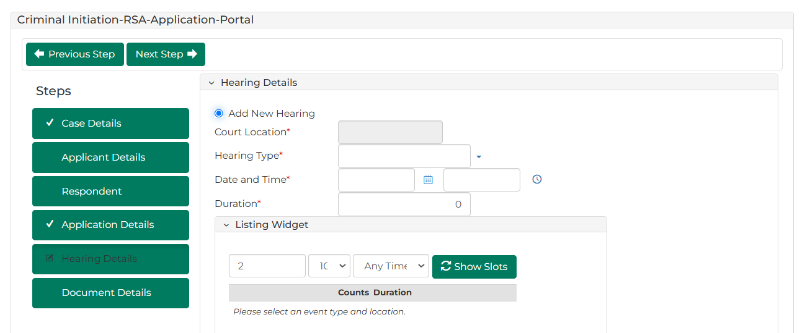
- Complete required panels and fields.
Panel: Hearing Details
Field: | Action:
Add New Hearing | -
Court Location | -
Hearing Type | Select: Application  Select relevant option from Listing Widget
Date and Time | Do not change.
Resources | Select resource(s).
Hearing Notes | Type if required.

- Click: Next Step
Fee Exemption screen displays:
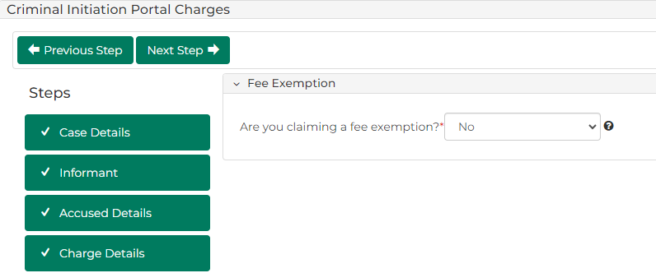
- Complete required panels and fields.
Panel: Fee Exemption
Field: | Action:
Are you claiming a fee exemption? | Change if required.  Note:  - If Yes, complete Reasons for fee exemption field  - Certain organisations are automatically exempt from paying fees

- Click: Next Step
Document Details screen displays:
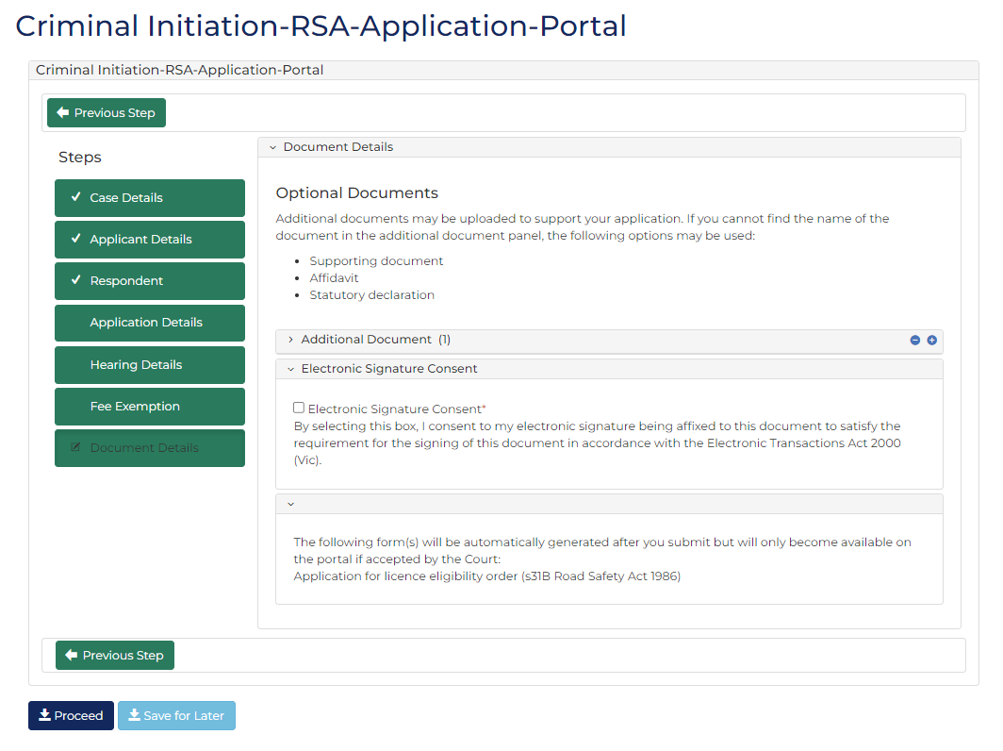

- Complete required panels and fields.
Panel: Additional Documents
Field: | Action:
Code / Name | Type name and select additional document(s).
Upload Documents | Select: Attach File  Click: Choose File and attach PDF document.
Electronic Signature Consent | Select checkbox.

Note:
To add another document, click: Add Another Document
- Is fee required?
If | Then
Yes | Click: Proceed  Resource:  See Quick Reference Guide: Make payment
No | Go to next step

- Click: Submit Payment
Confirmation of Filing screen displays:
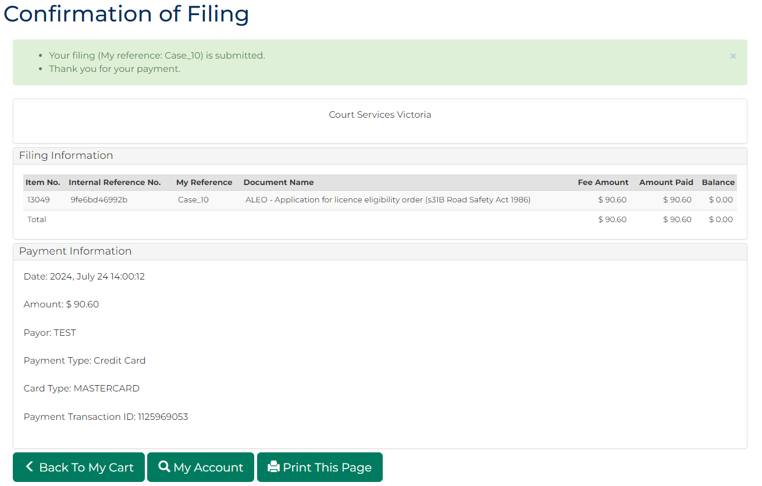
Note:
- Document is generated and placed in work queue for registry to review
- If approved, document is accessed through My Account screen
 | Resource:  See Quick Reference Guide: Download document

Initiate secondary licence eligibility application
Prerequisite: Before start, ensure applicant has lost licence by court order.

- From CMS Portal Home page, click: File on One of My Cases
List of cases display:
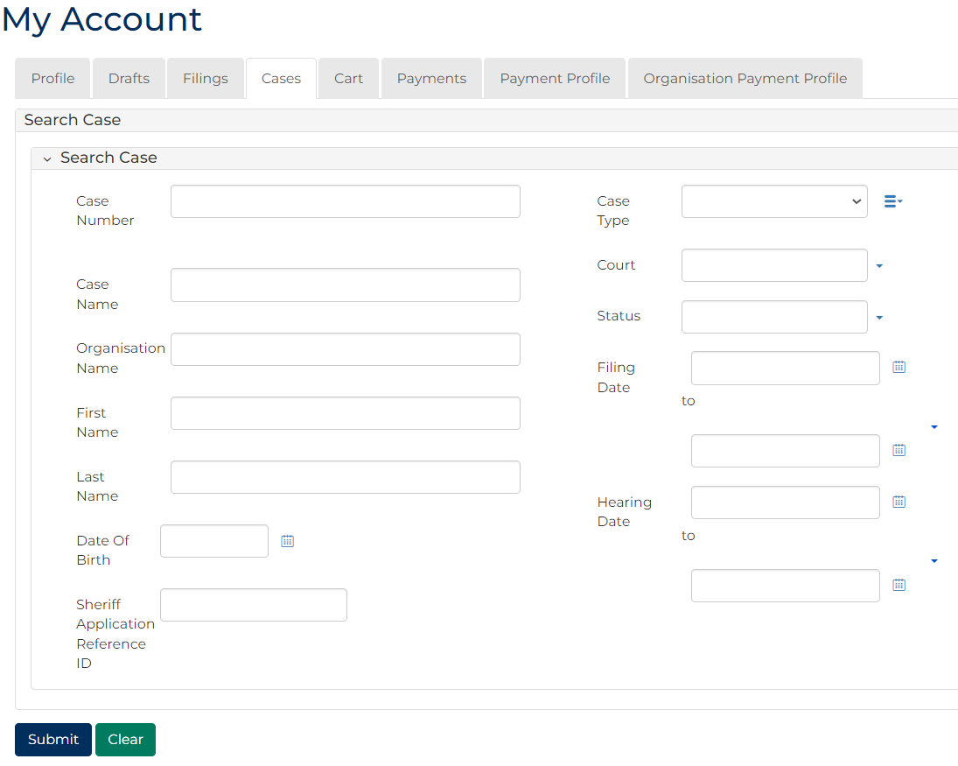
Note:
Only cases user previously filed on or requested access to, display.
Resources:
See Quick Reference Guides:
- View and action case
- Request case access
- For relevant case, click: File a Subcase
Add Criminal Subcase screen displays:
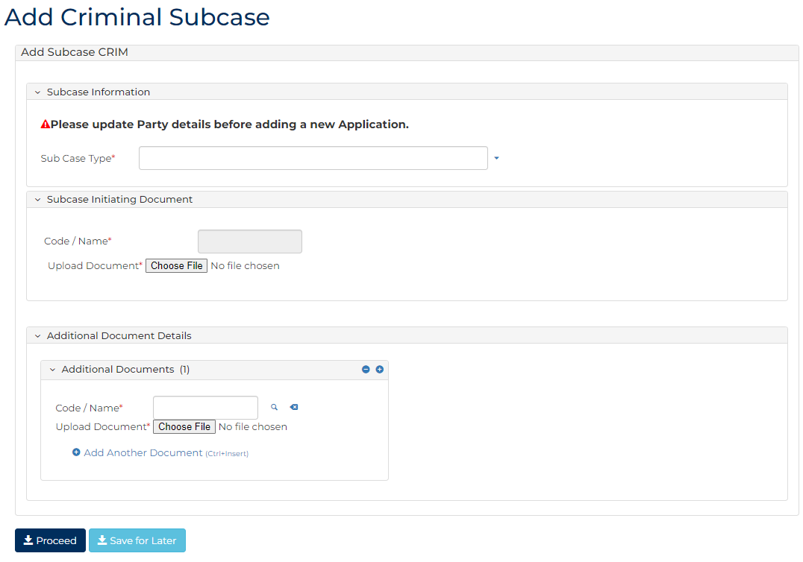

- Complete required panels and fields.
Panel: Subcase Information
Field: | Action:
Sub Case Type | Select: Licence Eligibility
What offence were you disqualified for (either first and only offence or most recent)? | Select relevant option.
Did the court make a finding that the offence was committed while you were under the influence of alcohol, or both alcohol and a drug, which contributed to the offence? | Select Yes or No  Note:  Field does not display if Drug driving option selected in What offence were you disqualified for (either first and only offence or most recent)? field.
Date of offence | Type date or click calendar icon to select date.
Is this your first and only offence (where a conviction or finding of guilt has been made) or the only offence that occurred within the last ten years? | Select Yes or No
Date disqualification commenced | Type date or click calendar icon to select date.
Duration of disqualification | Type duration.
If a fine was imposed in relation to the offence, has this been paid in full? | Select Yes or No

Panel: Subcase Initiating Document
Field: | Action:
Code / Name | -
Filed By (Existing Party) | Select party.
Representation | Select filing party's legal representation if applicable.  Note:  To add representation, click: Add Representation
Filed Against | -
Related Orders | Select relevant Licence Cancellation/Disqualification order.

Panel: Add Hearing
Field: | Action:
Add New Hearing | Select: Add New Hearing  Select relevant option from Calendar Assistant
Event Location | -
Result Type | -
Event Status | -
Hearing Type | -
Date and Time | Do not change.
Duration | Do not change.
Resources | Select resources(s).
Interpreter | Select party requiring interpreter.
Duration | Type interpreter booking duration.
Interpreter Language | Select required interpreter language.
Is gender specific interpreter required? | Select Yes or No if required.  Note:  If Yes, select gender.

Panel: Additional Document Details
Field: | Action:
Code / Name | Type name and select additional document(s)
Upload Document | Click: Choose file and attach PDF document.

Note:
To add another document, click: + Add Another Document

Panel: Fee Exemption
Field: | Action:
Are you claiming a fee exemption? | Change if required.  Note:  - If Yes, complete Reasons for fee exemption field  - Certain organisations are automatically exempt from paying fees

Panel: Electronic Signature Consent
Field: | Action:
Electronic Signature Consent | Select checkbox.
- Is fee required?
If | Then
Yes | Click: Proceed  Resource:  See Quick Reference Guide: Make payment
No | Go to next step

- Click: Proceed
Confirmation of Filing screen displays:
Note:
- Document is generated and placed in work queue for registry to review
- If approved, document is accessed through My Account screen
Resource:
See Quick Reference Guide: Download document

