
Portal Quick Reference Guide
MCV and ChCV | Criminal
File exhibit
Purpose
Quick Reference Guide shows how to File exhibit in CMS Portal.
Prerequisites
Before start, ensure case exists with pending hearing.

- From CMS Portal Home page, click: File on One of My Cases
List of cases display:
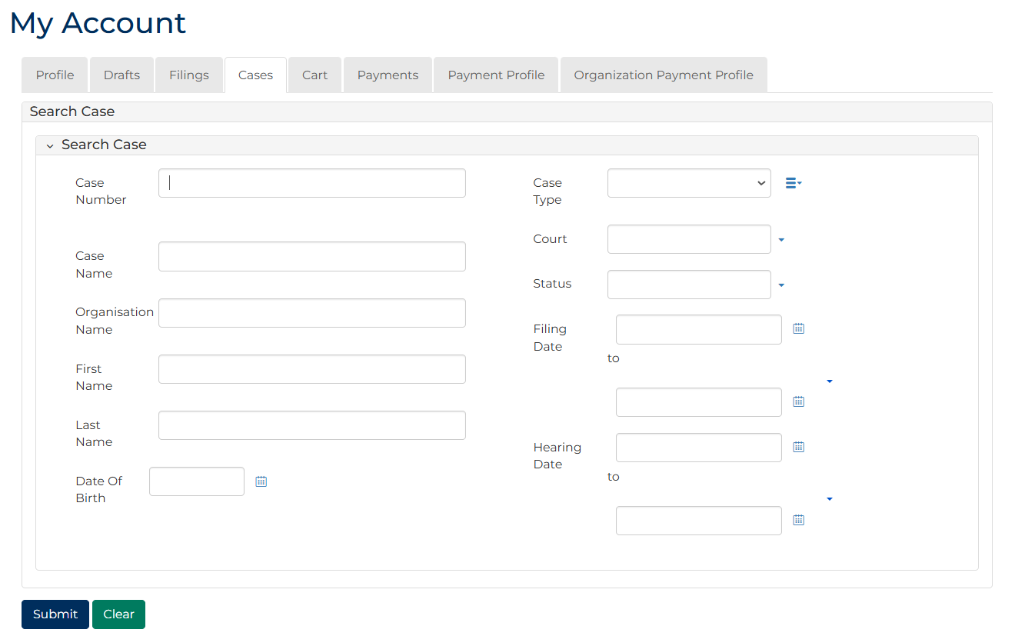
 | Note:  Only cases user previously filed on or requested access to, display.
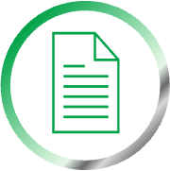 | Resources:  See Quick Reference Guides:  - View and action case  - Request case access

- For relevant case, click: File Exhibit
Add Criminal Exhibit screen displays:
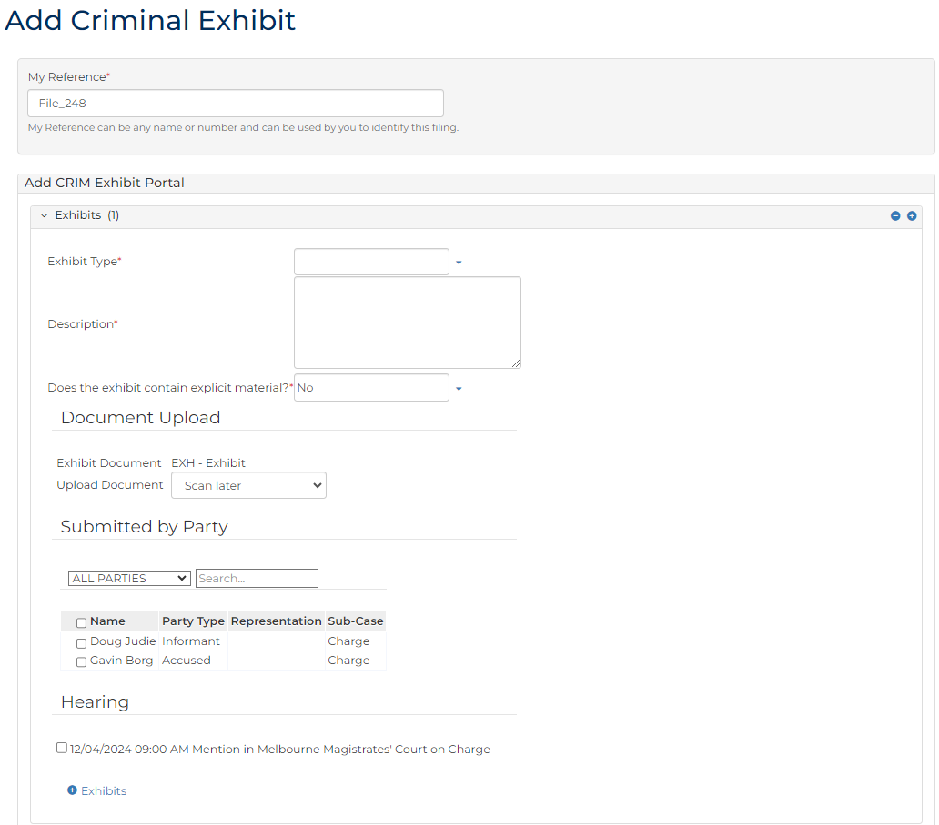
- To identify filing, type reference in My Reference field.

- Complete required panels and fields.
Panel: Exhibits
Field: | Action:
Exhibit Type | Select relevant option.
Description | Type description.
Does the exhibit contain explicit material | Change if required.
Exhibit Document | -
Upload Document | Click: Choose file and attach PDF document.
Submitted by Party | Select party.
Hearing | Select hearing.

- Click: Proceed
Confirmation of Filing screen displays:
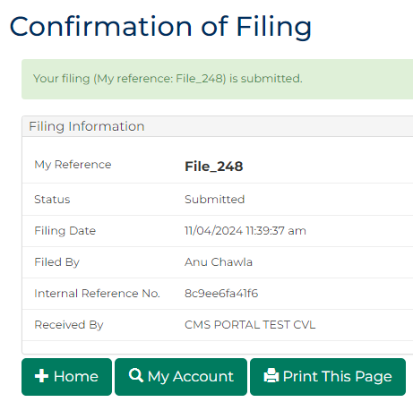
Note:
- Document is placed in work queue for Registry to review
- Document only available to download or view in Portal if shared with user by Registry staff
Resource:
See Quick Reference Guide: Download document

