
Portal Quick Reference Guide
MCV | Criminal
File Contravention Charge
Purpose
Quick Reference Guide shows how to File Contravention Charge in CMS.
Prerequisite
Before start, ensure order that can be contravened exists on case.

- From CMS Portal Home page, select: Magistrates' Court of Victoria
Select a Case Type screen displays:
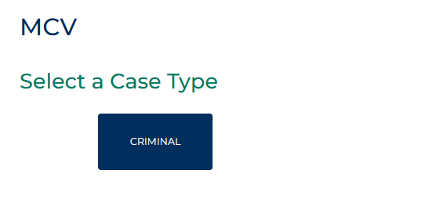
- Select: Criminal
Criminal screen displays:
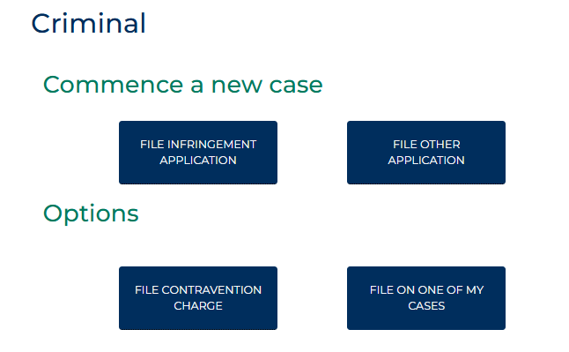

- Select: File Contravention Charge
Case Number Search Contravention screen displays:
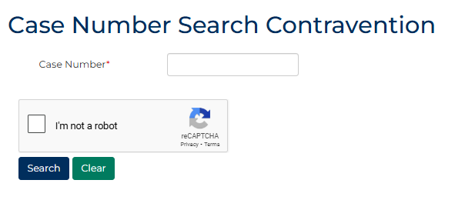
- Complete required panels and fields.
Panel: Case Details
Field: | Action:
Case Number | Type Full Case Number
I'm not a robot | Select checkbox.

- Click: Search
Case Number Search Contravention screen displays:
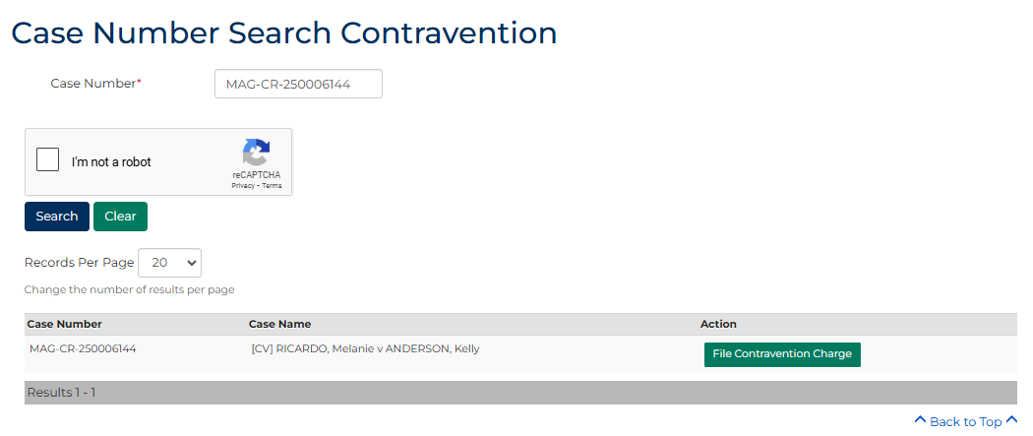
- Click: File Contravention Charge
Add Contravention Portal screen displays:
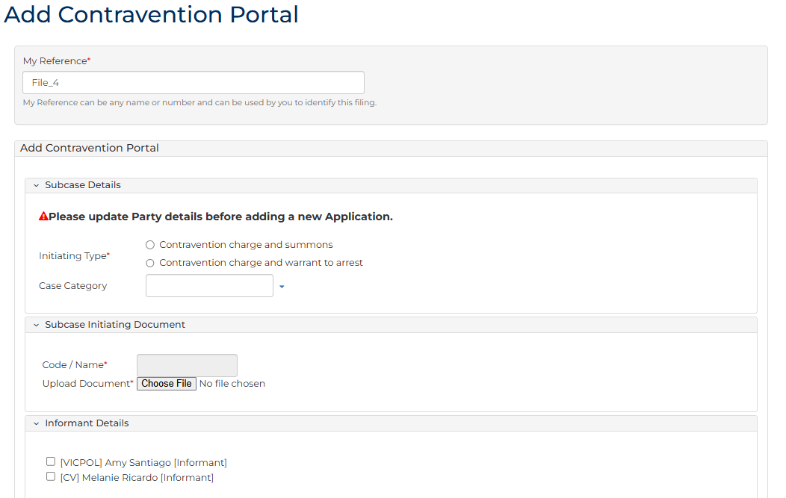
- To identify filing, type reference in My Reference field.
- Complete required panels and fields.
Panel: Subcase Details
Field: | Action:
Initiating Type | Select initiating type.  Note:  Additional fields may display based on selection.
Case Category | Select relevant option if applicable.
What would you like to do? | Select required option from dropdown menu.  Note:  Additional fields may display based on selection.
Panel: Subcase Initiating Document
Field: | Action:
Code / Name | -  Note:  Type of Subcase Initiating Document to upload will depend on Initiating Type selected.
Upload Document | Select: Attach File  Click: Choose File and attach PDF document.  Note:  Additional field Warrant Outcome displays when Contravention charge and warrant to arrest - Previously Issued is selected.
- Is existing Informant filing Contravention Charge?
If | Then
Yes | Select Informant.  Go to step 11.
No | Go to next step
- Complete required panels and fields.
Panel: Add New Informant
Field: | Action:
Prosecuting Agency | Type Surname and select name of Informant.  Note:  Additional fields will prepopulate when Informant is selected.
- Is Representation required?
If | Then
Yes | Select Add Representation and complete required fields.
No | Go to next step
- Complete required panels and fields.
Panel: Offender Details
Field: | Action:
Offender Details | Select name of Accused/Offender

Panel: Order
Field: | Action:
Order | Select relevant order.
- Does this contravention relate to an FCO/FDO order?
If | Then
No | Go to next step
Yes | Complete additional mandatory fields
- Complete required panels and fields.
Panel: Contravention Charge Details
Field: | Action:
Date Period | Change if required.  Note:  Offence To Date field displays if In between dates selected.
Offence Date | Type date or click calendar icon to select date.
Place of Offence Suburb | Type suburb.  Select correct option from results.  Note:  If offence took place at unknown location, type suburb in Place of Offence (Text only) field  Place of Offence Postcode field automatically populates when selection made
Place of Offence (Text only) | Type place of offence if relevant.
- Are Bail/Remand Details required?
If | Then
Yes | Complete additional fields
No | Go to next step
- Complete required panels and fields.
Panel: Hearing Details
Field: | Action:
Add New Hearing | Select Add Hearing and select relevant option from Calendar Assistant  Note:  Panel does not display when Initiating Type - Contravention charge and warrant to arrest, What would you like to do? - Court issued is selected.
Hearing Type | -
Date and Time | Do not change.
Duration | -
Calendar Assistant | Select relevant option from Listing Widget
Resources | Select resource(s) if applicable.
Interpreter | If Yes, expand panel, complete additional fields.
Hearing Notes | Type if required.
- Are you claiming fee exemption when Court Issued is selected?
If | Then
Yes | Complete additional fields  Note:  - If Yes, complete Exemption Reason field  - Certain organisations are automatically exempt from paying fees
No | Go to next step

- Complete required panels and fields.
Panel: Additional Documents
Field: |  | Action:
Code / Name |  | Type name and select additional document(s).
Upload Documents |  | Select: Attach File  Click: Choose File and attach PDF document.
 | Note:  To add another document, click: Add Another Document
- Is fee required?
If | Then
Yes | Click: Proceed  Resource:  See Quick Reference Guide: Make payment
No | Go to next step

- Click: Proceed
Confirmation of Filing screen displays:
