
Portal Quick Reference Guide
MCV and ChCV | Criminal
File Continuation of Charges
Purpose
Quick Reference Guide shows how to File Continuation of Charges in CMS Portal.

- From CMS Portal Home page, click: File on One of My Cases
List of cases display:
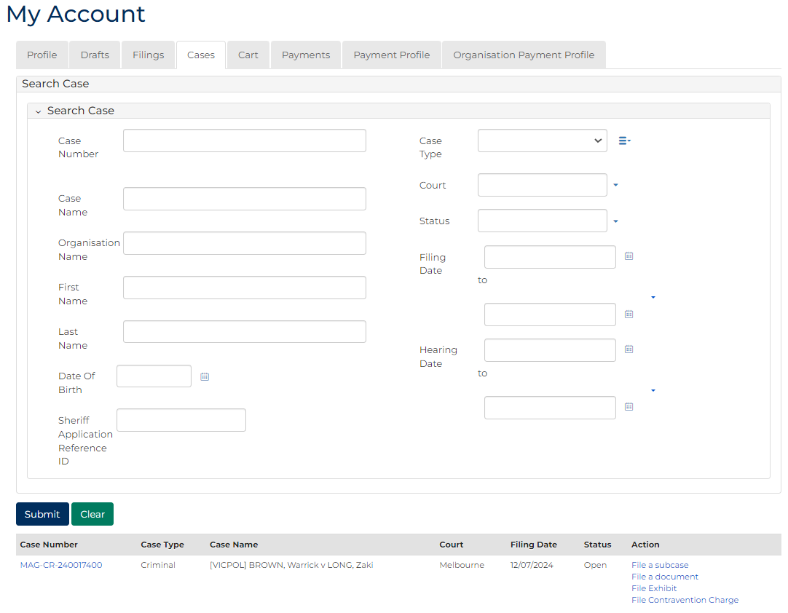
 | Note:  Only cases user previously filed on or requested access to display.
 | Resources:  See Quick Reference Guides:  - View and action case  - Request case access

- For relevant case, click: File a Document
SubCases panel displays:
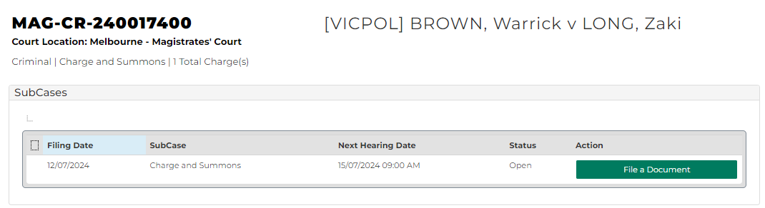
Note:
The document can only be filed on the following sub case types:
- Charge
- Charge and Summons
- Charge and Warrant to Arrest
- Notice to Appear

- For relevant subcase, click: File a Document
Add Document Submission CRIM screen displays:
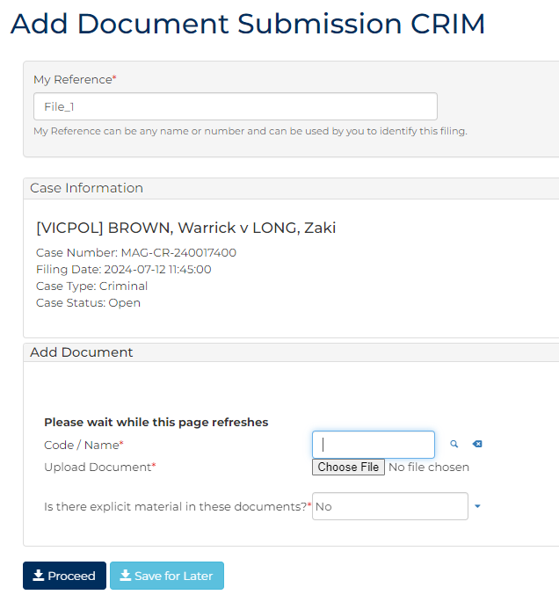
- To identify filing, type reference in My Reference field.

- Complete required panels and fields.
Panel: Add Document
Field: | Action:
Code/Name | Type: CHGCO to select Continuation of charges
Upload Document | Click: Choose File and attach PDF document
Is there explicit material in these documents? | Change if required.

Additional Panels
Field: | Action:
Filed By | Select party.  Note:  - Filed By party should be Informant for the charge(s) being filed  - To add new party, complete Add Filed By (New Party) panel
Representation | Select filing party's legal representation if applicable.  Note:  To add representation, click: Add Representation
Filed Against | Select party.
Related Documents | Select relevant charges document.
Related Hearings | Select relevant hearing.

Panel: Additional Documents
Field: | Action:
Code/Name | Type name and select additional document(s).
Upload Document | Click: Choose File and attach PDF document

Panel: Fee Exemption
Field: | Action:
Are you claiming a fee exemption? | Change if required.  Note:  If Yes, complete Reasons for fee exemption field.
- Is fee required?
If | Then
Yes | Click: Proceed  Resource:  See Quick Reference Guide: Make payment
No | Go to next step

- Click: Proceed
Confirmation of Filing screen displays:
