
Portal Quick Reference Guide
MCV and ChCV | Criminal
File Consolidation Request
Purpose
Quick Reference Guide shows how to File Consolidation Request in CMS Portal.

- From CMS Portal Home page, click: File on One of My Cases
List of cases display:
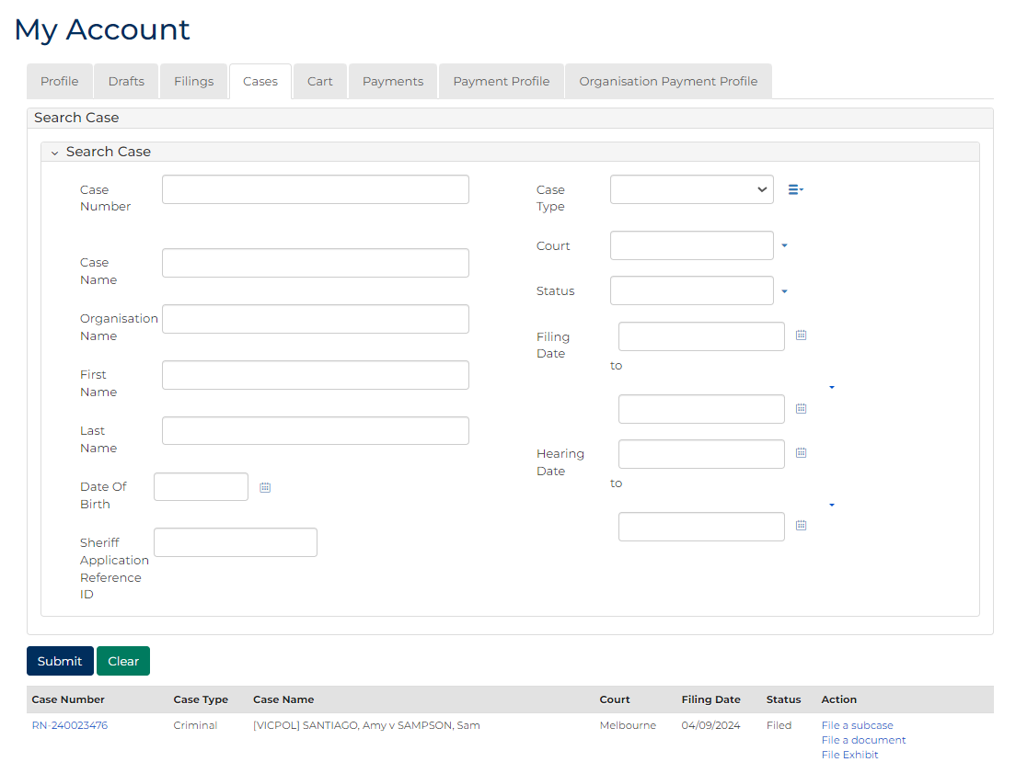
 | Note:  Only cases user previously filed on or requested access to, display.
 | Resources:  See Quick Reference Guides:  - View and action case  - Request case access

- For relevant case, click: Case Number
Filings panel displays:
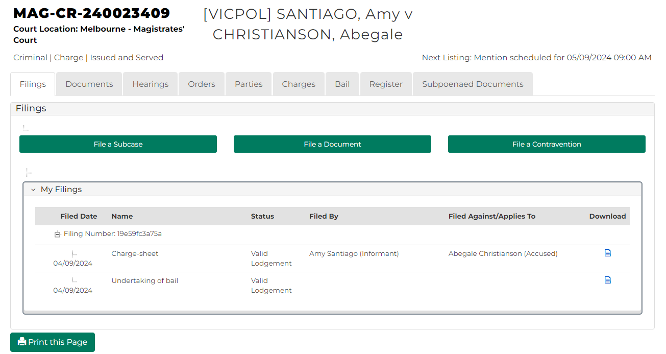
- For relevant case, click: File a Document
SubCases panel displays:
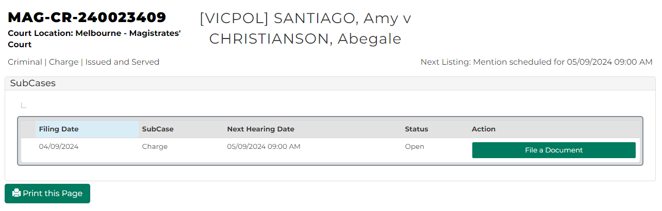

- For relevant subcase, click: File a Document
Add Filing screen displays:
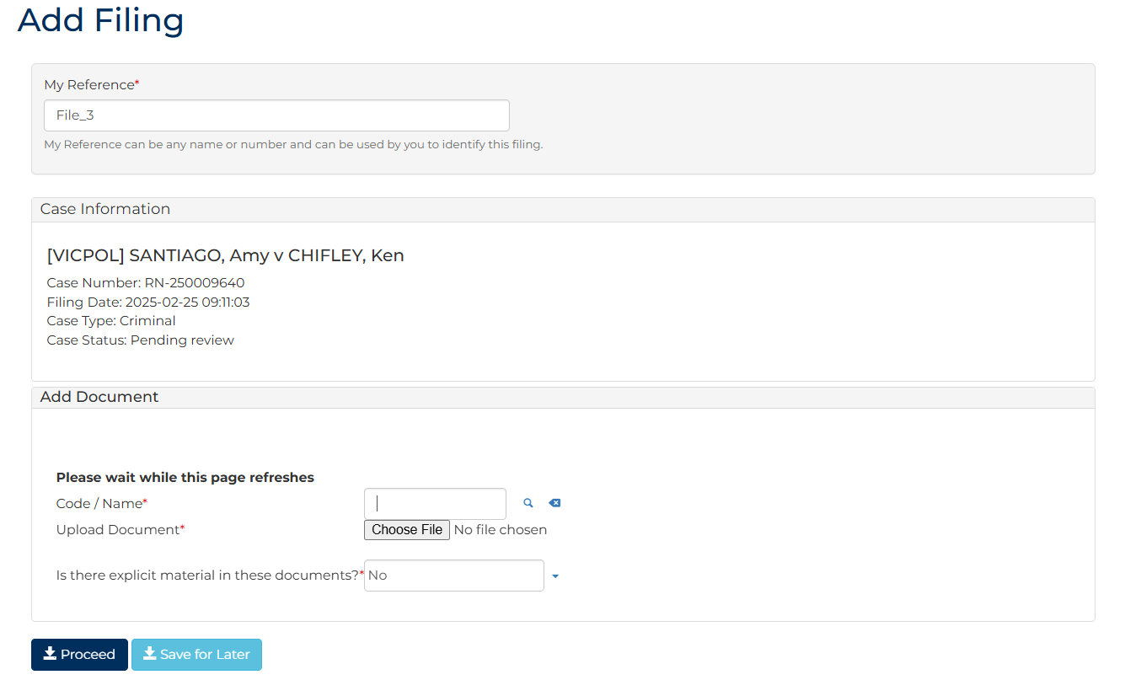
- To identify filing, type reference in My Reference field.

- Complete required panels and fields.
Panel: Add Document
Field: | Action:
Code/Name | Type Consolidation and select Consolidation plea booking form  Note:  - Click magnifying glass icon to look up document  Further fields display depending on document selected
Upload Document | Click: Choose File and attach PDF document.
Is there explicit material in these documents? | Change if required.

Panel: Additional Information
Field: | Action:
Is the Accused in custody | Select relevant option.
Filed By | Select party.
Representation | Select filing party’s legal representation if applicable.  Note:  To add representation, click: Add Representation

- Click: Proceed
Confirmation of Filing screen displays:
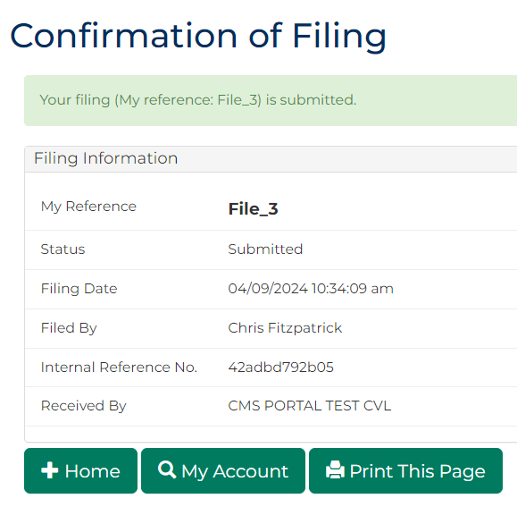
Note:
- Request is placed in work queue for registry to review
- If approved, request is accessed through My Account screen

