
Portal Quick Reference Guide
MCV and ChCV | Criminal
File Charge, Bail or Service document
Purpose
Quick Reference Guide shows how to File Charge, Bail or Service document in CMS Portal.

Contents
File Charge document 2
File Affidavit of Service 8
File Undertaking of Bail 13

File Charge document
Prerequisites
Victoria Police users only.
Before start, ensure case exists where date has been obtained from Mention Diary for either:
Charge and Summons
Charge Sheet for bail only
Charge and Warrant to Arrest for bail where the Charge and Warrant to Arrest was issued prior to CMS Go Live

- From Portal Home page, click: File on One of My Cases
List of cases display:
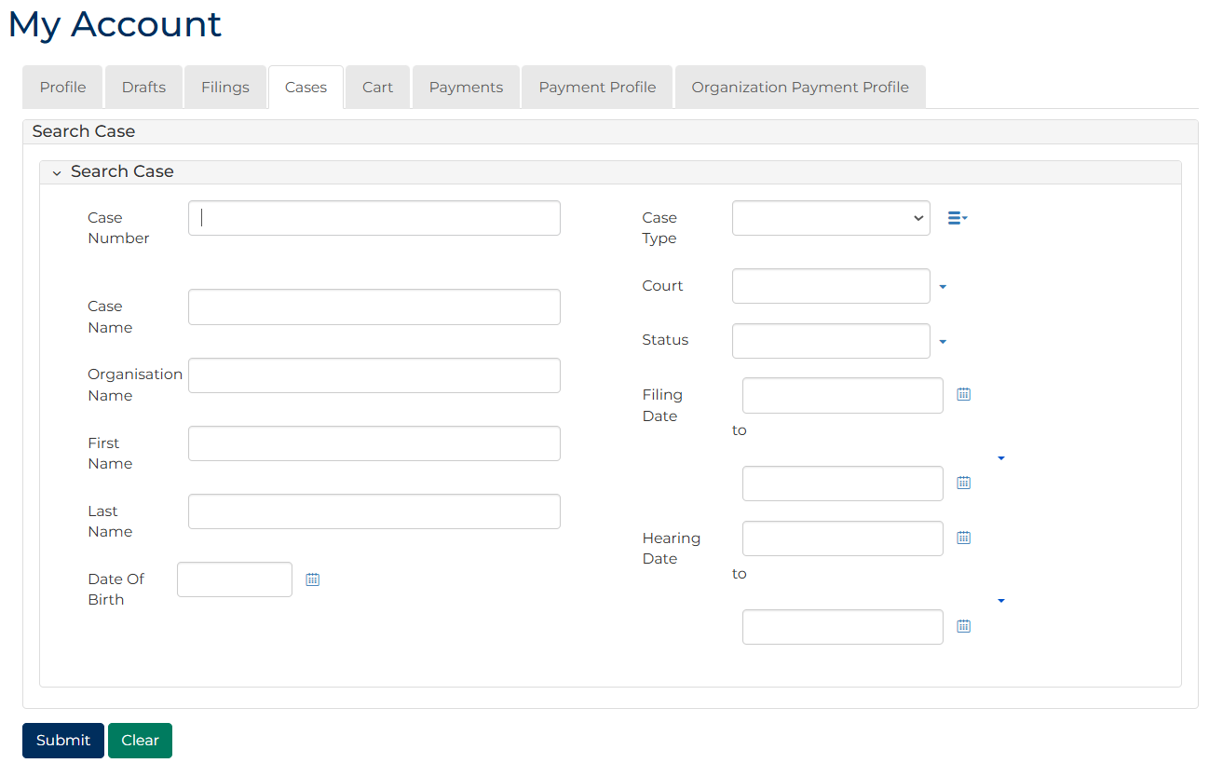
 | Note:  Only cases user previously filed on or requested access display.
 | Resources:  See Quick Reference Guide:  - View and action case  - Request case access

- For relevant case, click: File a Document
SubCases panel displays:
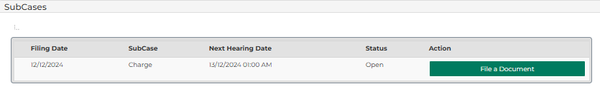
- For relevant subcase, click: File a Document
Add Filing screen displays:
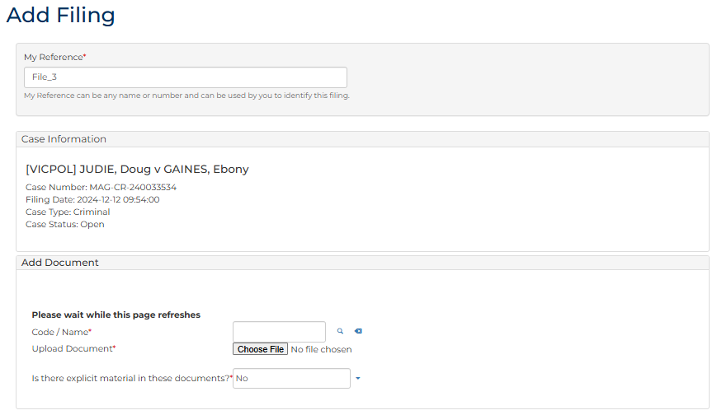
- To identify filing, type reference in My Reference field.

- Complete required panels and fields.
Panel: Add Document
Field: | Action:
Code/Name | Type Charge and select either:  - Charge-sheet (VicPol)  - Charge-sheet and summons (Corporate accused) (VicPol)  - Charge-sheet and summons (VicPol)  - Charge-sheet and warrant to arrest (VicPol)
Upload Document | Click: Choose File and attach PDF document
Is there explicit material in these documents? | Change if required.

Panel: Additional Information
Field: | Action:
What would you like to do? | Select relevant option where required.  Note:  No selection required for Charge-sheet (VicPol) and Charge-sheet and warrant to arrest (VicPol) documents.
Warrant Outcome | Select relevant option.  Note:  Field displays if document being uploaded is Charge-sheet and warrant to arrest (VicPol).

Panel: Additional Information
Field: | Action:
Filed by | Select party.
Filed Against | Select party.
Related Hearings | Select if required.

Panel: Upload Document
Field: | Action:
Code / Name | Type name and select additional document(s).  Note:  Affidavit/Declaration of service required for Charge-sheet and summons when Issued and Served selected  Undertaking of Bail required for  Charge-sheet (VicPol)  Charge-sheet and warrant to arrest (VicPol) where outcome Returned Executed
Upload Documents | Click: Choose File and attach PDF document.

Note:
Different documents are required based on selection in What would you like to do? field
To add another document, click: + Upload Document
- Click: Proceed
Confirmation of Filing screen displays:
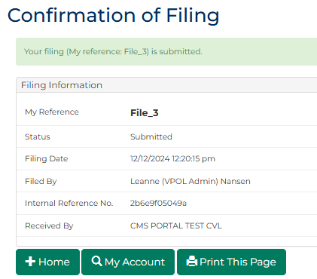
Note:
- Document is placed in work queue for registry to review
- For Charge-sheet and summons where Informant Issued and Not Served selected, no work queue task is generated

File Affidavit of Service
Prerequisites
Before start, ensure one the following exists:
- Charge and summons filed by Victoria Police where the case status is Issued
- Charge and summons filed by Trusted Agency generated where case status is Issued
- Continuation of Charges filed
- Contravention Charge and Summons where the subcase status is Issued
- Witness Summons filed

- From Portal Home page, click: File on One of My Cases
List of cases display:
Note:
Only cases user previously filed on or requested access to, display.
Resources:
See Quick Reference Guide:
- View and action case
- Request case access

- For relevant case, click: File a Document
SubCases panel displays:
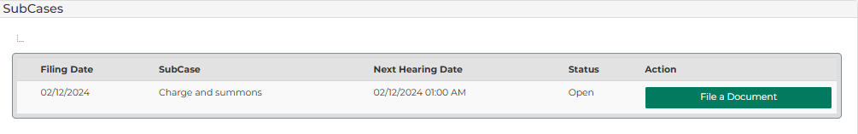
- For relevant subcase, click: File a Document
Add Filing screen displays:
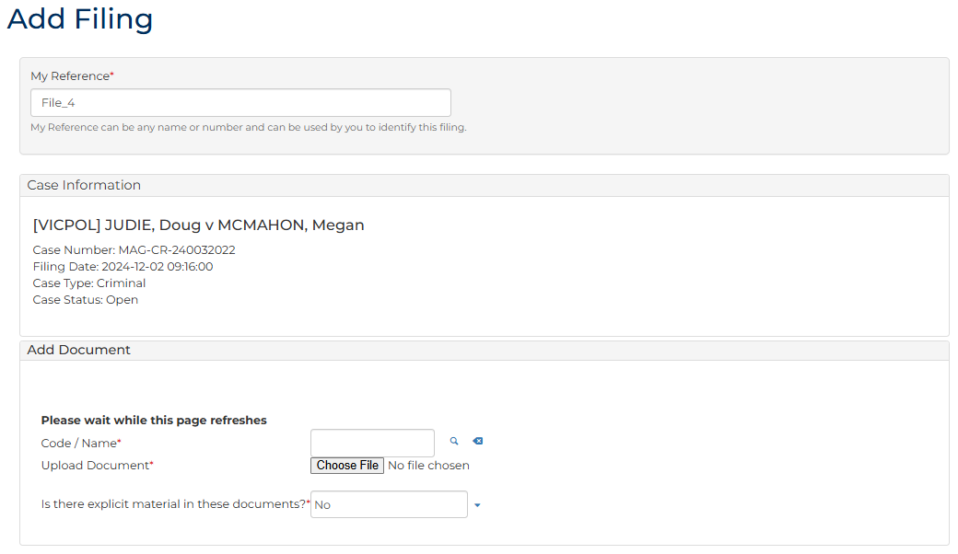
- To identify filing, type reference in My Reference field.

- Complete required panels and fields.
Panel: Add Document
Field: | Action:
Code/Name | Type: AFDESE  Select: Affidavit/Declaration of Service
Upload Document | Click: Choose File and attach PDF document.
Is there explicit material in these documents? | Change if required.

Panel: Additional Information
Field: | Action:
Filed by | Select party.  Note:  To add new party, complete Filed By (Add a New Party) panel.
Representation | Select filing party’s legal representation if applicable.  To add representation, click: Add Representation
Filed Against | Select party.  Note:  To add new party, complete Filed Against (New Party) panel.
Related Documents | Select document that has been served.
Related Hearings | Select if required.
- Click: Proceed
Confirmation of Filing screen displays:
Note:
Document is placed in work queue for registry to review.

File Undertaking of Bail
Prerequisites
Trusted Agencies only.
Before start, ensure case exists with either:
Charge Sheet generated by Trusted Agency where case status is Issued
Contravention Charge and Warrant to Arrest has been issued where subcase status is Issued

- From Portal Home page, click: File on One of My Cases
List of cases display:
Note:
Only cases user previously filed on or requested access to, display.
Resources:
See Quick Reference Guide:
- View and action case
- Request case access

- For relevant case, click: File a Document
SubCases panel displays:
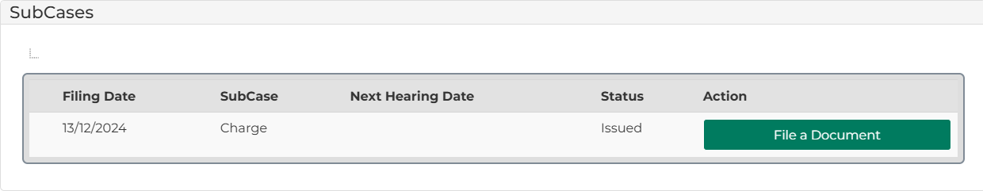
- For relevant subcase, click: File a Document
Add Filing screen displays:
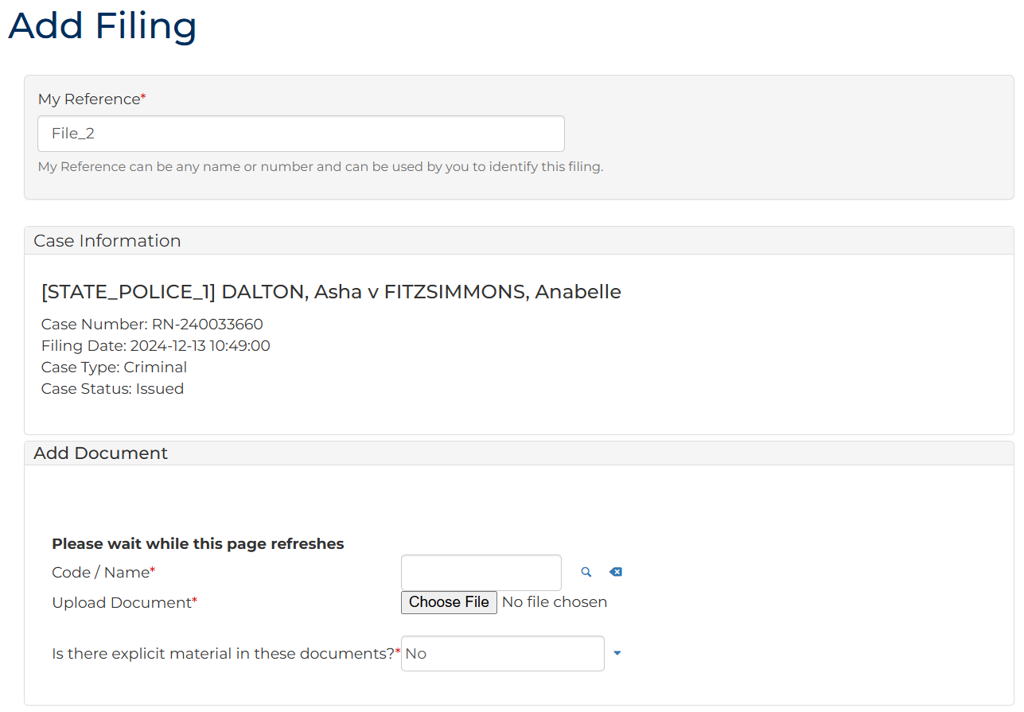
- To identify filing, type reference in My Reference field.

- Complete required panels and fields.
Panel: Add Document
Field: | Action:
Code/Name | Type: Bail  Select: Undertaking of Bail
Upload Document | Click: Choose File and attach PDF document.
Is there explicit material in these documents? | Change if required.

Panel: Additional Information
Field: | Action:
Filed by | Select party.  Note:  To add new party, complete Filed By (Add a New Party) panel.
Filed Against | Select party.
Related Orders | Select if required.

Panel: Additional Documents
Field: | Action:
Code / Name | Type name and select additional document(s).  Note:  Optional documents include:  - Notice of Obligations of Bail  - Affidavit of Justification of Surety
Upload Documents | Click: Choose File and attach PDF document.

Note:
To add another document, click: + Upload Document

- Click: Proceed
Confirmation of Filing screen displays:
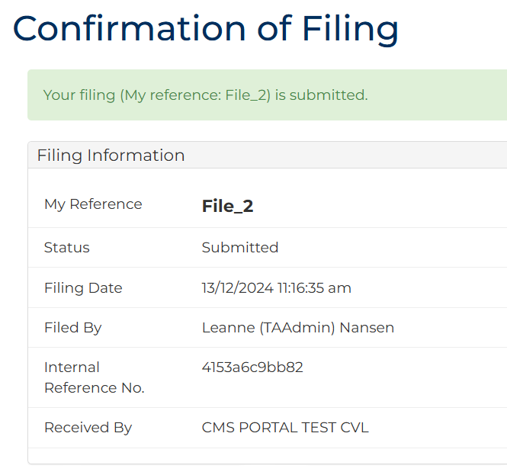
Note:
Document is placed in work queue for registry to review.

