
Portal Quick Reference Guide
MCV and ChCV | Criminal
File Charge and Warrant to Arrest
Purpose
Quick Reference Guide shows how to File Charge and Warrant to Arrest in CMS.
Contents
File Charge and Warrant to Arrest - Victoria Police 2
File Charge and Warrant to Arrest - Non-Victoria Police 14

File Charge and Warrant to Arrest - Victoria Police
- From CMS Portal Home page, select: Magistrates' Court of Victoria or Children's Court Victoria
Select a Case Type screen displays:
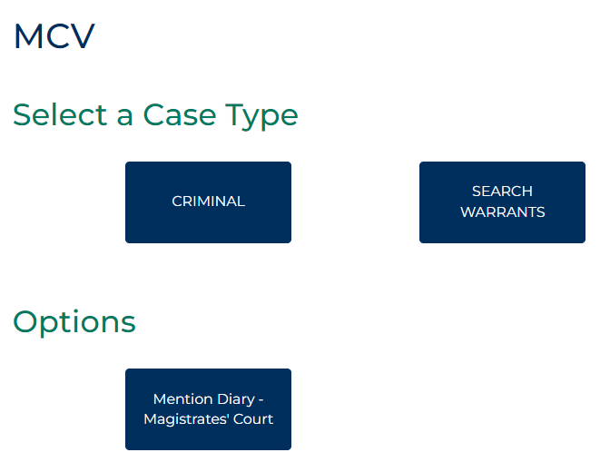

- Select: Criminal
Criminal screen displays:
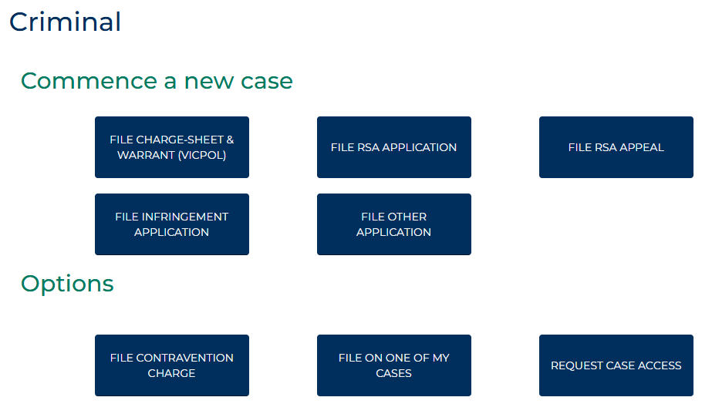

- Select: Charge and Warrant to Arrest VICPOL
Criminal Initiation Portal Charges - VicPol screen displays:
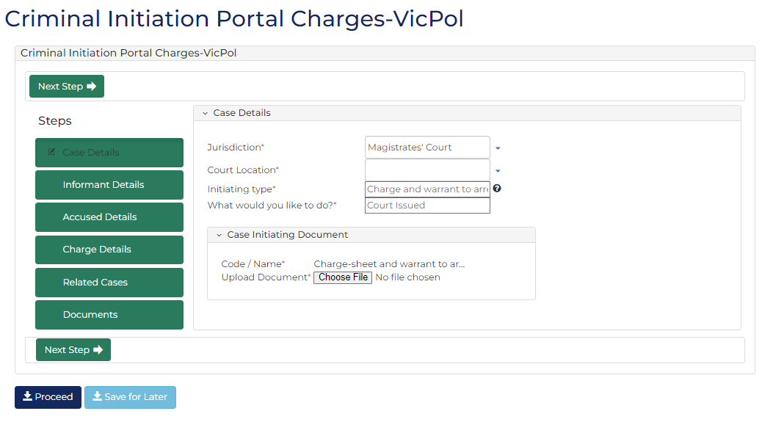
- Complete required panels and fields.
Panel: Case Details
Field: | Action:
Jurisdiction | -
Court Location | Change if required.
Initiating type | -
What would you like to do? | -

Panel: Case Initiating Document
Field: | Action:
Upload Document | Click: Choose File and attach PDF document.
- Click: Next Step
Informant Details screen displays:
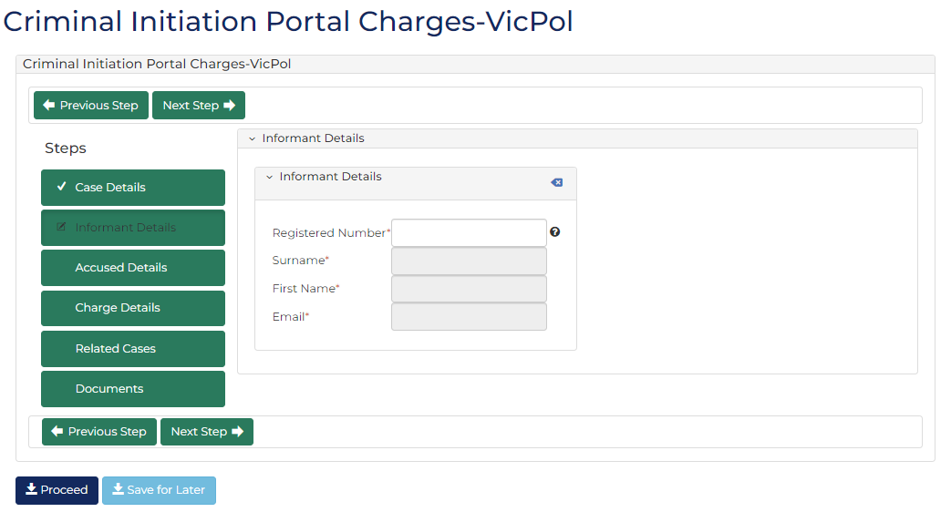
- Complete required panels and fields.
Panel: Informant
Field: | Action:
Registered Number | Type number.  Select correct option from results.

- Click: Next Step
Accused Details screen displays:
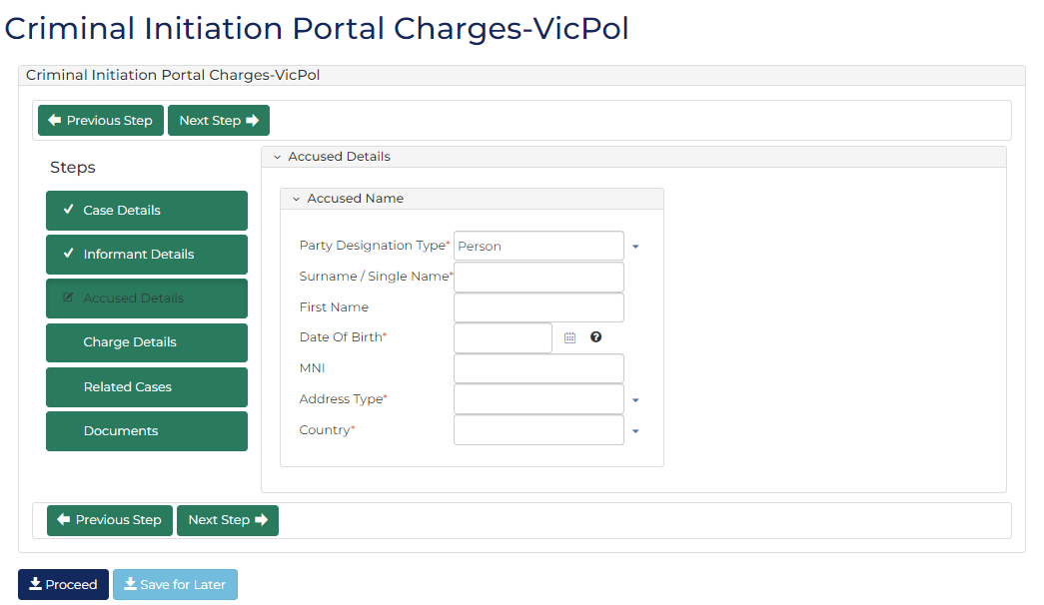

- Complete required panels and fields.
Panel: Accused
Field: | Action:
Party Designation Type | Change if required.
Surname / Single Name | Type name.
First Name | Type name.
Date Of Birth | Type date or click calendar icon to select date.
MNI | Type number if provided.
Address Type | Select relevant option.  Note:  Different fields display if No fixed place of abode selected.
Suburb/Town | Type suburb.  Select correct option from results.  Note:  Postcode, State and Country fields automatically populate based on selection.

- Click: Next Step
Charge Details screen displays:
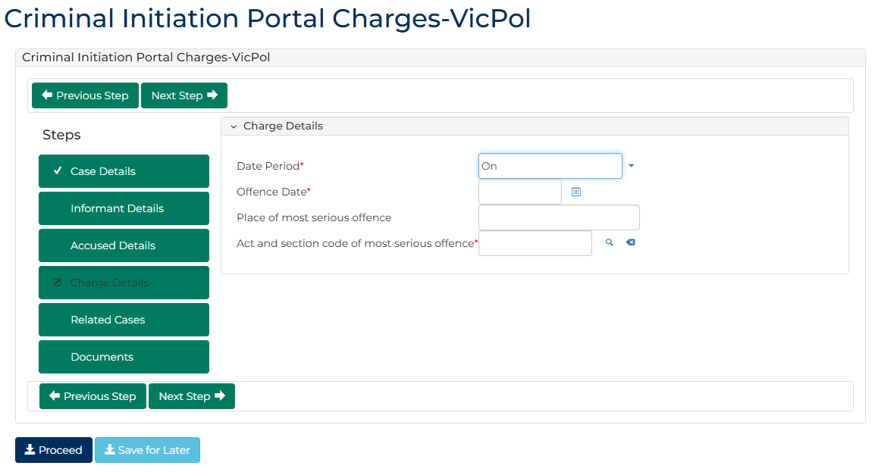

- Complete required panels and fields.
Panel: Charge Details
Field: | Action:
Date Period | Change if required.  Note:  Offence To Date field displays if In between dates selected.
Offence Date | Type date or click calendar icon to select date.
Place of most serious offence | Type suburb.  Select correct option from results.  Note:  Place of Offence Postcode field automatically populates when selection made
Act and section code of most serious offence | Type offence code or keyword(s).  Select correct option from results.

- Click: Next Step
Related Cases screen displays:
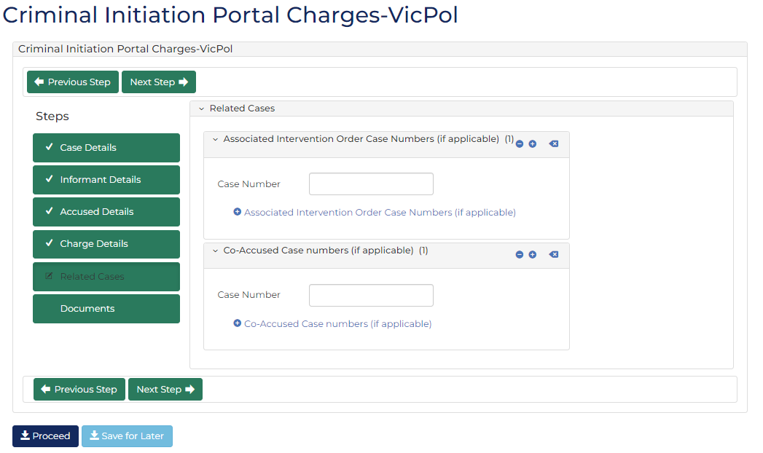

- Complete required panels and fields.
Panel: Related Cases
Field: | Action:
Associated Intervention Order Case Numbers | Type number if provided.  Note:  To add another related intervention order case number:  Click: + Associated Intervention Order Case Numbers  Complete additional panels
Co-Accused Case numbers | Type number if provided.  Note:  To add another Co-Accused case number:  - Click: + Co-Accused Case numbers  - Complete additional panels

- Click: Next Step
Documents screen displays:
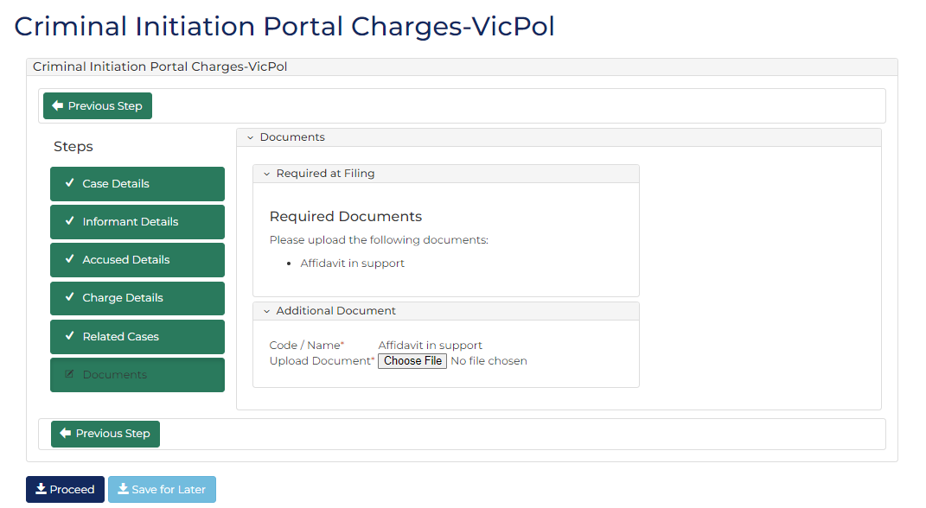
- Complete required panels and fields.
Panel: Additional Documents
Field: | Action:
Code / Name | -
Upload Documents | Click: Choose File and attach PDF document.

- Click: Proceed
Confirmation of Filing screen displays:
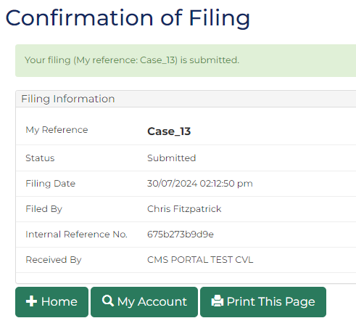
 | Note:  - Document is placed in work queue for registry to review  - If approved, document is accessed through My Account screen
 | Resource:  See Quick Reference Guide: Download document

File Charge and Warrant to Arrest - Non-Victoria Police
- From CMS Portal Home page, select: Magistrates' Court of Victoria or Children's Court Victoria
Select a Case Type screen displays:
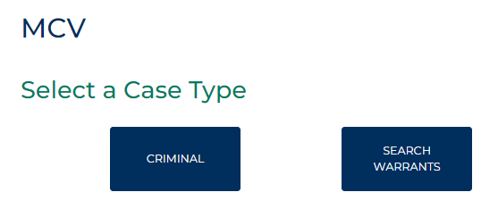
- Select: Criminal
Criminal screen displays:
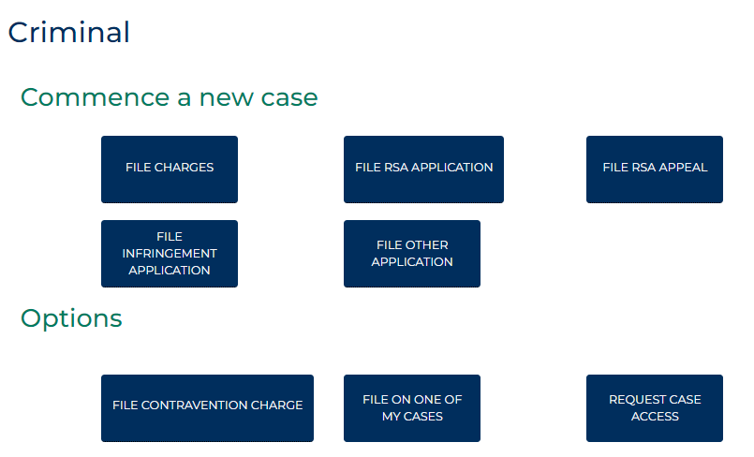

- Select: File Charges
Criminal Initiation Portal Charges screen displays:
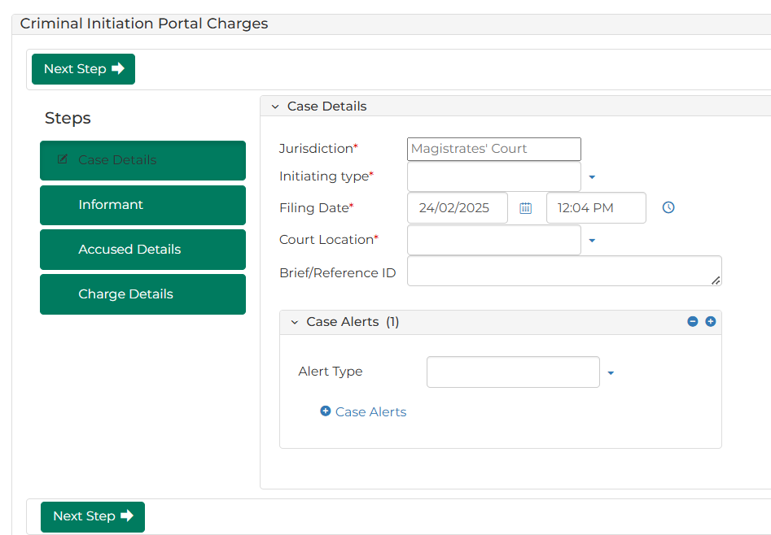
- To identify filing, type reference in My Reference field.

- Complete required panels and fields.
Panel: Case Details
Field: | Action:
Jurisdiction | -
Initiating Type | Select: Charge and Warrant to Arrest
What would you like to do? | Select relevant option.  Note:  Different fields display based on selection.
Filing Date | Change if required.
Court Location | Select location.
Brief/Reference ID | Type number if provided.

Panel: Case Alerts
Field: | Action:
Alter type | Select if required.

- Was Court Issued selected in What would you like to do? field?
If | Then
Yes | Go to next step
No | Go to step 8
- Complete required panels and fields.
Panel: Warrant to Arrest Grounds
Field: | Action:
Grounds for Warrant to Arrest | Type grounds.
It is probable the person will not answer to a summons | Change if required.
The person has absconded or is likely to abscond | Change if required.
The person is avoiding the service of a summons | Change if required.
The warrant is required | Change if required.
The warrant is authorised by another act namely | Change if required.
Other | Change if required.

Panel: Case Initiating Document
Field: | Action:
Case Initiating Document | -
- Was Previously Issued selected in What would you like to do? field?
If | Then
Yes | Go to next step
No | Go to step 10
- Complete required panels and fields.
Panel: Previously Issued Charge and Warrant to Arrest Details
Field: | Action:
Date Issued | Type date or click calendar icon to select date.
Court Location issued | Type court location.  Select correct option from results.
Court Warrant number | Type number if provided.

Panel: Case Initiating Document
Field: | Action:
Upload Document | Click: Choose File and attach PDF document.
Warrant Outcome | Select relevant option.

- Click: Next Step
Informant Details screen displays:
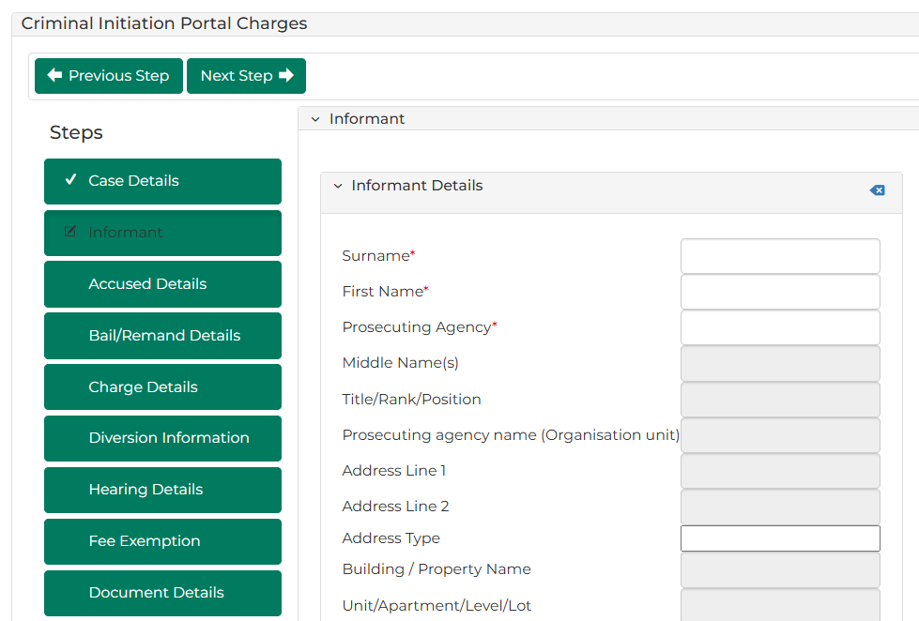
- Complete required panels and fields.
Panel: Informant
Field: | Action:
Surname | Type surname.  Select correct option from results.
Is there a legal representative? | Change if required.
- Click: Next Step
Accused Details screen displays:
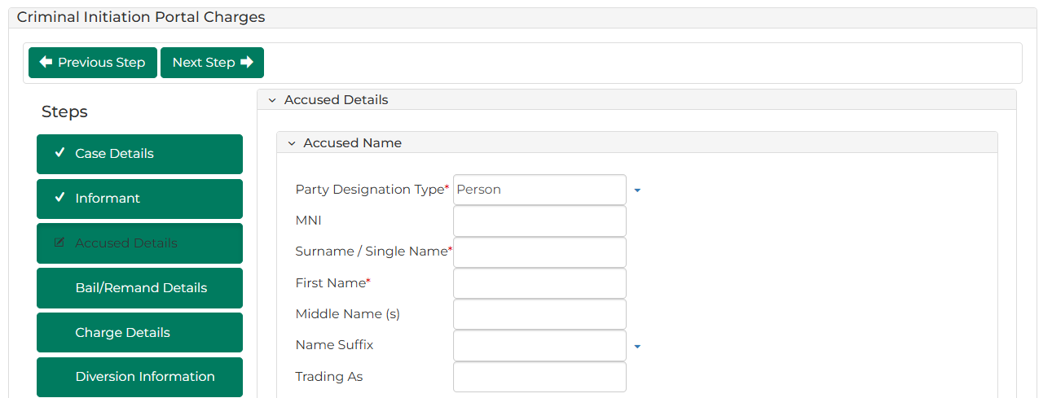

- Complete required panels and fields.
Panel: Accused Name
Field: | Action:
Party Designation Type | Change if required.
MNI | Not applicable.
Surname / Single Name | Type name.
First Name | Type name.
Middle Name | Type name(s) if provided.
Name Suffix | Select relevant option if provided.
Trading As | Type name if provided.

Panel: Alias Details
Field: | Action:
Party Designation Type | Select relevant option if provided.  Note:  Different fields display based on selection.
Title | Select relevant option.
Surname / Single Name | Type name.
First Name | Type name.
Middle Name (s) | Type name(s) if provided.
Name Suffix | Select relevant option if provided.

Panel: Address Details
Field: | Action:
Address Type | Select relevant option.  Note:  Different fields display if Unknown or Overseas selected.
Address | Type address.  Select correct option from results.  Note:  If address cannot be located, type address details into relevant fields.

Note:
To add another address:
- Click: + Add Another Address
- Complete additional panels

Panel: Contact Details
Field: | Action:
Mobile Number | Type number if provided.
Home Number | Type number if provided.
Work Number | Type number if provided.
Fax Number | Type number if provided.
Email Address | Type address if provided.
Panel: Additional Details
Field: |  | Action:
Date Of Birth |  | Type date or click calendar icon to select date.
Gender |  | Select relevant option.
Identified term and/or pronouns |  | Type if provided.
Indigenous Status |  | Select relevant option.
Is an interpreter provided? |  | Select Yes or No  Note:  If Yes, complete additional fields.

Panel: Identification Details
Field: | Action:
Australian Business Number (ABN) | Type number if provided.
Corrections Reference Number | Type number if provided.
Panel: Driver’s Licence / Permit Details
Field: |  | Action:
Is it an international driver’s licence/permit? |  | Change if required.
Driver’s licence/permit state |  | Change if required.
Driver’s licence / permit number |  | Type number if provided.
Vehicle registration number |  | Type number if provided.
Vehicle registration state |  | Select relevant option if provided.
- Click: Next Step
- Does Bail/Remand panel display?
If | Then
Yes | Go to next step
No | Go to step 24

- Is Accused on Bail?
If | Then
Yes | Go to next step
No | Go to step 22
- Complete required panels and fields.
Panel: Bail/Remand Details
Field: | Action:
Bail Category | -
Bail Status | Select: Entered  Different panels display based on selection.
Bail decision | -
Type of bail | Select relevant option.  Different panels display based on selection.
Date bailed/remanded to | Type date or click calendar icon to select date.
Time bailed/remanded to | Type time or click clock icon to select time.
Court bailed/remanded to | Type court location.  Select correct option from results.
Date bail entered | Type date or click calendar icon to select date.
Place bail entered suburb | Type suburb.  Select correct option from results.  Place bail entered postcode field automatically populates when selection made.
Conduct conditions | Select relevant conditions.
- Is type, Bail Guarantee or Bail Guarantee and Deposit?
If | Then
Yes | Go to next step
No | Go to step 19
- Complete required panels and fields.
Panel: Deposit
Field: | Action:
Deposit Amount | Type amount.

Note:
Deposit panel displays if type of bail is Bail Guarantee and Deposit

Panel: Bail Guarantor
Field: | Action:
Party Designation Type | Change if required.
Surname / Single Name | Type name.
First Name | Type name.
Middle Name (s) | Type name(s) if required.
Name Suffix | Select relevant option if required.

Panel: Address
Field: | Action:
Address Type | -
Physical Address | Type address.  Select correct option from results.  If address cannot be located, type address details into relevant fields.

Panel: Contact Details
Field: | Action:
Mobile Number | Type number if provided.
Home Number | Type number if provided.
Work Number | Type number if provided.
Fax Number | Type number if provided.
International number | Type number if provided.
Country Code | Type code if provided.
Email Address | Type address if provided.
Panel: Financial Details
Field: | Action:
Account Name | Type name if provided.
BSB Number | Type number if provided.
Account Number | Type number if provided.

Additional Panels
Field: | Action:
Is this bail guarantor a bail guarantor in any other matter(s)? | Change if required.
Total bail guarantee amount | Type amount.
Date bail guarantee provided | Type date or click calendar icon to select date.
Bail Guarantee amount | Type amount.
Bail Guarantee Type | Select relevant option.  Note:  Additional fields may display based on selection.

Note:
To add additional Bail Guarantee details:
- Click: + Bail Guarantee Details
- Complete additional panels
To add additional Bail Guarantor details:
- Click: > Bail Guarantor
- Complete additional panels

- Is type of bail Deposit?
If | Then
Yes | Go to next step
No | Go to step 22
- Complete required panels and fields.
Panel: Deposit
Field: | Action:
Deposit Amount | Type amount.
- Is Accused on Remand?
If | Then
Yes | Go to next step
No | Go to step 24

- Complete required panels and fields.
Panel: Bail/Remand Details
Field: | Action:
Bail Status | Select: Remand
Bail decision | Select relevant option.
Date bailed/remanded to | Type date or click calendar icon to select date.
Time bailed/remanded to | Type time or click clock icon to select time.
Court bailed/remanded to | Type court location.  Select correct option from results.
Notes to registrar | Type additional information if required.

- Click: Next Step
Charge Details screen displays:
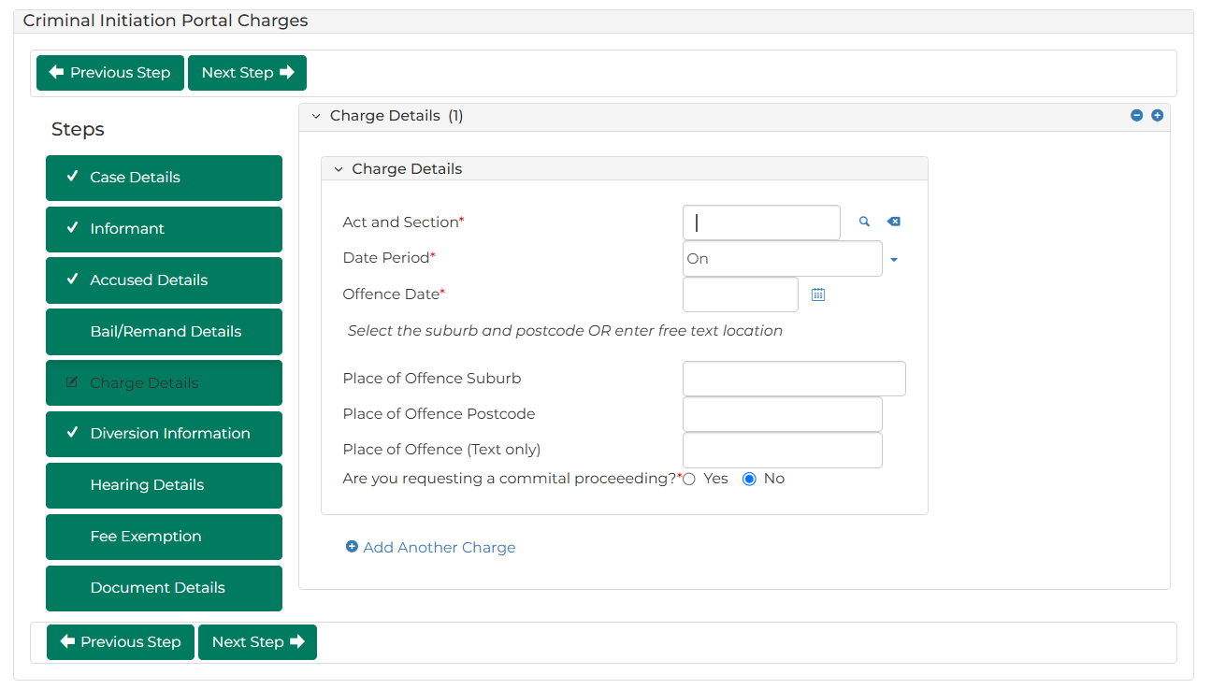

- Complete required panels and fields.
Panel: Charge Details
Field: | Action:
Act and Section | Type offence code or keyword(s).  Select correct option from results.
Date Period | Change if required.  Note:  Offence To Date field displays if In between dates selected.
Offence Date | Type date or click calendar icon to select date.
Place of Offence Suburb | Type suburb.  Select correct option from results.  Note:  Place of Offence Postcode field automatically populates when selection made  If offence took place at unknown location, type location in Place of Offence (Text only) field
Place of Offence (Text only) | Type place of offence if relevant.
Are you requesting a committal proceeding? | Change if required.
Description of Offence | Type details  Note:  Field displays if Court Issued selected in What would you like to do? field.
Is this an infringement offence? | Change if required.  Note:  Field displays if Court Issued selected in What would you like to do? field.

Note:
To add further charges:
Click: + Add Another Charge
- Complete additional panels
- Was Previously Issued selected in What would you like to do? field?
If | Then
Yes | Go to next step
No | Go to step 29

- Click: Next Step
Diversion Information screen displays:
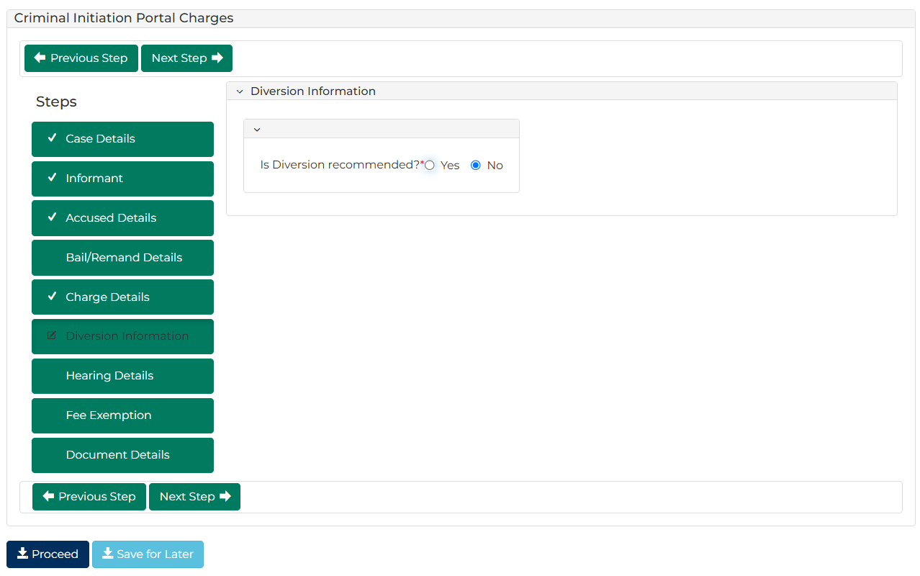
- Complete required panels and fields.
Panel: Diversion Information
Field: | Action:
Is Diversion recommended? | Change if required.  Note:  If Yes:  - upload Diversion notice  - complete additional panels and fields

- Was Previously Issued selected in What would you like to do? field?
If | Then
Yes | Go to next step
No | Go to step 34
- Click: Next Step
Hearing Details screen displays:
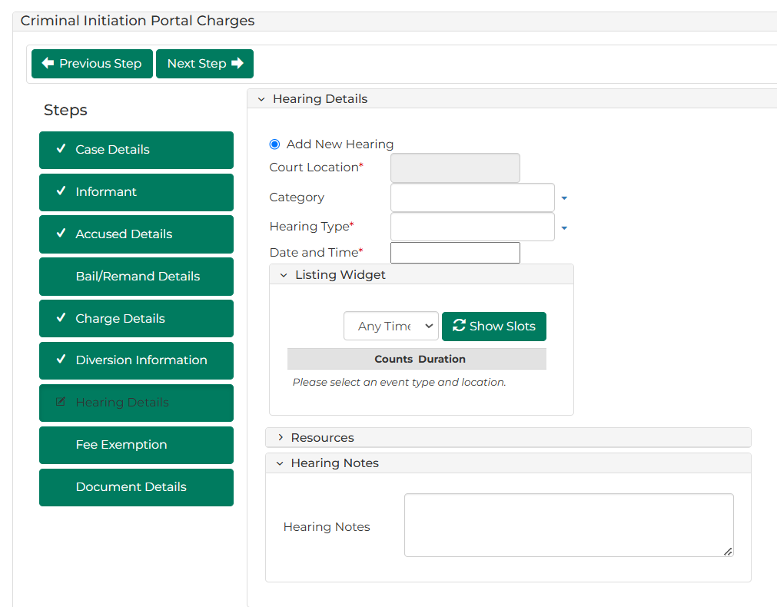

- Complete required panels and fields.
Panel: Hearing Details
Field: | Action:
Add New Hearing | -
Court Location | -
Hearing Type | Select relevant option.  Select relevant option from Listing Widget
Date and Time | Do not change.
Resources | Select resources(s).
Hearing Notes | Type if required.
- Click: Next Step
Fee Exemption screen displays:
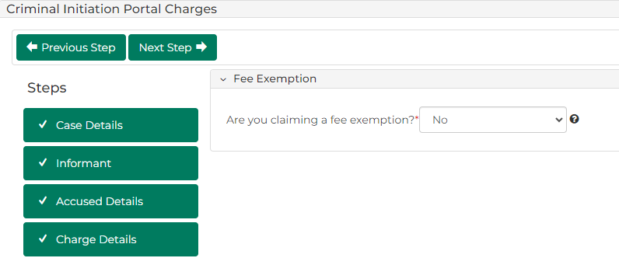

- Complete required panels and fields.
Panel: Fee Exemption
Field: | Action:
Are you claiming a fee exemption? | Change if required.  Note:  If Yes, complete Exemption Reasons field  Certain organisations are automatically exempt from paying fees

- Click: Next Step
Document Details screen displays:
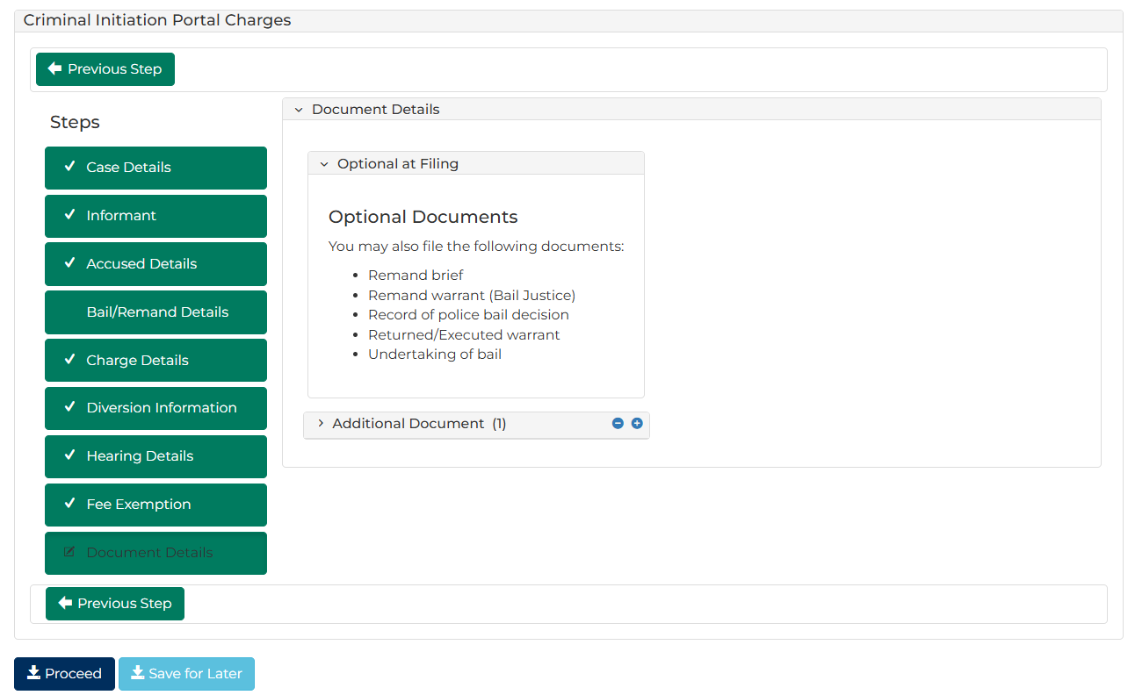

- Complete required panels and fields.
Panel: Additional Document
Field: | Action:
Code / Name | Type name and select additional document(s).
Upload Documents | Click: Choose File and attach PDF document.

Panel: Electronic Signature Consent
Field: | Action:
Electronic Signature Consent | Select checkbox if required.  Note:  Field displays if Court Issued selected in What would you like to do? field.
- Is fee required?
If | Then
Yes | Click: Proceed  Resource:  See Quick Reference Guide: Make payment
No | Go to next step

- Click: Proceed
Confirmation of Filing screen displays:
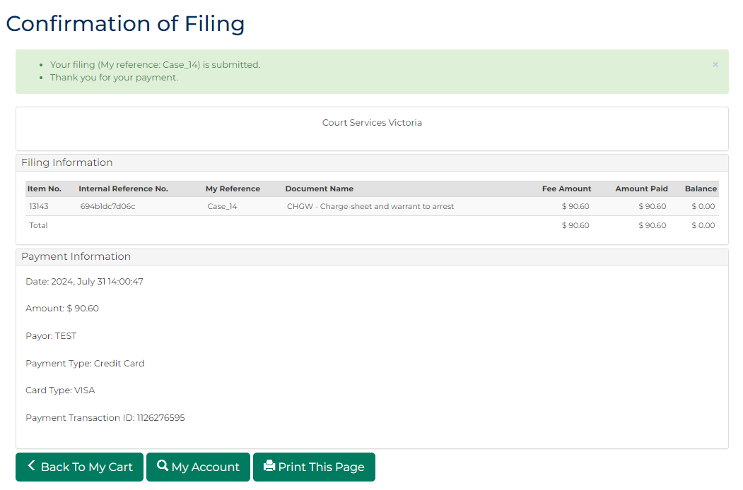
Note:
- If Court Issued selected:
  - document is generated and placed in work queue for registry to review
  - If approved, document is accessed through My Account screen
If Previously Issued selected, case number is generated
Resource:
See Quick Reference Guide: Download document

