
Portal Quick Reference Guide
MCV and ChCV | Criminal
File Charge and Summons
Purpose
Quick Reference Guide shows how to File Charge and Summons in CMS.
Prerequisite
Before start, ensure prosecuting agency is non-Victoria Police.

- From CMS Portal Home page, select: Magistrates' Court of Victoria or Children's Court of Victoria
Select a Case Type screen displays:
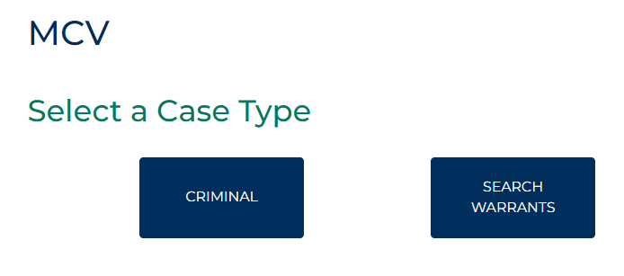
- Select: Criminal
Criminal screen displays:
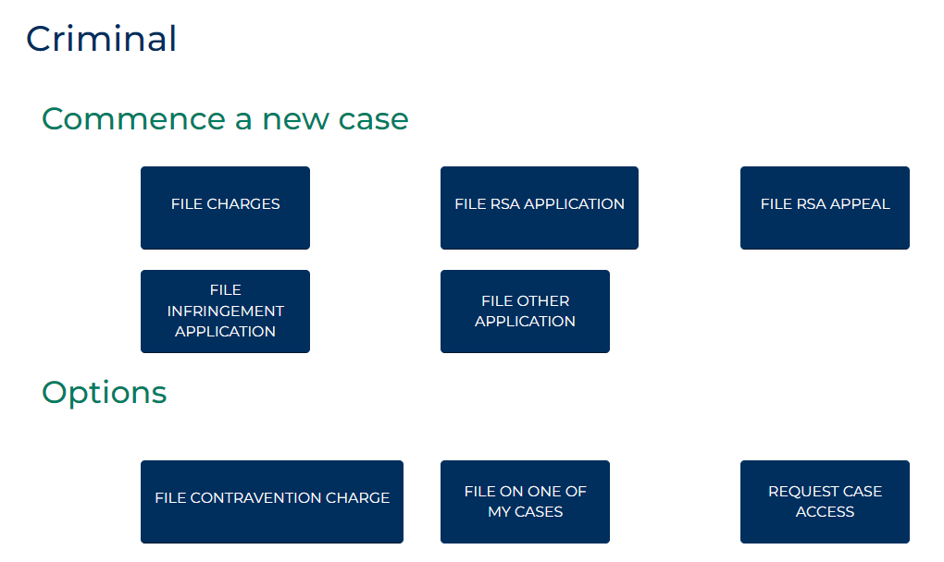

- Select: File Charges
Criminal Initiation Portal screen displays:
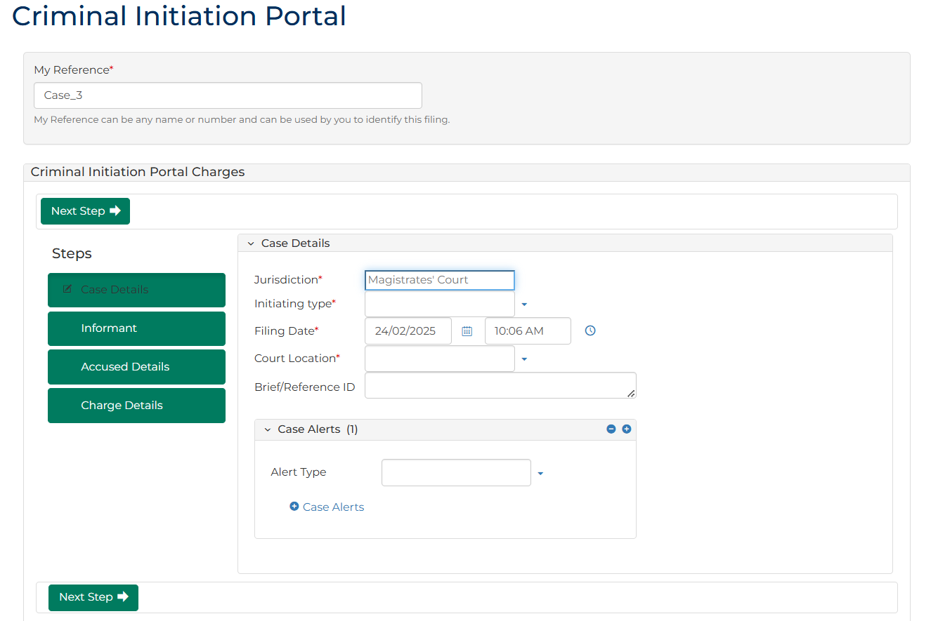
- To identify filing, type reference in My Reference field.

- Complete required panels and fields.
Panel: Case Details
Field: | Action:
Jurisdiction | -
Initiating Type | Select: Charge and Summons
Is the accused a person or an organisation? | Select relevant option.  Note:  Field only displays for Magistrates' Court of Victoria cases.
What would you like to do? | Select relevant option.
Filing Date | Change if required.
Court Location | Select location.
Brief/Reference ID | Type number if provided.

Panel: Case Alerts
Field: | Action:
Alert Type | Select if required.

Panel: Case Initiating Document
Field: | Action:
Case Initiating Document | -
- Click: Next Step
Informant screen displays:
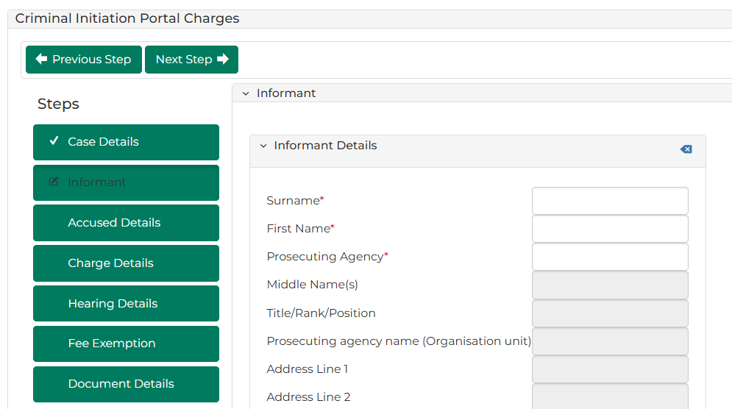

- Complete required panels and fields.
Panel: Informant
Field: | Action:
Surname | Type surname.  Select correct option from results.
Is there a legal representative? | Change if required.
- Click: Next Step
Accused Details screen displays:
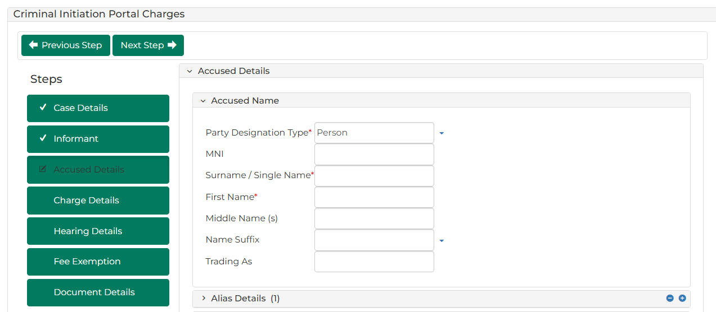

- Complete required panels and fields.
Panel: Accused Name
Field: | Action:
Party Designation Type | Change if required.  Note:  Different fields display if Organisation selected.
MNI/JAID | Type number if provided.
Surname / Single Name | Type name.
First Name | Type name.
Middle Name | Type name(s) if provided.
Name Suffix | Select relevant option if provided.
Trading As | Type name if provided.  Note:  Field only displays for Magistrates' Court of Victoria cases.

Panel: Alias Details
Field: | Action:
Party Designation Type | Select relevant option if provided.  Note:  Different fields display based on selection.
Title | Select relevant option.
Surname / Single Name | Type name.
First Name | Type name.
Middle Name (s) | Type name(s) if provided.
Name Suffix | Select relevant option if provided.

 | Note:  Panel does not display if Party Designation Type is Organisation

Panel: Address Details
Field: | Action:
Address Type | Select relevant option.  Note:  Different fields display if Unknown, Homeless or Overseas selected.
Physical Address | Type address.  Select correct option from results.  Note:  If address cannot be located, type address details into relevant fields.

Panel: Contact Details
Field: | Action:
Mobile Number | Type number if provided.
Home Number | Type number if provided.
Work Number | Type number if provided.
Fax Number | Type number if provided.
Email Address | Type address if provided.

Panel: Additional Details
Field: | Action:
Date Of Birth | Type date or click calendar icon to select date.
Gender | Select relevant option.
Identified term and/or pronouns | Type if provided.
Indigenous Status | Select relevant option.
Is an interpreter provided? | Select Yes or No  Note:  If Yes, complete additional fields.

Panel: Identification Details
Field: | Action:
Australian Business Number (ABN) | Type number if provided.
Corrections Reference Number | Type number if provided.

Panel: Driver’s Licence / Permit Details
Field: | Action:
Is it an international driver’s licence/permit? | Change if required.
Driver’s licence/permit state | Change if required.
Driver’s licence / permit number | Type number if provided.
Vehicle registration number | Type number if provided.
Vehicle registration state | Select relevant option if provided.
- Click: Next Step
Charge Details screen displays:
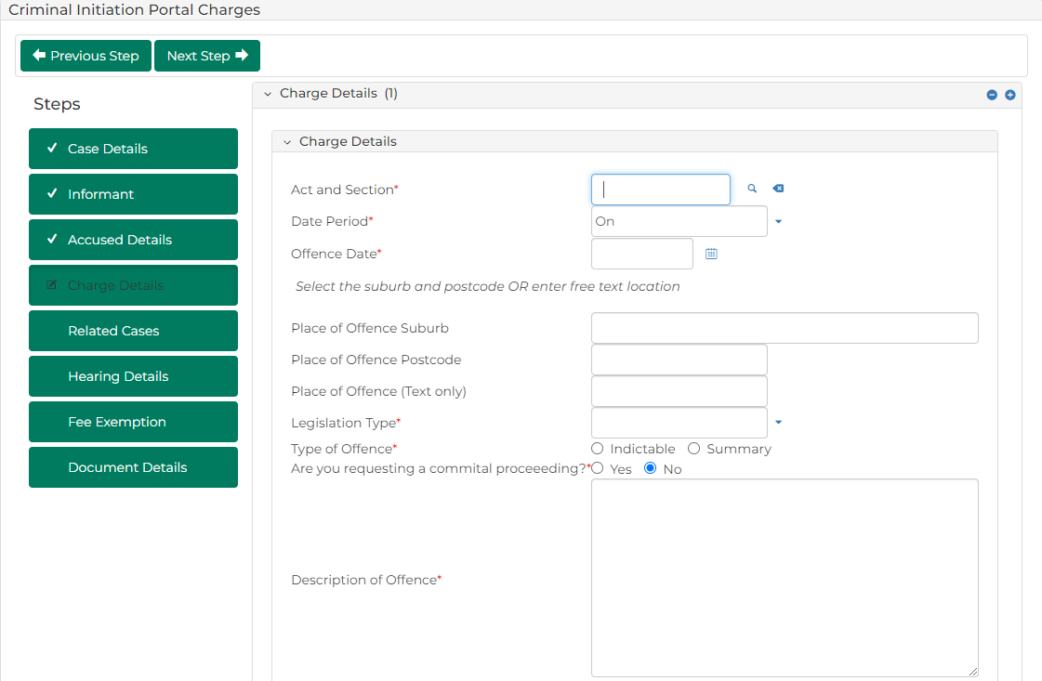
- Complete required panels and fields
Panel: Charge Details
Field: | Action:
Act and Section | Type offence code or keyword(s).  Select correct option from results.
Date Period | Change if required.  Note:  Offence To Date field displays if In between dates selected.
Offence Date | Type date or click calendar icon to select date.
Place of Offence Suburb | Type suburb.  Select correct option from results.  Note:  If offence took place at unknown location, type suburb in Place of Offence (Text only) field  Place of Offence Postcode field automatically populates when selection made
Place of Offence (Text only) | Type place of offence if relevant.
Legislation Type | Select relevant option.
Type of Offence | Select Indictable or Summary
Description of Offence | Type description.

Panel: Charge Details
Field: | Action:
Is this an infringement offence? | Change if required.  Note:  If Yes, complete additional fields.

Note:
To add further charges:
- Click: + Add Another Charge
- Complete additional panels
- Click: Next Step
Hearing Details screen displays:
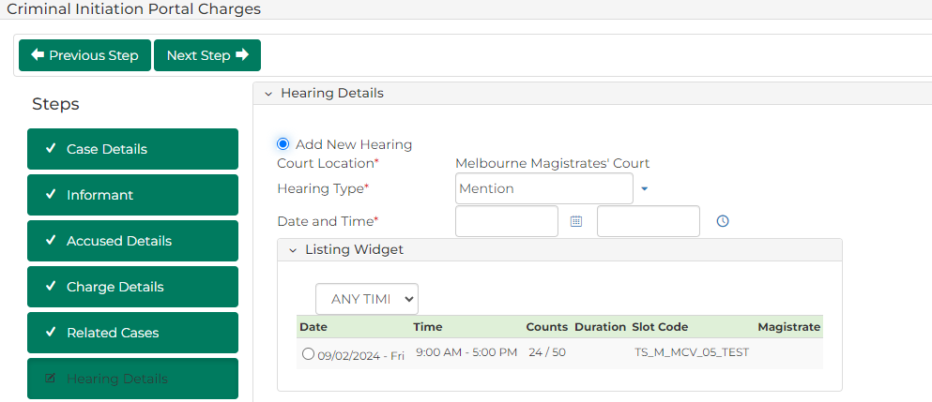

- Complete required panels and fields.
Panel: Hearing Details
Field: | Action:
Add New Hearing | -
Court Location | -
Hearing Type | Select relevant option.  Select relevant option from Listing Widget
Date and Time | Do not change.
Resources | Select resource(s).
Hearing Notes | Type if required.
- Click: Next Step
Fee Exemption screen displays:
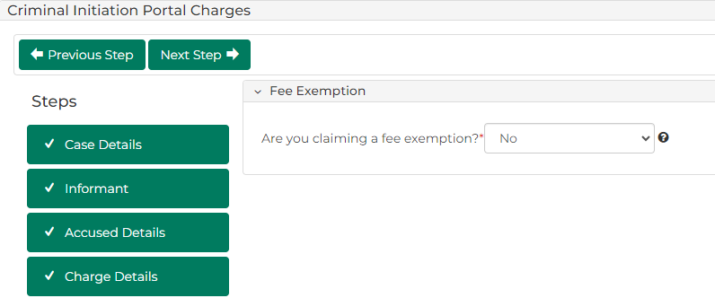

- Complete required panels and fields.
Panel: Fee Exemption
Field: | Action:
Are you claiming a fee exemption? | Change if required.  Note:  - If Yes, complete Exemption Reason field  - Certain organisations are automatically exempt from paying fees  - Fees not required for filings with Children's Court of Victoria
- Click: Next Step
Document Details screen displays:
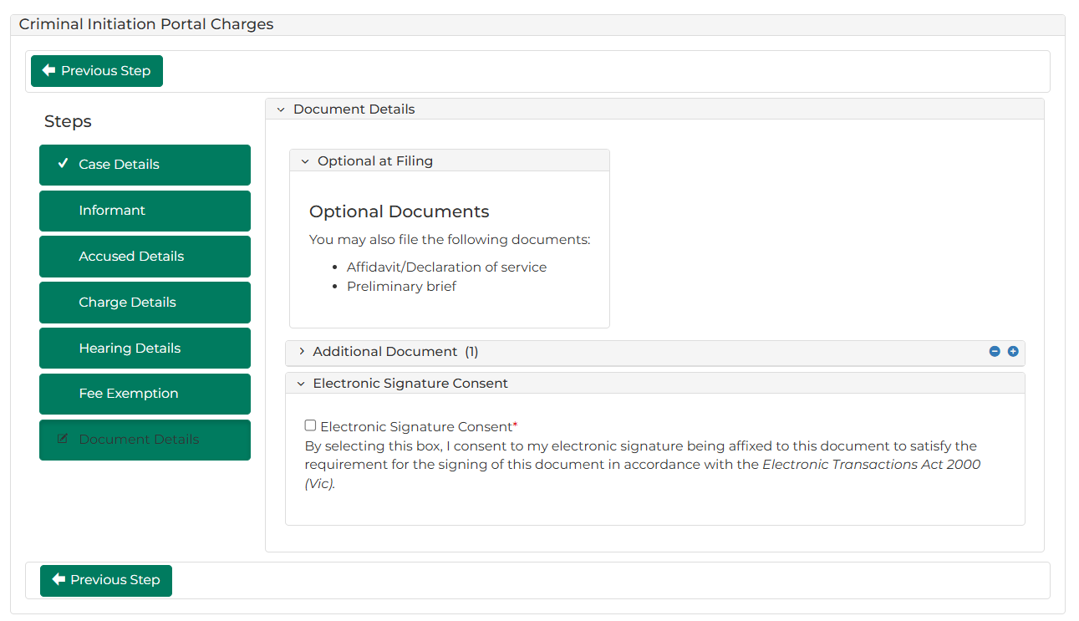

- Complete required panels and fields.
Panel: Additional Documents
Field: | Action:
Code / Name | Type name and select additional document(s).
Upload Documents | Select: Attach File  Click: Choose File and attach PDF document.
Electronic Signature Consent | Select checkbox.

Note:
To add another document, click: Add Another Document
- Is fee required?
If | Then
Yes | Click: Proceed  Resource:  See Quick Reference Guide: Make payment
No | Go to next step

- Click: Proceed
Confirmation of Filing screen displays:
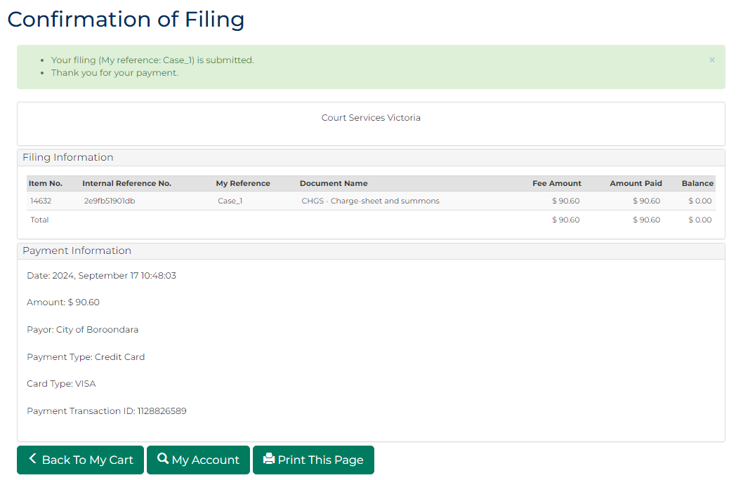
Note:
- If Court Issue selected:
  - document is placed in work queue for registry to review
  - and approved, document is accessed through My Account screen
- If Informant Issued and Not Served selected, document is generated and accessed through My Account screen
 | Resource:  See Quick Reference Guide: Download document

