
Portal Quick Reference Guide
MCV and ChCV | Criminal
File Case Direction Notice
Purpose
Quick Reference Guide shows how to File Case Direction Notice in CMS Portal.

- From CMS Portal Home page, click: File on One of My Cases
List of cases display:
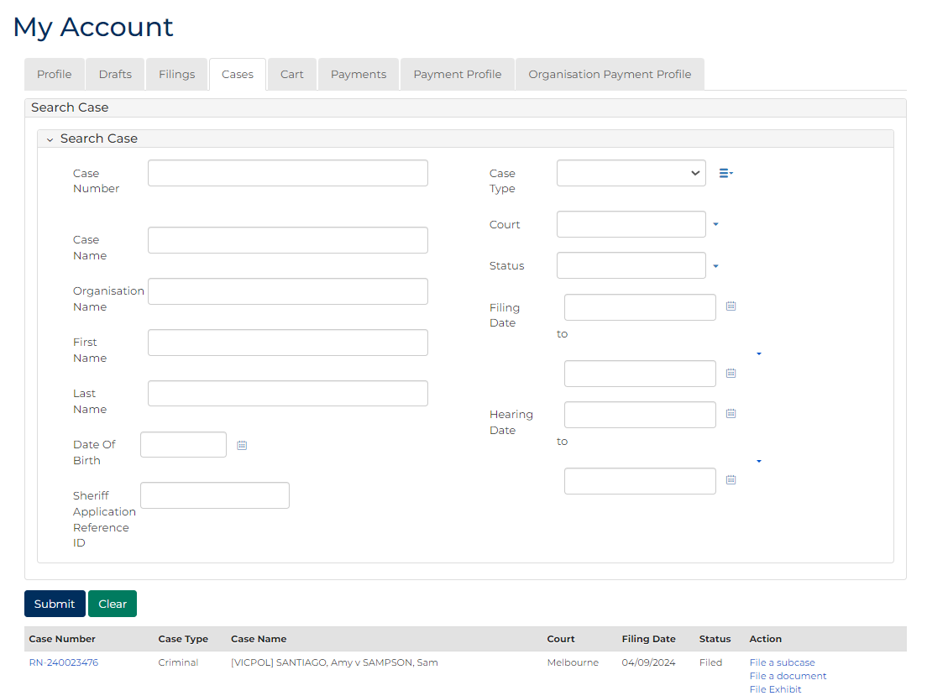
 | Note:  Only cases user previously filed on or requested access to display.
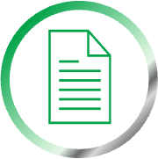 | Resources:  See Quick Reference Guides:  - View and action case  - Request case access

- For relevant case, click: File a Document
SubCases panel displays:
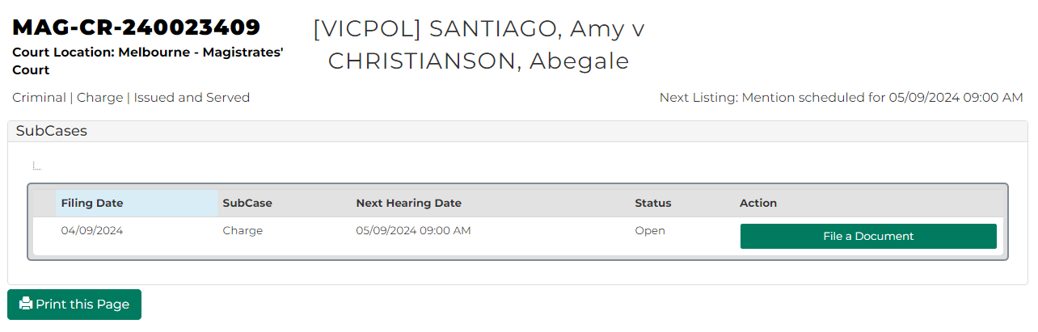
- For relevant subcase, click: File a Document
Add Document Submission CRIM screen displays:
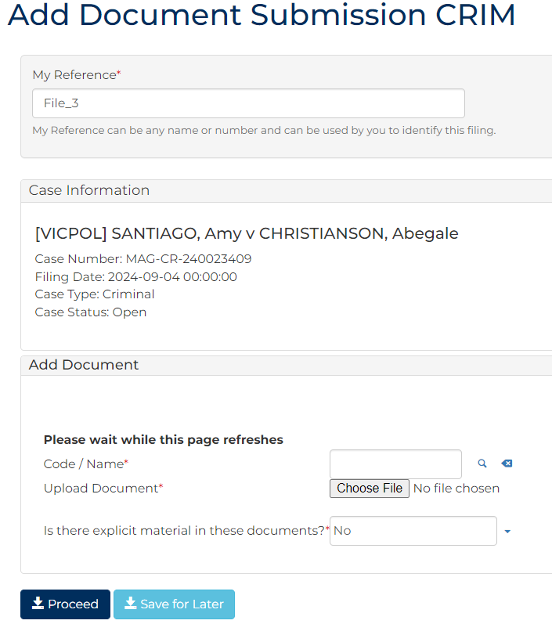
- To identify filing, type reference in My Reference field.
- Complete required panels and fields.
Panel: Add Document
Field: | Action:
Code/Name | Type direction and select Case direction notice
Upload Document | Click: Choose File and attach PDF document.
Is there explicit material in these documents? | Change if required.

Panel: Additional Information
Field: | Action:
Filed By | Select party.  Note:  To add another party, click: Filed By (Add a New Party)
Representation | Select filing party’s legal representation if applicable.  Note:  To add representation, click: Add Representation
Related Hearings | Select related hearing.

- Click: Proceed
Confirmation of Filing screen displays:
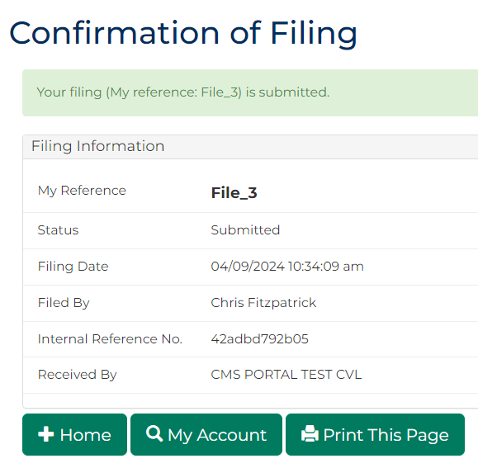
Note:
Document is accessed through My Account screen.

