
Portal Quick Reference Guide
ChCV | Criminal
File Breach Application
Purpose
Quick Reference Guide shows how to File Breach Application in CMS.
Prerequisite
Before start, ensure order that can be breached exists on case.

- From CMS Portal Home page, select: File on One of My Cases
List of cases display:
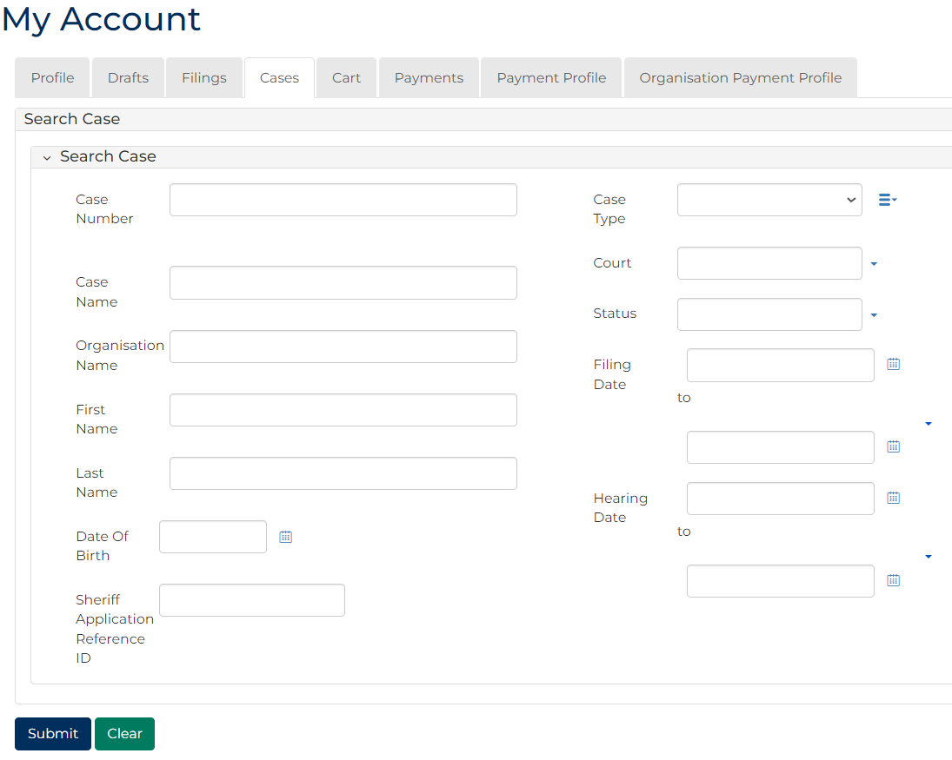
 | Note:  Only cases user previously filed on or requested access to, display.
 | Resources:  See Quick Reference Guides:  - View and action case  - Request case access
- For relevant case, click: File Breach - notice to appear
Add Breach Portal screen displays:
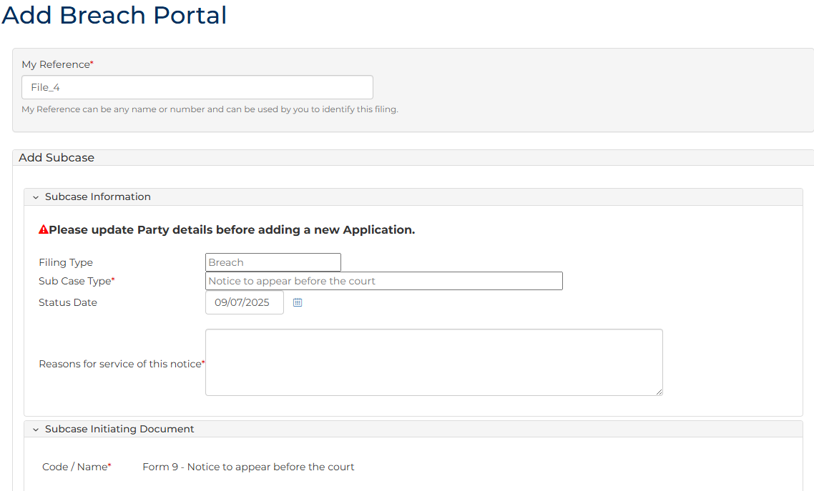
- To identify filing, type reference in My Reference field.
- Complete required panels and fields.
Panel: Subcase Information
Field: | Action:
Filing Type | -
Sub Case Type | -
Status Date | Do not change.
Reasons for service of this notice | Type reasons.

Panel: Subcase Initiating Document
Field: | Action:
Code / Name | -

Additional Panels
Field: | Action:
Filed By (Existing Party) | Select party.  Note:  To add new party, complete Filed By (Add a New Party) panel.
Filed Against | Select party.
Related Orders | Select relevant order.

Panel: Additional Documents
Field: | Action:
Code / Name | Type name and select additional document(s).
Upload Documents | Select: Attach File  Click: Choose File and attach PDF document.

Note:
To add another document, click: + Upload Document

- Click: Proceed
Confirmation of Filing screen displays:
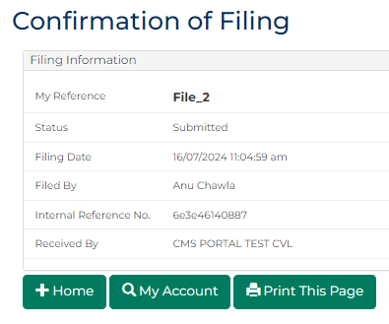
Note:
- Document is generated and placed in work queue for registry to review
- If approved, document is accessed through My Account screen
Resource:
See Quick Reference Guide: Download document

