
Portal Quick Reference Guide
MCV and ChCV | Criminal
File audio recording request
Purpose
Quick Reference Guide shows how to File audio recording request in CMS Portal.

- From CMS Portal Home page, click: File on One of My Cases
List of cases display:
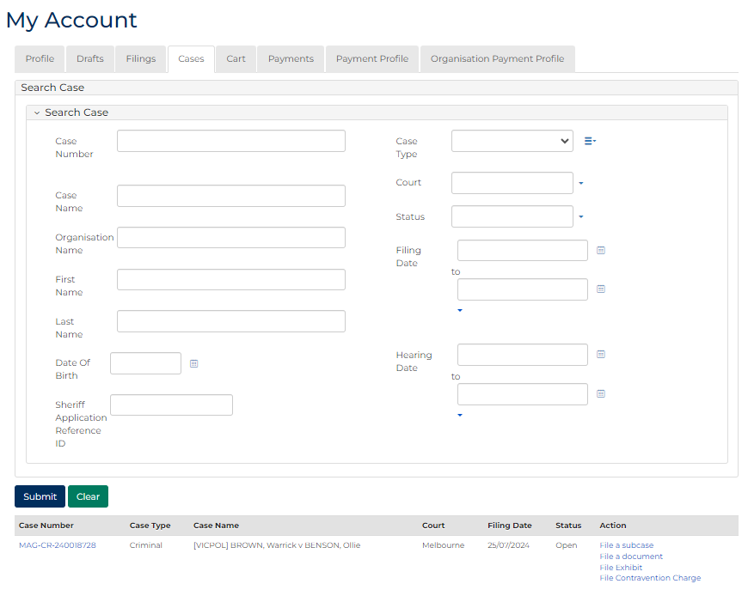
- For relevant case, click: File a Document
SubCases panel displays:
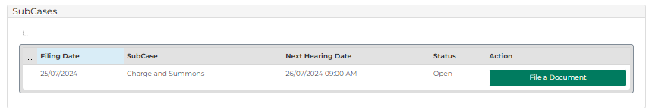

- For relevant subcase, click: File a Document
Add Filing screen displays:
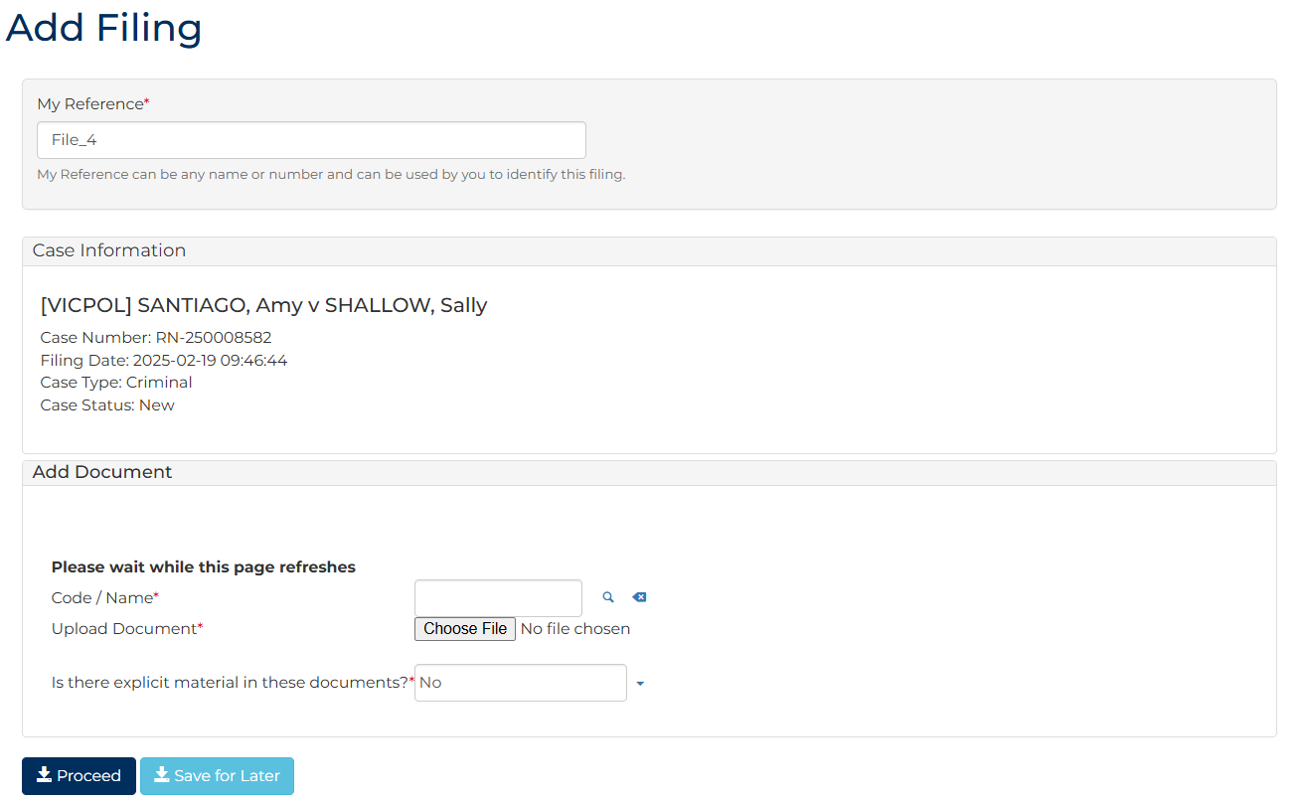
- To identify filing, type reference in My Reference field.

- Complete required panels and fields.
Panel: Add Document
Field: | Action:
Code/Name | Type Audio to select Request for copy of audio recording  Note:  Further fields display depending on document selected.
Enter Number of hearing days requested | Type number of days.
Upload Document | Click: Choose File and attach PDF document
Is there explicit material in these documents? | Change if required.

Additional Panels
Field: | Action:
Filed by | Select party.
Representation | Select filing party's legal representation if applicable.  Note:  To add representation, click: Add Representation
Are you applying to waive the fee? | Change if required.  Note:  If Yes, upload fee waiver application.
- Is fee required?
If | Then
Yes | Click: Proceed  Resource  See Quick Reference Guide: Make payment
No | Go to next step

- Click: Proceed
Confirmation of Filing screen displays:
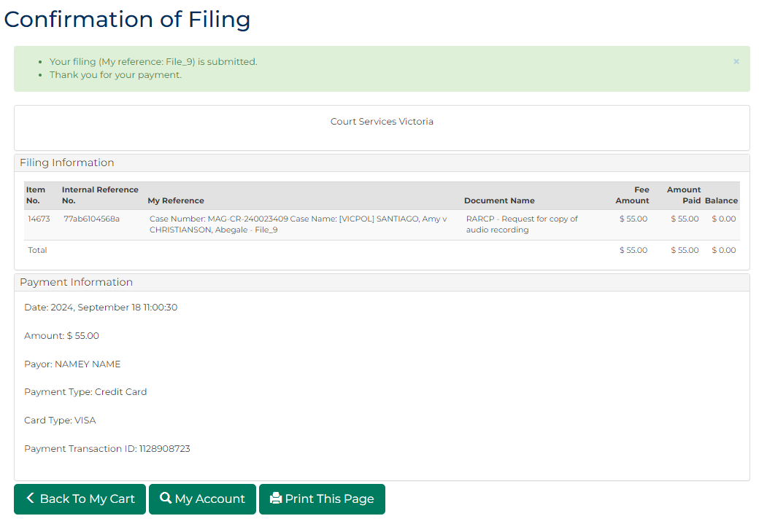
 | Note:  - Application is placed in work queue for registry to review  - Document status displays as Pending Review and is updated once work queue task is actioned

