
Portal Quick Reference Guide
MCV and ChCV | Criminal
File Application for Bail
Purpose
Quick Reference Guide shows how to File Application for Bail in CMS Portal.

- From CMS Portal Home page, click: File on One of My Cases
List of cases display:
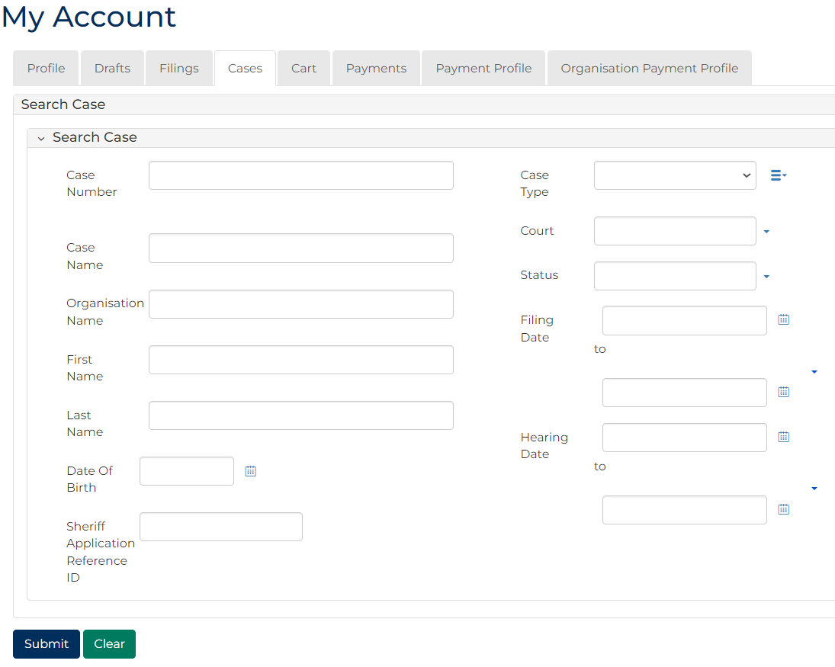
 | Note:  Only cases user previously filed on or requested access to, display.
 | Resources:  See Quick Reference Guides:  - View and action case  - Request case access
- For relevant case, click: File a Subcase
Add Criminal Subcase screen displays:
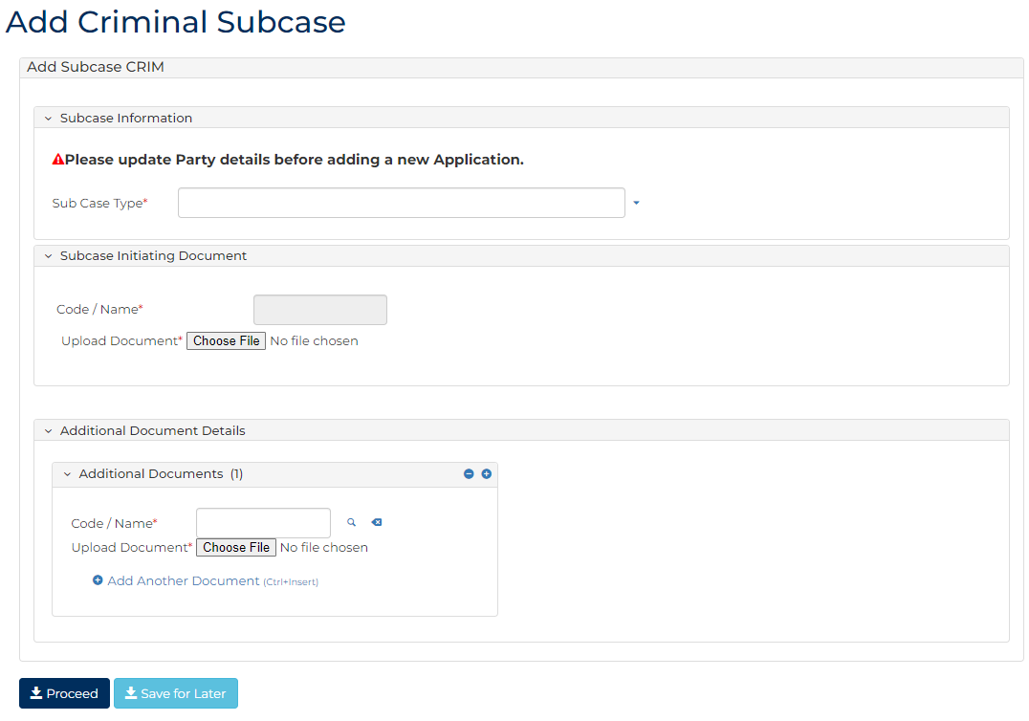
- Complete required panels and fields.
Panel: Subcase Information
Field: | Action:
Sub Case Type | Select: Application for bail
Address (Prison) | Select location.

Panel: Subcase Initiating Document
Field: | Action:
Code / Name | -

Additional Panels
Field: | Action:
Filed By (Existing Party) | Select party.  Note:  To add new party, complete Filed By (Add a New Party) panel.
Representation | Select filing party's legal representation if applicable.  Note:  To add representation, click: Add Representation
Filed Against | Select party.
Related Orders | Select relevant bail order.  Note:  Panel displays when Sub Case Type is Further application for bail

Panel: Add Hearing
Field: | Action:
Add New Hearing | Select: Add New Hearing  Select relevant option from Calendar Assistant
Event Location | -
Result Type | -
Event Status | -
Hearing Type | -
Date and Time | Do not change.
Duration | Do not change.
Resources | Select resources(s).
Interpreter | Select party requiring interpreter.
Duration | Type interpreter booking duration.
Interpreter Language | Select required interpreter language.
Is gender specific interpreter required? | Select Yes or No if required.  Note:  If Yes, select gender.

Panel: Add Document Details
Field: | Action:
Code / Name | Type name and select additional document(s).
Upload Document | Click: Choose file and attach PDF document.
Electronic Signature Consent | Select checkbox.

Note:
To add another document, click: + Add Another Document

- Click: Proceed
Confirmation of Filing screen displays:
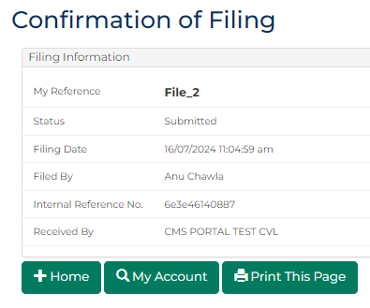
Note:
- Document is generated and placed in work queue for registry to review
- If approved, document is accessed through My Account screen
Resource:
See Quick Reference Guide: Download document

