
Portal Quick Reference Guide
MCV and ChCV | Criminal
File Appearance
Purpose
Quick Reference Guide shows how to File Appearance in CMS Portal.
Prerequisite
Before start, ensure user assigned LLF Admin, LLF User, VLA Admin or VLA User profile.

- From CMS Portal Home page, click: File on One of My Cases
List of cases display:
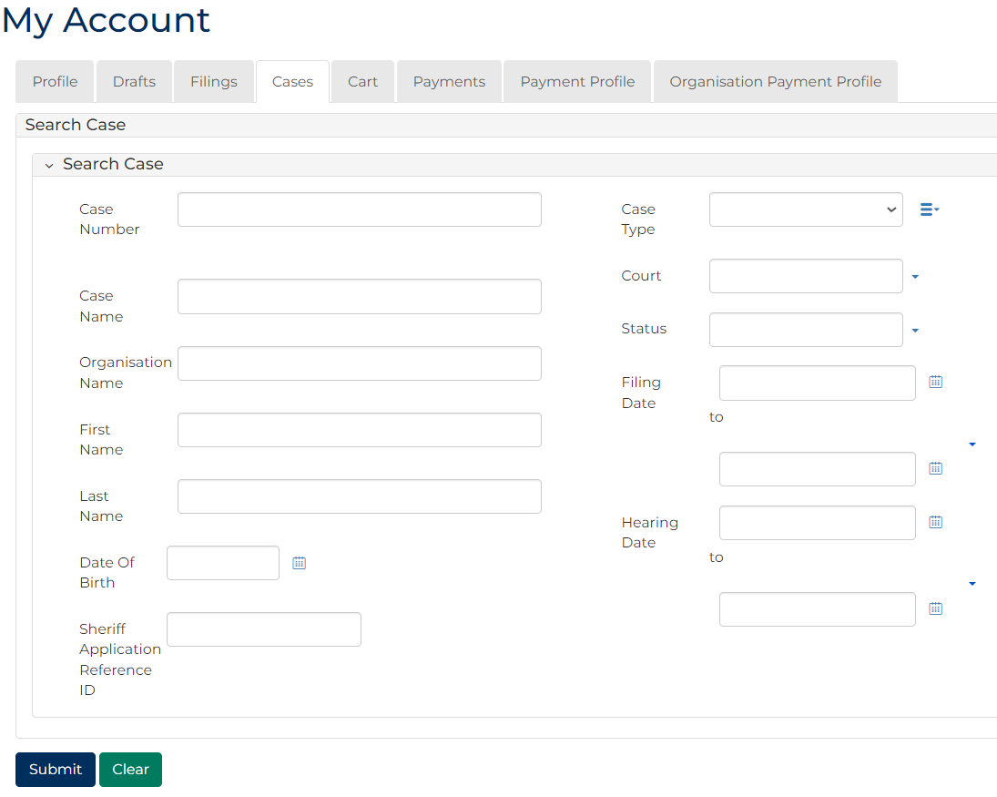
 | Note:  Only cases user previously filed on or requested access to, display.
 | Resources:  See Quick Reference Guides:  - View and action case  - Request case access
- For relevant case, click Case Number link.
Case Summary screen displays:
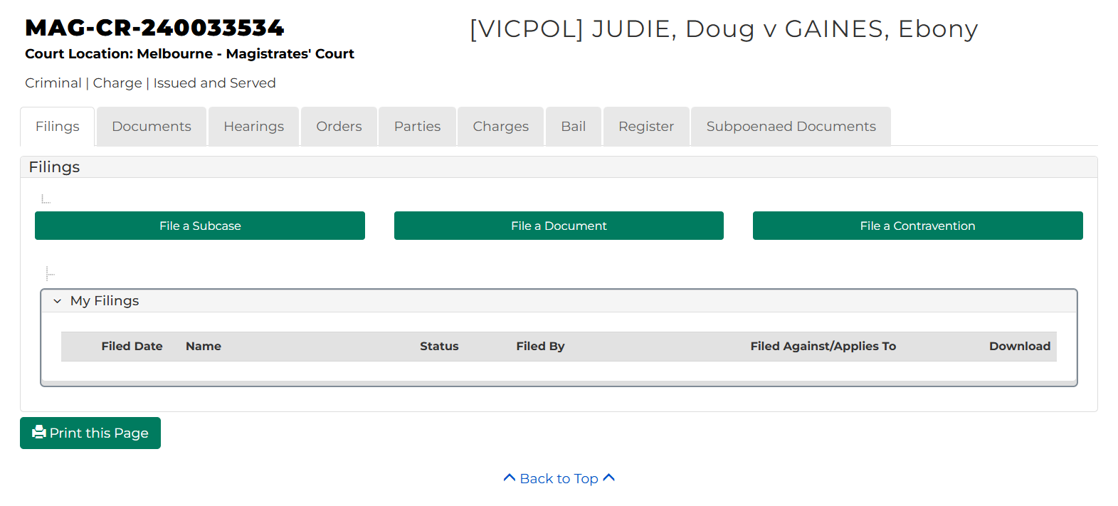
- Click: Hearings tab.
Hearings screen displays:
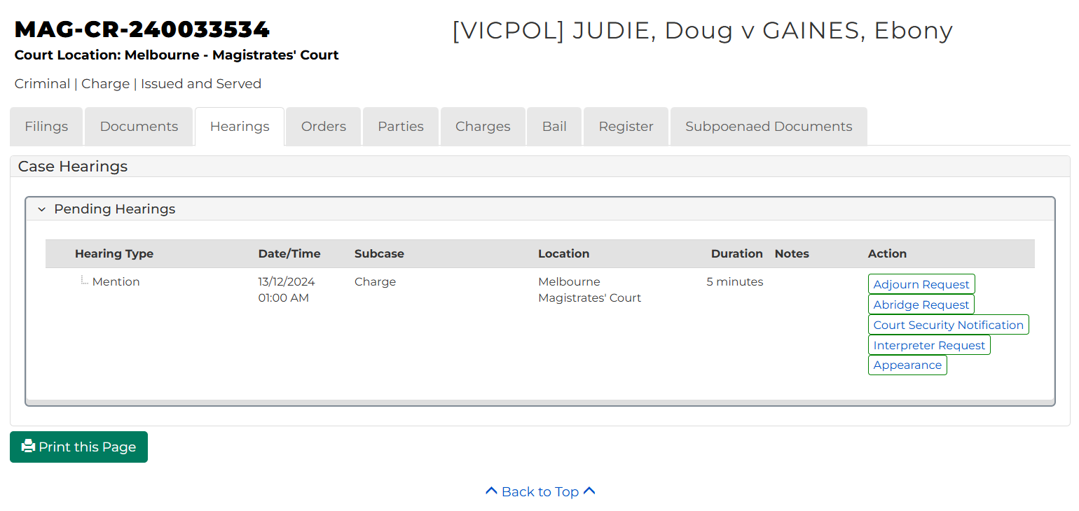

- For relevant hearing, click: Appearance
File Appearance screen displays:
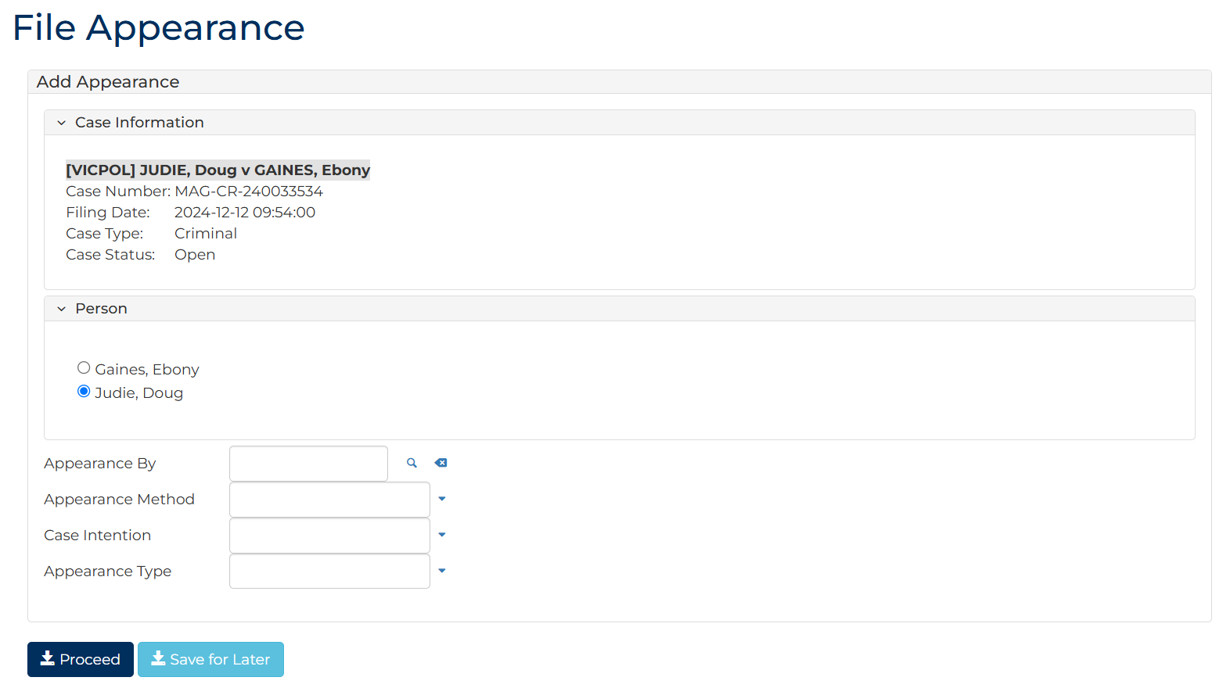

- Complete required panels and fields.
Panel: Hearing Information
Field: | Action:
Person | Select relevant party.
Appearance By | Either:  Type solicitor's or barrister's surname and select from results  Click magnifying glass to search for legal representative  Note:  - Populate field if appearance is by barrister or solicitor  - Directory Person field only lists solicitor's and barrister's registered with Legal Services Board
Appearance Method | Select relevant option.
Case Intention | Select relevant option.
Appearance Type | Select relevant option.

- Click: Proceed
Confirmation of Filing screen displays:
