
Portal Quick Reference Guide
MCV and ChCV | Criminal
File Adjournment Request
Purpose
Quick Reference Guide shows how to File Adjournment Request in CMS Portal.
Prerequisite
Before start, ensure hearing does not have a status of tentative, cancelled or heard.

- From CMS Portal Home page, click: File on One of My Cases
List of cases display:
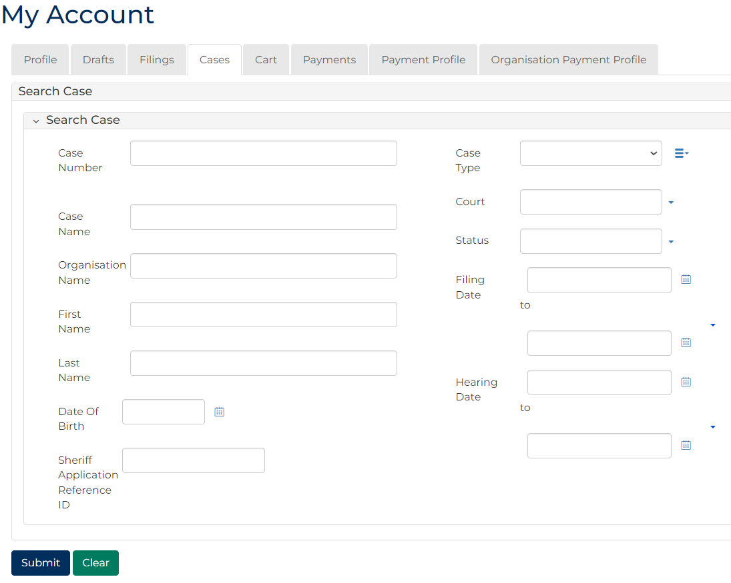
 | Note:  Only cases user previously filed on or requested access to, display.
 | Resources:  See Quick Reference Guides:  - View and action case  - Request case access
- For relevant case, click Case Number link.
Case Summary screen displays:
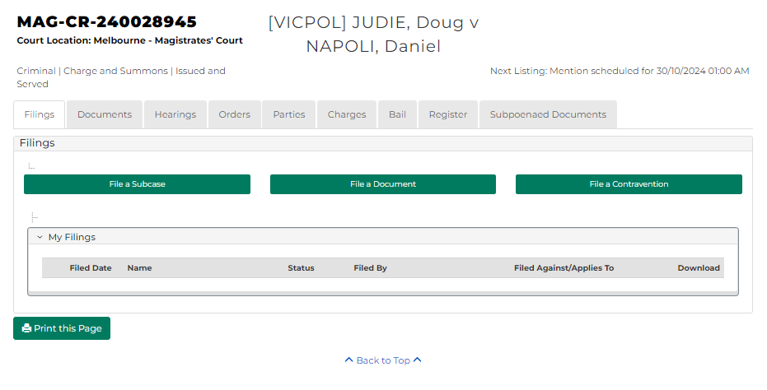
- Click: Hearings tab.
Hearings screen displays:
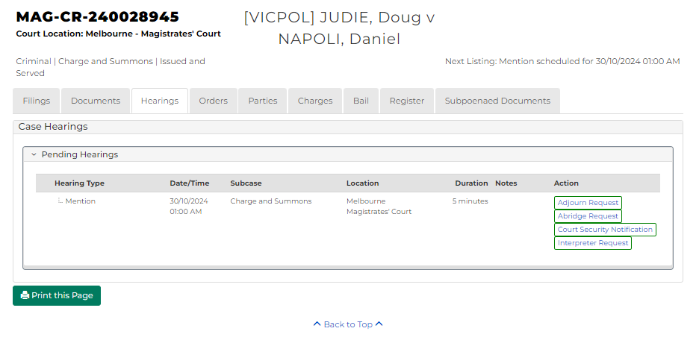

- For relevant hearing, click: Adjourn Request
Add Adjournment Request Portal screen displays:
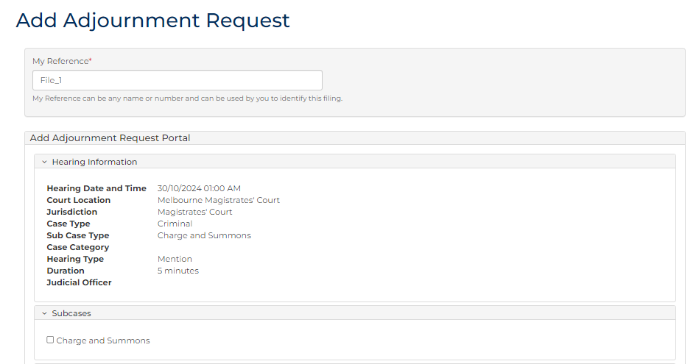
- Complete required panels and fields.
Panel: Hearing Information
Field: | Action:
Hearing Date and Time | -
Court Location | -
Jurisdiction | -
Case Type | -
Hearing Type | -
Duration | -
Judicial Officer | -

Panel: Subcases
Field: | Action:
Subcase | Select relevant subcase(s).

Panel: Requesting Parties
Field: | Action:
Name | Select relevant option.

Panel: Consent
Field: | Action:
Do all parties consent to the Adjournment request? | Select relevant option.  If No, complete additional field.

Panel: Proposed Hearing Details
Field: | Action:
Proposed hearing type | Select relevant option.
Event Location | Change if required.
Proposed date/time | Select relevant option from Calendar Assistant.
Proposed hearing duration | Change if required.
Resources | Select resources(s).
Interpreter | Select party requiring interpreter.
Duration | Type interpreter booking duration.
Interpreter Language | Select required interpreter language.
Is gender specific interpreter required? | Select Yes or No if required.  Note:  If Yes, select gender.

Panel: Adjournment Details
Field: | Action:
Adjournment Reason | Select relevant option.
Adjournment Notes | Type if required.

Panel: Document Details
Field: | Action:
Code / Name | Type name and select additional document(s).  - For MCV, only the following documents can be uploaded:  - Summary Case Conference  - Request for Contested Summary Hearing  - Supporting Document  - For ChCV, only the following documents can be uploaded:  - Request for Contest Mention  - Supporting Document
Upload Document | Click: Choose file and attach PDF document.

Note:
To add another document, click: + Add Another Document

- Click: Proceed
Confirmation of Filing screen displays:
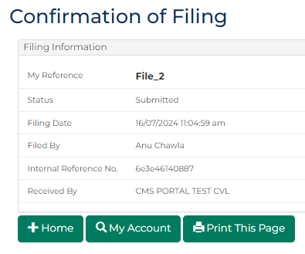
Note:
Request is placed in work queue for Registry to review.

