
Portal Quick Reference Guide
MCV and ChCV | Criminal
File Abridgement request
Purpose
Quick Reference Guide shows how to File Abridgement request in CMS Portal.

- From CMS Portal Home page, click: File on One of My Cases
List of cases display:
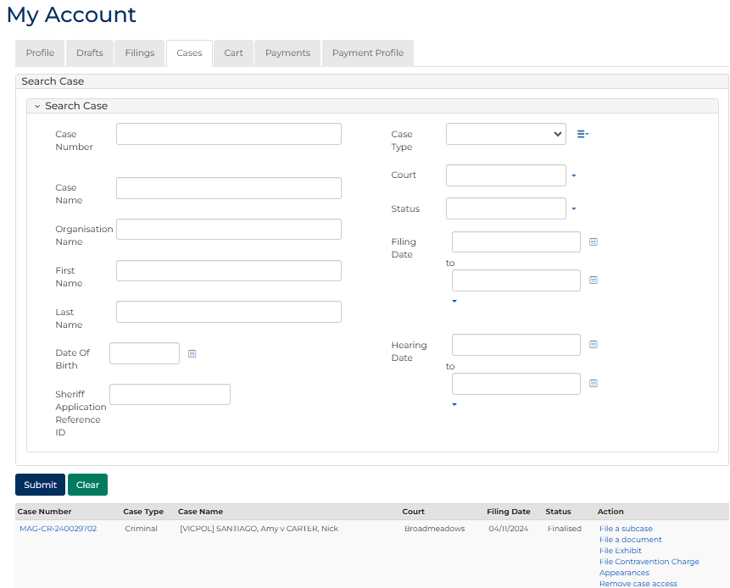
 | Note:  Only cases user previously filed on or requested access to, display.
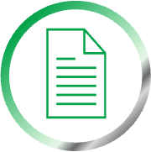 | Resources:  See Quick Reference Guides:  - View and action case  - Request case access

- For relevant case, click: Case Number link.
Case Summary screen displays:
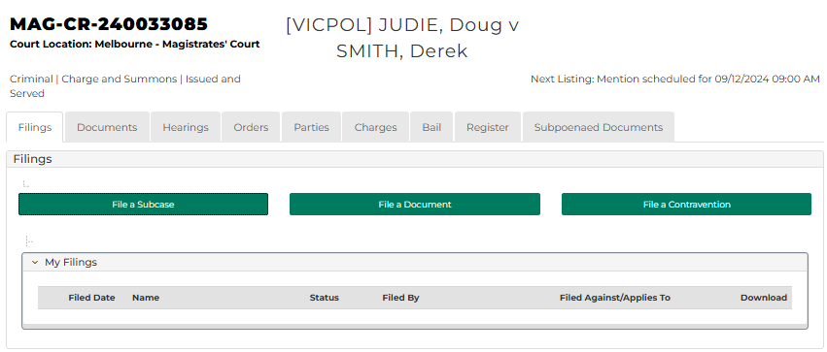
- Click: Hearings tab.
Hearings screen displays:
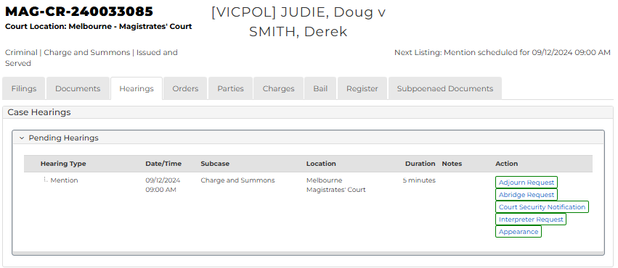

- For relevant hearing, click: Abridge Request
Add Abridgement Request panel screen displays.
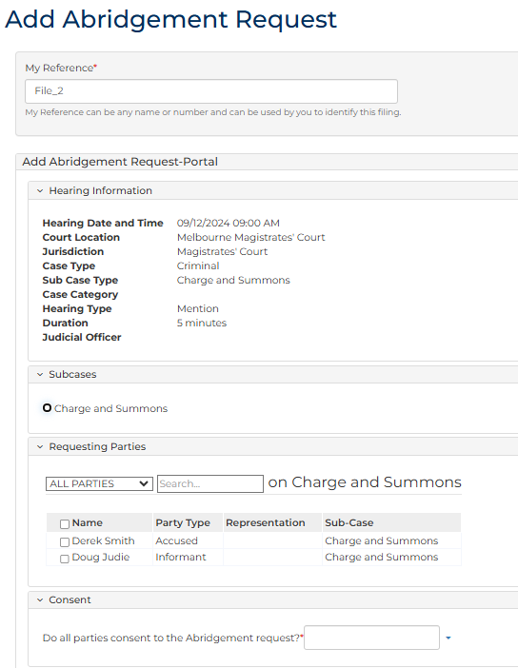
- To identify filing, type reference in My Reference field.

- Complete required panels and fields.
Panel: Hearing Information
Field: | Action:
Hearing Date and Time | -
Court Location | -
Jurisdiction | -
Case Type | -
Hearing Type | -
Duration | -
Judicial Officer | -

Panel: Subcases
Field: | Action:
Subcases | Select subcase(s).

Panel: Requesting Parties
Field: | Action:
Requesting Parties | Select relevant option.

Panel: Consent
Field: | Action:
Do all parties consent to the Abridgement request? | Select Yes or No  Note:  If No, complete additional field.

Additional Panels
Field: | Action:
Proposed hearing type | Select relevant option.
Event Location | Change if required.
Proposed date/time | Select relevant option from Calendar Assistant
Proposed hearing duration | Change if required.
Resources | Select resource(s).
Interpreter | Select party requiring interpreter.
Duration | Type interpreter booking duration.
Interpreter Language | Select required interpreter language.
Is gender specific interpreter required? | Select Yes or No if required.  Note:  If Yes, select gender.

Panel: Abridgement Details
Field: | Action:
Abridgement Reason | Select relevant option.
Abridgement Notes | Type if required.

Panel: Document Details
Field: | Action:
Document Details | Type name and select additional document(s).  Note:  - Mandatory document  - Case Abridgement Application (MCV)  - Case Abridgement Notice (ChCV)  - Optional document(s)  - Summary Case Conference Form (MCV only)  - Supporting document  - Letter of consent
Upload Document | Click: Choose file and attach PDF document.

Note:
To add another document, click: +Document Details

- Click: Proceed
Confirmation of Filing screen displays:
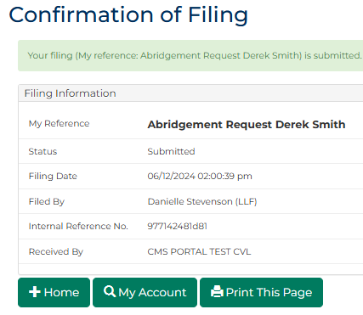
Note:
Request is placed in work queue for Registry to review.

