
POR
Portal Quick Reference Guide
MCV and ChCV | Criminal
Download document
Purpose
Quick Reference Guide shows how to Download document in CMS Portal.

- From CMS Portal Home page, click: File on One of My Cases
List of cases display:
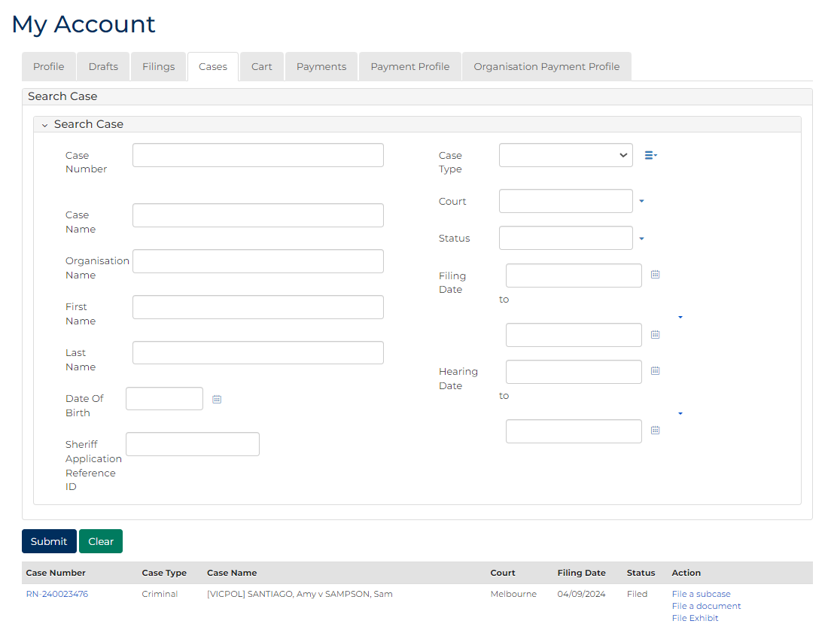
 | Note:  Only cases user previously filed on or requested access to, display.
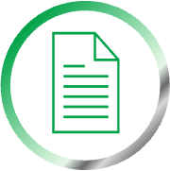 | Resources:  See Quick Reference Guides:  - View and action case  - Request case access

- Click Case Number link.
Filings screen displays:
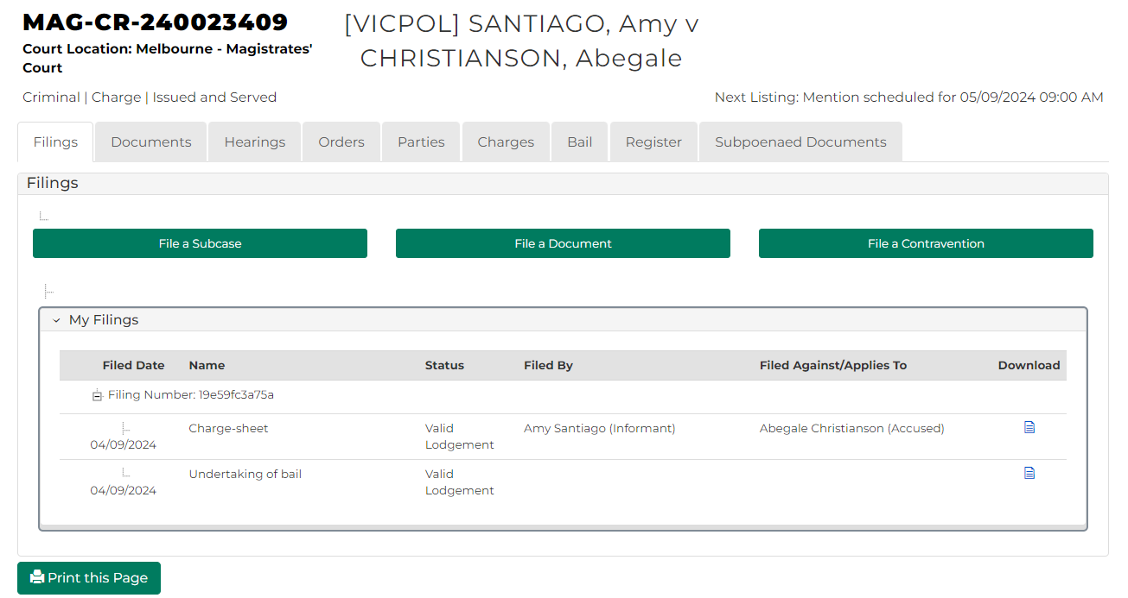
- In case header, click: Documents
Case Documents screen displays:
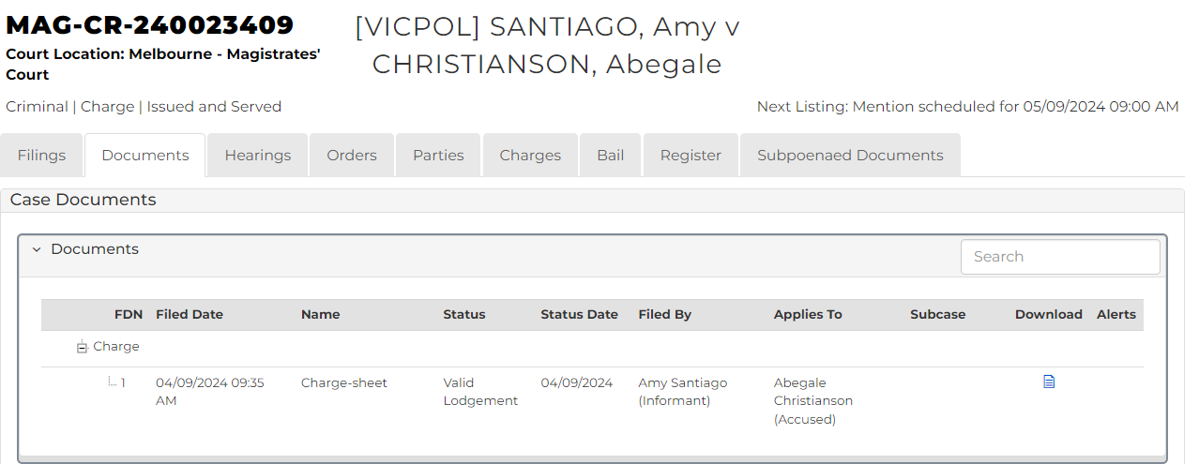
- For relevant document, click download icon.
Document downloads.

