
Portal Quick Reference Guide
MCV and ChCV | Criminal
Book First Mention - Electronic Mention Diary
Purpose
Quick Reference Guide shows how to Book First Mention - Electronic Mention Diary in CMS.
Prerequisite
Before start, ensure you are logged in as Victoria Police user.

- From CMS Portal Home page, select: Magistrates' Court of Victoria or Children's Court of Victoria
Select a Case Type screen displays:
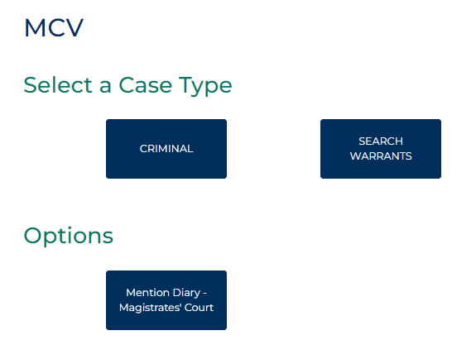
- Select: Mention Diary - Magistrates Court or Mention Diary - Children's Court
Criminal Initiation Portal EMD screen displays:
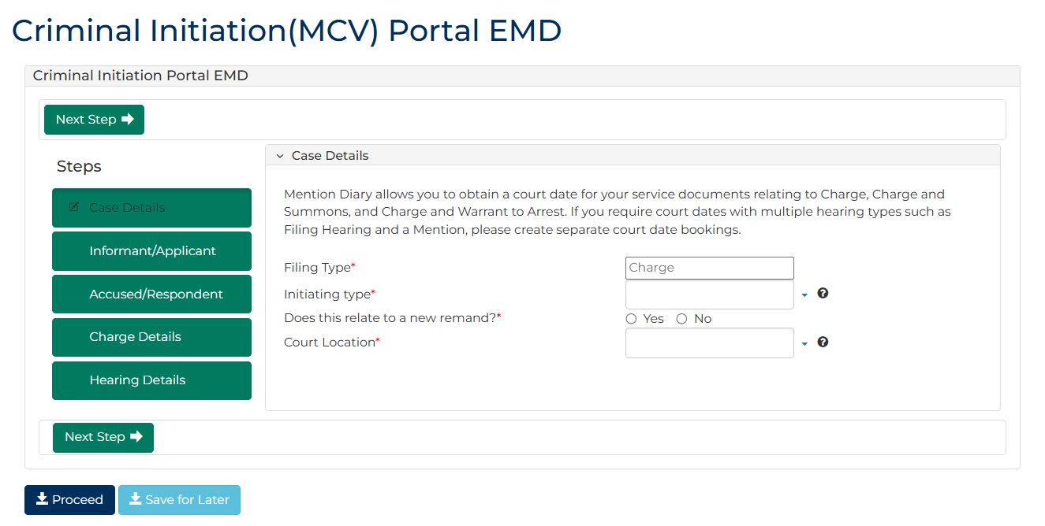

- Complete required panels and fields.
Panel: Case Details
Field: | Action:
Filing Type | -
Initiating Type | Select relevant option.  Note:  If Charge and Summons selected, Are charges related to traffic offences only? will display. Select relevant option.
Does this relate to a new remand? | Select: No  Note:  If Yes selected, error message displays. Remand paperwork must be manually filed with Court.
Court Location | Select location.

- Click: Next Step
Informant/Applicant screen displays:
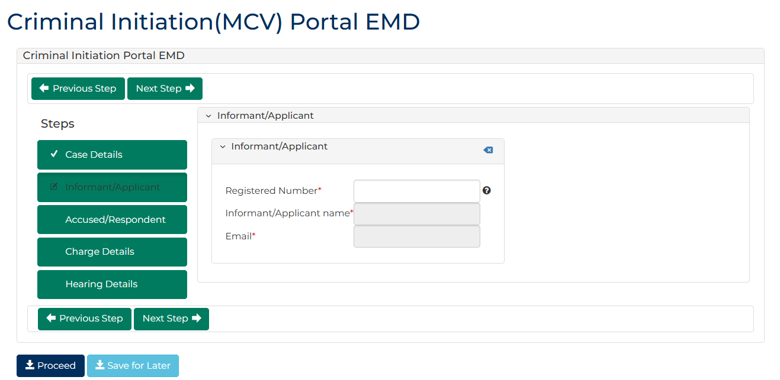
- Complete required panels and fields.
Panel: Informant/Applicant
Field: | Action:
Registered Number | Type number.  Select correct option from results.  Note:  If Registered Number unknown, type surname into field and select correct option from results.
Informant/Applicant name | -
Email | -

- Click: Next Step
Accused/Respondent Details screen displays:
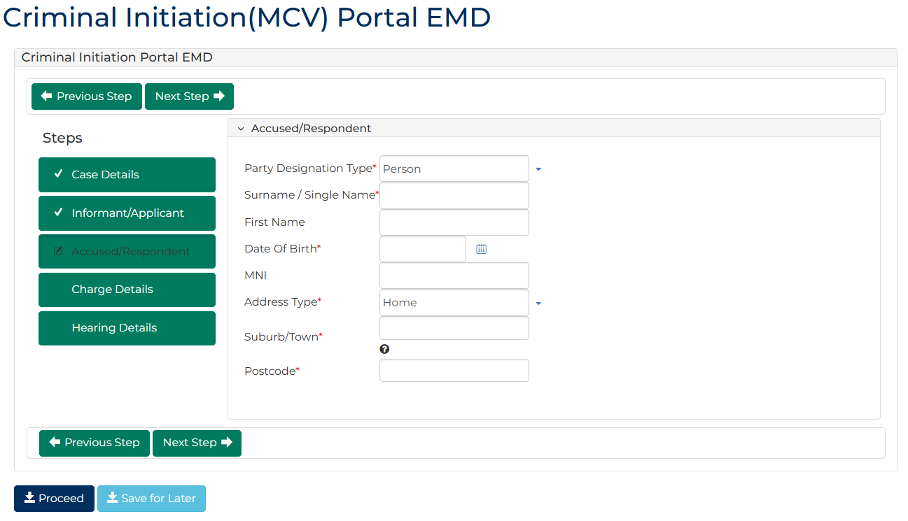

- Complete required panels and fields.
Panel: Accused/Respondent
Field: | Action:
Party Designation Type | Change if required.
Surname / Single Name | Type name.
First Name | Type name.
Date Of Birth | Type date or click calendar icon to select date.
MNI | Type number if provided.
Address Type | Select relevant option.  Note:  If No fixed place of abode selected, no further details to complete
Suburb/Town | Type Suburb.  Select correct option from results.
Postcode | -  Note:  Postcode field automatically populates when selection made.

- Click: Next Step
Charge Details screen displays:
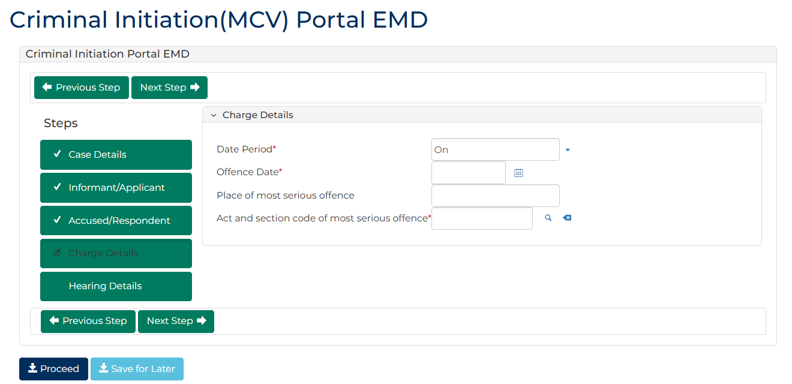

- Complete required panels and fields.
Panel: Charge Details
Field: | Action:
Date Period | Change if required.  Note:  Offence To Date field displays if In between dates selected.
Offence Date | Type date or click calendar icon to select date.
Place of most serious offence | Type suburb.  Select correct option from results.  Note:  Place of Offence Postcode field automatically populates when selection made.
Act and section code of most serious offence | Type offence code or keyword(s).  Select correct option from results.

- Click: Next Step
Hearing Details screen displays:
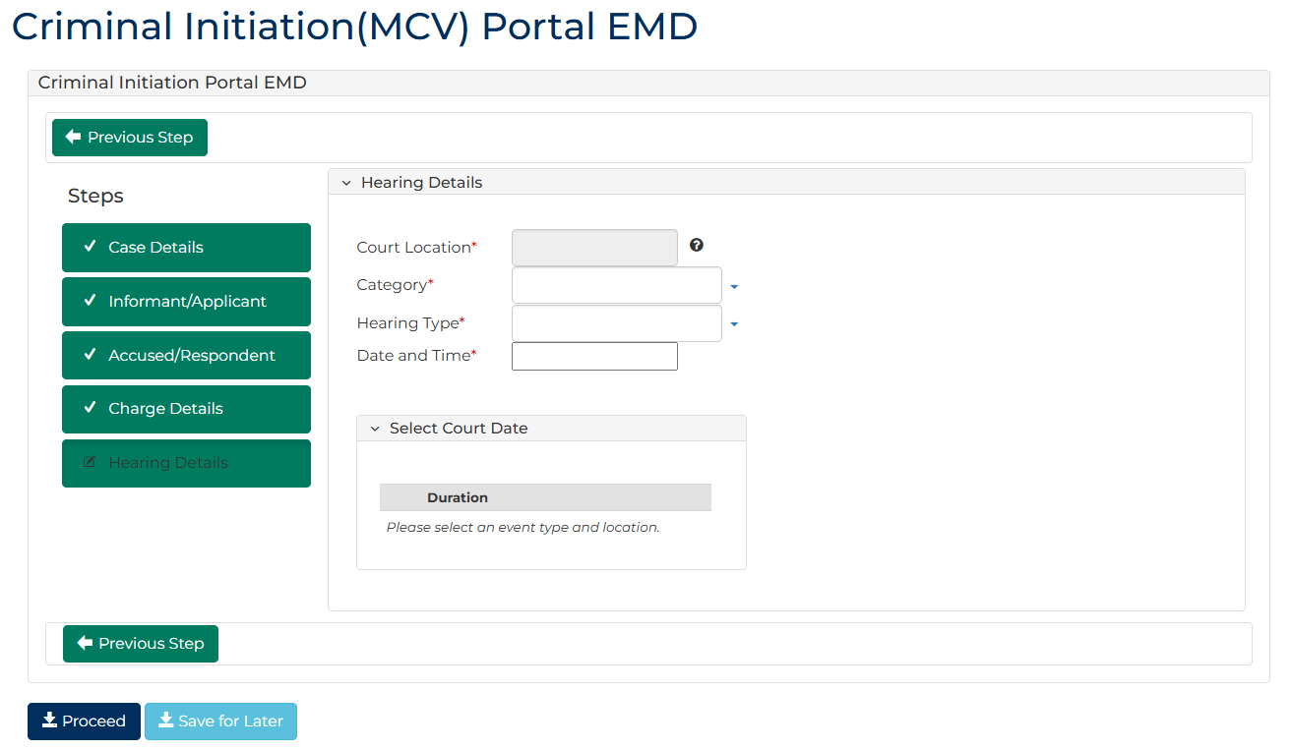
- Complete required panels and fields.
Panel: Hearing Details
Field: | Action:
Court Location | -
Hearing Type | Select relevant option.
Event Category | Select relevant option.
Date and Time | Select relevant option from Listing Widget

- Click: Proceed
Confirmation of Filing screen displays:
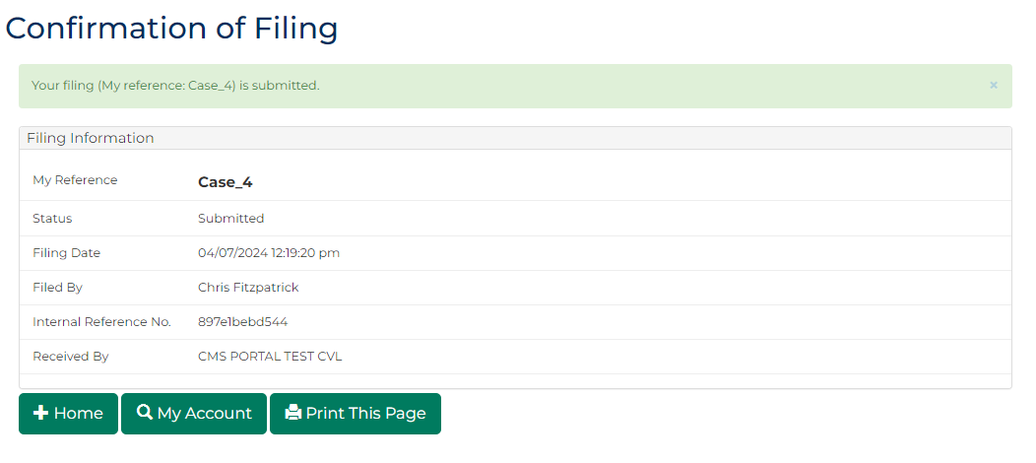
 | Note:  - Record Number (RN-250012356) is created within CMS  - Record Number can be accessed through My Account screen  - Record the case record numeric digits only to be recorded in LEAP for future interfacing between LEAP and CMS

