View and action case

Portal Quick Reference Guide

|  |
| --- |
| Purpose |
| Quick Reference Guide shows how to: View and action case in CMS Portal |

|  |  |
| --- | --- |
|  | Note:  This Quick Reference Guide outlines steps required to view and action a case that organisation already has access to. |

1. Log in to Portal.

Home screen displays:

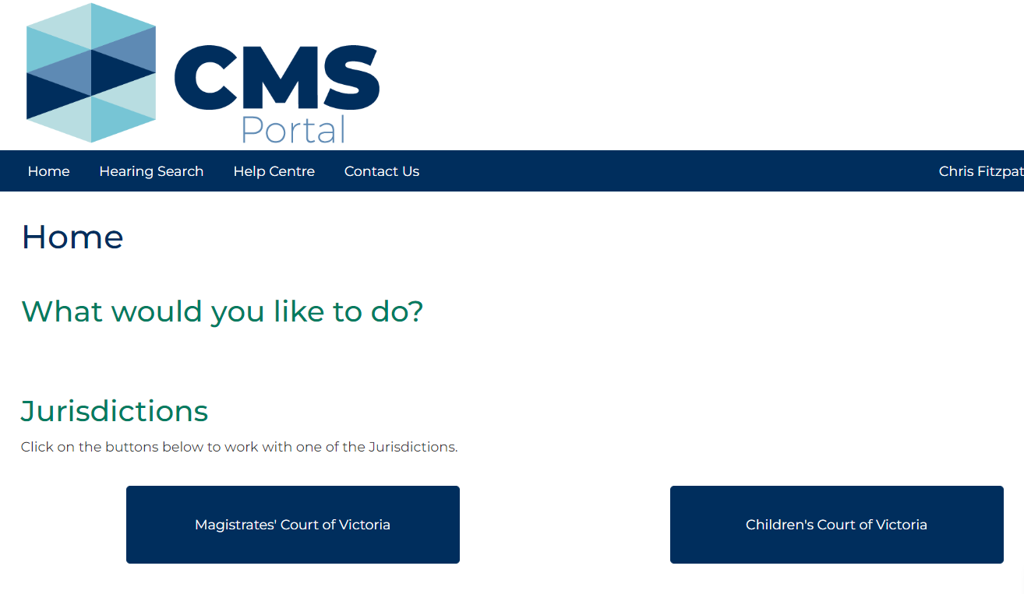

1. Click: My Account

My Account screen displays:

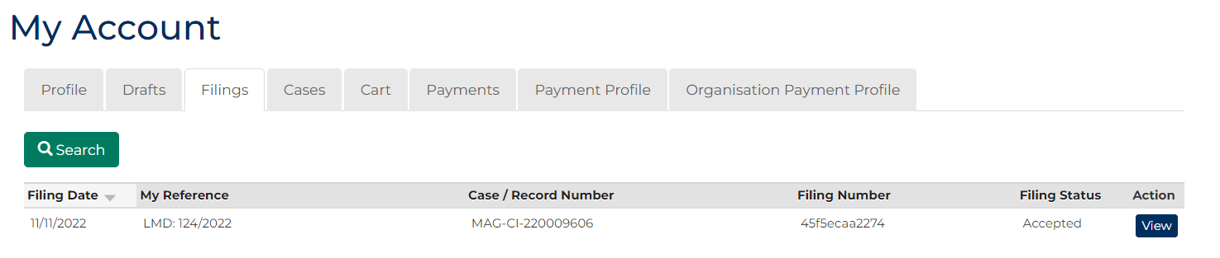

1. Click: Cases tab.

Search Case screen displays:

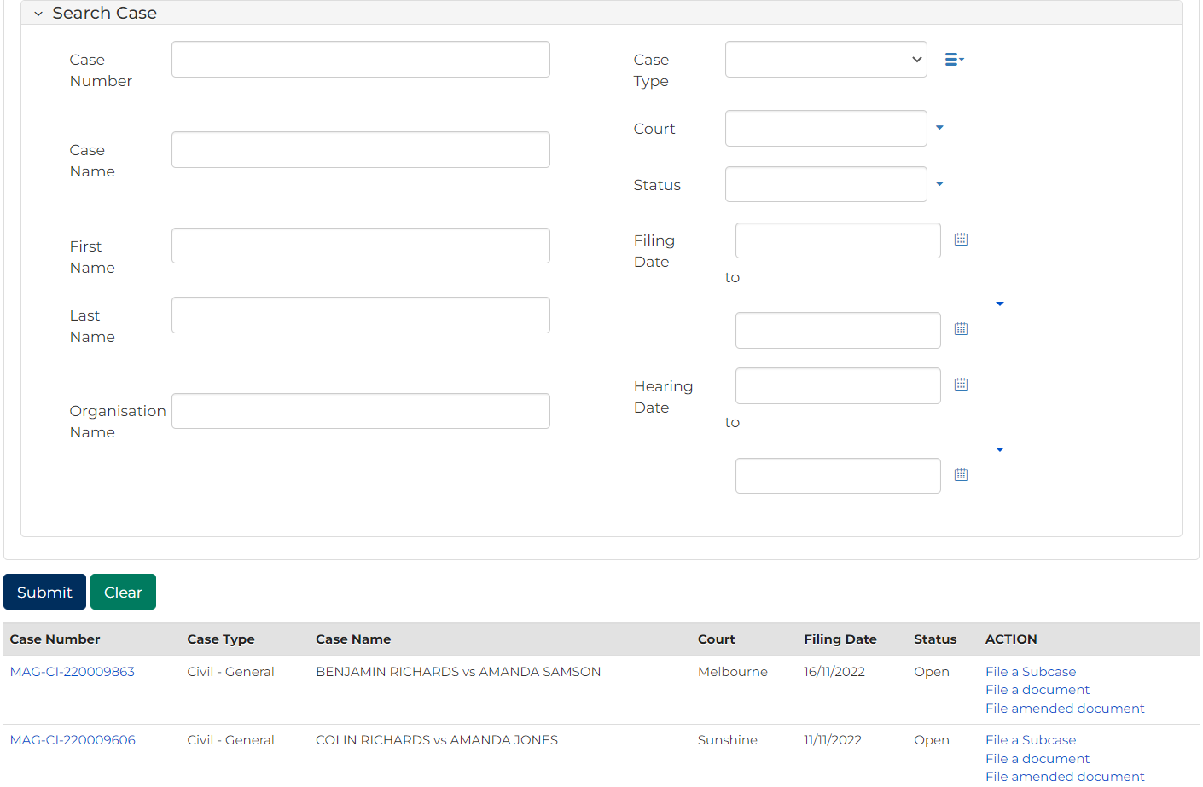

|  |  |
| --- | --- |
|  | Note:  List of cases that have permitted access displays at bottom of screen. If relevant case is visible in list, click **Case Number** to access or a link in **Actions** column to file on case  This page enables to search by numerous filters  If viewing is denied, requesting access to case is required |

|  |  |
| --- | --- |
|  | Resource:  See Quick Reference Guide: Request access to a case |

1. Complete required panels and fields.

| Panel: Case Details | |
| --- | --- |
| Field: | Action: |
| Case Number | Type full or partial Case Number. |
| Case Name | Type full or partial Case Name. |
| First Name | Type First Name of a party in case. |
| Last Name | Type Last Name of a party in case. |
| Organisation Name | Type Organisation Name. |
| Case Type | Select relevant option. |
| Court | Select relevant option. |
| Status | Select relevant option. |
| Filing Date | Select date (or range of dates) of filing. |
| Hearing Date | Select date (or range of dates) of hearing. |

1. Click: Submit

**Results** panel displays cases matching search criteria:

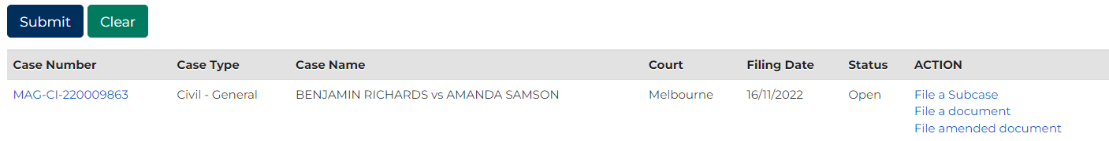

|  |  |
| --- | --- |
|  | **Notes:**  If relevant case does not display in list of results, adjust search criteria and click: **Submit**  To reset all fields, click: **Clear** |

1. What action is required?

|  |  |
| --- | --- |
| If | Then |
| Access case details | Click Case Number link |
| File on case | In Action column, click link for relevant filing type  Resource:  See Quick Reference Guide: File document on existing case |