Navigate My Account screen

Portal Quick Reference Guide

|  |
| --- |
| Purpose |
| Quick Reference Guide shows how to: Navigate My Account screen in CMS Portal |

|  |  |
| --- | --- |
|  | Note:  Quick Reference Guide Includes instructions on how to navigate to:  My Account screen  Filings tab to view and download documents  Profile tab to make changes to user profile  Payments tab to view payments  Cart tab to view/action undelivered documents (if applicable) |

1. Log in to Portal.

Home screen displays:

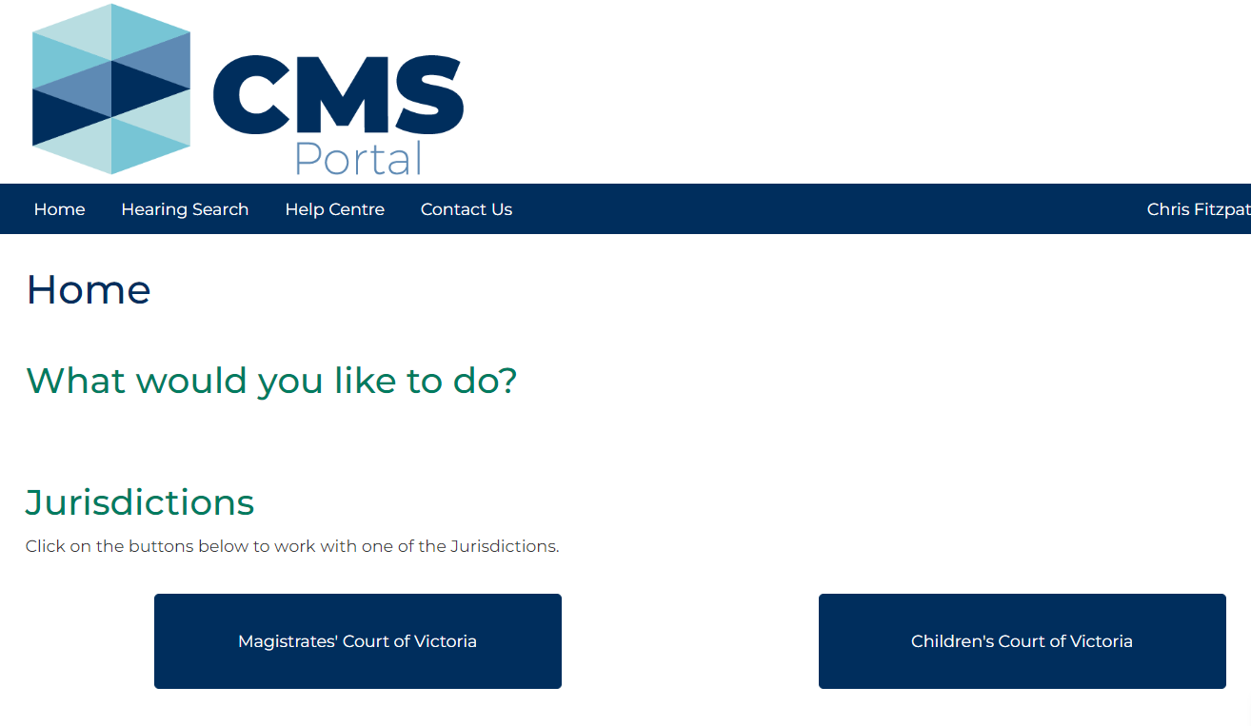

1. Click: My Account

My Account page displays My Filings tab:

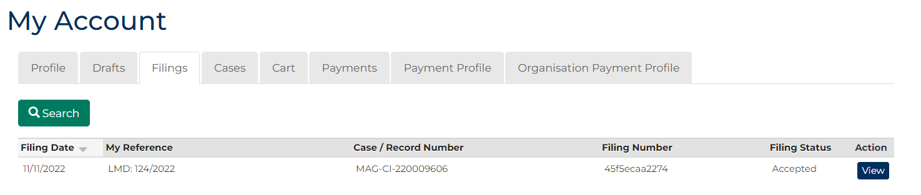

1. In Action column for relevant case. click: View

Case Summary screen displays:

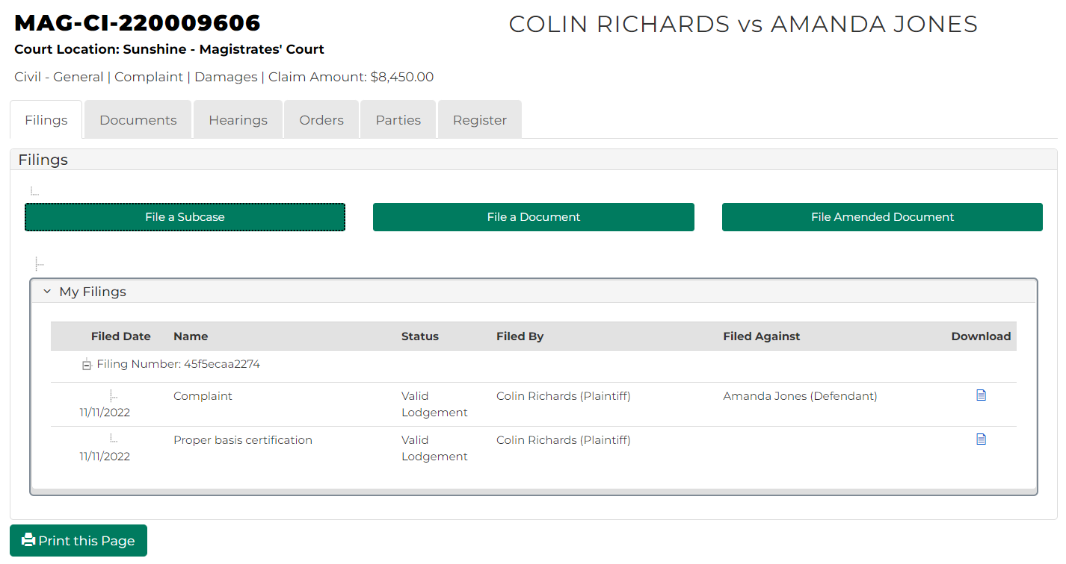

1. To download document, click: Download icon.

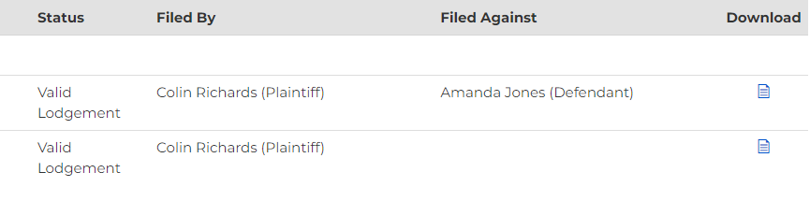

1. Click: Profile

Profile screen displays:

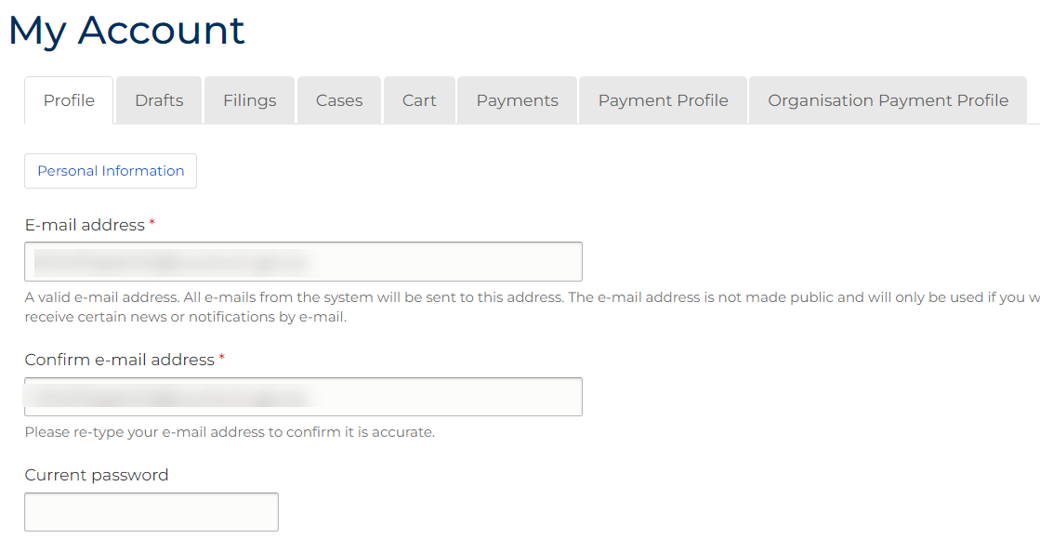

|  |  |
| --- | --- |
|  | Note:  In this tab, information can be added or changed such as:  Personal Information  Email address  Profile Password |

1. Click: Drafts tab.

Drafts screen displays:

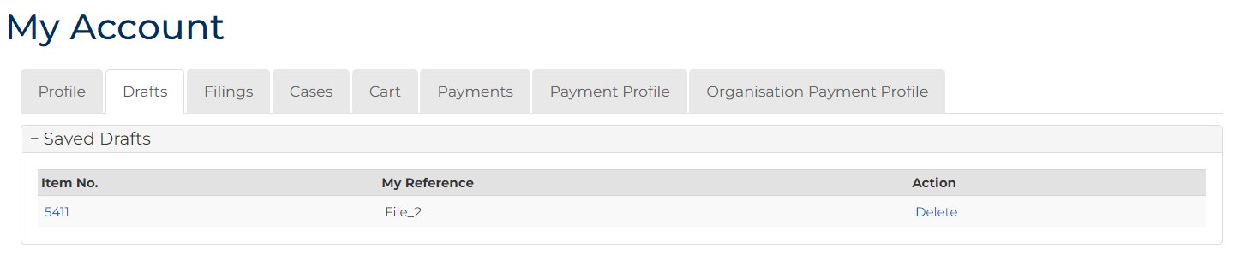

|  |  |
| --- | --- |
|  | Note:  Indicates any saved filings that have NOT been submitted. |

1. Click: Cases tab

Search Case screen displays:

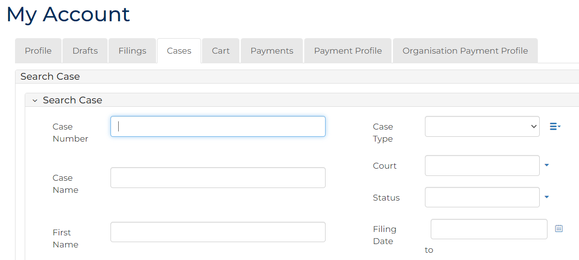

|  |  |
| --- | --- |
|  | Note:  List of cases that have permitted access displays at bottom of screen. If relevant case is visible in this list, click Case Number to access or link in Actions column to file on case.  This page enables to search by numerous filters. |

1. To view undelivered documents, click: Cart tab.

Cart screen displays:

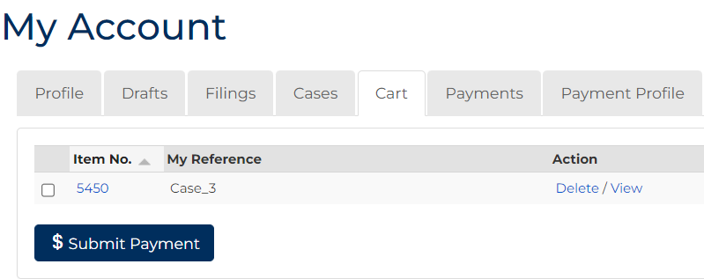

|  |  |
| --- | --- |
|  | Note:  To delete or view documents, check box next to Item No. |

1. To submit payment of document/s, tick box next to Item No., click: $ Submit Payment

Process Payment screen displays:

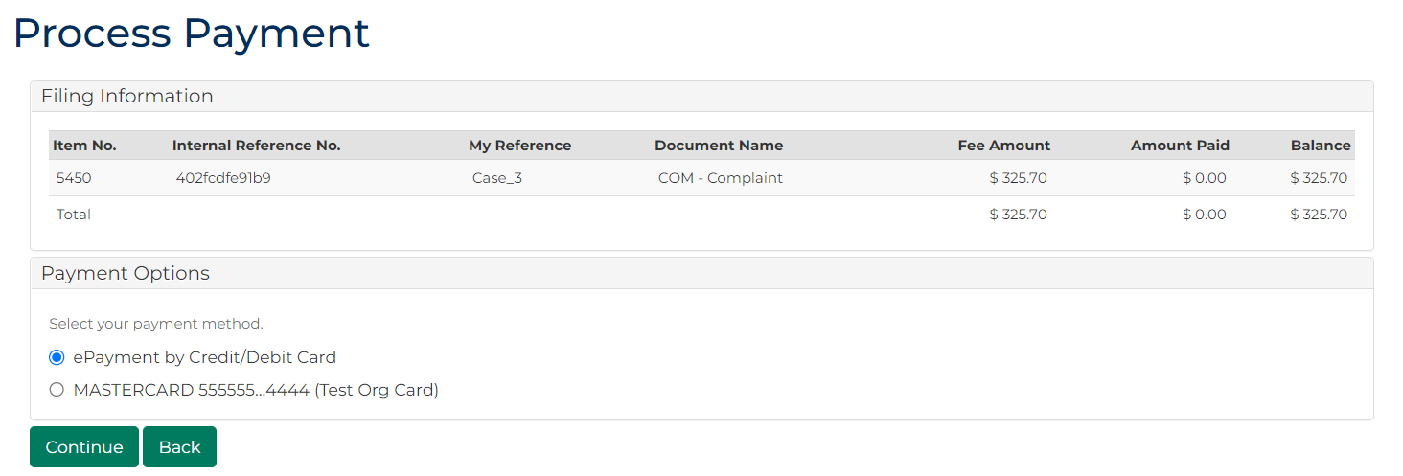

1. To view payment information, click: Payments tab.

Payments screen displays:

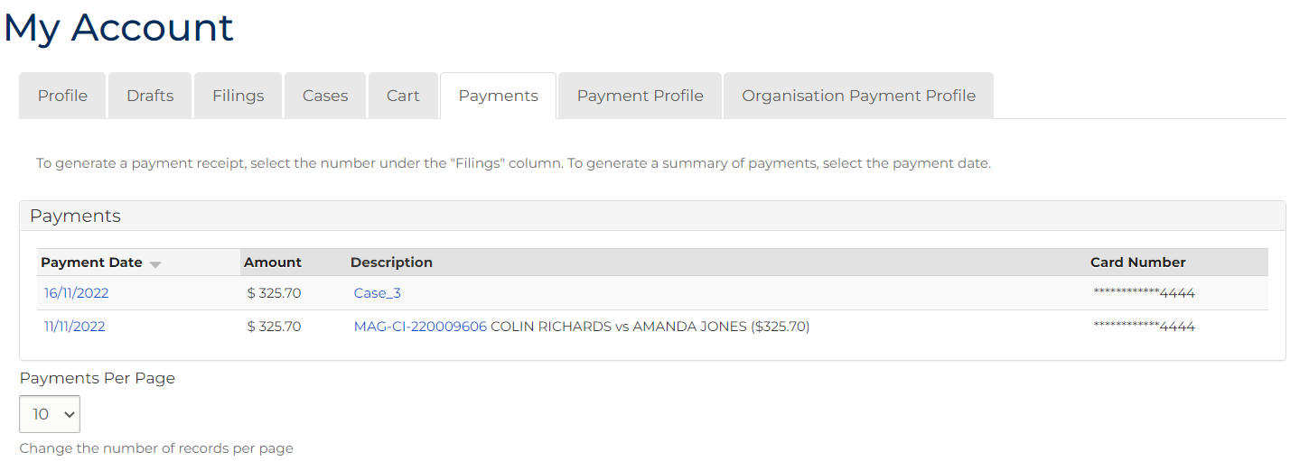

1. Click: Payment Profile tab.

Payment Profile screen displays:

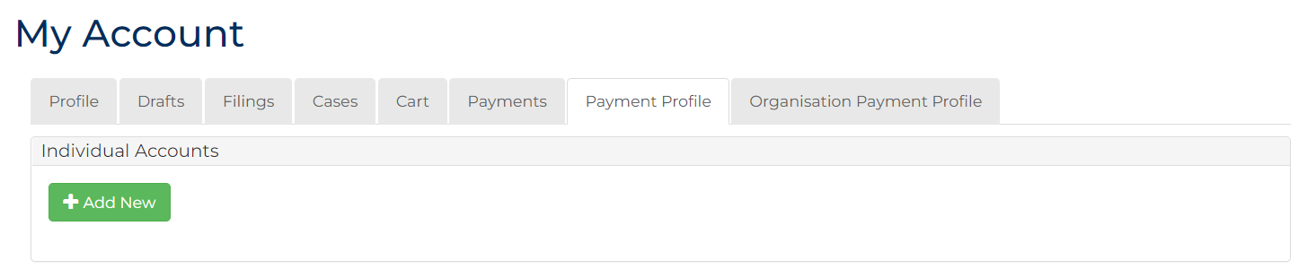

|  |  |
| --- | --- |
|  | Note:  Credit card payment details can be added by clicking: + Add New |

1. Admin User Profile Only – Click: Organisation Payment Profile tab.

Organisation Payment screen displays:

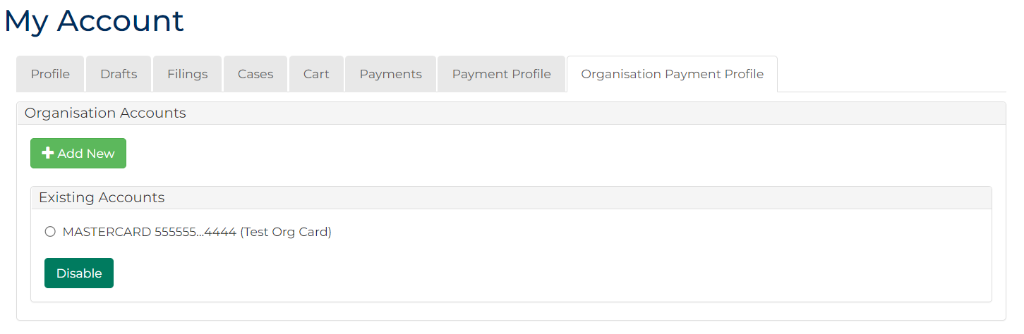

|  |  |
| --- | --- |
|  | Notes:  Credit card payment details can be added by clicking: + Add New  Disable Existing Accounts by ticking box and clicking: Disable |