Navigate home screen functionality

Portal Quick Reference Guide

|  |
| --- |
| Purpose |
| Quick Reference Guide shows how to: Navigate home screen functionality |

## Home Page

1. Log in to Portal

Home screen displays:

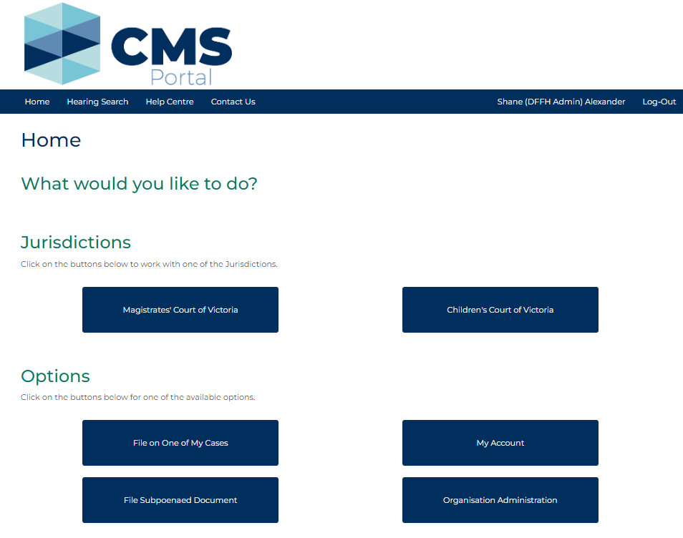

1. Navigating CMS Portal home screen

| Top navigation menu | |
| --- | --- |
| Button: | Action: |
| Home | Return to Home screen after navigating to a different screen. |
| Hearing Search | Search for hearings currently listed in CMS.  Note:  Child Protection hearings are unable to be searched and will therefore not appear. |
| Help Centre | Online support for external parties using CMS Portal. |
| Contact Us | Contact information for technical and procedural support. This service does not provide advice on legal matters. |

| Jurisdictions | |
| --- | --- |
| Button: | Action: |
| Magistrates’ Court of Victoria | Click court jurisdiction to initiate a case, file a new application or take actions on an existing case. |
| Children’s Court of Victoria | Click court jurisdiction to initiate a case, file a new application or take actions on an existing case. |

| Options | |
| --- | --- |
| Button: | Action: |
| File on One of My Cases | Search for case you already have access to file on. |
| My Account | Access the following related to your account:   * Your Profile Information * Draft Documents * Filed Documents * Draft Orders * Court Orders   Resources:  See Quick Reference Guide:   * Navigate My Account screen |
| File Subpoenaed Document | Type case number to file a subpoena. |
| Organisation Administration | Administrators access to manage user accounts, case access and filing reports. |