Locate and view case

Portal Quick Reference Guide

|  |
| --- |
| Purpose |
| Quick Reference Guide shows how to: Locate and view case |

1. From CMS Portal Home page, click: My Account

My Account screen displays:

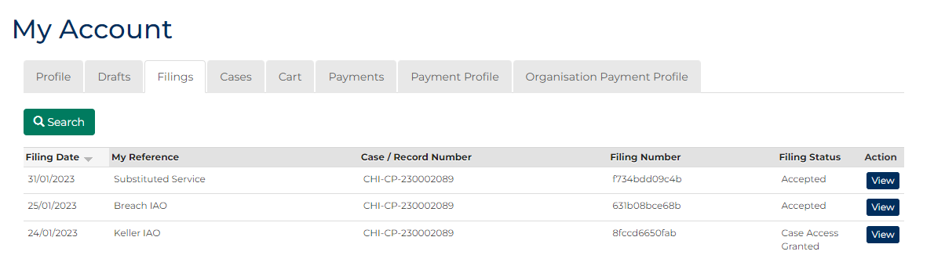

1. Click Cases tab.

Search Case panel displays:

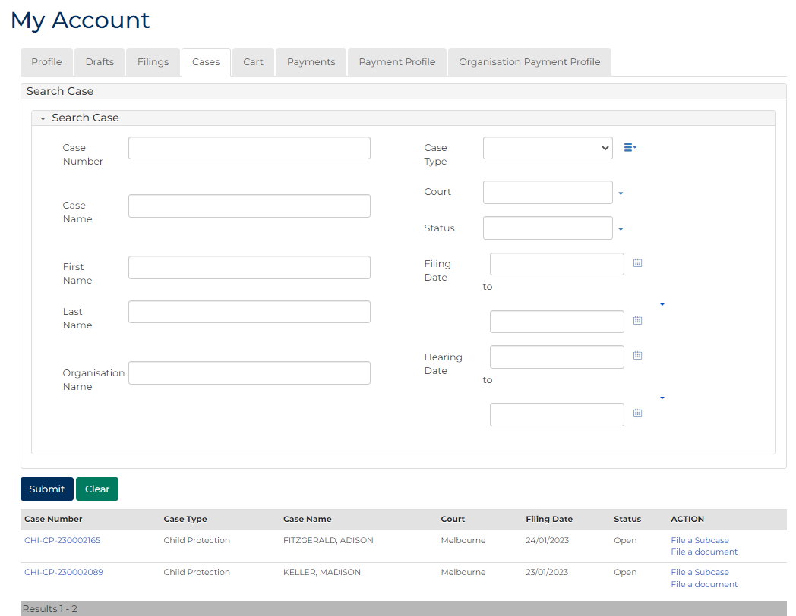

|  |  |
| --- | --- |
|  | Notes:   * List of recently accessed cases display at bottom of screen * Case search not required if case displays * Only cases user previously filed on or requested access to, display |
|  |  |
|  | Resource:  See Quick Reference Guide: Request Case Access |

1. Is case search required?

|  |  |
| --- | --- |
| If | Then |
| Yes | Go to next step |
| No | Go to step 6 |

1. Type details in one or more Search Case fields.

| Search filters | |
| --- | --- |
| Field: | Action: |
| Case Number | Type full or partial case number. |
| Case Name | Type full or partial case name. |
| First Name | Type first name of party. |
| Last Name | Type last name of party. |
| Organisation Name | Type organisation name. |
| Case Type | Select relevant option. |
| Court | Select relevant option. |
| Status | Select relevant option. |
| Filing Date | Select date (or range of dates) of filing. |
| Hearing Date | Select date (or range of dates) of hearing. |

1. Click: Submit

Search results display:

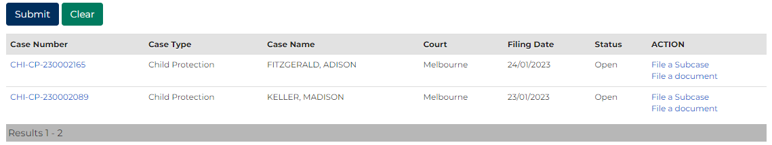

1. Does case display in Results panel?

|  |  |
| --- | --- |
| If | Then |
| Yes | Go to next step |
| No | Refine search criteria and repeat search  **Notes:**  If relevant case does not display in list of results, adjust search criteria and click: **Submit**   * To reset all fields, click: **Clear** |

1. Is view of full case required?

|  |  |
| --- | --- |
| If | Then |
| Yes | Go to next step |
| No | Go to step 9 |

1. Click Case Number link.

Case Summary screen displays:

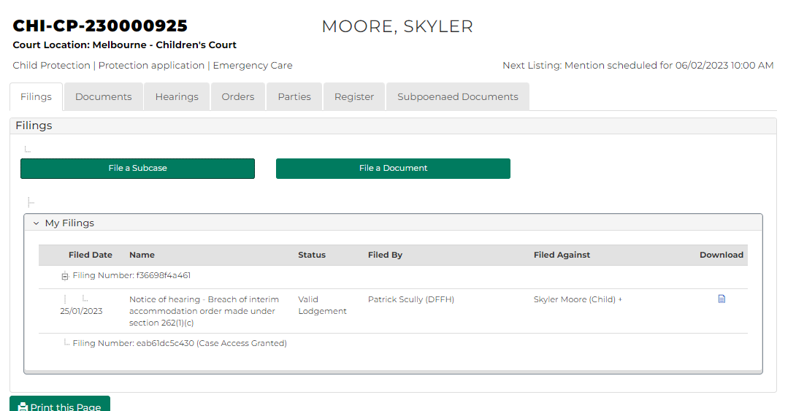

1. Is filing required on case?

|  |  |
| --- | --- |
| If | Then |
| Yes | Click File a Subcase or File a document  Resources:  See Quick Reference Guides:   * File document on case * Relevant Quick Reference Guide for application type |
| No | Complete required action on case. |