View hearings and lodge adjournment request

Portal Quick Reference Guide

|  |
| --- |
| Purpose |
| Quick Reference Guide shows how to: View hearings and lodge adjournment request in CMS Portal |

1. Log in to Portal.

Home screen displays:

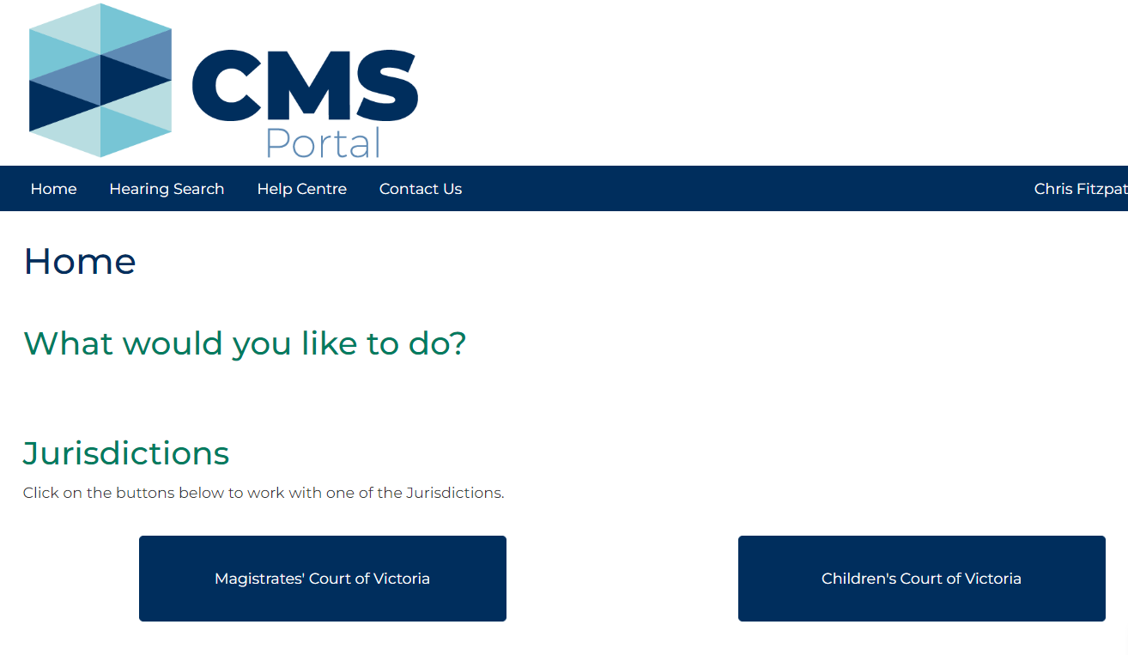

1. Click: File on One of My Cases

Search Case screen displays:

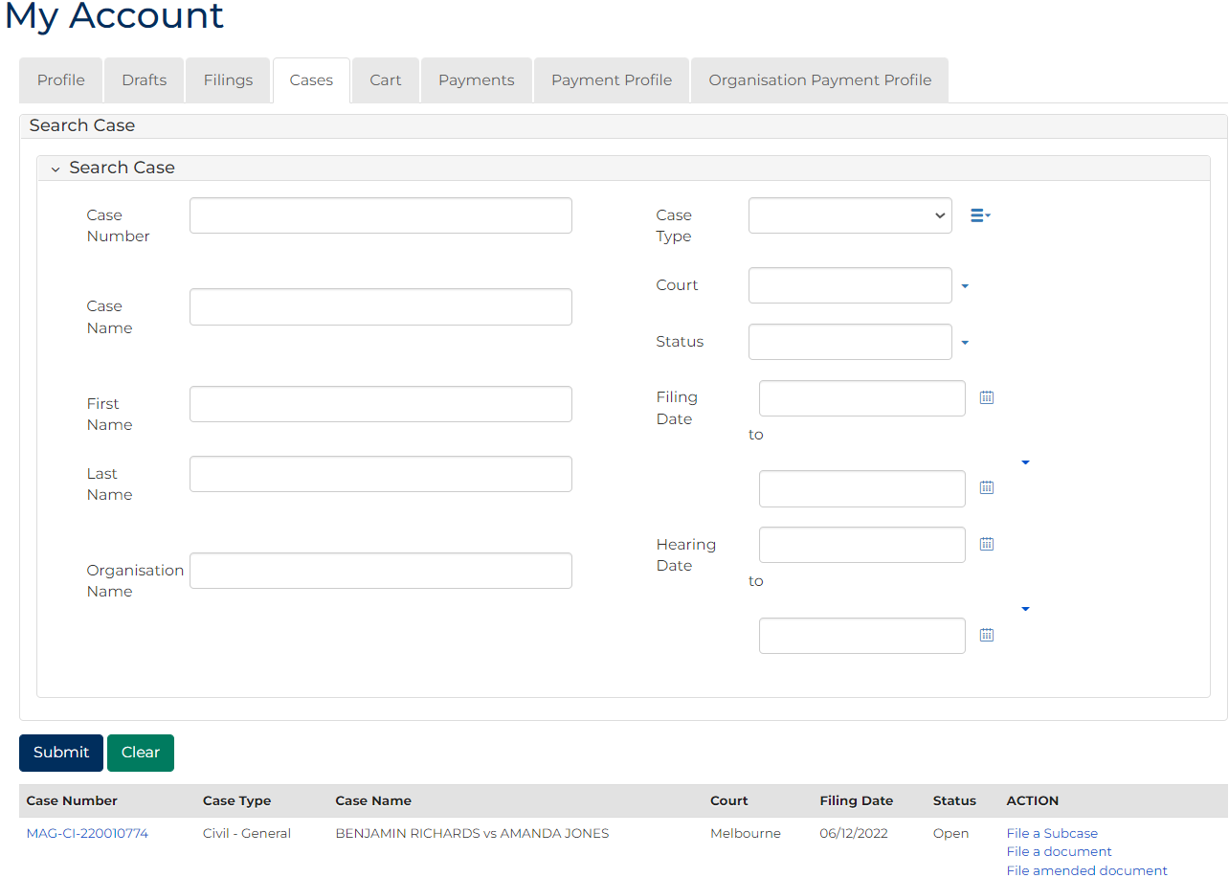

|  |  |
| --- | --- |
|  | Note:  List of cases that have permitted access displays at bottom of screen. If relevant case is visible in list, click Case Number to access or a link in Actions column to file on the case  This page enables to search by numerous filters  If viewing is denied, requesting access to case is required |

|  |  |
| --- | --- |
|  | Resource:  See Quick Reference Guide: Request access to a case |

1. In Case Number column for relevant case, click: Case Number link.

Case Summary screen displays:

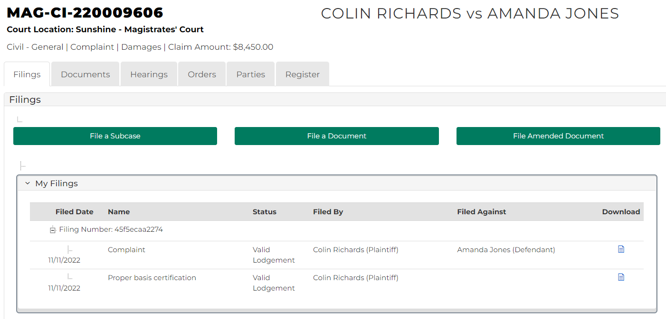

1. Click: Hearings tab.

Case Hearings screen displays:

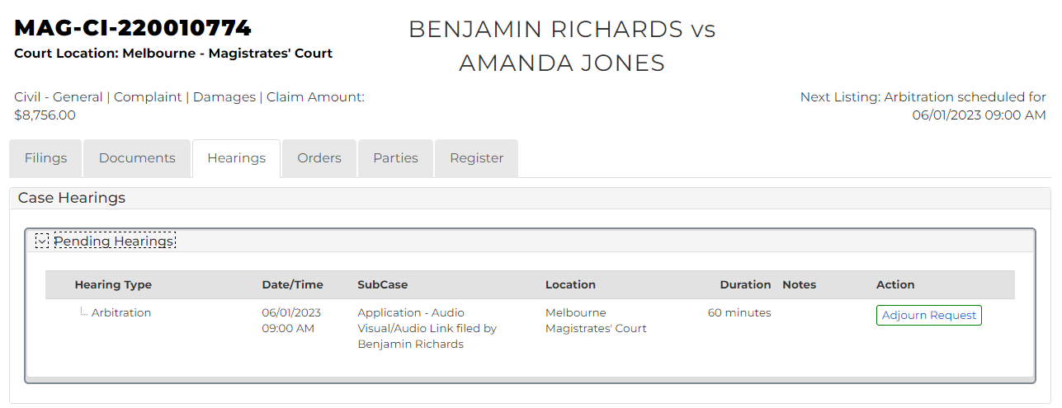

|  |  |
| --- | --- |
|  | Note:  Displays pending and finalised hearings in separate panels. |

1. Is an adjournment request required?

|  |  |
| --- | --- |
| If | Then |
| Yes | Go to next step |
| No | - |

1. Click: Adjourn Request

Add Adjournment Request screen displays:

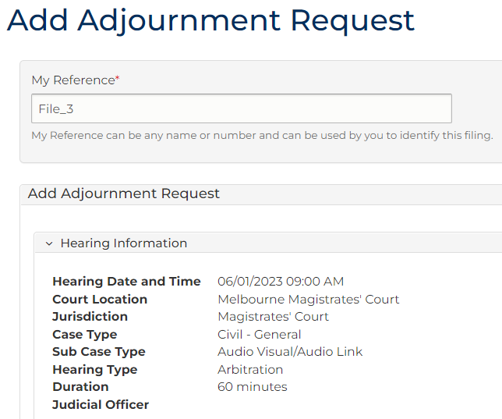

1. Complete required panels and fields.

| Panel: Add Adjournment Request | |
| --- | --- |
| Field: | Action: |
| Subcases | Select subcase(s). |
| Requesting Parties | Select party |
| Consent | Select Yes or No  Note:  When selecting No, further fields display. |
| Proposed Hearing Type | Change if required. |
| Event Location | Change if required. |
| Calendar Assistant  Click: Show Slots | Select Time Slot.  Note:  Error occurs when available slots is not selected. |
| Resources | Select resource(s). |
| Interpreter | Select party who requires Interpreter. |
| Interpreter language | Select required Interpreter language.  Note:  Complete Interpreters details if booked for client. |
| Add to Underlying Cases | Select related cases. |

| Panel: Add Adjournment Request | |
| --- | --- |
| Field: | Action: |
| Adjournment Details | Select reason. |
| Adjournment Notes | Type required notes. |

1. Click: Proceed

Confirmation of Filing screen displays:

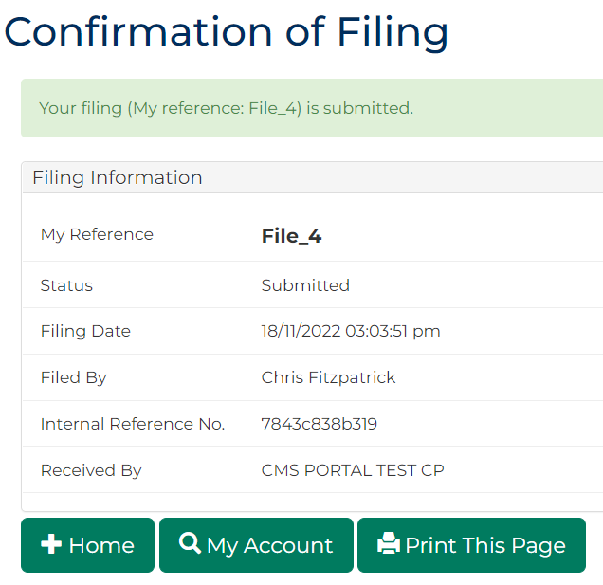

|  |  |
| --- | --- |
|  | Note:  Acknowledgment for filing email sent to Portal user when adjournment request is filed  An additional email is sent once adjournment request is reviewed by registry staff |