View filed document

Portal Quick Reference Guide

|  |
| --- |
| Purpose |
| Quick Reference Guide shows how to: View filed document in CMS Portal |

Contents­­­

View previously filed document 2

View undelivered documents 4

# View previously filed document

1. Log in to Portal.

Home screen displays:

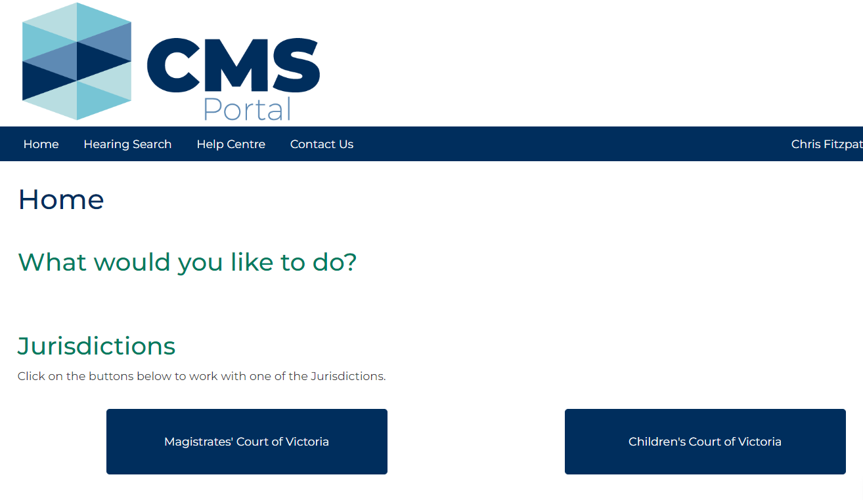

1. Click: My Account

My Account screen displays My Filing tab:

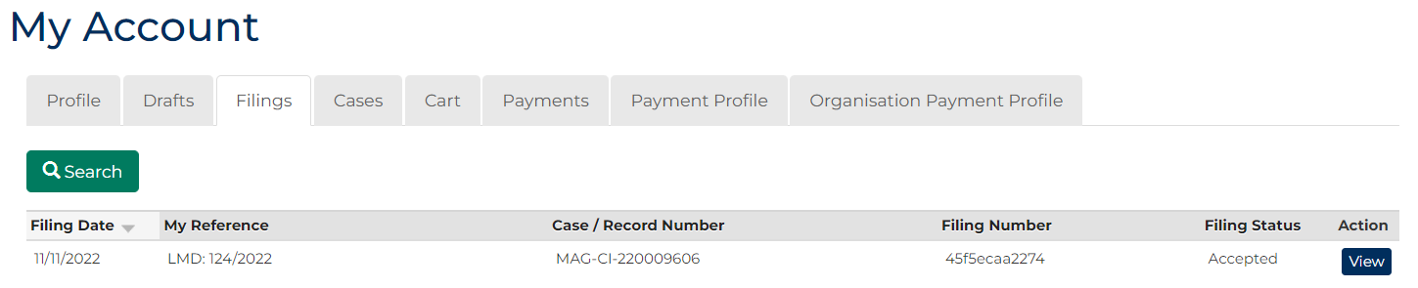

1. In Action column for relevant case, click: View

Case Summary screen displays:

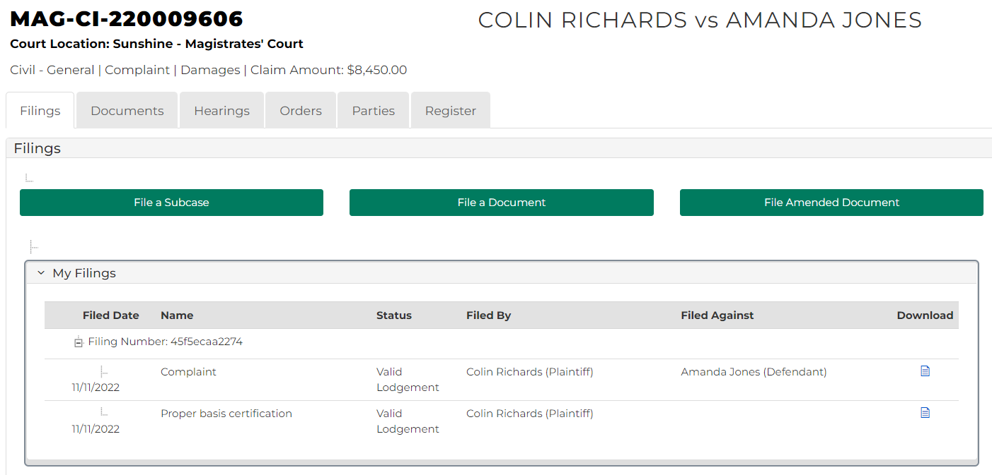

|  |  |
| --- | --- |
|  | Note:  Filings tab displays details of filing, including:  status of filed document, and  icon to download a copy of document |

# View undelivered documents

1. Log in to Portal.

Home screen displays:



1. Click: My Account

My Account screen displays My Filings tab:



1. Click: Drafts

Saved Drafts screen displays:

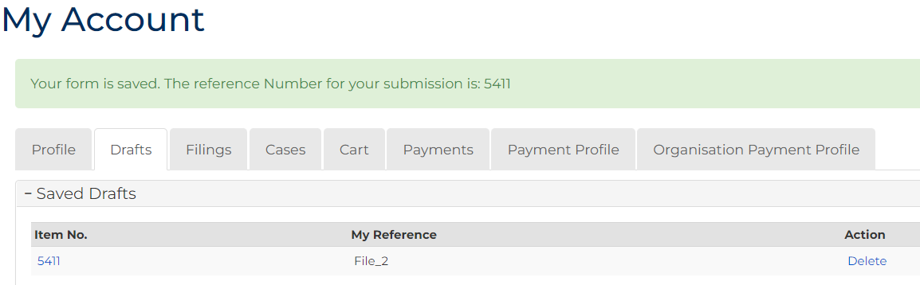

|  |  |
| --- | --- |
|  | Note:  If user account does not have any undelivered documents, Drafts tab displays: No case found |

1. To delete document, in Action column, click: Delete

Confirmation message displays, to proceed click: Delete

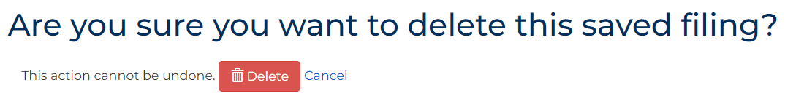

1. To view document, click: Item No. link.

Filings Details screen displays:

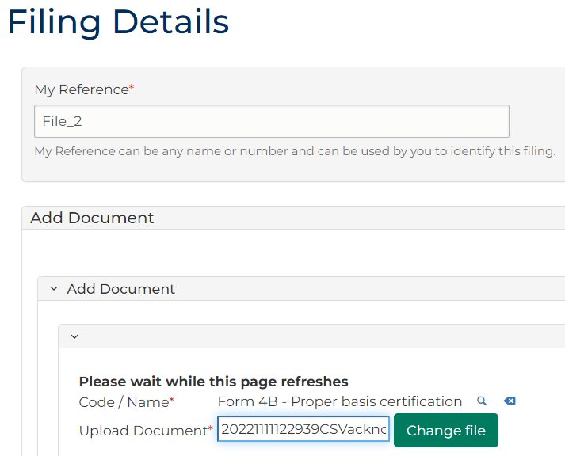

1. Make required changes, then click: Proceed, or Save for later