Run filings report

Portal Quick Reference Guide

|  |
| --- |
| Purpose |
| Quick Reference Guide shows how to: Run filings report in CMS |

1. Log in to Portal

Home screen displays:

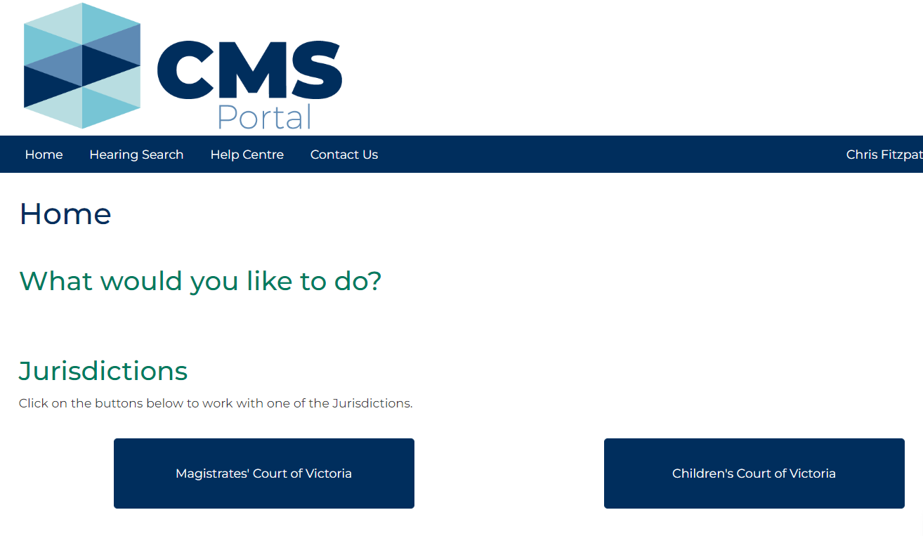

1. Click: Organisation Administration

Organisation Administration screen displays:

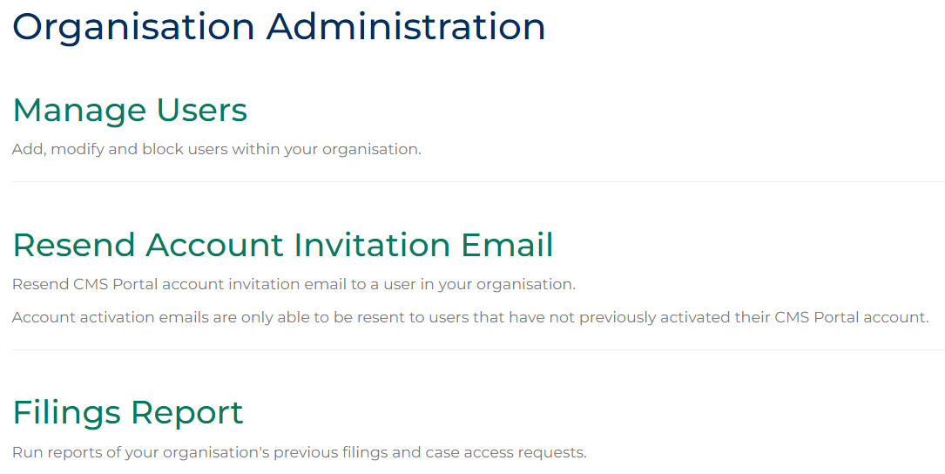

1. Click: Filings Report

Filings Report screen displays:

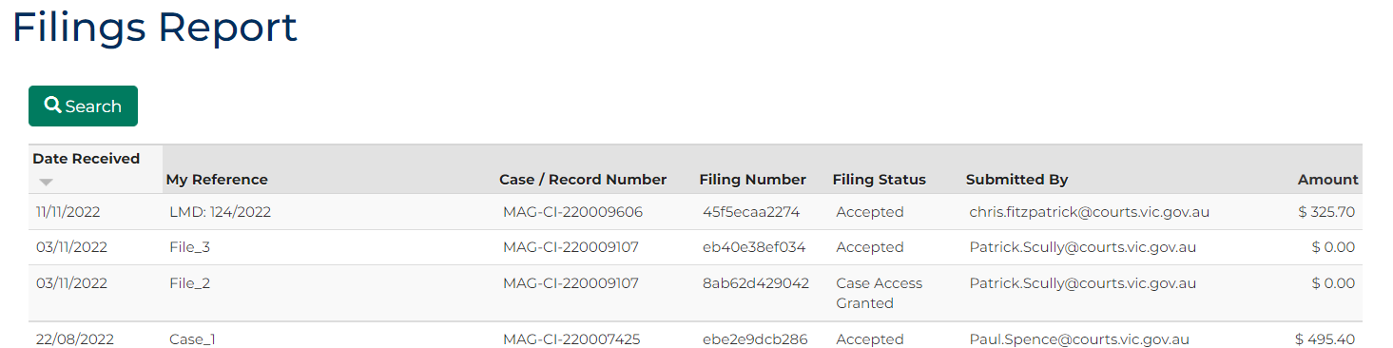

1. Click: Search

Search fields display:

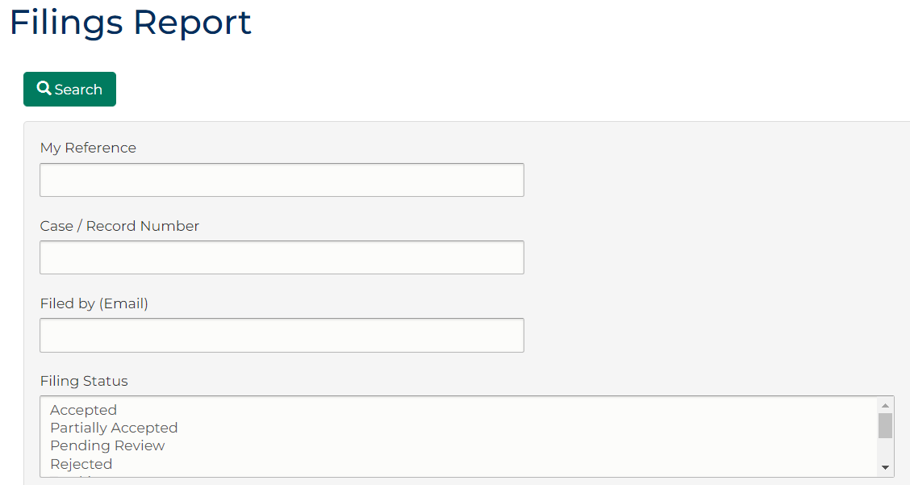

1. Complete required panels and fields.

| Panel: Filings Report | |
| --- | --- |
| Field: | Action: |
| My Reference | Type case reference assigned to case. |
| Case/Record Number | Type Case/Record number assigned to case. |
| Submitted by (Email) | Type email address of person who submitted case. |
| Filing Status | Select file status. |
| Filing Date From | Select date. |
| Filing Date To | Select date. |

1. Click: Search

Search results appear at bottom of screen:

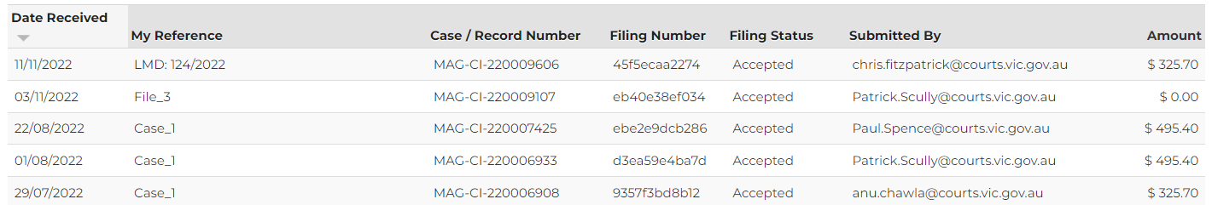

|  |  |
| --- | --- |
|  | Note:  Filings report can be sorted by list of fields, single or multiple fields can be selected. |

1. Click: Download

Results download as Excel spreadsheet:

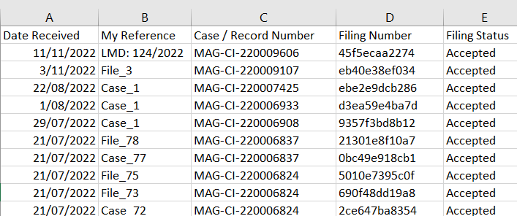

|  |  |
| --- | --- |
|  | Notes:  Save files as per internal processes and naming convention.  No more than 1000 records can be downloaded at one time. |