Request case access

Portal Quick Reference Guide

|  |
| --- |
| Purpose |
| User Guide shows how to: Request case access in CMS |

1. Log in to Portal.

Home screen displays:

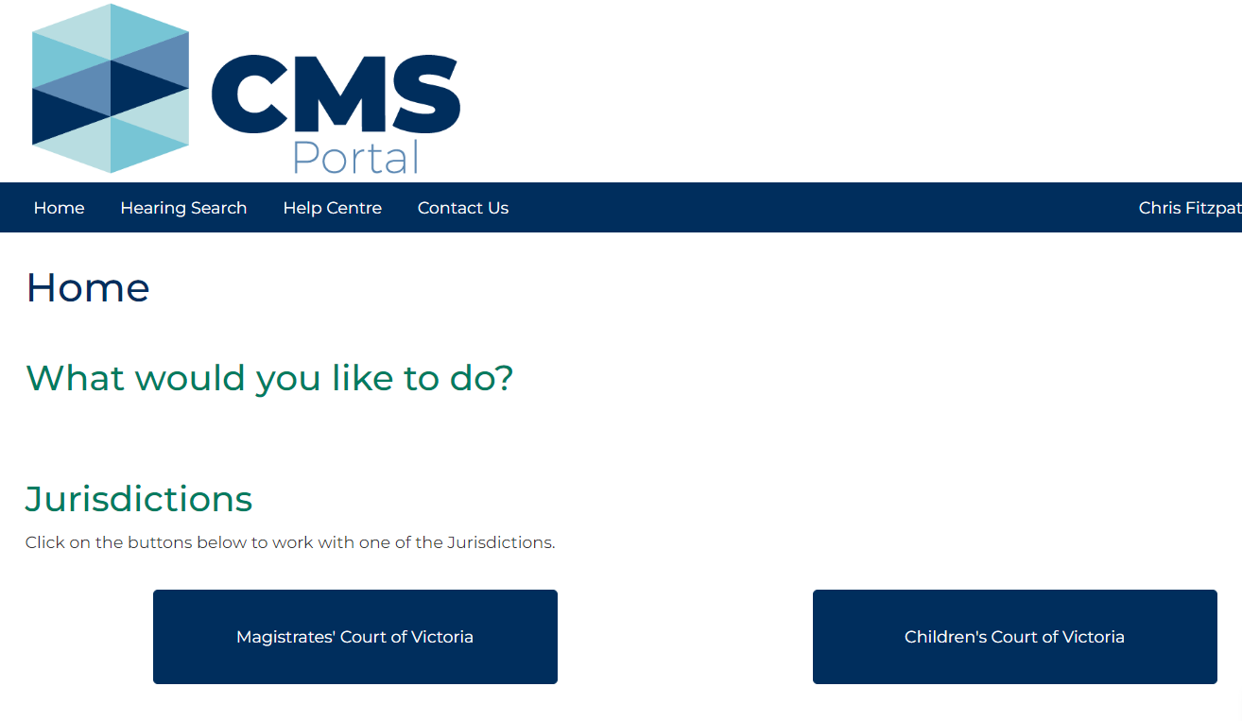

1. Select relevant Jurisdiction

Case Type screen displays:

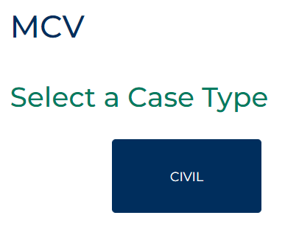

1. Select Case Type

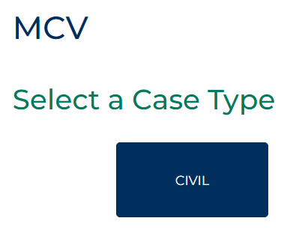

1. Click: Request Case Access

Case Access Search screen displays:

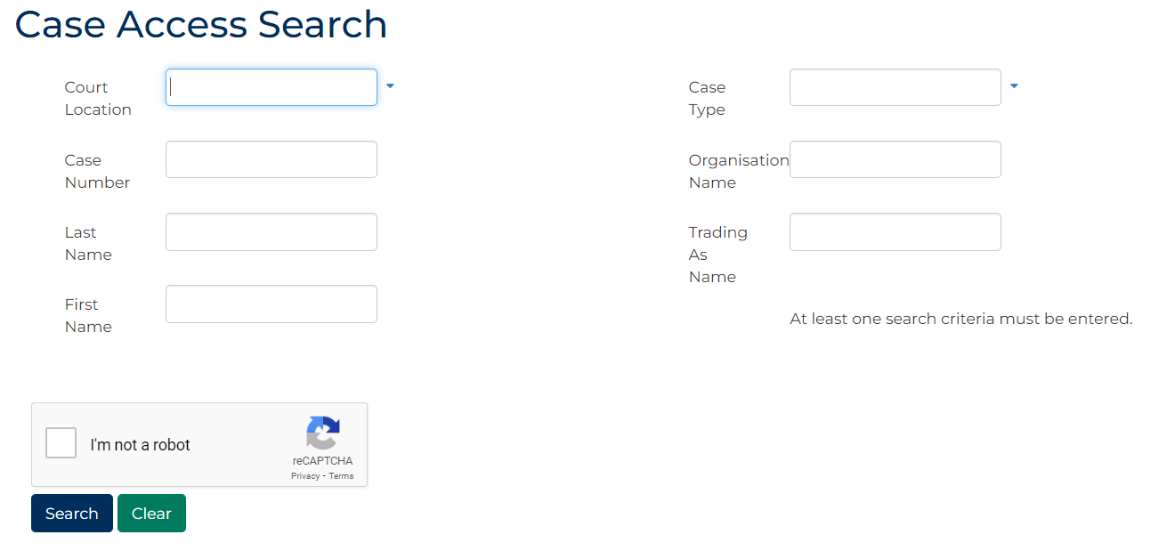

1. Complete required panels and fields.

| Panel: Case Access Search | |
| --- | --- |
| Field: | Action: |
| Court Location | Select Court Location. |
| Case Number | Type Case Number. |
| Last Name | Type Last Name of party. |
| First Name | Type First Name of party. |
| Case Type | Select Case Type. |
| Organisation Name | Type Organisation Name of party. |
| Trading As Name | Type Trading As Name of party. |

1. Select: I’m not a robot
2. Click: Search

Case results displays:

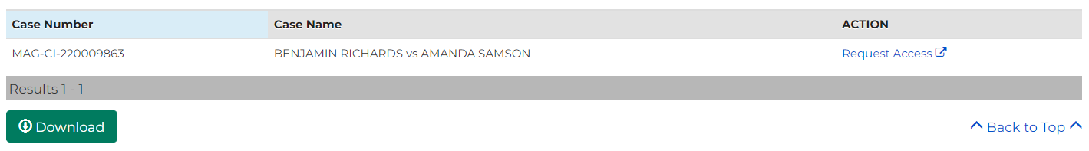

|  |  |
| --- | --- |
|  | Note:  If relevant case does not display in list of results, adjust search criteria and click: Submit  To reset all fields, click: Clear |

1. In Action column for relevant case, select: Request Access

Request Case Access screen displays:

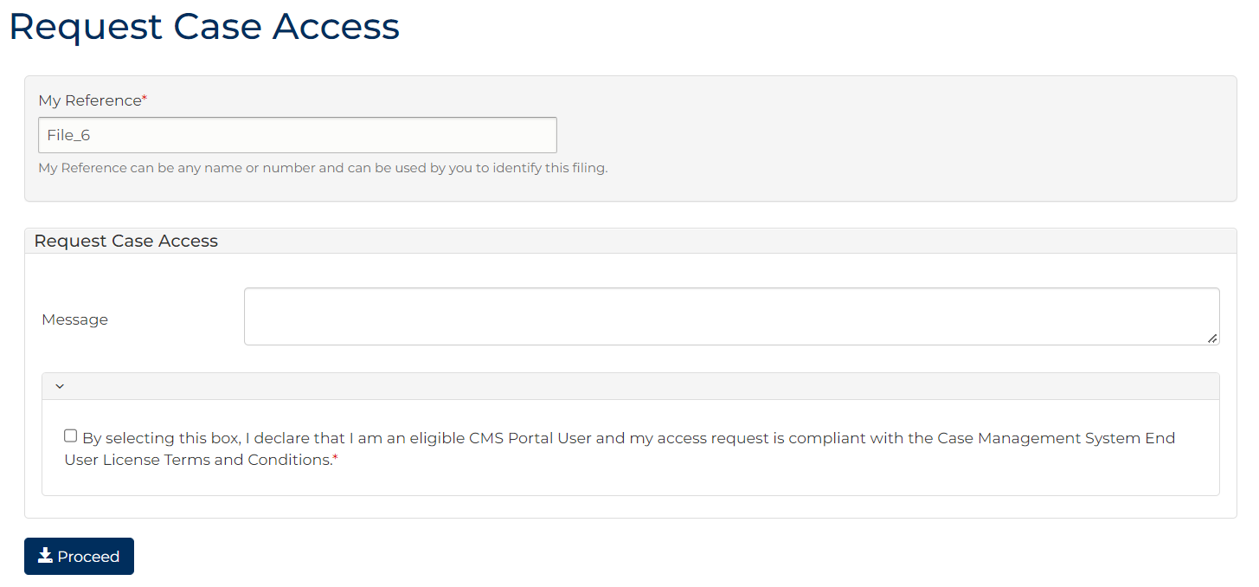

1. Complete required panels and fields.

| Panel: Request Case Access | |
| --- | --- |
| Field: | Action: |
| My Reference | Type reference name or number to identify filing. |
| Message | Type information to support case access request. |
| CMS Portal User Declaration | Select box. |

1. Click: Proceed

Confirmation of Filing screen displays:

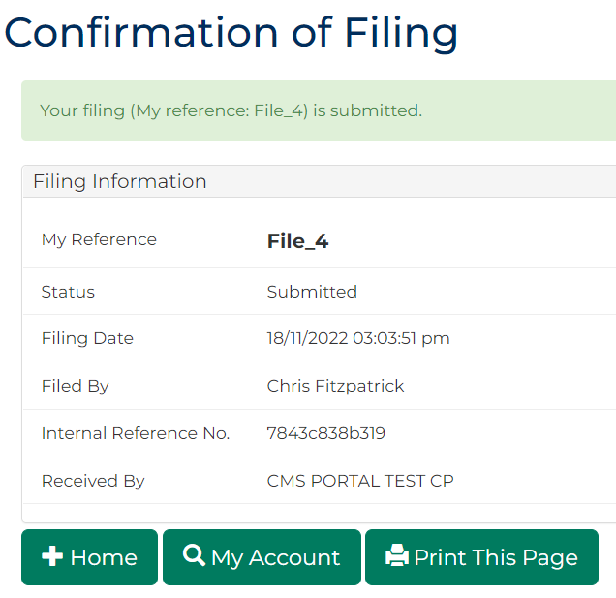

|  |  |
| --- | --- |
|  | Note:   * Case Access Notification email sent to email of user that requested case access * Ensure the requesting user is logged in to Portal before actioning the token in the email. * Ensure Google Chrome set as default browser for token to work. |

1. Log in to email and locate Case Access Notification for CMS Portal email.
2. Open email and click access token link.

Case Access Invitation message displays:

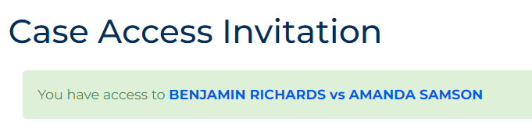

|  |  |
| --- | --- |
|  | Note:   * Token in email will only work for user that requested case access * Do not forward or share email with another user * Case is now available in Cases tab on My Account screen. |

|  |  |
| --- | --- |
|  | **Resource:**  See User Guide: **View and action case** |