Register Interstate order

Portal Quick Reference Guide

|  |
| --- |
| Purpose |
| Quick Reference Guide shows how to: Register Interstate order in CMS Portal |

1. Log in to Portal.

Home screen displays:

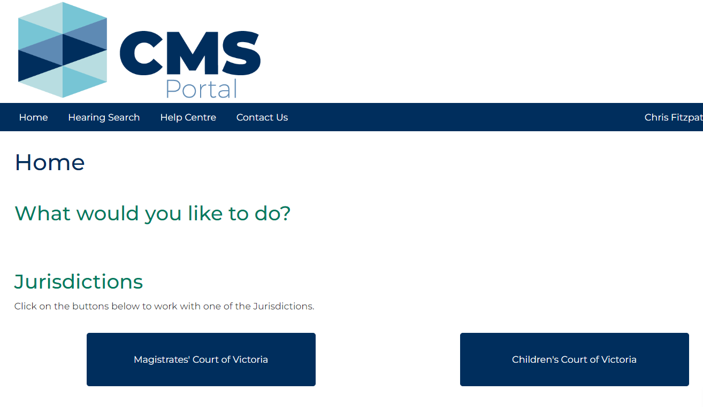

1. Click: Magistrates’ Court Victoria

Case Type screen displays:

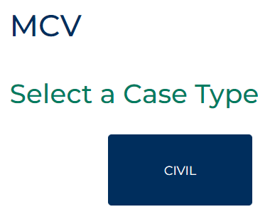

1. Click: Civil

Civil screen displays:

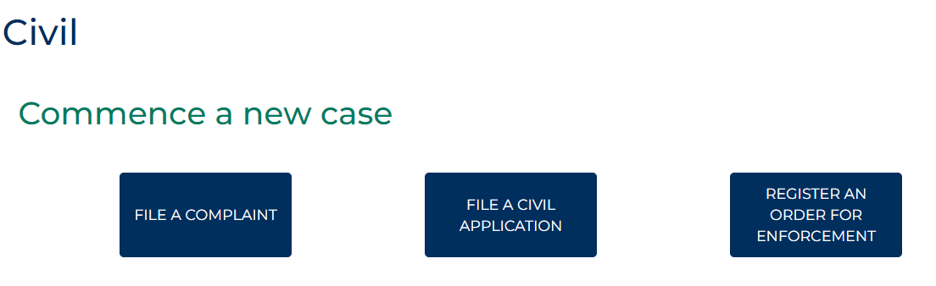

1. Click: Register an order for enforcement

Register/Enforcement Order screen displays:

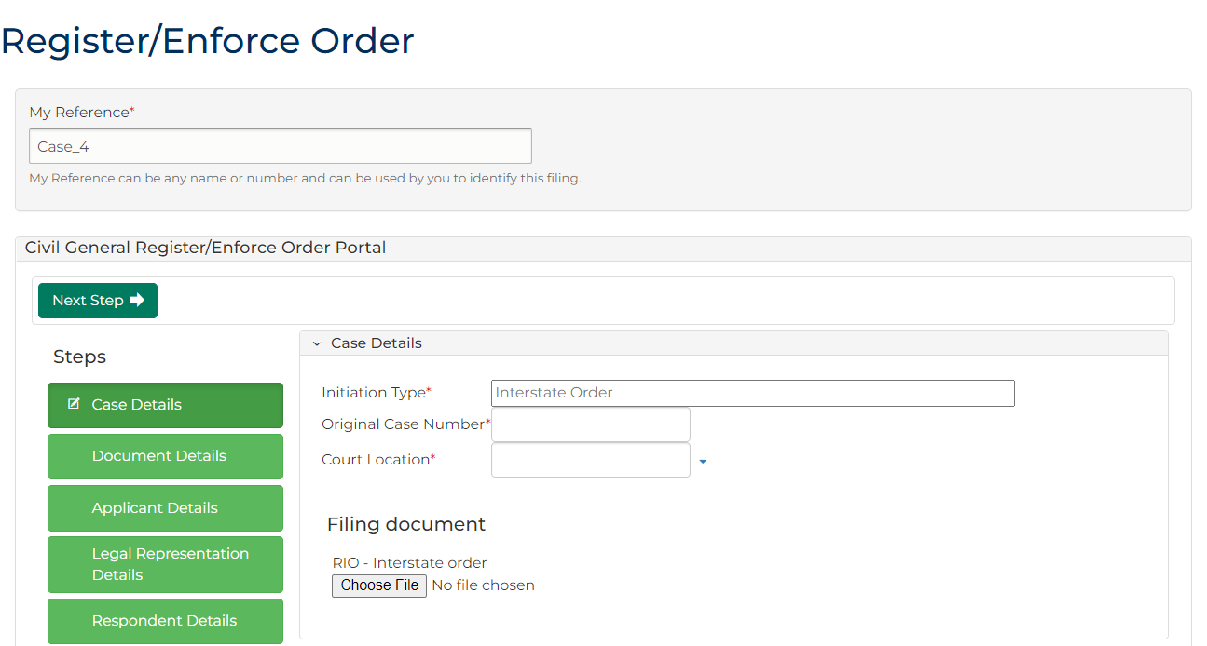

1. Complete required panels and fields.

| Panel: My Reference | |
| --- | --- |
| Field: | Action: |
| My Reference | Type reference name or number to identify filing. . |

| Panel: Case Details | |
| --- | --- |
| Field: | Action: |
| Initiation Type | - |
| Original Case Number | Type original case number. |
| Court Location | Select court location. |
| Filing Document | Click: Choose File and add required PDF document to case.  Note:  All document uploads must be PDF. |

|  |  |
| --- | --- |
|  | Note:  Click: Save for Later at any stage prior to application being filed  Application can be retrieved from Drafts tab located in My Account screen |

1. Click: Next Step

Document Details screen displays:

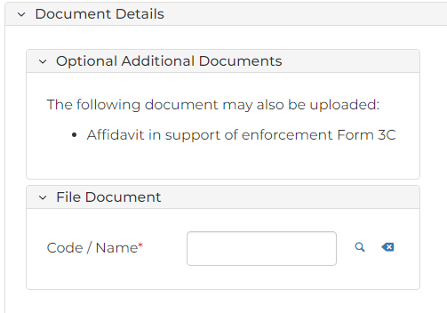

|  |  |
| --- | --- |
|  | Note:  Click green panels to navigate back and forth through initiation steps. |

1. Complete required panels and fields.

| Panel: Optional Additional Documents | |
| --- | --- |
| Field: | Action: |
| Code/Name | Type name of document and select. |
| Upload Document | Click: Choose File and add required PDF document to case.  Note:  All document uploads must be PDF. |

1. Click: Next Step
2. Complete required panels and fields.

| Panel: Applicant Name | |
| --- | --- |
| Field: | Action: |
| Party Designation Type | Select applicant type.  Note:  When designated party is business, select Organisation as designation type.  Do not select Agency or Company |
| Party Type | - |
| Other fields | Complete all required fields. |

| Panel: Applicant Address | |
| --- | --- |
| Field: | Action: |
| Address Type | Select address type. |
| Physical Address | Start typing address in search box and select correct option from auto-results.  Note:  To add another address, click: Applicant Address |

| Panel: Applicant Contact Details | |
| --- | --- |
| Field: | Action: |
| All fields | Type relevant contact information. |
| Email Address | Type email address.  Note:  If Applicant does not have legal representation, email address is mandatory. |

| Panel: Applicant Identification | |
| --- | --- |
| Field: | Action: |
| Australian Business Number (ABN) | Type Applicant’s ABN if relevant. |
| Australian Company Number (ACN) | Type Applicant's ACN if relevant. |
| Panel: Applicant Financial Details | |
| Field: | Action: |
| Financial Details | Type financial information if relevant. |

| Panel: Applicant Representation Capacity or Litigation Guardian | |
| --- | --- |
| Field: | Action: |
| Are you acting in a Representative Capacity? | Select Yes or No for each field. |
| Do you have a Litigation Guardian? |

1. Is there only one Applicant?

|  |  |
| --- | --- |
| If | Then |
| Yes | Go to next step |
| No | Click: + Applicant Details  Go to step 9 |

1. Click: Next Step
2. Complete required panels and fields.

| Panel: Legal Representation Details | |
| --- | --- |
| Field: | Action: |
| Business Name | Start typing legal firm name into search box and select correct option from results. |
| Reference Number | Type reference name or number to identify filing. |

1. Click: Next Step
2. Complete required panels and fields.

| Panel: Respondent Name | |
| --- | --- |
| Field: | Action: |
| Party Designation Type | Select Respondent type.  Note:  When designated party is business, select Organisation as designation type.  Do not use Agency or Company |
| Party Type | - |
| Other fields | Complete all required fields. |

| Panel: Respondent Address | |
| --- | --- |
| Field: | Action: |
| Address Type | Select address type. |
| Physical Address | Type address in search field and select correct option from auto-results. |
|  | To add another address, click: + Respondent Address |

| Panel: Respondent Contact | |
| --- | --- |
| Field: | Action: |
| All fields | Type relevant contact information. |

| Panel: Respondent Identification | |
| --- | --- |
| Field: | Action: |
| Australian Business Number (ABN) | Type Respondent’s ABN if relevant. |
| Australian Company Number (ACN) | Type Respondent's ACN if relevant. |
| Panel: Respondent Financial Details | |
| Field: | Action: |
| Financial Details | Type financial information if relevant. |

1. Is there only one Respondent?

|  |  |
| --- | --- |
| If | Then |
| Yes | Go to next step |
| No | Click + Respondent Details  Go to step 14 |

1. Click: Next Step
2. Complete required panels and fields.

| Panel: Order details | |
| --- | --- |
| Field: | Action: |
| Date of Order | Click Calendar icon to record date Order was made. |
| Court/Tribunal Details or Authority Details | Start typing interstate destination into search box and select correct court/tribunal details from results. |
| Order Amount | Type order amount. |
| Costs | Type cost amount.  Note:  If no costs claimed, enter $0.00 in Costs field. |
| Interest | Type interest amount.  Note:  If no interest claimed, enter $0.00 in Interest field. |
| Total | - |
| Other Costs (cost of registration) | Type other cost amount.  Note:  If no other costs claimed, enter $0.00 in Other Costs field. |

1. Click: Next Step
2. Complete required panels and fields.

| Panel: Fee Waiver | |
| --- | --- |
| Panel: | Action: |
| Fee Waiver | Change to Yes if applying for fee waiver. |

1. Click: Proceed

My Account screen displays:

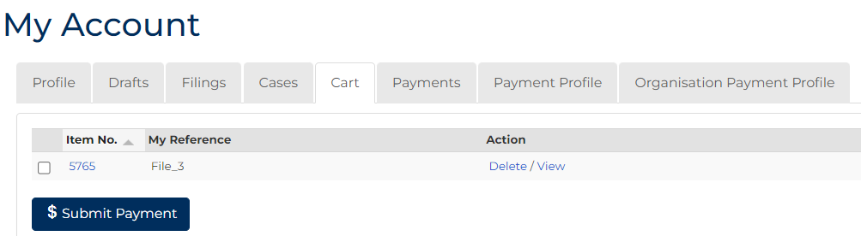

1. To submit payment, tick box next to Item No., click: $ Submit Payment

Process Payment screen displays:

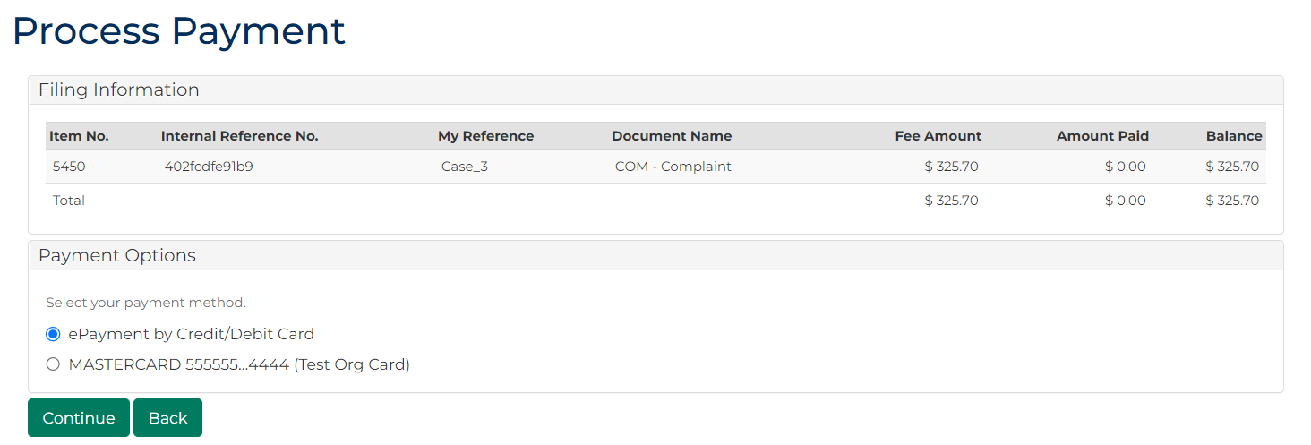

1. In Payment Options panel, select payment method, click: Continue

Confirmation of Filing screen displays:

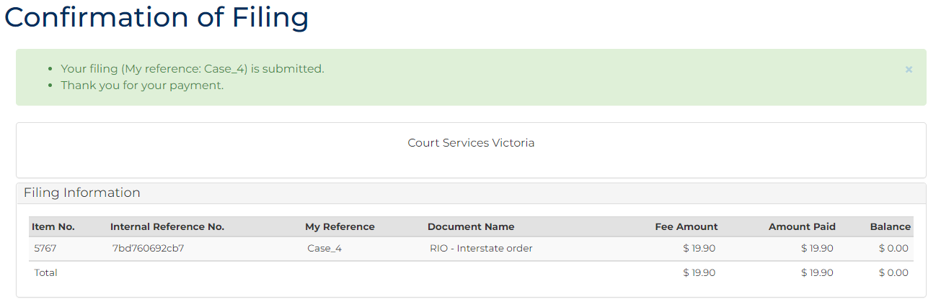

|  |  |
| --- | --- |
|  | Note:  Acknowledgment for filing email sent to Portal user when document is filed  An additional email is sent once document is reviewed by registry staff |

1. Click: My Account

My Account screen displays indicating pending review, accepted, or rejected:

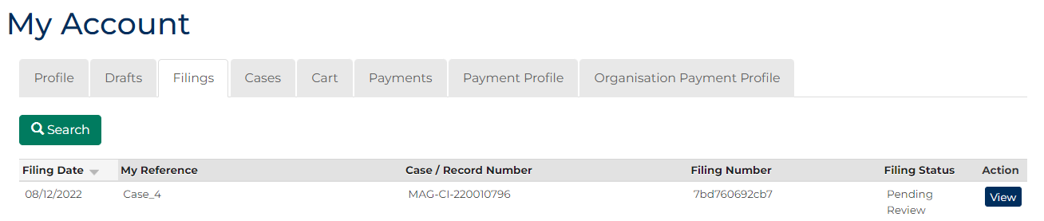

1. To see record of filing, in the Action column, click: View

Case Summary screen displays:

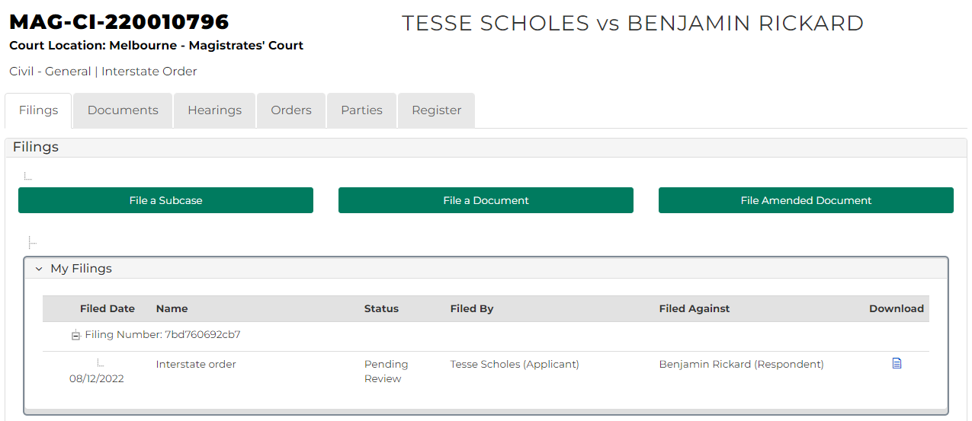

|  |  |
| --- | --- |
|  | Note:  Once filing is accepted, access copy of order from Documents tab in Case Summary screen  Notice of registration to Interstate/NZ court is available to download in Generated Documents field |

|  |  |
| --- | --- |
|  | Resource:  See Quick Reference Guide: Download document |