Initiate Summons for Oral Examination (SOE)

Portal Quick Reference Guide

|  |
| --- |
| Purpose |
| Quick Reference Guide shows how to: Initiate Summons for Oral Examination (SOE) in CMS Portal |

|  |  |
| --- | --- |
|  | Note:  References to submission on CMS Portal, and in related documentation, refers to process of electronically filing a document through portal and should not be confused with other definitions related to submission in a legal context. |

1. Log in to Portal.

Home screen displays:

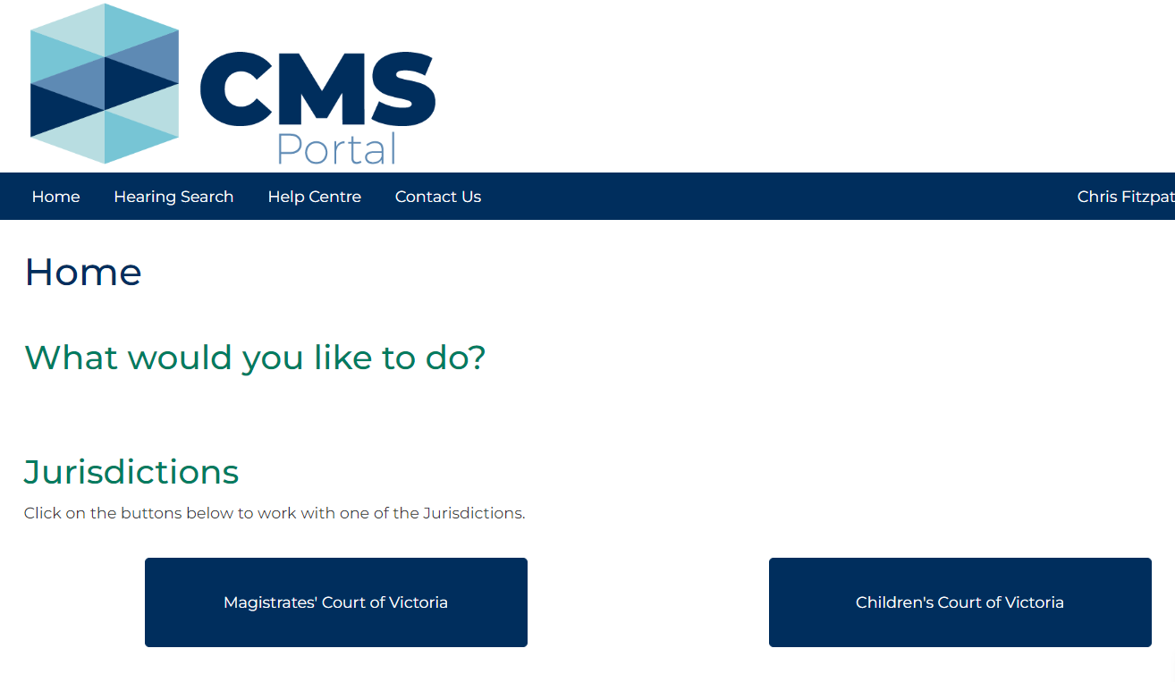

1. Click: File on One of My Cases

Search Case screen displays:

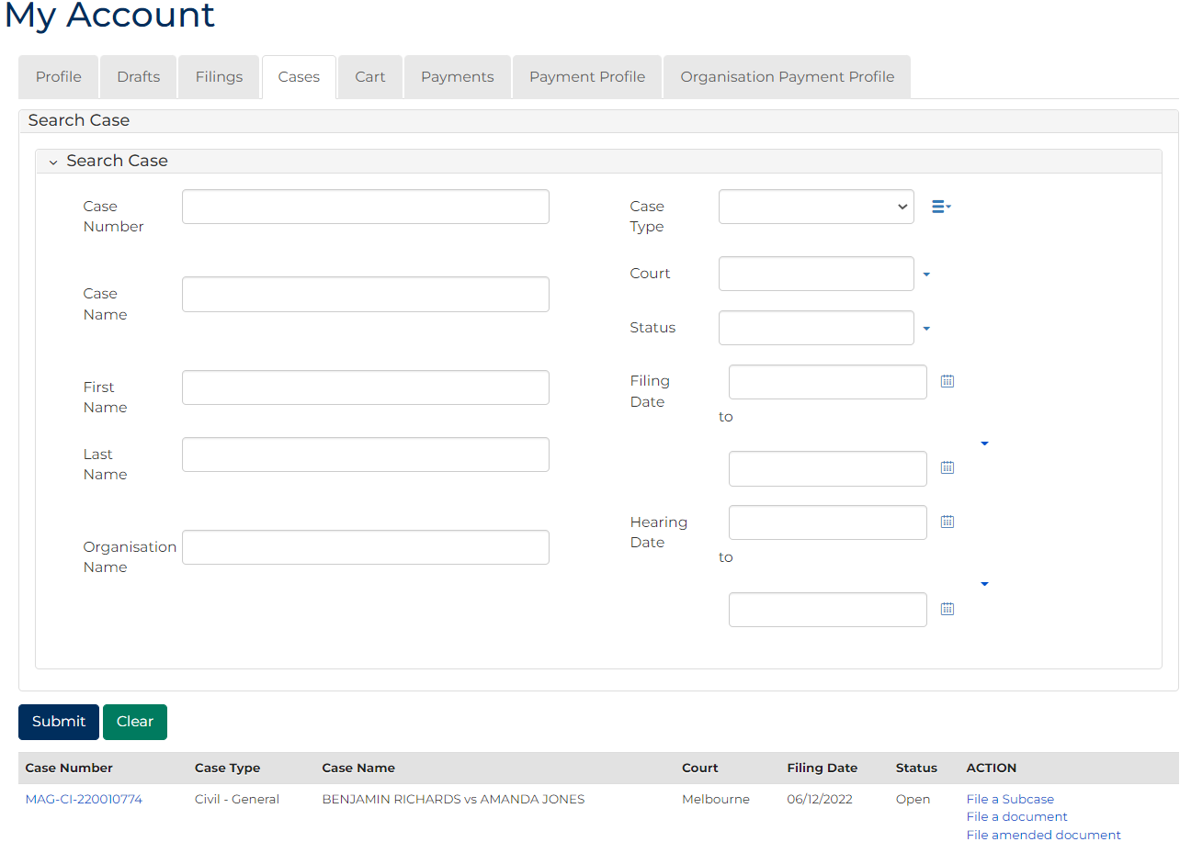

|  |  |
| --- | --- |
|  | Note:  List of cases that have permitted access displays at bottom of screen. If relevant case is visible in list, click Case Number to access or a link in Action column to file on case  This page enables to search by numerous filters  If viewing is denied, requesting access to case is required |

|  |  |
| --- | --- |
|  | Resource:  See Quick Reference Guide: Request access to a case |

1. In Action column for relevant case, click: File a Subcase link

Add Subcase screen displays:

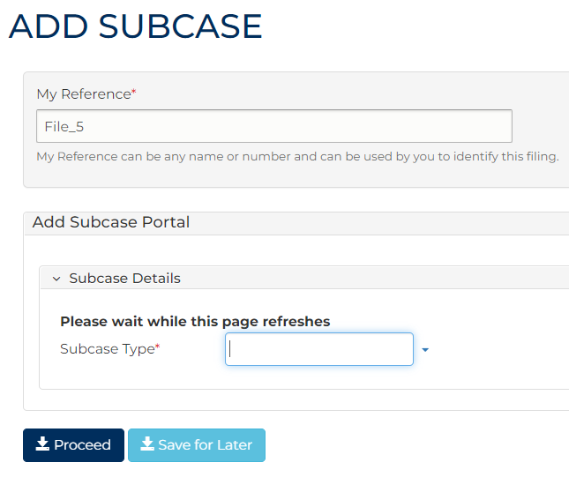

1. Complete required panels and fields.

|  |  |
| --- | --- |
|  | Note:  Information typed into following fields is used to create Summons for oral examination subcase. |

| Panel: My Reference | |
| --- | --- |
| Field: | Action: |
| My Reference | Type reference name or number to identify filing. |

| Panel: Subcase Type | |
| --- | --- |
| Field: | Action: |
| Subcase Type | Type: Summons  Select: Summons for Oral Examination |

| Panel: Subcase Initiating Document | |
| --- | --- |
| Field: | Action: |
| Code/Name | - |

| Panel: Additional Information | |
| --- | --- |
| Field: | Action: |
| Amount awarded on claim | Type total amount owed by judgment debtor. |
| Costs ordered | Type awarded costs amount if relevant. |
| Interest | Type interest amount charged if relevant. |
| Amount paid since order made | Type amount paid since order was made. |
| Professional Costs | Type Professional Costs. |
| Filing fee | Type Filing fee. |
| Service fee | Type Service fee. |
| Conduct money | Type amount. |
| Other amount | Type any other fees.  Note:  If no other amount claimed, enter $0.00 in field. |
| Provide details of other amount | Type details of fees associated to other amount, if required. |

| Panel: Interest | |
| --- | --- |
| Field: | Action: |
| Manual interest calculation required | Select Yes or No  Note:  If Yes is selected, a percentage amount field displays. |
| From | Select interest period start date using the calendar icon. |
| To | Select interest period end date using the calendar icon. |
| Principal Amount $ | Type amount. |
| Interest Total | - |

| Panel: Additional Panels | |
| --- | --- |
| Field: | Action: |
| Filed By | Select party. |
| Representation | Select filing party's legal representation if applicable. |
| Filed Against | Select party.  Note:  If lodging an SOE against a corporation, an appropriate officer of corporation must be added via Add Filed Against |
| Address Details | Select address type. |
| Physical Address | Type address into search field and select correct option from auto-results.  Note:  Address MUST be where Judgment debtor resides. |
| Related Orders | Select related order. |
| Fee Waiver | Change to Yes if party applying for fee waiver. |

1. Click: Proceed

My Account screen displays:

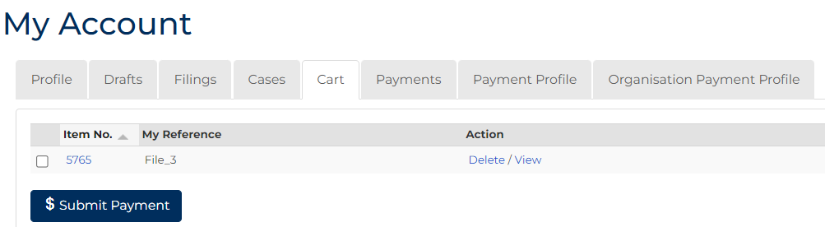

1. To submit payment, tick box next to Item No., click: $ Submit Payment

Process Payment screen displays:

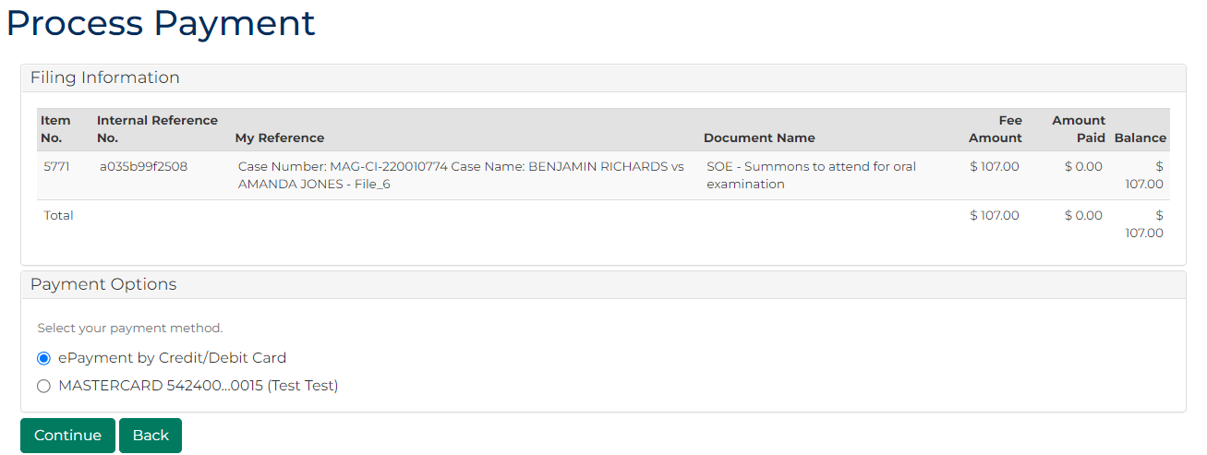

1. In Payment Options panel, select payment method, click: Continue

Confirmation of Filing screen displays:

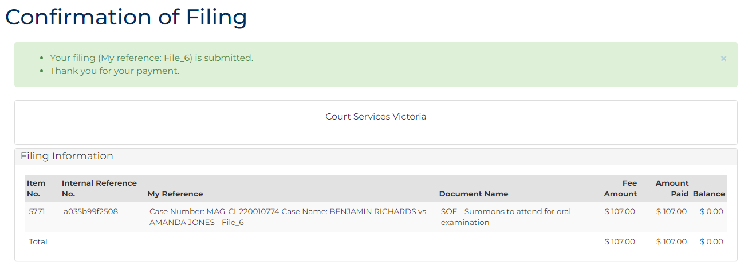

|  |  |
| --- | --- |
|  | Notes:  Summons for Oral Examination are automatically issued in certain circumstances.  Acknowledgment for filing email is sent to CMS Portal user when document is filed  An additional email is sent once filing is reviewed by registry staff |

1. Click: My Account

My Account screen displays indicating pending review, accepted, or rejected:

