File Warrant to Seize Property

Portal Quick Reference Guide

|  |
| --- |
| Purpose |
| Quick Reference Guide shows how to: File Warrant to Seize Property in CMS Portal |
| Prerequisite |
| Before start, ensure case exists meeting criteria where:  Claim or monetary order has been made, and  Have access to case in CMS Portal. |

|  |  |
| --- | --- |
|  |  |

1. Log in to Portal.

Home screen displays:

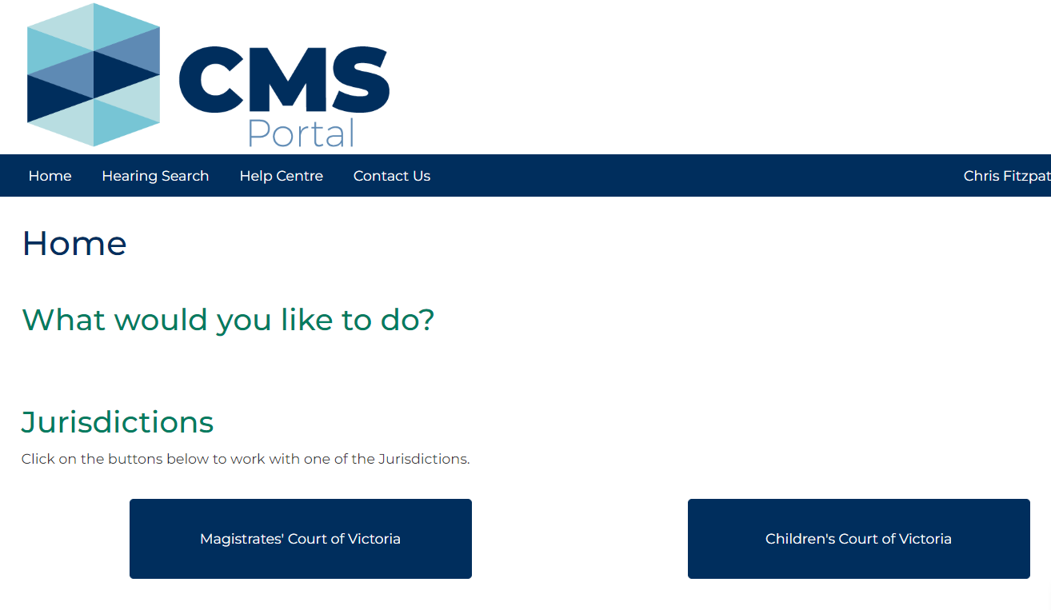

1. Click: File on One of My Cases

Search Case screen displays:

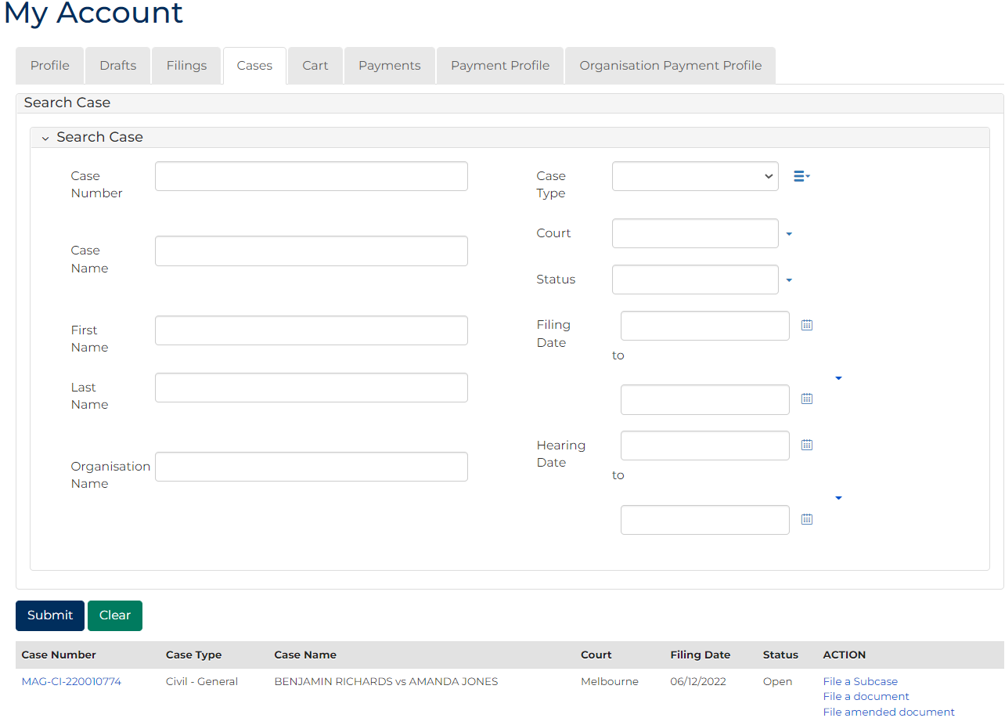

|  |  |
| --- | --- |
|  | Note:  List of cases that have permitted access displays at bottom of screen. If relevant case is visible in list, click Case Number to access or a link in Action column to file on the case  This page enables to search by numerous filters  If viewing is denied, requesting access to case is required |

|  |  |
| --- | --- |
|  | Resource:  See Quick Reference Guide: Request access to a case |

1. In Action column for relevant case, click: File a document link.

Case Summary screen displays:

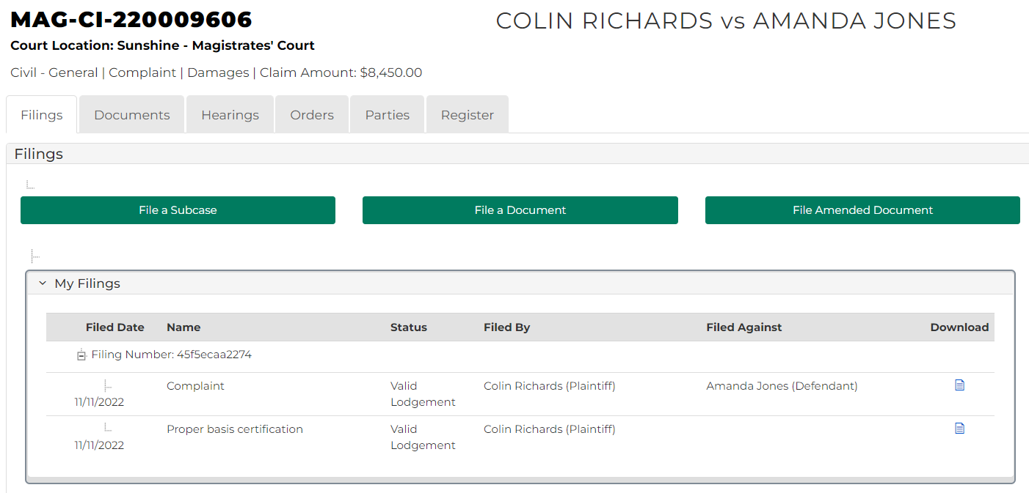

1. Click: File a document

Add Filing screen displays:

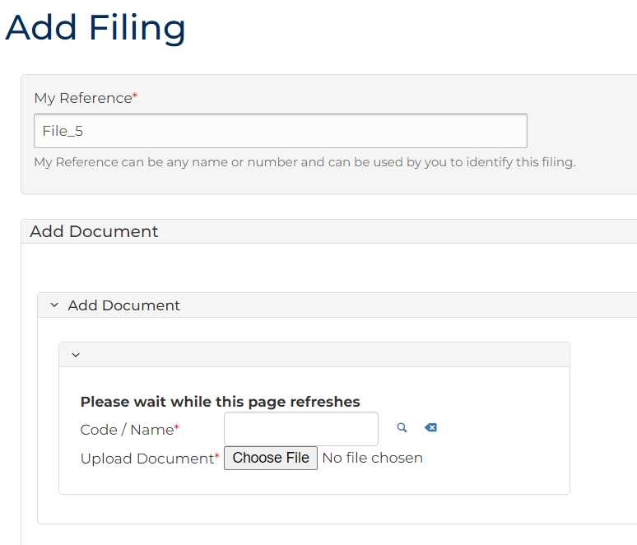

1. Complete required panels and fields.

| Panel: My Reference | |
| --- | --- |
| Field: | Action: |
| My Reference | Type reference name or number to identify filing. |

| Panel: Add Document | |
| --- | --- |
| Field: | Action: |
| Code/Name | Type: Warrant  Select: Warrant to seize property |
| Upload Document | Click: Choose File and add required PDF document to case.  Note:  All document uploads must be PDF. |

| Panel: Claim | |
| --- | --- |
| Field: | Action: |
| Date of judgement | Type date judgement was made. |
| Claim amount | Type amount.  Note:  Amount entered in claim fields must match exact amounts awarded in order related to Warrant to Seize Property. |
| Cost amount | Type amount. |
| Interest ordered | Type amount. |
| Amount paid since order made | Type amount. |
| Total | - |

| Panel: Costs | |
| --- | --- |
| Field: | Action: |
| Fees on Warrant | Type amount. |
| Professional Costs | Type amount. |
| Previous Warrant Costs | Type amount. |
| Previous SOE costs | Type amount. |
| Other Costs (Monetary Amount) | Type amount. |
| Other Cost Description | Type description for Other Costs, if applicable. |
| Total | - |

|  |  |
| --- | --- |
|  | Note:  Amount entered for fees and scaled costs must match fees paid or amounts allowed in scale. |

| Panel: Interest | |
| --- | --- |
| Field: | Action: |
| Manual interest calculation required | Select Yes or No  Note:  If Yes is selected, a percentage amount field displays. |
| From | Select interest period start date using the calendar icon. |
| To | Select interest period end date using the calendar icon. |
| Principal Amount $ | Type the principal interest amount. |
| Interest Total | - |

| Panel: Additional Panels | |
| --- | --- |
| Field: | Action: |
| Address Details | Start typing the address into the search box and select the correct option from the results.  Note:  The address MUST be in Victoria. |
| Filed By | Select party. |
| Representation | Select filing party's legal representation if applicable. |
| Filed Against | Select party. |
| Related Orders | Select related order. |
| Fee Waiver | Change to Yes if applying for fee waiver. |

1. Click: Proceed

My Account screen displays:

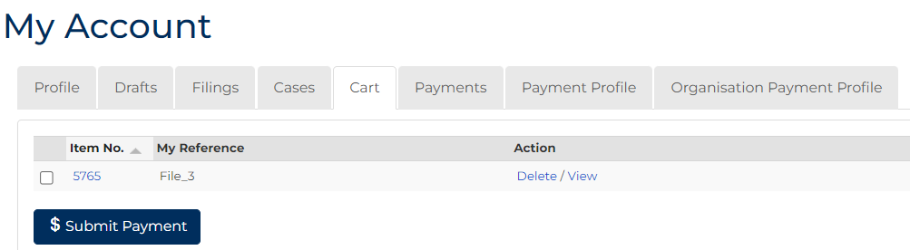

1. To submit payment, tick box next to Item No., click: $ Submit Payment

Process Payment screen displays:

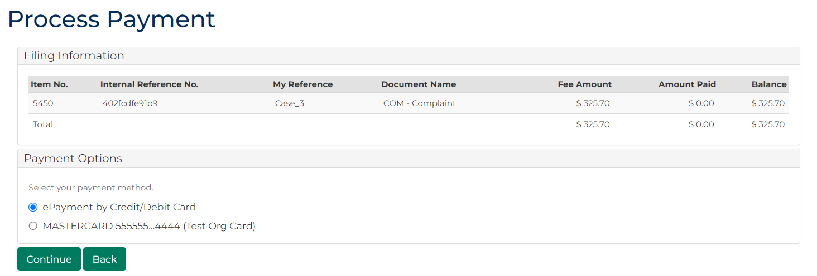

1. In Payment Options panel, select payment method, click: Continue

Confirmation of Filing screen displays:

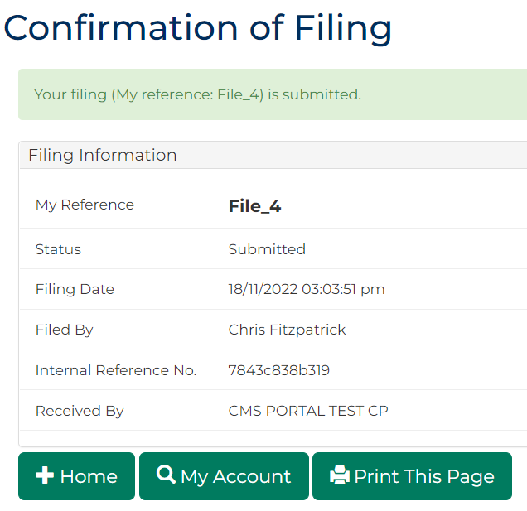

|  |  |
| --- | --- |
|  | Note:  Warrants to Seize Property are automatically issued in certain circumstances. Warrants with alternate interest claimed, or with previous or other costs claimed, are subject to review by the court and issued manually  Acknowledgment for filing email sent to Portal user when document is filed  Additional email is sent once document is reviewed by registry staff  Emails may arrive simultaneously if Warrant to Seize Property is automatically approved by Portal |

1. Click: My Account

My Account screen displays indicating pending review, accepted, or rejected:

