File amended document

Portal Quick Reference Guide

|  |
| --- |
| Purpose |
| Quick Reference Guide shows how to: File amended document in CMS Portal |

|  |  |
| --- | --- |
|  | Notes:  ALL amended documents are subject to court review. Filer will receive an email notification advising whether filing has been accepted or rejected.  If fee reimbursement is required for an amended document, request needs to be filed in person at relevant Registry. |

1. Log in to Portal.

Home screen displays:

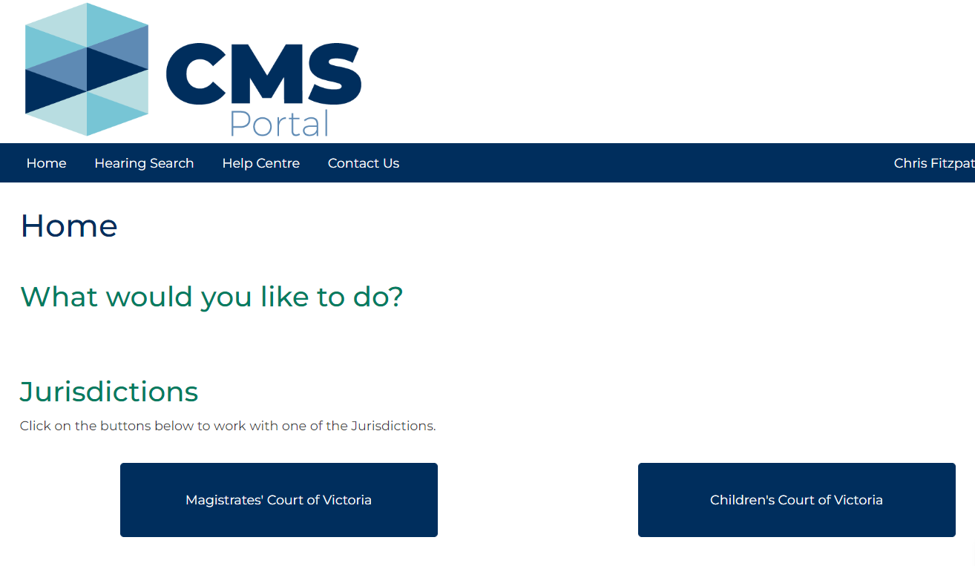

1. Click: File on One of My Cases

Search Case screen displays:

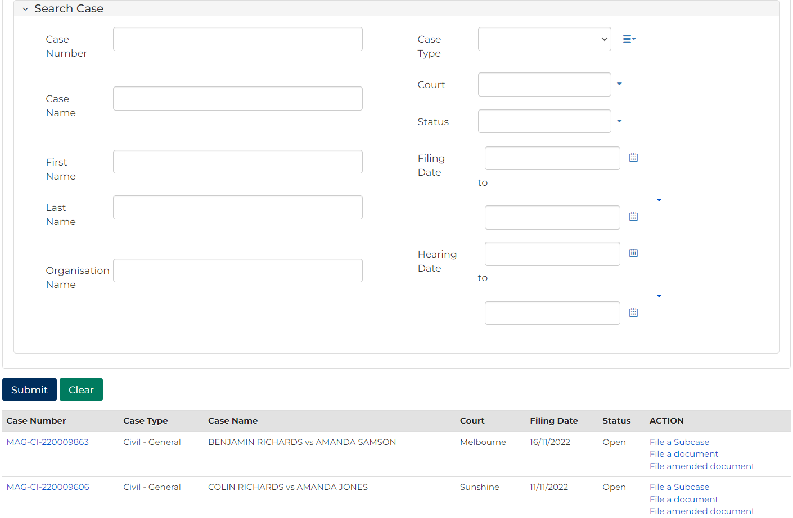

|  |  |
| --- | --- |
|  | Note:  List of cases that have permitted access displays at bottom of screen. If relevant case is visible in list, click **Case Number** to access or a link in **Actions** column to file on the case  This page enables to search by numerous filters  If viewing is denied, requesting access to case is required |

|  |  |
| --- | --- |
|  | Resource:  See Quick Reference Guide: Request access to a case |

1. In Action column for relevant case, click: File amended document link.

Case Summary screen displays:

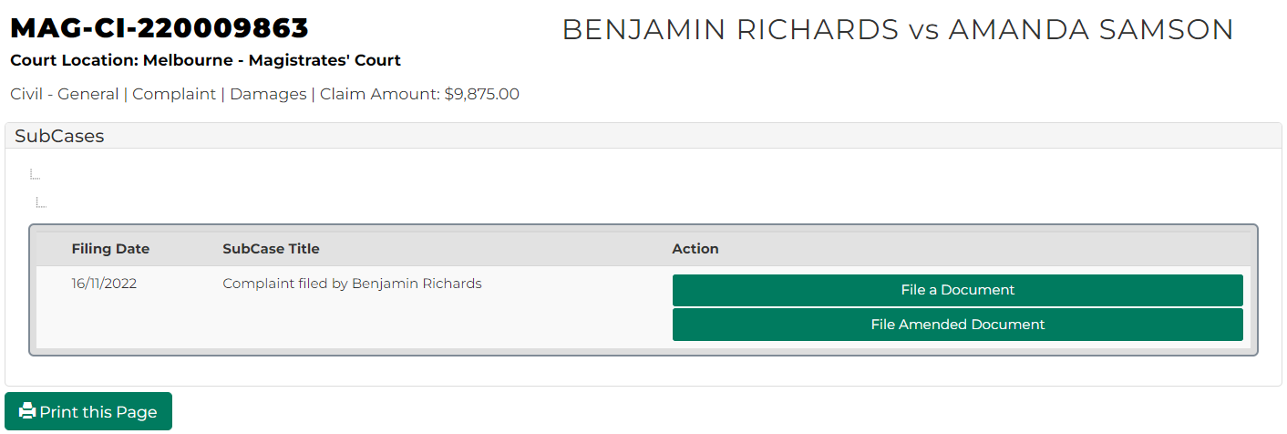

1. Click: File Amended Document

File Amended Document screen displays:

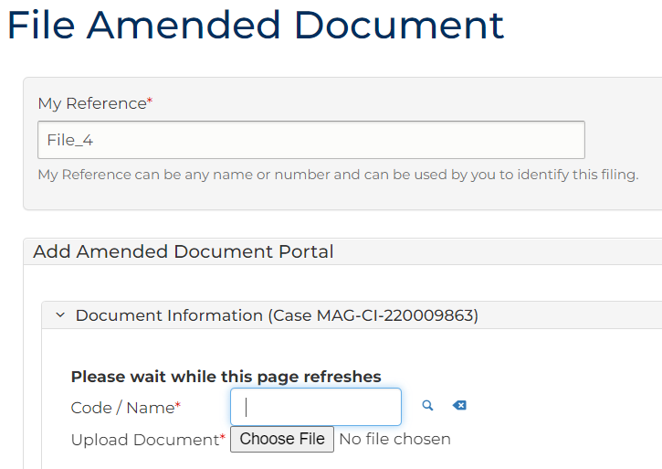

|  |  |
| --- | --- |
|  | Note:  Panels and fields will vary depending on Document type selected. |

1. Complete required panels and fields.

| Panel: My Reference | |
| --- | --- |
| Field: | Action: |
| My Reference | Type reference name or number to identify filing. |
| Panel: Add Amended Document Portal | |
| Field: | Action: |
| Code/Name | Type Code/Name and select document from list.  Note:  If unsure of Code/Name click magnifying glass icon to open search functionality. |
| Upload Document | Click: Choose File and add required PDF document to case.  Note:  All document uploads must be PDF |

| Panel: Filed By | |
| --- | --- |
| Field: | Action: |
| Filed by | Select party. |
| Represenation | Select filing party’s legal representation if applicable.  To add representation, click: Add Representation |
| Related Documents | Select related documents. |
| Related Hearings | Select related hearings date. |

1. Click: Proceed

Confirmation of Filing screen displays:

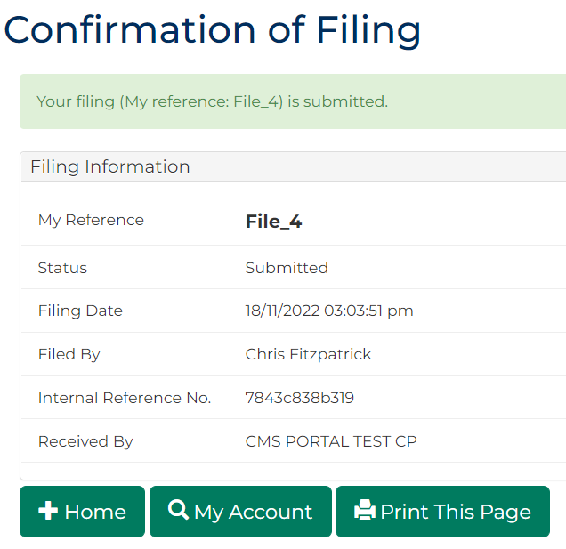

|  |  |
| --- | --- |
|  | Notes:  Acknowledgment for filing email is sent to Portal user when document is filed  An additional email is sent once filing is reviewed by registry staff |

1. Click: My Account

My Account screen displays indicating pending review, accepted or rejected:

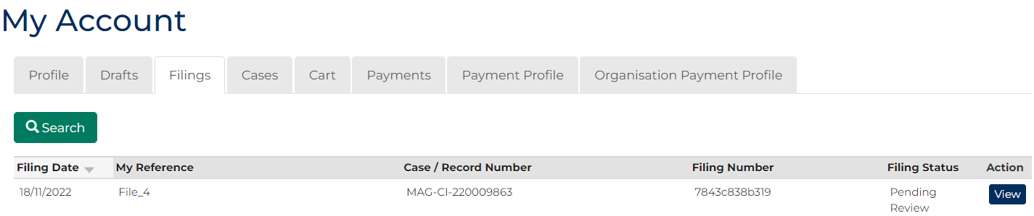

1. To see record of filing, in the Action column, click: View

Case Summary screen displays:

